Overview
This document contains the necessary information to build the Cedar USB Joystick. This includes a Customization Guide, 3D Printing Guide, Assembly Guide, and instructions to test the finished joystick.
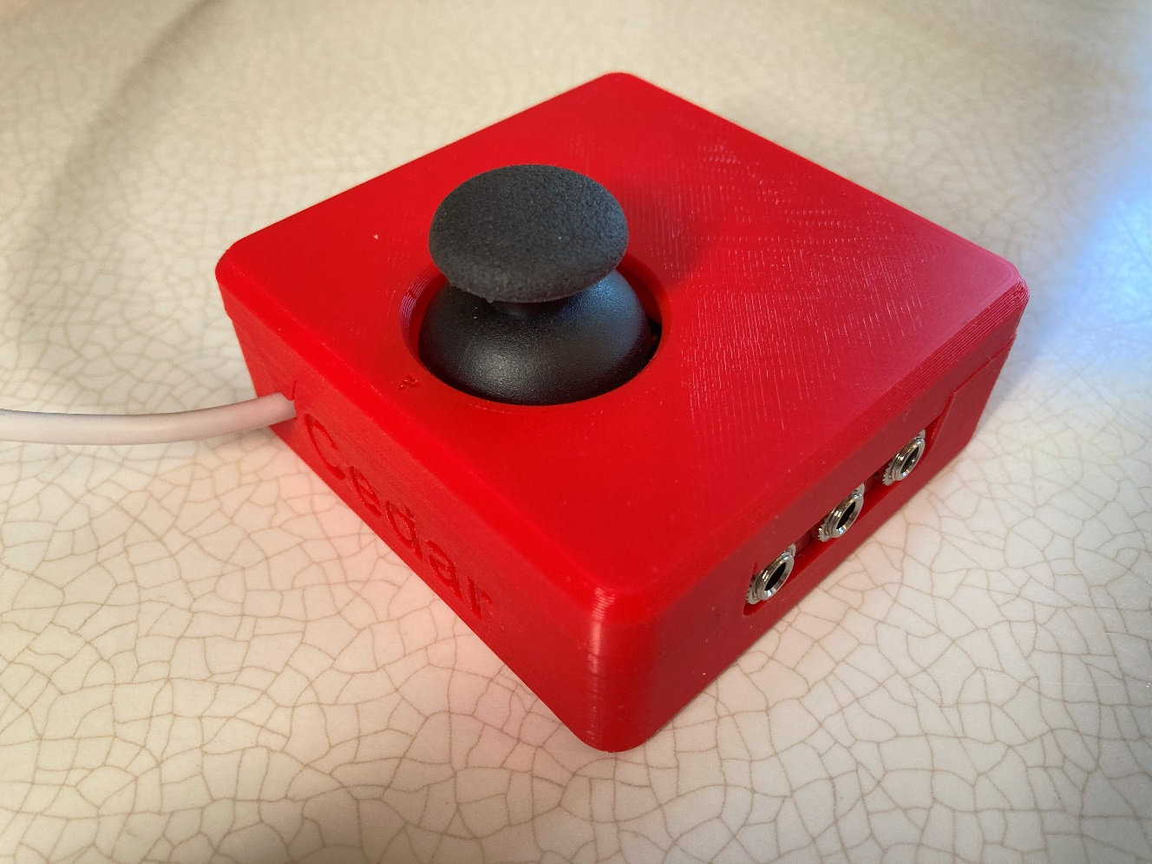

Contents
Overview 1
Maker Checklist 3
Maker To Do List 3
Items to Give to User 3
Tool List 4
Tools / Equipment 4
Supplies 4
Personal Protective Equipment (PPE) 4
Customization Guide 5
Joystick 5
Toppers 5
Mounting 5
3D Printing Guide 6
3D Printing Summary 6
3D Printing Settings 6
Post-Processing 6
Examples of Quality Prints 7
Assembly Guide 8
Part A: Joystick Assembly 8
Required Components 8
Required Tools 9
Required Personal Protective Equipment (PPE) 9
Assembly Steps 9
Part B: Flashing Firmware to Joystick 22
Testing 23

Maker Checklist
This list provides an overview of the steps required to build and deliver the device.

Maker To Do List
- Read through the Maker Guide to become familiar with required components, tools, supplies, and safety gear and overall assembly steps.
- Talk to User about customization options (e.g., colour, any special requests, etc.)
- Ask the user if they would like any joystick toppers.
- Ask the user if they would like a specific mounting solution.
  - Tabletop
    - Hook and Loop Fasteners
    - Non slip material
  - Camera Mount Adapter
  - RAM Mount Adapter
- Order hardware components
- Gather tools, supplies, and safety equipment.
- Print the 3D printed components.
- Assemble the device
- Test device
- Print “User Guide”

Items to Give to User
- Assembled, tested joystick
- Any joystick toppers if requested
- Any mount adapters if requested
- “User Guide”

Tool List

Tools / Equipment
Tool ID | Description | Required / Recommended | Notes
T01 | Flush Cutters | Required
T02 | Wire Strippers | Required
T03 | Soldering Iron | Required
T04 | Philips Head Screwdriver | Required
T05 | Computer with USB port | Required | Must have Arduino IDE or the ability to install it

Supplies
Supplies ID | Description | Quantity |  | Notes
S01 | Solder | 5 grams

Personal Protective Equipment (PPE)
PPE ID | Description | Notes
P01 | Safety Goggles

Customization Guide

Joystick
The enclosure can be printed in the user’s desired colour(s). Colour swaps can be done to further customize the joystick and make the forward arrow on the top stand out more.

Toppers
3D printed joystick toppers can be added to the joystick to better suit the user’s needs and abilities.
Any PS2 style thumbstick toppers will work here, one example is this set of toppers designed by AbleGamers. A copy of the AbleGamers toppers can be found in the toppers folder.
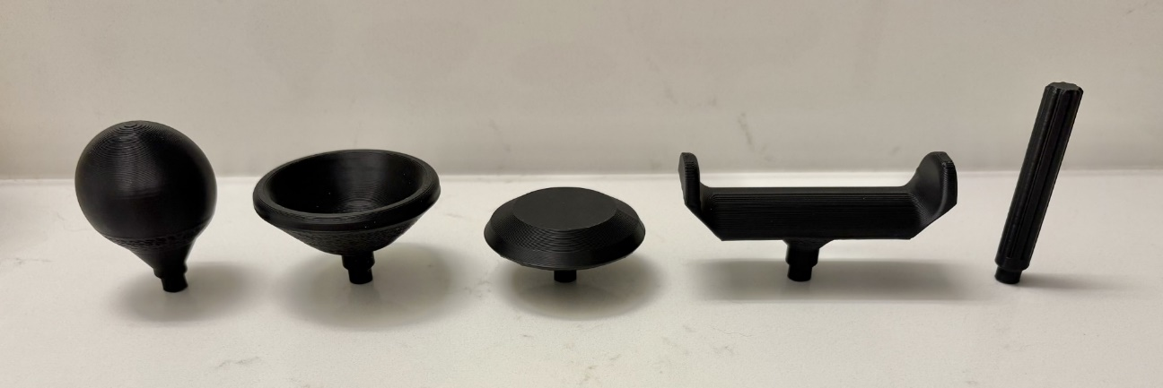

Mounting
A Mounting Adapter can be added for custom mounting solutions. Current mounting options include nonslip pads, hook and loop fastener, and a ¼-20 UNC Camera Mount Adapter.

3D Printing Guide

3D Printing Summary
Metrics | Single Unit
Total Print Time (min) | 4h53m
Total Number of Components | 4
Typical Total Mass (g) | 41
Typical Number of Print Setups | 1

3D Printing Settings
Note that the 3D printing material should be assumed to be PLA unless otherwise noted in the table below.
Print File Name | Qty | Total Print Time (hr:min) | Mass (g) | Infill (%) | Support  (Y/N) | Layer Height/ Nozzle Diameter(mm) | Notes
Enclosure_bottom.stl | 1 | 2:29 | 20 | 20 | N | 0.2/0.4 | Print in orientation given in STL
Enclosure_top.stl | 1 | 1:19 | 12 | 20 | N | 0.2/0.4 | Print in orientation given in STL
3D_PCB.stl | 1 | 0:57 | 8 | 20 | N | 0.2/0.4 | Print in orientation given in STL
Slide_switch.stl | 1 | 0:08 | 1 | 20 | N | 0.2/0.4 | Print in orientation given in STL

Post-Processing
Inspect the 3D printed parts for any printing defects, sharp edges, or burrs. Sharp edges and burrs can be removed with sanding or deburring tools.

Examples of Quality Prints
Compare your 3D prints to the images here. If there are significant differences, you may need to reprint the part.
Joystick Enclosure
Enclosure_bottom.stl | Enclosure_top.stl | 3D_PCB.stl
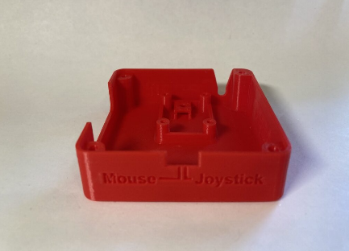 | 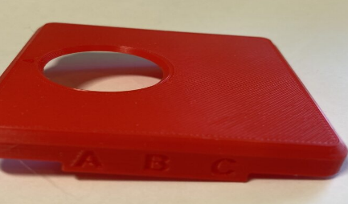 | 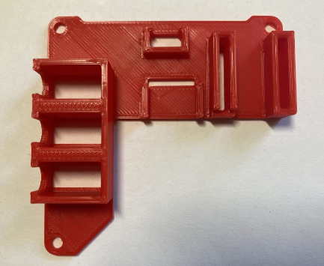
Slide_switch.stl
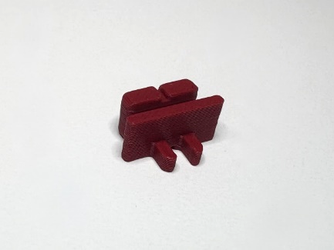

Assembly Guide

Part A: Joystick Assembly

Required Components
1 | Joystick Component | QTY 1 | 2 | USB-C cable | QTY 1 | 3 | Adafruit QT Py SAMD21 board | QTY 1
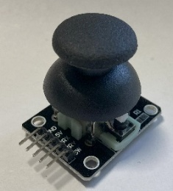 |  |  | 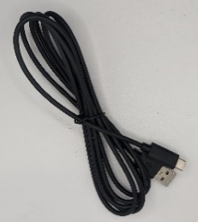 |  |  | 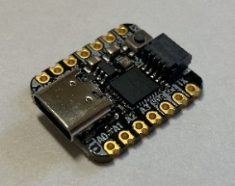
4 | 3.5 mm mono jack, panel mount | QTY 3 | 5 | Slide Switch | QTY 1 | 6 | Right angle 5 pin female header | QTY 1
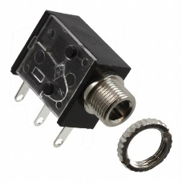 |  |  | 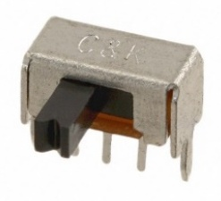 |  |  | 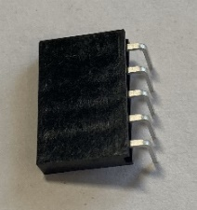
7 | Female header, 7 pin | QTY 2 | 8 | #4-3/8” Sheet metal screw, self threading | QTY 4 | 9 | 24AWG solid core wire, multiple colours | Length:  2 feet
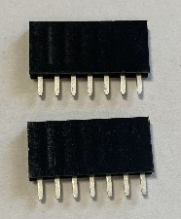 |  |  | 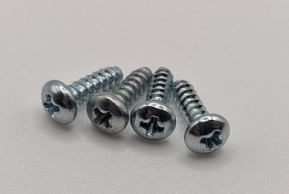 |  |  | 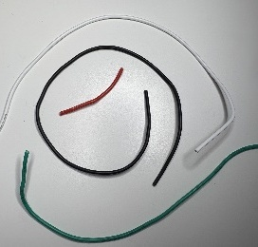
10 | Cable Tie, 4” | QTY 1 | 11 | M3 Hex Nuts | QTY 2 | 12 | 3D Printed PCB | QTY 1
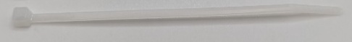 |  |  | 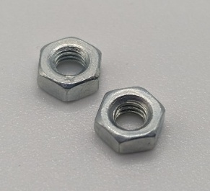 |  |  | 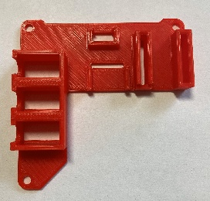

Required Tools
- Flush Cutters
- Wire Strippers
- Soldering Iron
- Philips Head Screwdriver
- Computer with USB port and Arduino IDE (or ability to install it)

Required Personal Protective Equipment (PPE)
- Safety Goggles

Assembly Steps

Step 1: Insert Slide Switch
Press fit the slide switch into the 3D Printed PCB so top is flush with 3D print  Use pliers to bend the two outer mounting legs outwards to secure the slide switch. | 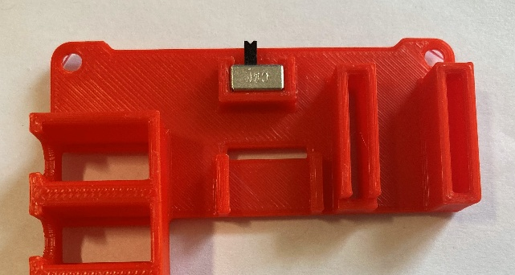  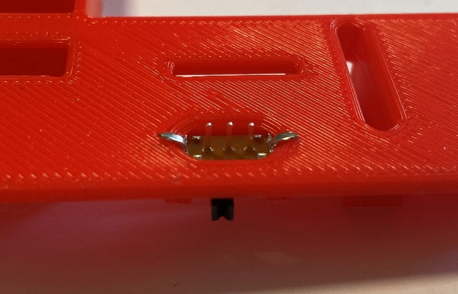

Step 2: Insert Female Headers
Insert components into 3D PCB:  - Press fit both 7 pin female headers so the tops are flush with the 3D print | 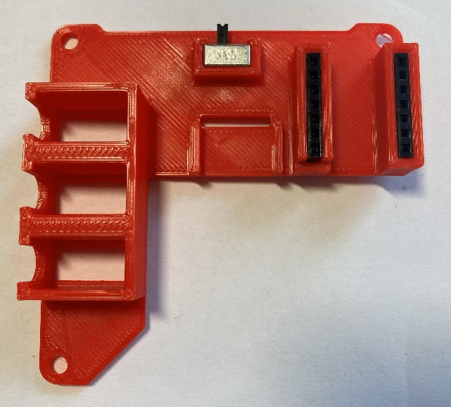

Step 3: Insert Right Angle Female Headers
Insert component into 3D PCB:  - Snap fit right angle 5 pin female header with pins through hole in the board | 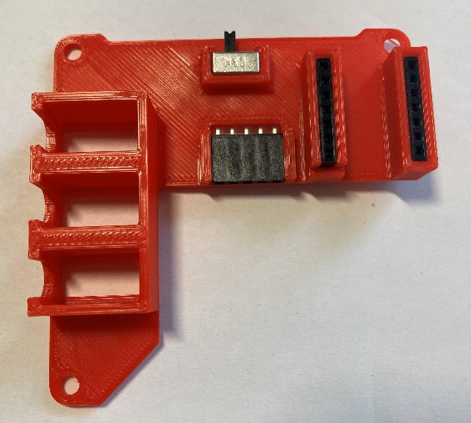

Step 4: Insert Mono Jacks
Insert components into 3D PCB:  - Press in the mono jacks so the tops are flush with the 3D print  - Install nuts on the mono jacks to secure them. | 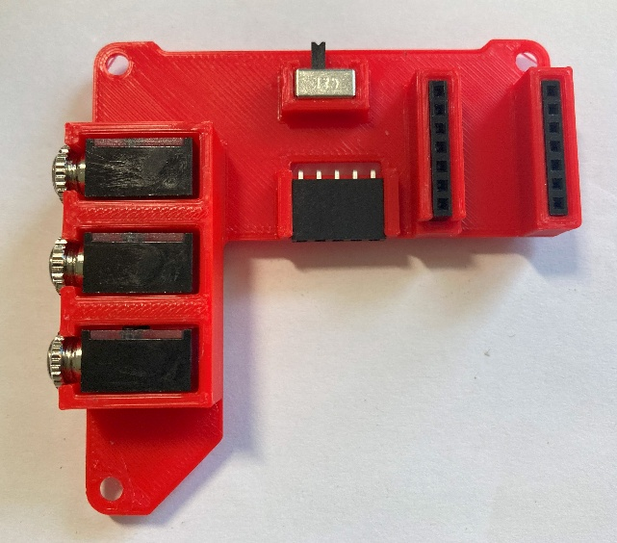  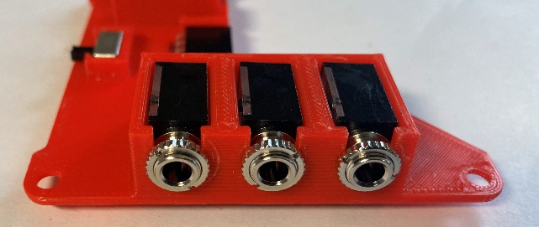

Wiring
Wiring the joystick will follow the diagram below and will be broken down into multiple steps.
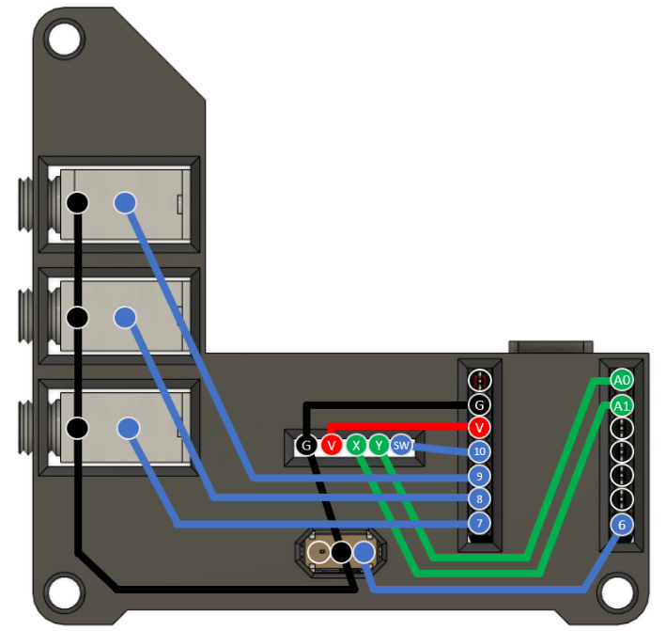
Figure 1. Joystick Wiring Guide

Step 5: Flip the 3D PCB
Flip the 3D PCB so that the pins are facing up, as shown. | 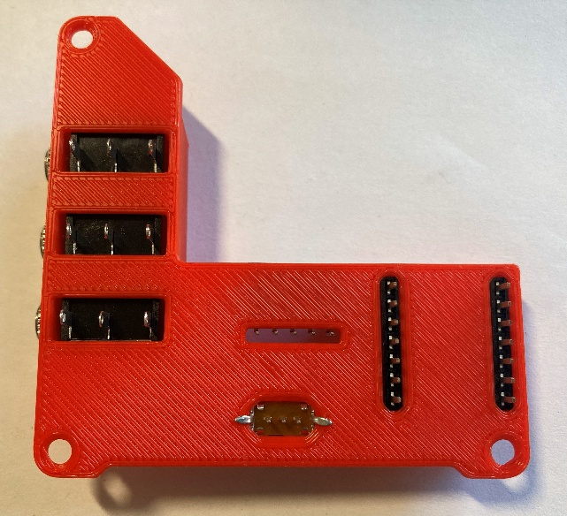

Step 6: Prepare Wires (Colour 1)
Take one colour of wire and cut two lengths, 7 cm and 4 cm.  From the longer wire, strip 1.5 cm fomr one end and 0.3 cm from the other end.  From the shorter wire, strip off 3 cm from one end and 0.3 cm from the other end. | 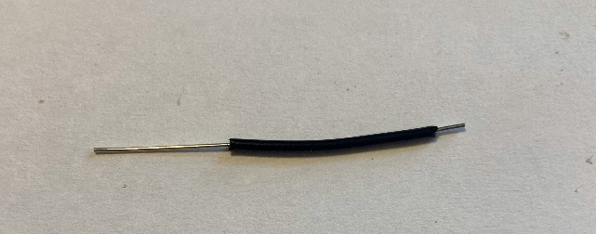  1.5 cm  0.3 cm  4 cm  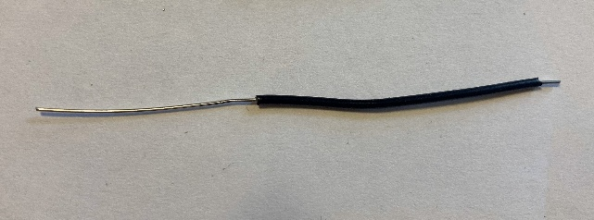  7 cm  0.3 cm  3 cm

Step 7: Solder First Ground Wire (Colour 1)
Take the longer wire from the previous step, bend it such that the longer stripped section is in contact with the leftmost pin of each of the 3 mono jacks, and the shorter stripped section is in contact with the middle pin on the slide switch.  Solder these connections. | 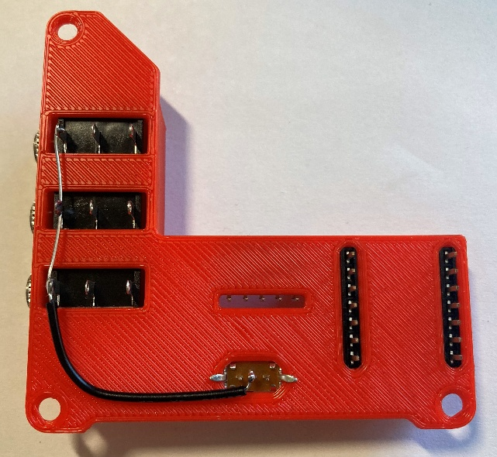

Step 8: Solder Second Ground Wire (Colour 1)
Take the shorter wire from Step 6, bend it such that:  - The longer stripped section is in contact with the middle pin of the slide switch and the leftmost pin on the joystick header (labelled G)  - The shorter stripped section is in contact with the 2nd pin from top left on QT Py header (labelled G on wiring diagram).  Solder these connections. | 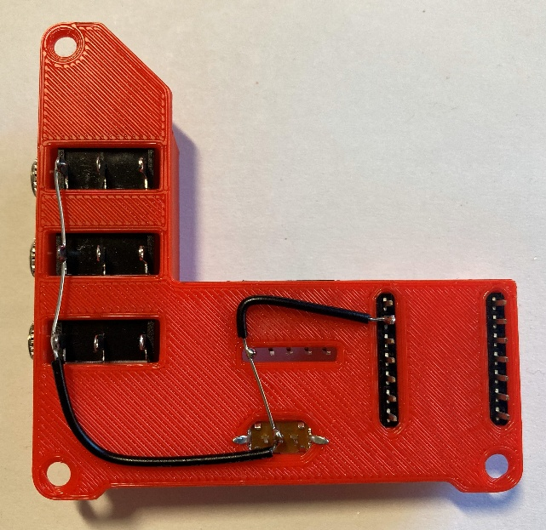

Step 9: Prepare Wire (Colour 2)
Take a second colour of wire and cut a 3 cm piece. Strip off roughly 0.3 cm from each end. | 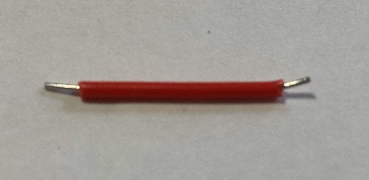  3 cm  0.3 cm  0.3 cm

Step 10: Solder Voltage Wire (Colour 2)
Take the wire (colour 2) from the previous step and bend it so it will touch:  - the second pin (from the left) on the joystick header (labelled V)  - the third pin from the top left on the QT Py header (3v3 pin, labelled V on wiring diagram).  Solder these connections. | 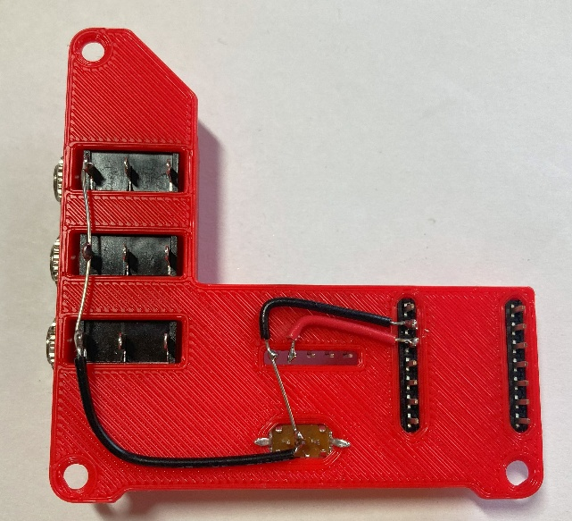

Step 11: Prepare Wires (Colour 3)
Take a third colour of wire and cut a two pieces 5 cm long each.  - Strip off roughly 0.3 cm from each end of both wires. | 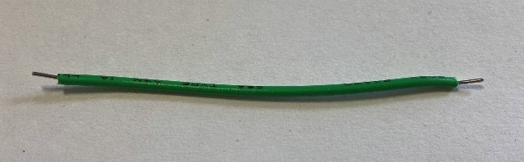  0.3 cm  0.3 cm  5 cm

Step 12: Solder Joystick Y Wire (Colour 3)
Take the 5 cm wire (colour 3) from the previous step and bend it so it will touch:  - the fourth pin (from the left) on the joystick header (labelled Y on wiring diagram)  - the first pin from the top right on the QT Py header (labelled A0 on wiring diagram).  Solder these connections. | 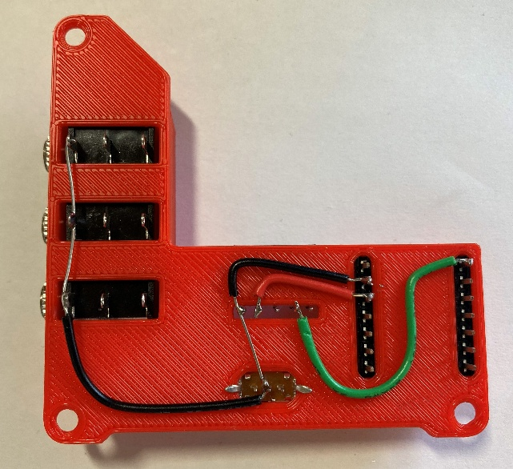

Step 13: Solder Joystick X Wire (Colour 3)
Take the 5 cm wire (colour 3) from the previous step and bend it so it will touch:  - the third pin (from the left) on the joystick header (labelled X on wiring diagram)  - the second pin from the top right on the QT Py header (labelled A1 on wiring diagram).  Solder these connections. | 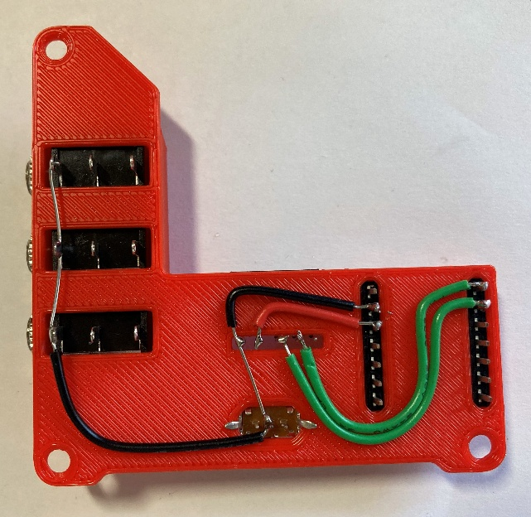

Step 14: Prepare Wire (Colour 4)
Take a fourth colour of wire and cut a piece 1 cm long.  Strip off roughly 0.2 cm from each end of the wire. | 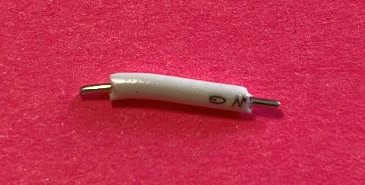  0.2 cm  0.2 cm  1 cm

Step 15: Solder Joystick Sw Wire (Colour 4)
Take the 1 cm wire (colour 4) from the previous step and connect it so it will touch:  - the fifth pin (from the left) on the joystick header (labelled Sw on wiring diagram)  - the third pin from the top left on the QT Py header (labelled V on wiring diagram).  Solder these connections. | 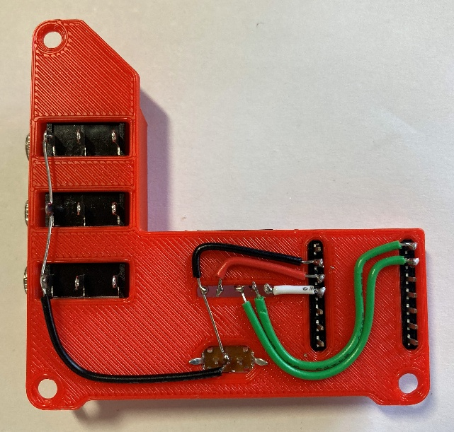

Step 16: Prepare Wires (Colour 4)
0.2 cm
0.2 cm
Take the fourth colour of wire and cut three pieces of lengths: 6.5 cm, 5.5 cm, 5.0 cm.  Strip off roughly 0.2 cm from one, and 1 cm from the other end of each wire.  Cut a fourth piece of wire 3.5 cm long and strip off roughly 0.2 cm from each end. |   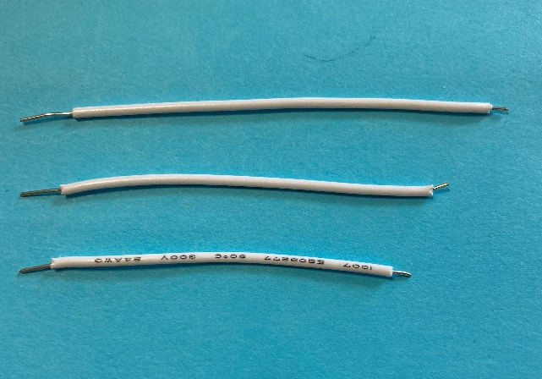  0.2 cm  3.5 cm  1 cm  5 cm  5.5 cm  6.5 cm

Step 17: Solder First Switch Jack Wire (Colour 4)
Take the 6.5 cm wire (colour 4) from the previous step and bend it so it will touch:  - the second pin (from the left) on the top mono jack (using the side with more stripped exposed wire)  - the fifth pin from the top left on the QT Py header (labelled 9 on wiring diagram).  Solder these connections. | 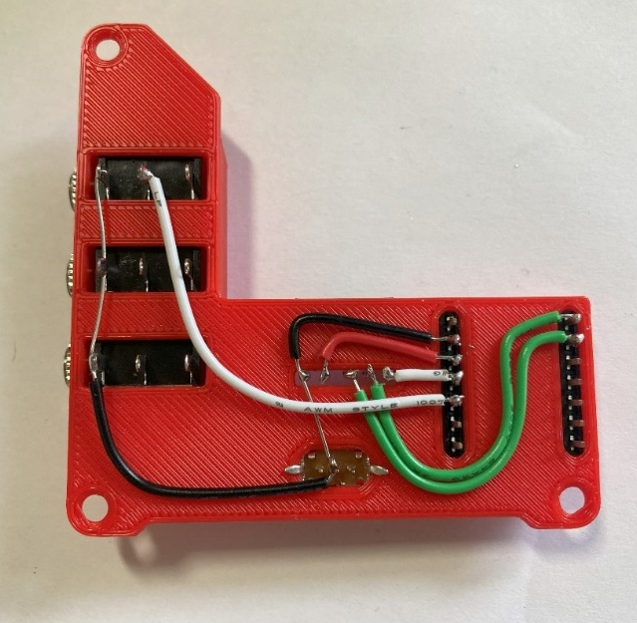

Step 18: Solder Second Switch Jack Wire (Colour 4)
Take the 5.5 cm wire (colour 4) from step 16 and bend it so it will touch:  - the second pin (from the left) on the middle mono jack (using the side with more stripped exposed wire)  - the sixth pin from the top left on the QT Py header (labelled 8 on wiring diagram).  Solder these connections. | 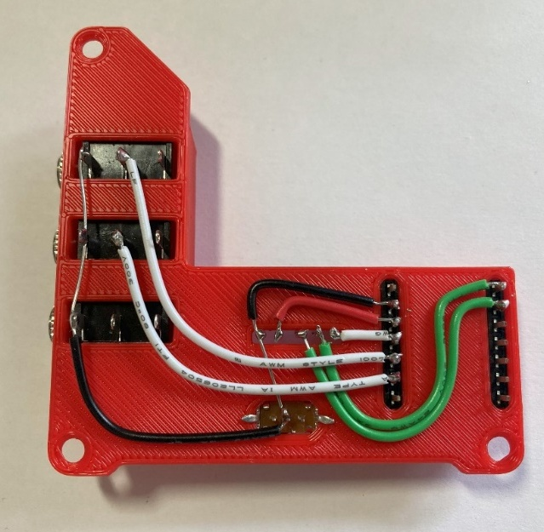

Step 19: Solder Switch Slide Wire (Colour 4)
Take the 3.5 cm wire (colour 4) from step 16 and bend it so it will touch:  - the right most pin on the slide switch  - the seventh pin from the top right on the QT Py header (labelled 6 on wiring diagram).  Solder these connections. | 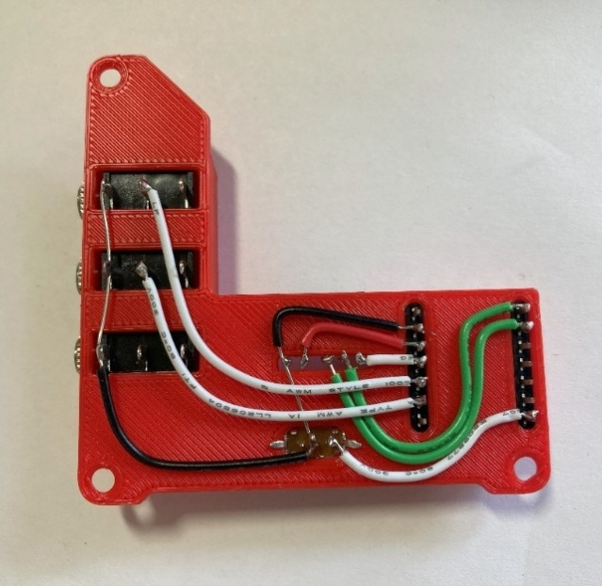

Step 20: Solder Third Switch Jack Wire (Colour 4)
Take the 5 cm wire (colour 4) from step 16 and bend it so it will touch:  - the second pin (from the left) on the bottom mono jack (using the side with more stripped exposed wire)  - the seventh pin from the top left on the QT Py header (labelled 7 on wiring diagram).  Solder these connections. | 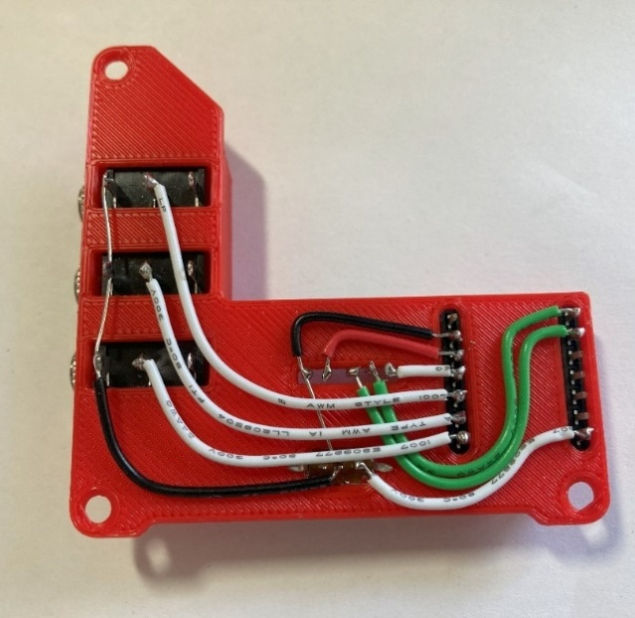

Step 21: Attach Microcontroller
From the male headers that came with the Adafruit QT Py SAMD21 board, break off two 7-pin pieces.  Insert the long side of the 7 pin male headers into 7 pin female headers on 3D printed board.  Place the Adafruit QT Py board on the male headers, ensuring the USB is facing towards the joystick.  Solder the male headers to the microcontroller. | 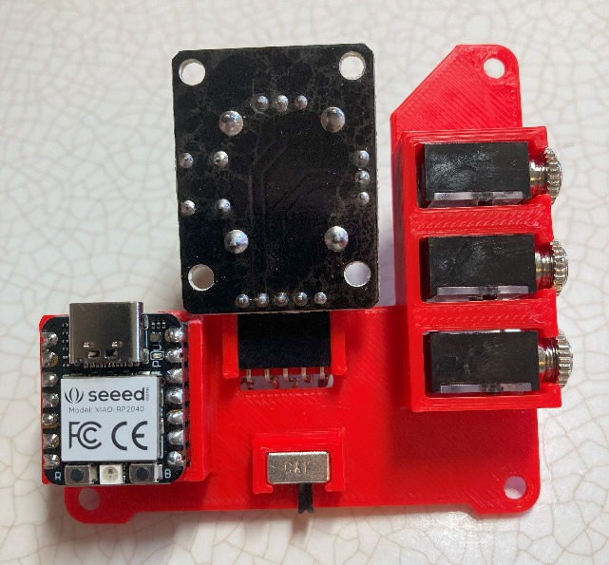

Step 22: Attach Joystick Unit
Insert joystick into angled headers.  All components should be “upside down” when joystick is upright. | 

Step 23: Check for Shorts
Inspect the board and check that none of the connections are shorted.  There should be no bridges/connections between adjacent pins.  If you have a multimeter, you can use it to double check continuity. | WARNING: If pins are shorted they may damage the USB port on your computer.  

Step 24: Insert M3 Hex Nuts into Enclosure
Insert M3 nuts into captive nut slots.  You might need to use pliers to push the nuts in. | 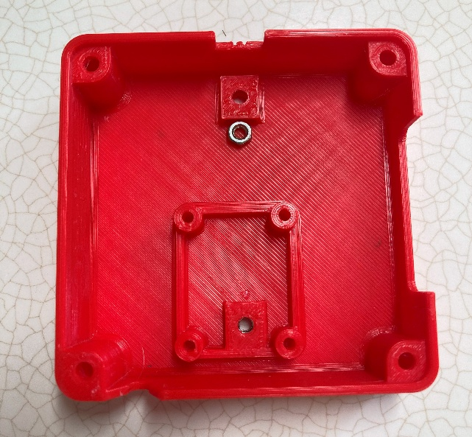

Step 25: Insert Switch Cover
Place the slide switch cover in the slot with the taller side/slot up. | 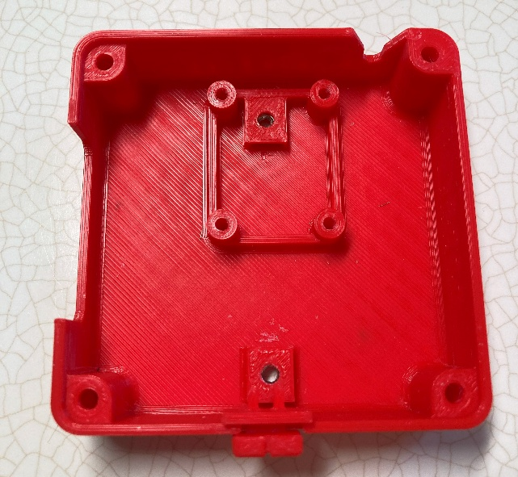

Step 26: Plug in USB-C Cable and Insert 3D PCB into Enclosure
Plug the USB-C cable into the Adafruit QT Py board.  Insert the 3D PCB into bottom of enclosure, the joystick should sit on the 4 posts.  You may need to move the slide switch cover so that it lines up with the slide switch and fits onto it.  Insert screws into the joystick board’s 4 screw holes. | 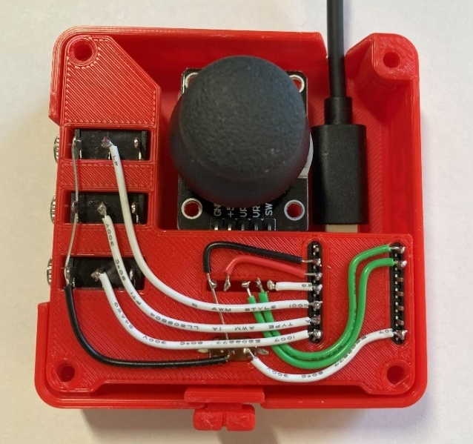

Step 27: Assemble Enclosure
Place the top onto the enclosure.  Screw in all 4 screws from the bottom. | 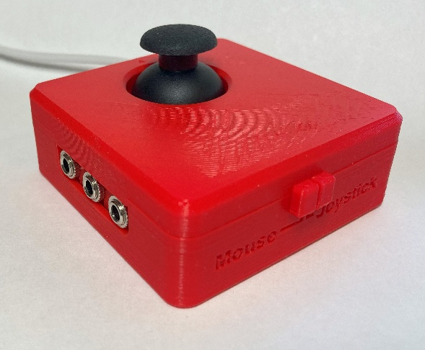  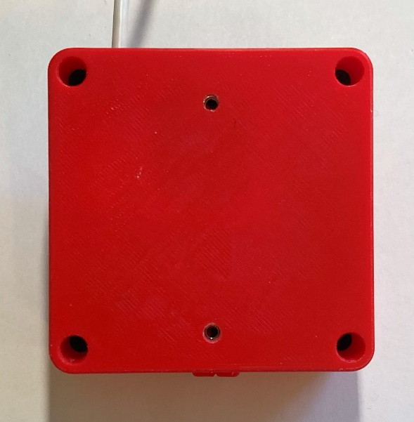

Part B: Flashing Firmware to Joystick

Step B01: Setup Arduino IDE
  - Download Arduino IDE for your operating system at https://www.arduino.cc/en/software
  - Install Arduino IDE

Step B02: Setup Core
  - Open Arduino IDE.
  - Click on File -> Preferences
  - Locate the text field that says Additional Boards Manager URLs beside it.
  - Copy and paste the following link into the field as a new line:
https://adafruit.github.io/arduino-board-index/package_adafruit_index.json
  - Click on OK.
  - Restart the Arduino IDE.
  - Open the Boards Manager option from the Tools-> Board-> Boards Manager..., search for “Adafruit SAMD” and select “Adafruit SAMD Boards” by Adafruit.

Step B03: Install Libraries
  - Go to https://github.com/cyborg5/TinyUSB_Mouse_and_Keyboard and go to Code -> Download ZIP and then rename this ZIP folder “TinyUSB_Mouse_and_Keyboard”.
  - In the Arduino IDE, go to Sketch -> Include Library -> Add .ZIP library and then select the “TinyUSB_Mouse_and_Keyboard” ZIP folder (likely found in your Downloads).
  - Go to Tools -> Manage Libraries…, search for “Flash Storage” and install the library “FlashStorage” by Arduino.

Step B04: Upload the Code to the joystick
  - Open OpenAT_Joystick_Mouse_M0_Software_Cedar.ino with Open Arduino IDE.
  - Select Adafruit QT Py M0 (SAMD21) from Tools -> Board -> Adafruit SAMD Boards
  - Click on Tools -> USB Stack and select Adafruit TinyUSB
  - Connect the joystick using the USB cable to the computer.
  - Select the correct port from Tools -> Port menu.
  - Verify and upload the code.

Testing
- Slide the Mode Switch to Joystick mode.
- Connect the joystick using the USB cable to the computer.
- If using Windows, open “Set up USB Game Controllers” from the Control Panel. You can find this by searching your computer in the search bar next to the Windows icon.
- Ensure that the joystick is registered as a game controller and select your joystick from the list and go to “Properties”.
- Move your joystick and observe the movement of the cross hatch in the “Axes” window. Ensure it moves in the proper directions when you move the joystick (the arrow points in the up direction). If not, open the joystick and check your connections.
- Using assistive switches plugged into each mono jack, activate each switch, and ensure that one of buttons 1-4 light up when you press the switch, and stops when you release the switch. If not, open the joystick and check your connections.

https://www.printables.com/model/501869-analog-thumbstick-topper-collection

