Overview
The Device Summary is intended to be a detailed summary of the device, product and maker information for the Cedar Mini USB Joystick, making it easier to add to the Makers Making Change website. It is intended for anyone who will view the device listing.
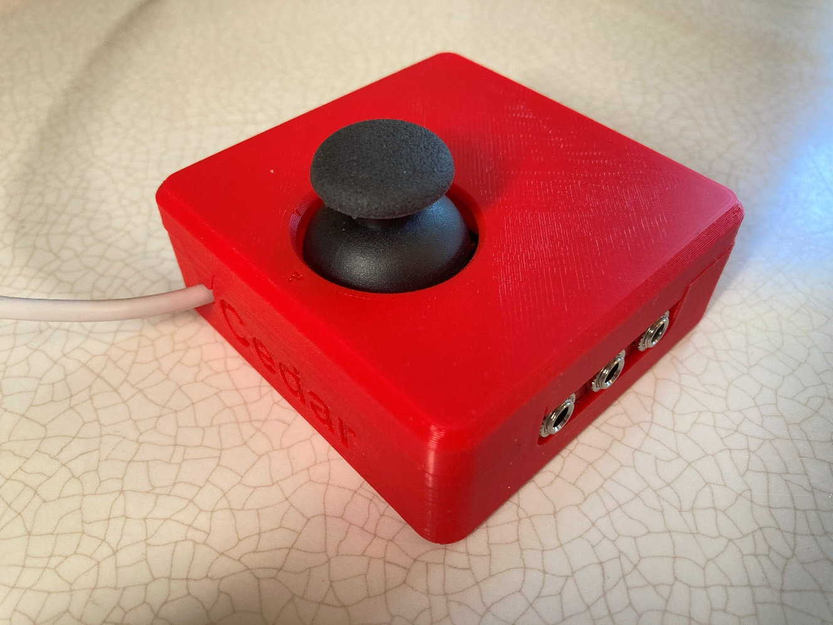

Product Information

Product Name
Cedar Mini USB Joystick

Device Category
Mark any relevant categories with an “X”:

 | Adapted Toys
 | Aids for Daily Living (ADL)
 | Assistive Switches
 | Communication Aids (AAC)
X | Computer Access
 | Environmental Controls
X | Gaming
 | Keyguard
 | Kits
 | LipSyncs
 | Mounting
 | Recreation and Leisure
 | Seating and Positioning
 | Switch Interfaces
 | Writing Aids

User Value Statement
A USB joystick with a small range of motion and additional switch ports that has a switch to toggle between mouse and gamepad output.

Designer
Makers Making Change

Device Information

Overview
The Cedar is a small USB joystick that can act as a HID Mouse or an HID Gamepad. It connects directly to a compatible device via the integrated USB cable. The mode can be changed by sliding a switch on the enclosure. The joystick can be pressed down as an input, and up to 3 assistive switches can be connected using the 3.5 mm input jacks.
The PS2-style game controller thumbstick joystick has a range of motion of ±30° and requires approximately 75 grams-force to fully deflect. A range of toppers are available for this joystick, including a set of toppers created by AbleGamers Charity.
In Joystick mode, it is compatible with the Xbox Adaptive Controller.
The Cedar Mini USB Joystick is the USB version of the Spruce Mini Joystick.

Compatibility
Mouse mode – compatible with PC, most Android phones and tablets, and Apple phones and tablets with iOS13 and iPadOS.
Joystick mode – compatible with PC (direct or gaming with Steam), most Android phones and tablets, and Apple phones and tablets with iOS13 and iPadOS, and with Xbox Adaptive Controller (XAC). Through the XAC it is compatible with PC and Xbox directly or can be used with other gaming consoles with adapters.

Disability Type
Select one or more disability types and mark with an “X”:

X | Agility / Dexterity
 | Arthritis
 | Cognitive
 | Hearing
 | Mobility
 | Pain
X | SCI
 | Vision
 | Other

Disability Type Description
This device is intended for users with a small range of motion that need an external joystick for adaptive gaming or computer access.

How To Use
For full instructions please refer to the User Guide.
Usage
Using the Joystick in Mouse Mode:
- Move the slide switch to the left for Mouse Mode, as indicated on the housing.
- Plug in assistive switches to the switch jacks. The default switch mapping is stated below.
- Plug the joystick into the device you wish to use it with.
- Orient the joystick so the arrow on top is facing away from the user and the cable is exiting the enclosure away from the user.
- Move the joystick to move the mouse, use the switches for the functions listed below.
Using the Joystick in Joystick Mode:
- Move the slide switch to the right for Joystick Mode, as indicated on the housing.
- If desired, plug in assistive switches to the switch jacks. The default switch mapping is stated below.
- Plug the joystick into the device you wish to use it with.
- Orient the joystick so the arrow on top is facing away from the user and the cable is exiting the enclosure away from the user.
- Move the joystick to move the mouse, use the switches for the functions listed above.
- Depending on what device you are using the joystick with, if you are using switches plugged into the jacks you will most likely want to remap them. This can be done in your system’s settings.

Estimated Cost
The estimated material cost of the device for a single build:
 | $0 - $10
 | $11 - $25
 | $26 - $50
X | $51 - $100
 | $101 - $250
 | $250+

Attribution
Designed by Neil Squire Society / Makers Making Change
Contributors:
- Josie Versloot, Neil Squire. Hardware and enclosure design, software, documentation
- Milad Hajihassan, Neil Squire. Software.
- Emily Schwitz, Neil Squire. Documentation.

Maker Information

Project Skills
Mark the required project skills with an “X”:

X | 3D Printing
 | Custom PCB
 | Electronics
 | Laser Cutting
 | Mechanics
X | Software
X | Soldering
 | Woodworking
 | Other

Skills Description

This is an advanced build requiring electronics, mechanics, 3D printing and using the Arduino IDE.

Tools Needed
< SELECT ANY TOOLS THAT ARE REQUIRED TO BUILD THIS DEVICE USING AN “X” IN THE TABLE >
X | 3D Printer
X | Common Hand Tools
 | Common Power Tools
 | Laser Cutter
X | Soldering Iron
 | Specialized Tooling

Print time (hrs)
4

Assembly time (hrs)
3

Build Instructions
This is an advanced build that requires routing and soldering wires using a 3D printed circuit board.
For full instructions please refer to the Maker Guide.
Print Settings:
- 0.2mm Layer Height
- 20% infill
- No supports

Download Link
https://github.com/makersmakingchange/Cedar-Mini-USB-Joystick/archive/refs/heads/main.zip

Project Link
https://github.com/makersmakingchange/Cedar-Mini-USB-Joystick

License

License
Hardware: CERN 2.0 Weakly Reciprocal license
Documentation: Attribution-ShareAlike4.0 International

