Overview
This document contains the necessary information to use the Cedar USB Joystick, a joystick with switch ports.
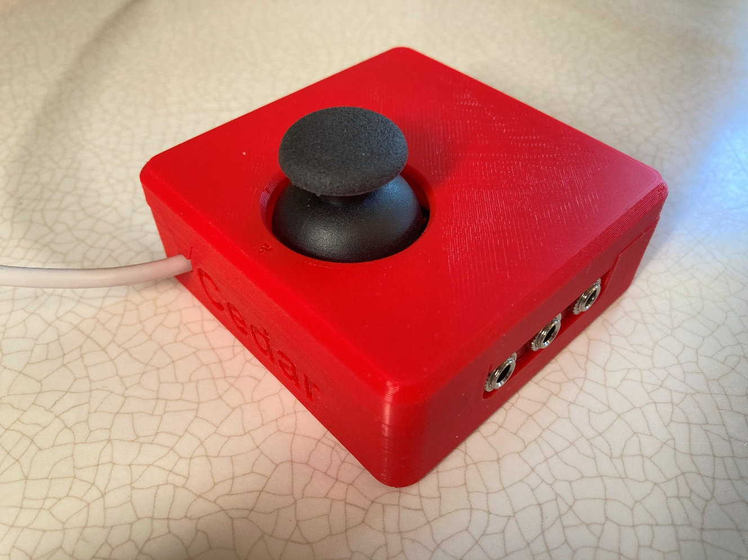

Contents
Overview 1
Contents 2
Introduction 3
Features 3
Mode Switch 4
External Assistive Switch Inputs 4
Mounting Holes 4
Compatibility 5
Usage 5
Input Mapping 6
Mounting 6
Specifications 8
Cleaning 8

Introduction
The Cedar is a small USB joystick that can act as a mouse or an HID Gamepad. It connects directly to a compatible device via the integrated USB cable. The mode can be changed by sliding a switch on the enclosure. The joystick can be pressed down as an input, and up to 3 assistive switches can be connected using the 3.5 mm input jacks.
The joystick has a range of motion of ±30° and requires approximately 75 grams-force to fully deflect.

Features
USB Cable
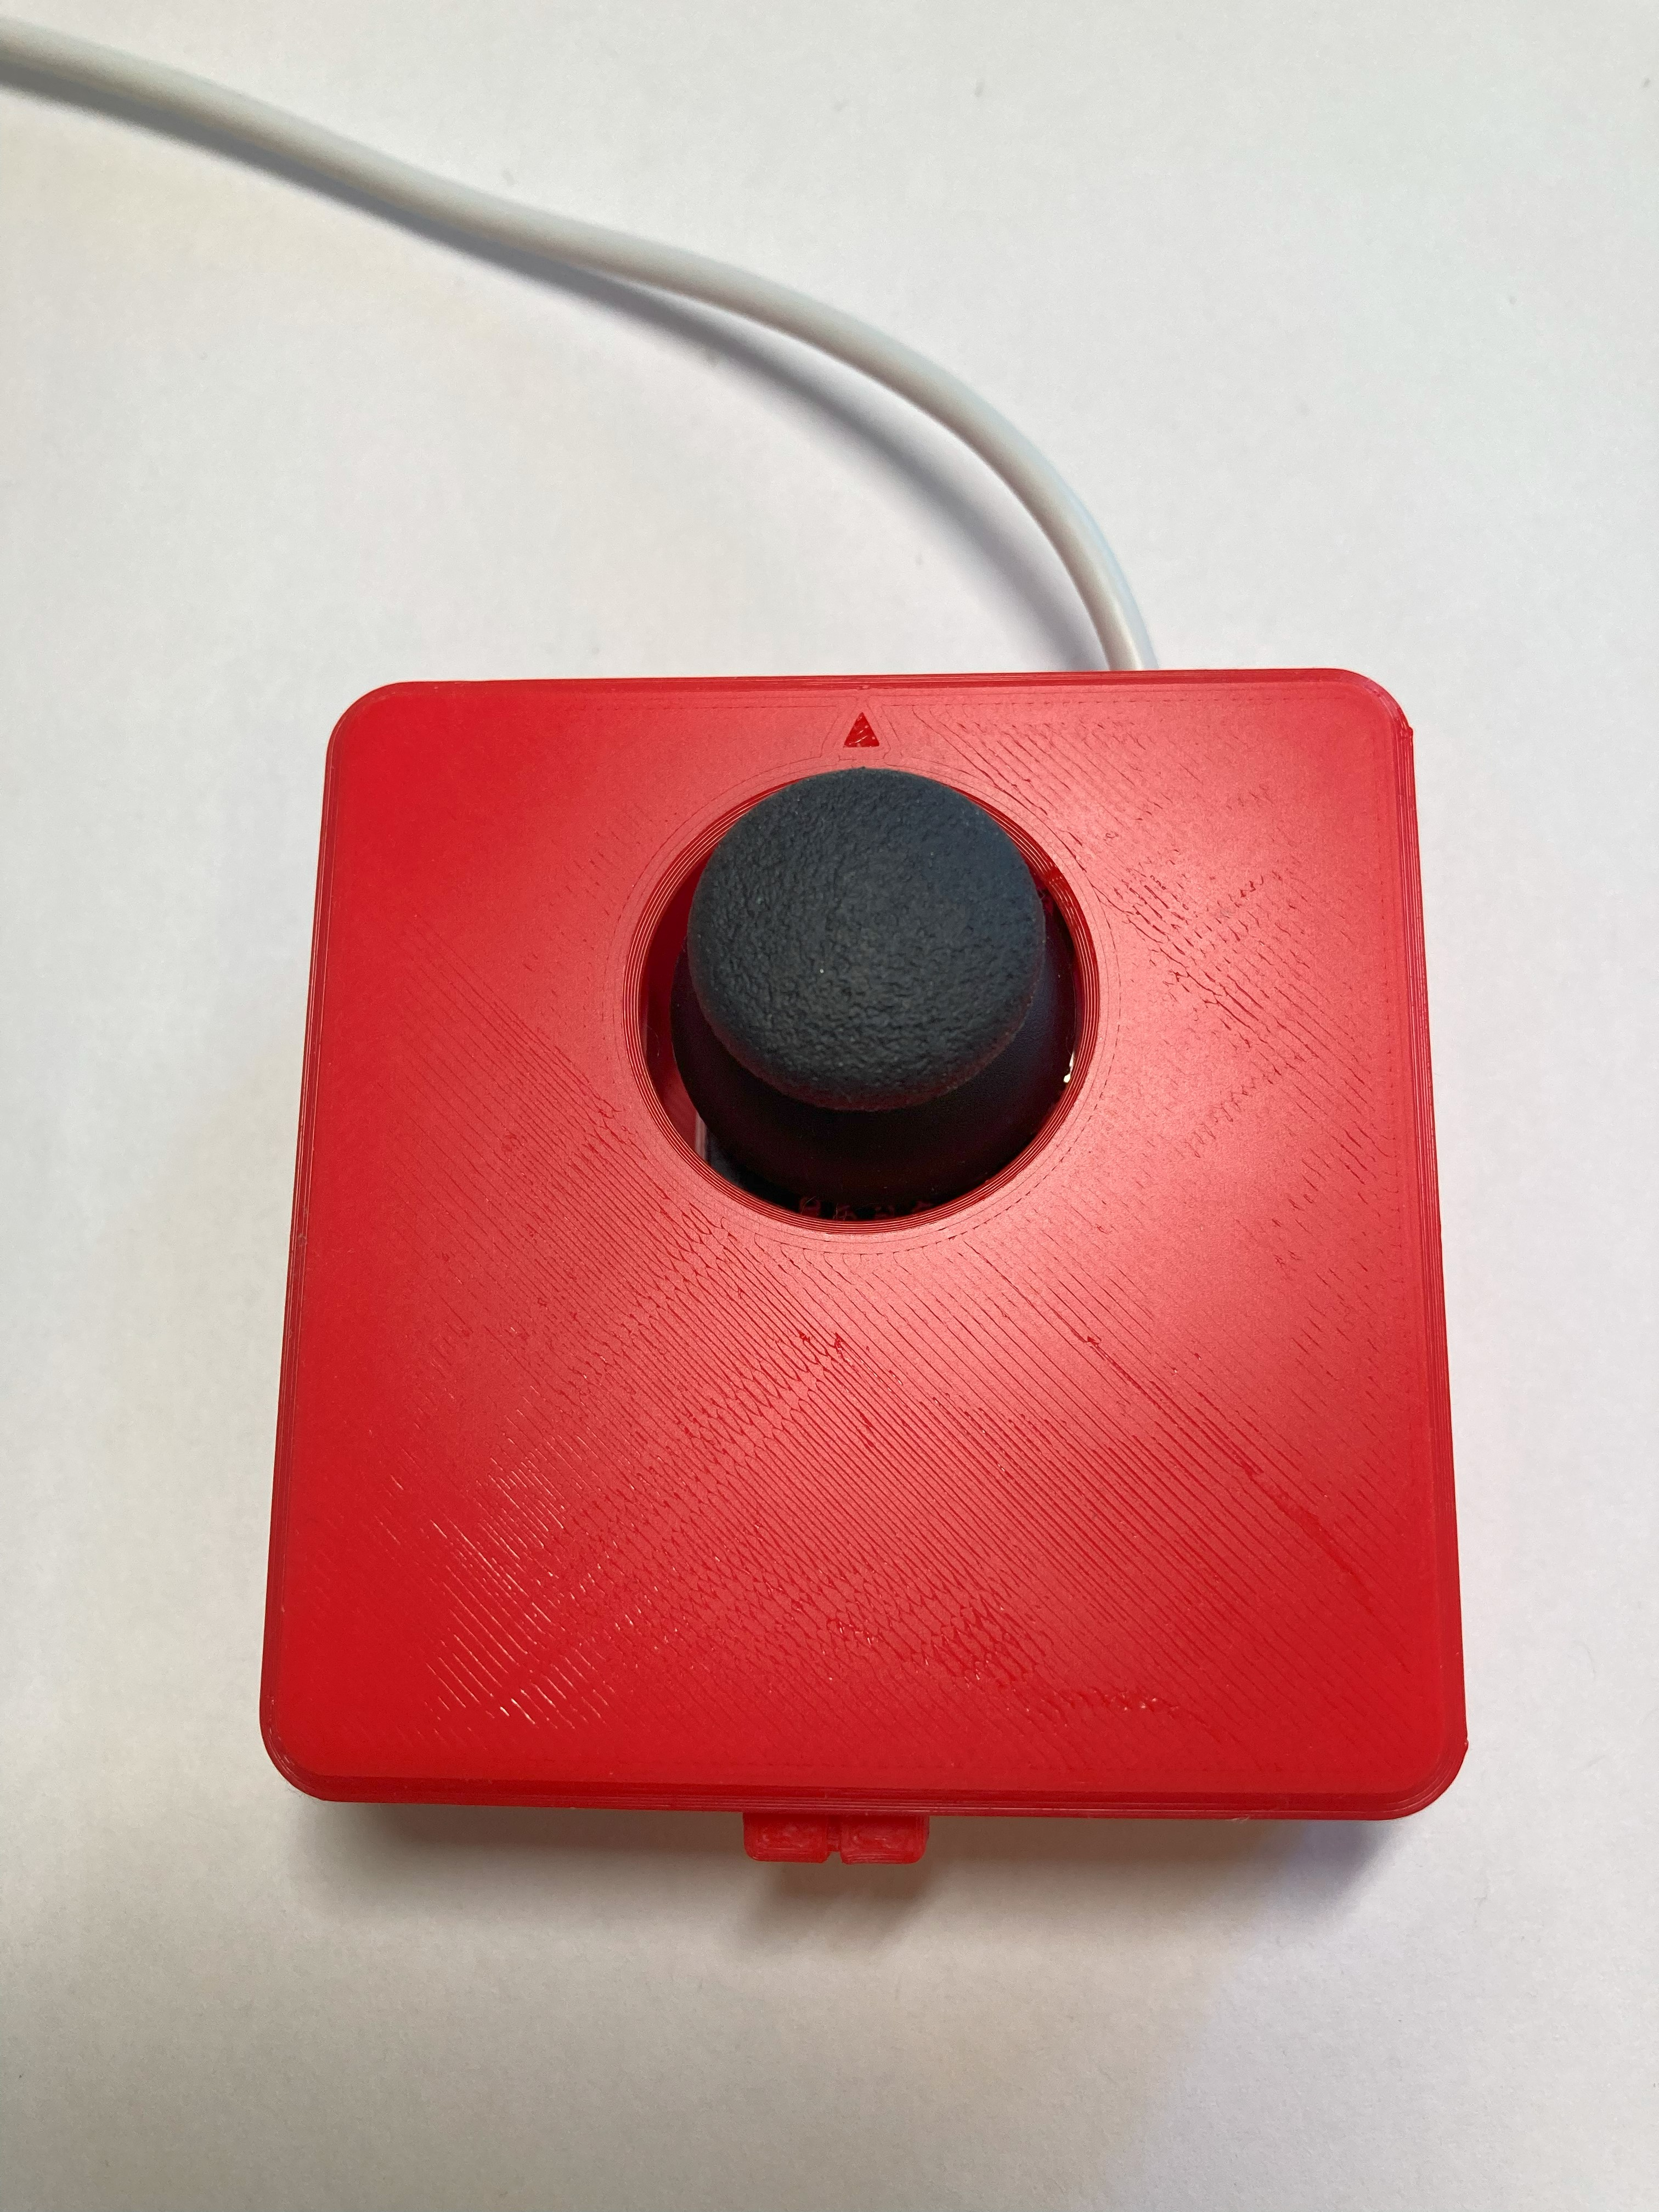
Joystick
Arrow indicating “up” direction on joystick
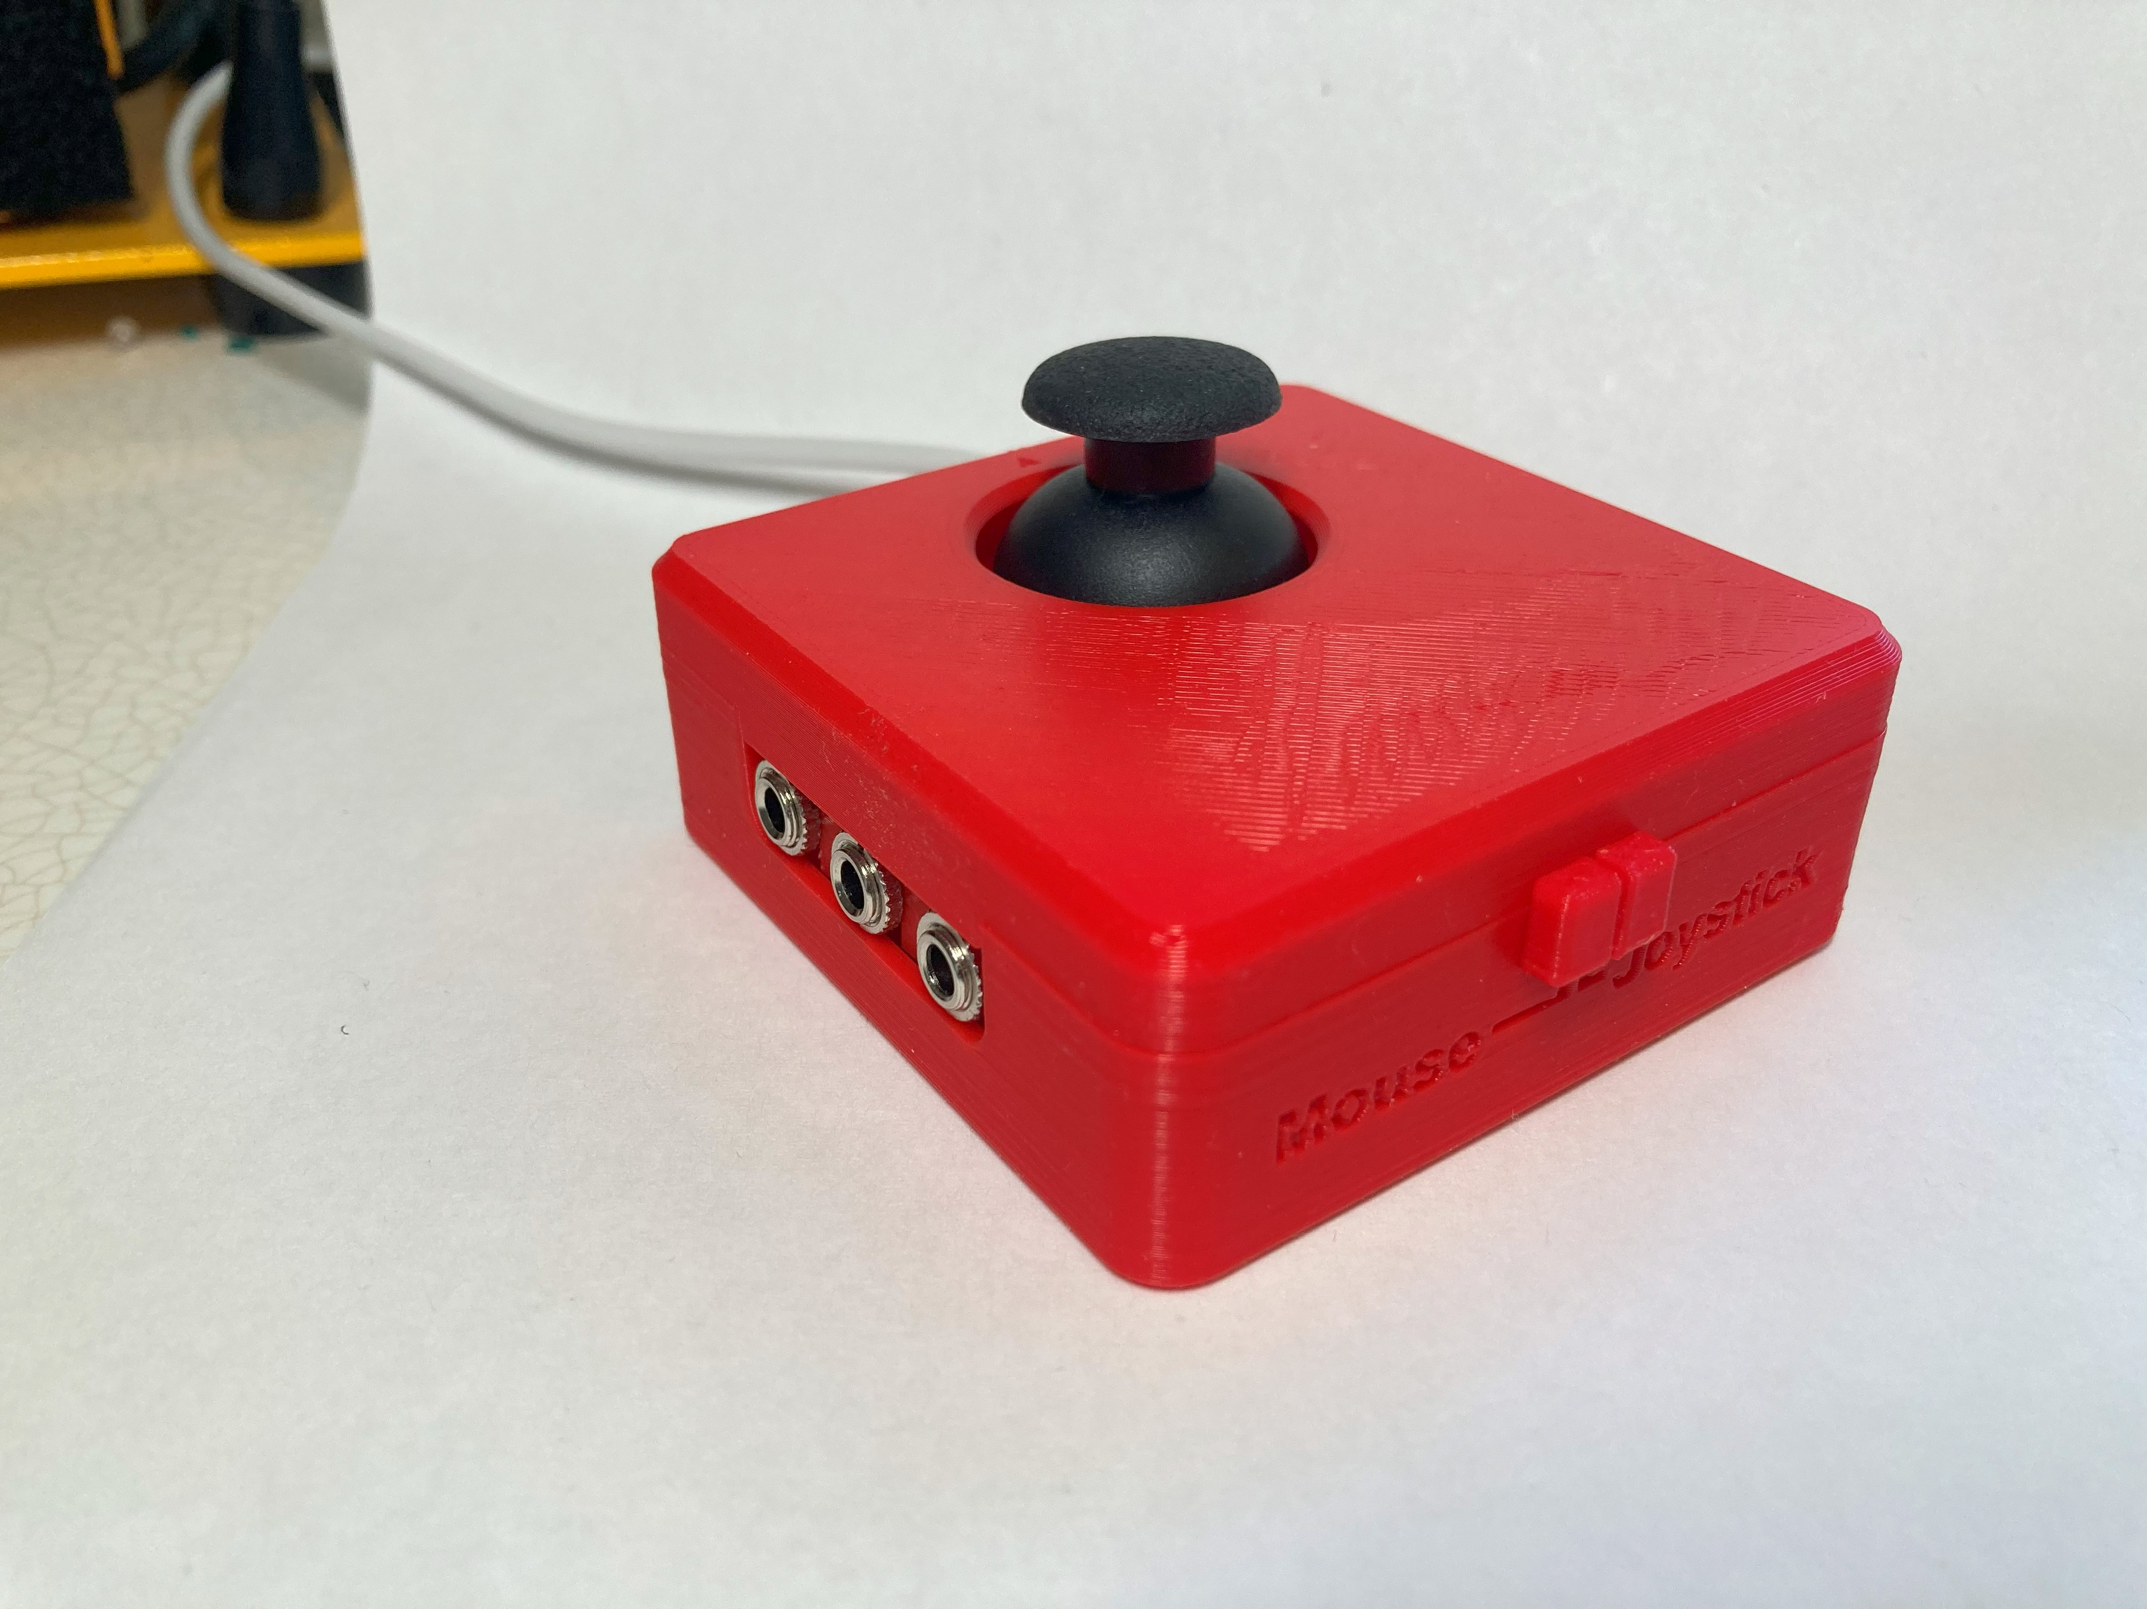
External Assistive Switch Inputs
Mode Switch

Mode Switch
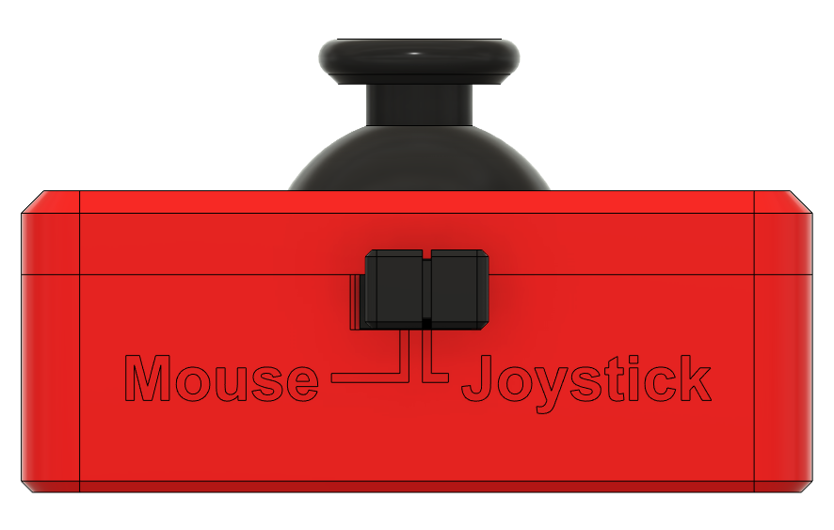

External Assistive Switch Inputs
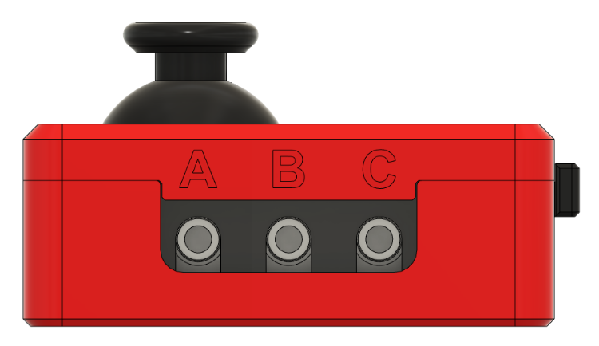
There are three 3.5 mm (1/8 in.) jacks on the side of the joystick for connecting external assistive switches. They are labelled from left to right as A, B, C.

Mounting Holes
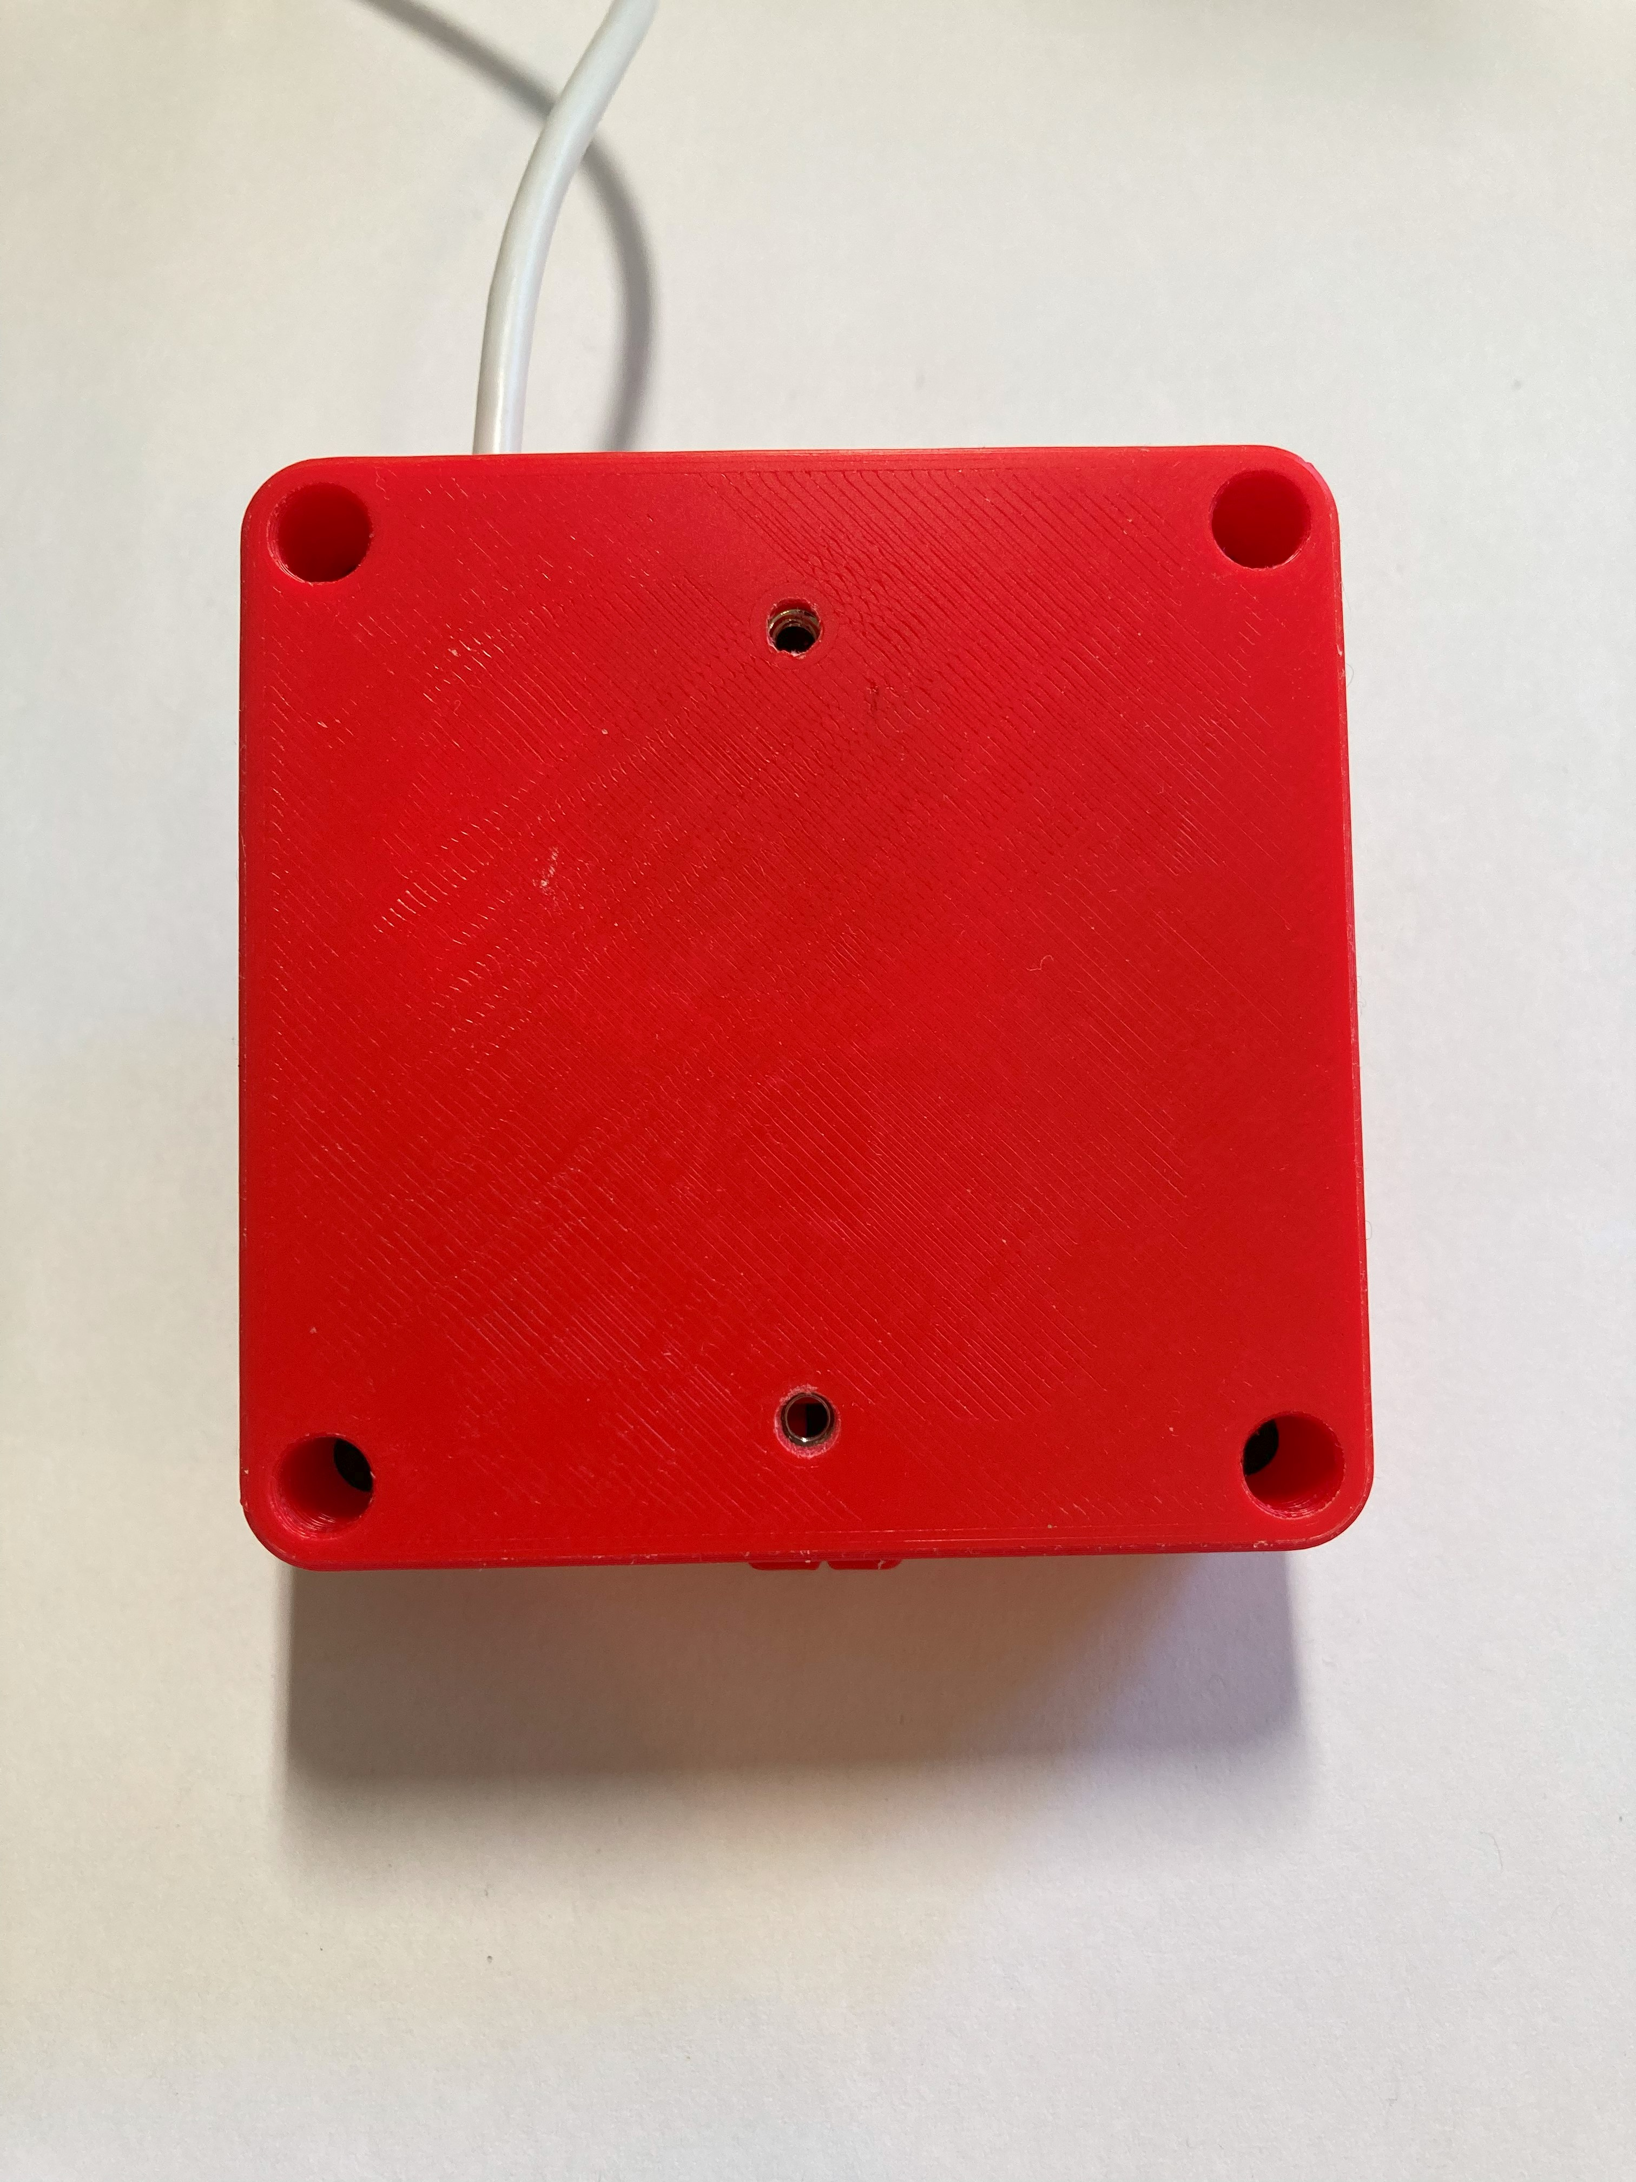
Screw holes for mount adapters

Compatibility
Mouse mode – compatible with PC, most Android phones and tablets, and Apple phones and tablets with iOS13 and iPadOS.
Joystick mode – compatible with PC (direct or gaming with Steam), most Android phones and tablets, and Apple phones and tablets with iOS13 and iPadOS, and with Xbox Adaptive Controller (XAC). Through the XAC it is compatible with PC and Xbox directly, or can be used with other gaming consoles with adapters.

Usage
For Mouse Mode:
- Move the slide switch to the left for Mouse Mode, as indicated on the housing.
- Plug in assistive switches to the switch jacks. The default switch mapping is stated below.
- Plug the joystick into the device you wish to use it with.
- Orient the joystick so the arrow on top is facing away from the user and the cable is exiting the enclosure away from the user.
- Move the joystick to move the mouse, use the switches for the functions listed below.
For Joystick Mode:
- Move the slide switch to the right for Joystick Mode, as indicated on the housing.
- If desired, plug in assistive switches to the switch jacks. The default switch mapping is stated below.
- Plug the joystick into the device you wish to use it with.
- Orient the joystick so the arrow on top is facing away from the user and the cable is exiting the enclosure away from the user.
- Move the joystick to move the mouse, use the switches for the functions listed above.
- Depending on what device you are using the joystick with, if you are using switches plugged into the jacks you will most likely want to remap them. This can be done in your system’s settings.
To Switch Modes:
- Disconnect the joystick from the host device by unplugging the USB Cable.
- Slide the Mode Switch to the desired mode.
- Reconnect the joystick to the host device by plugging in the USB Cable.

Input Mapping
Cedar | Mouse Mode | Joystick Mode
 |  | PC | XAC (Left USB) | XAC (Right USB)
Joystick | Cursor movement | Joystick | Left thumbstick | Right thumbstick
A | Left click | Button 1 | X1 | View
B | Middle click (scroll) | Button 2 | X2 | Menu
C | Right click | Button 3 | Left stick (left press) | Right stick (right press)
Joystick push down | Left click | Button 4 | Left bumper | Right bumper

Mounting
There are several options for positioning or mounting the joystick.

Tabletop – Non-slip pads
Nonslip pads or sheet (e.g., DYCEM) can be used to prevent the joystick from slipping on a tabletop or other hard surface.

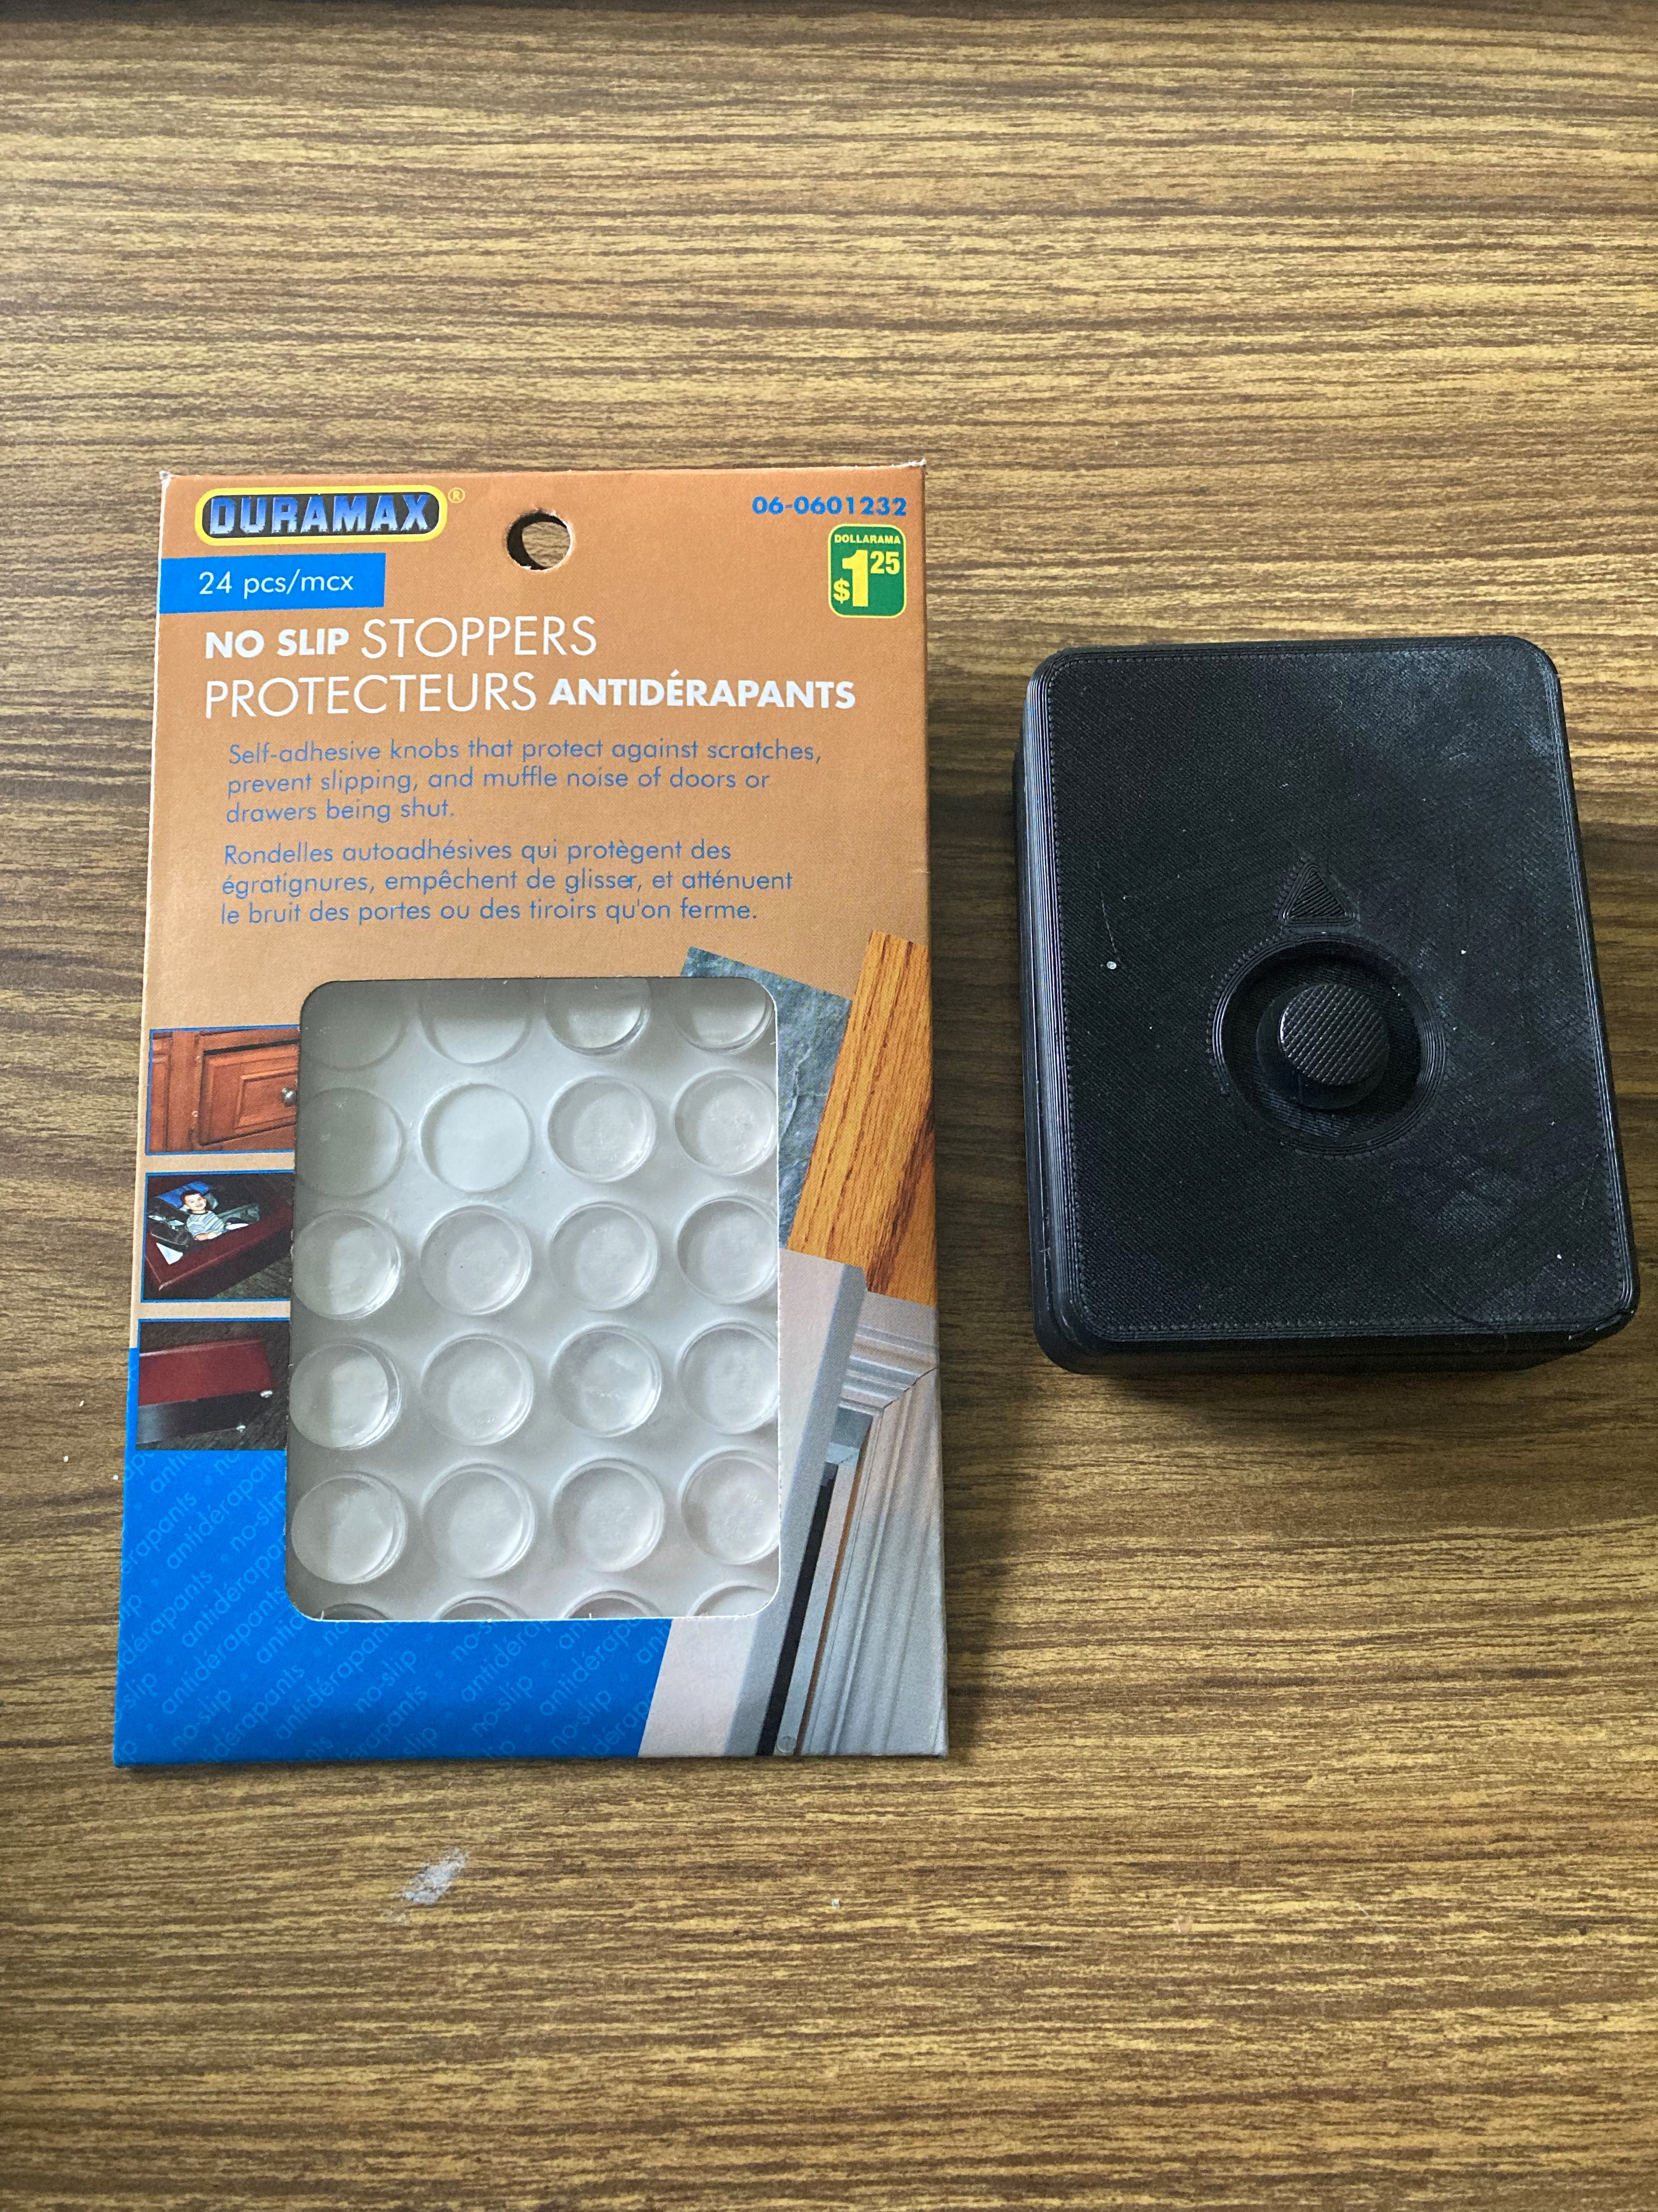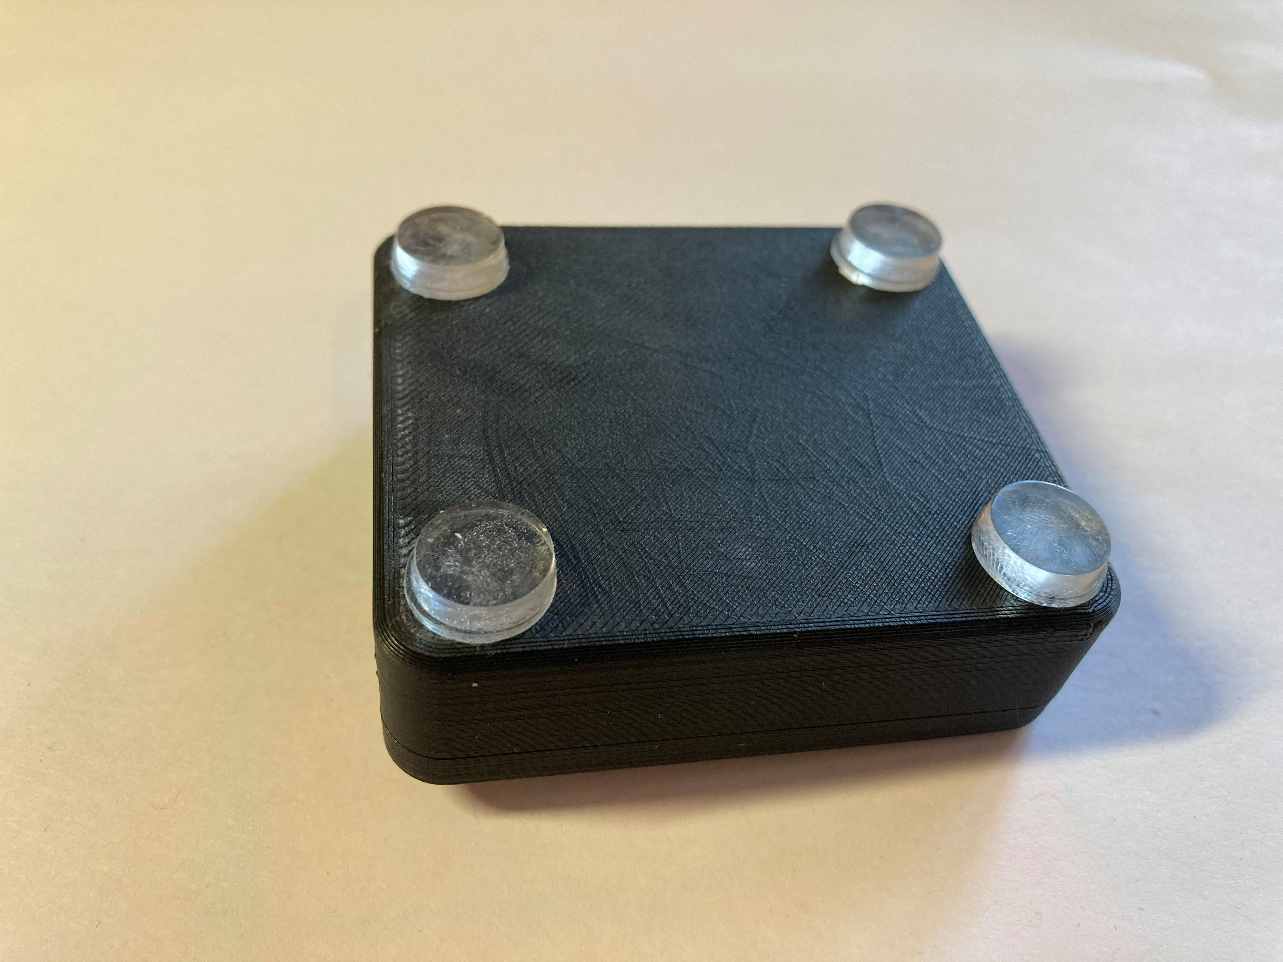

Tabletop – Hook and Loop Fastener
For more permanent use on a tabletop or other surface such as a lap tray, use hook and loop fastener (e.g., VELCRO).  Typically, best practice is to stick the side with the loops (the softer side) to the tabletop or other surface, and to stick the side with the hooks (rough side) to the joystick. | 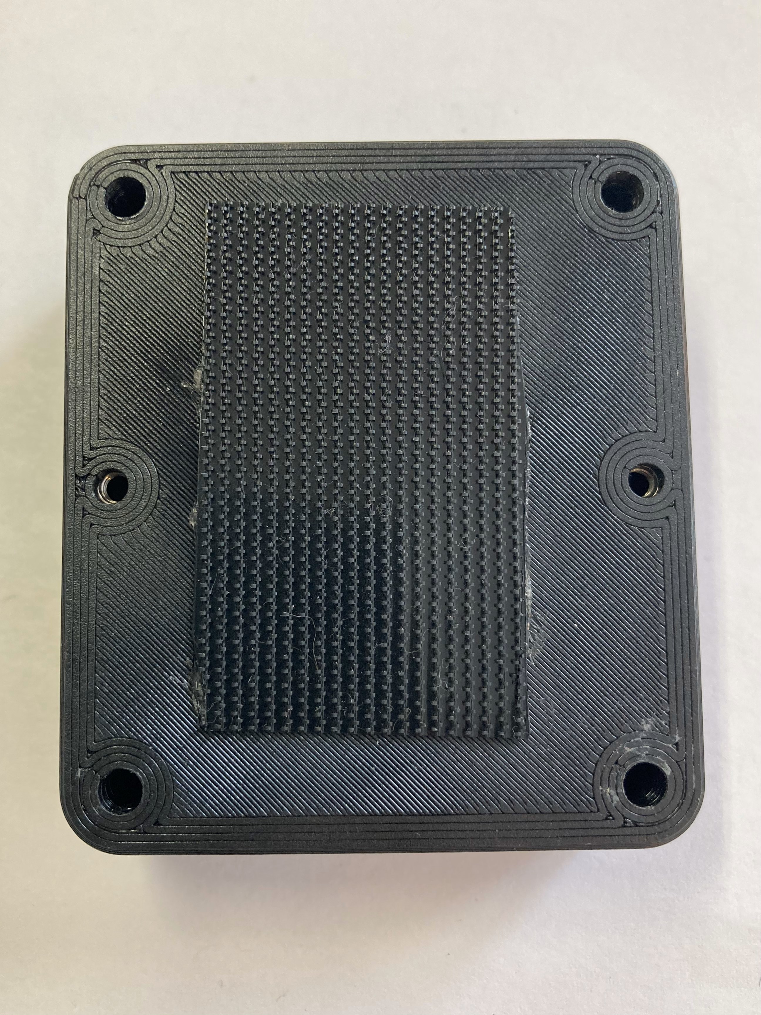

Camera / Tripod Mount (¼-20 UNC thread)
The joystick can be mounted using a range of commercial and DIY mounting arms by using the Camera Mount Adapter. The Camera Mount Adapter is attached to the bottom of the Joystick enclosure using two M3 screws that are at least 10 mm long and provides an internal ¼-20 UNC thread that can be attached to tripod mounts and other mounting solutions with an external ¼-20 UNC thread.
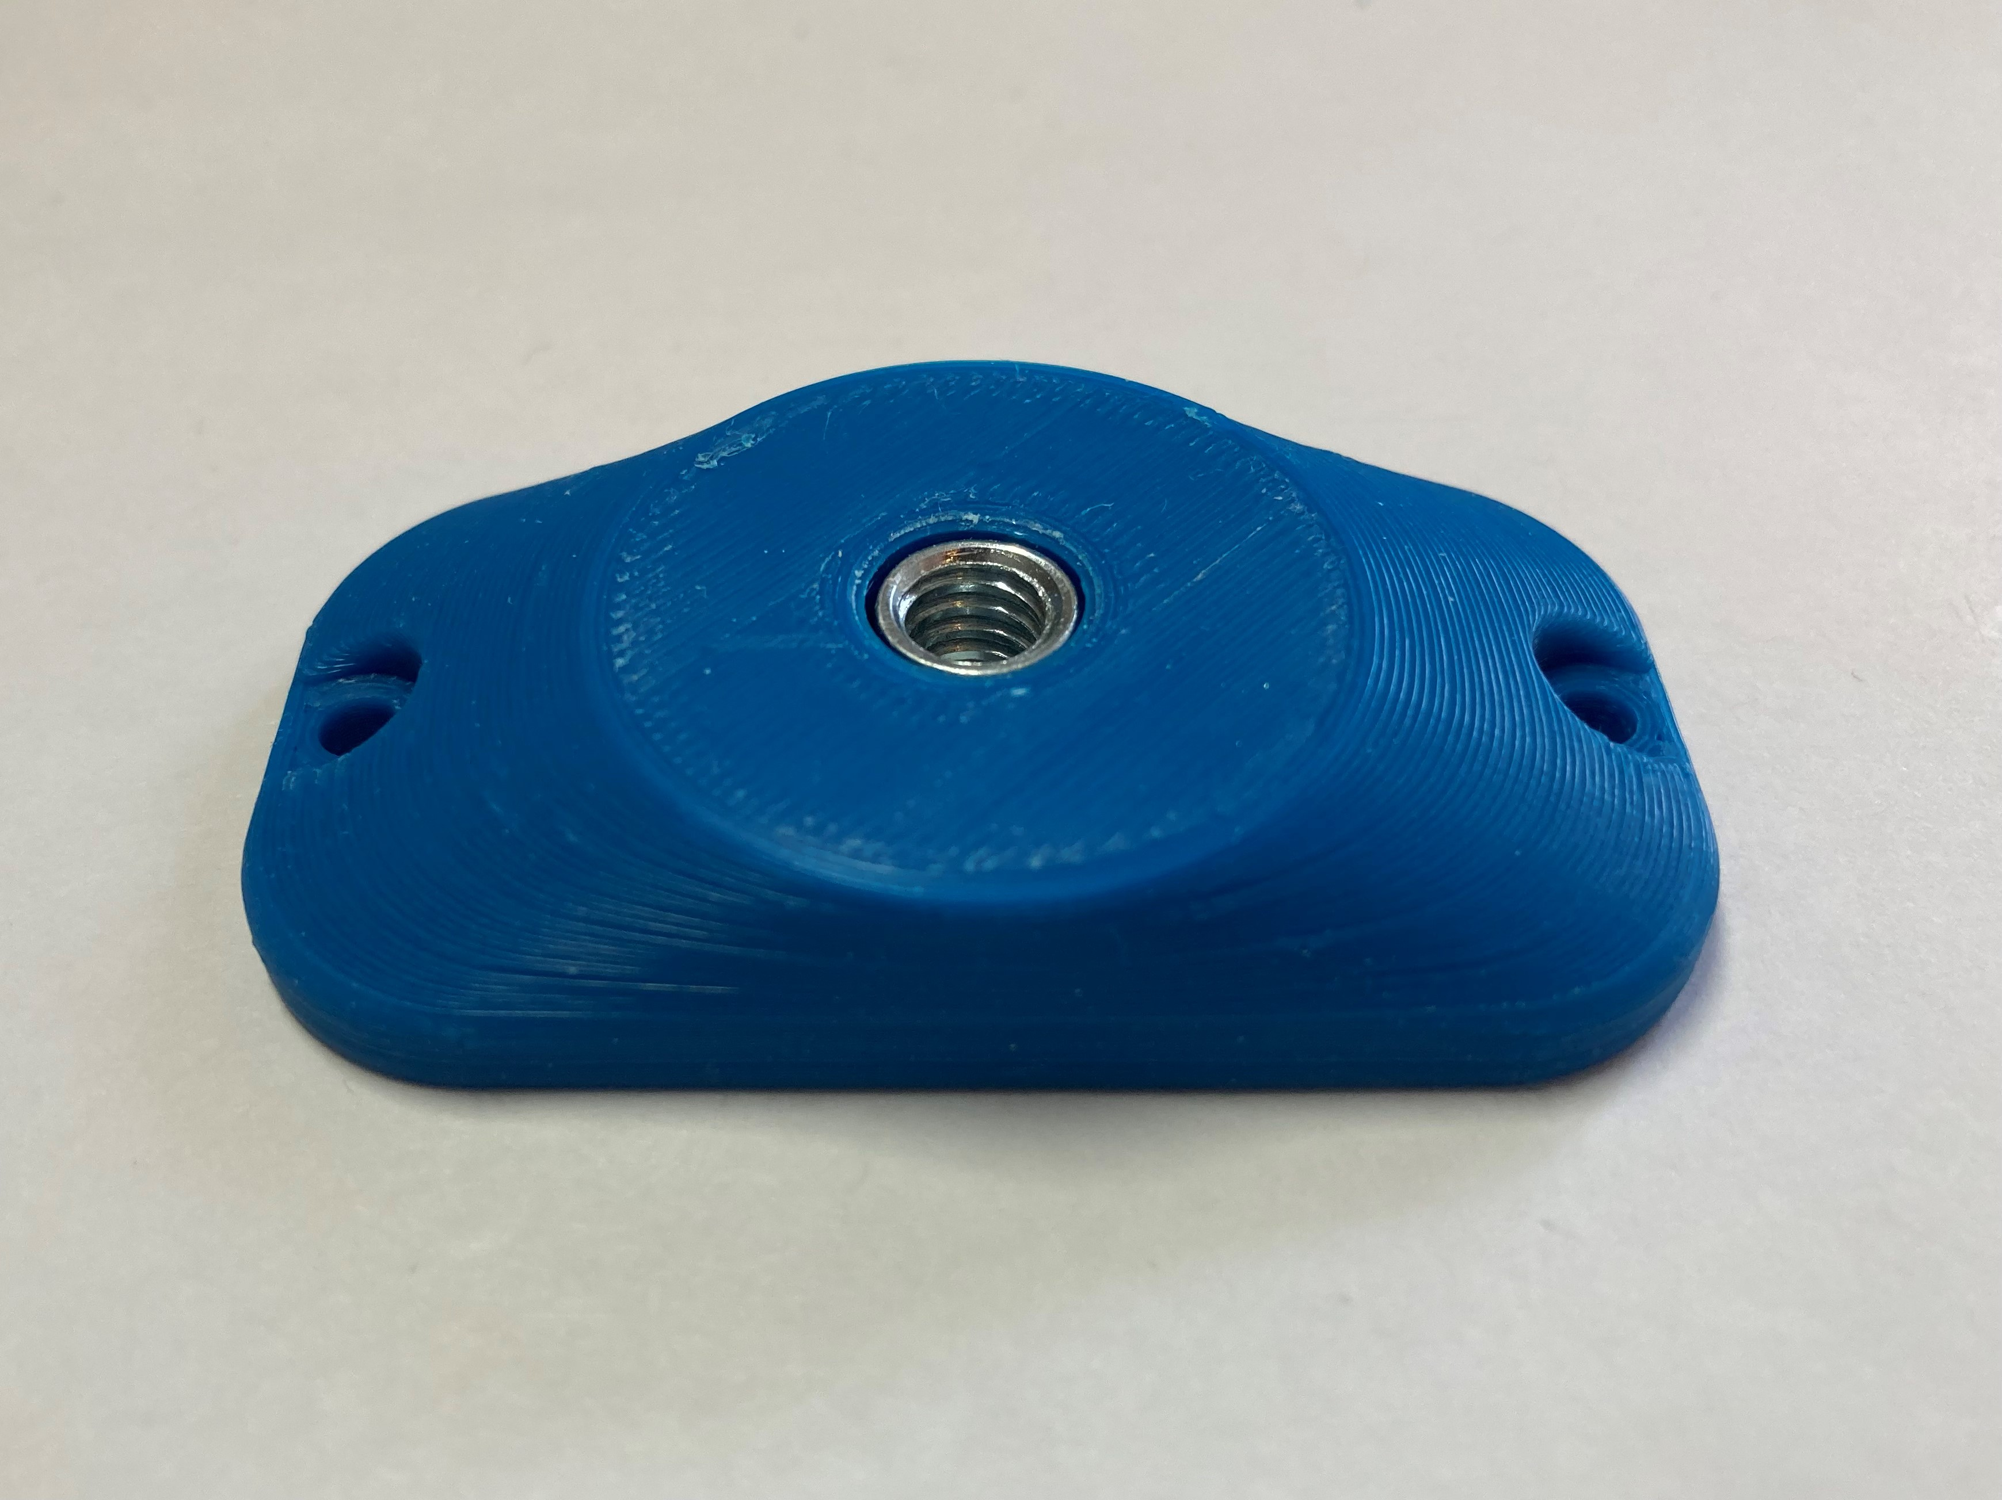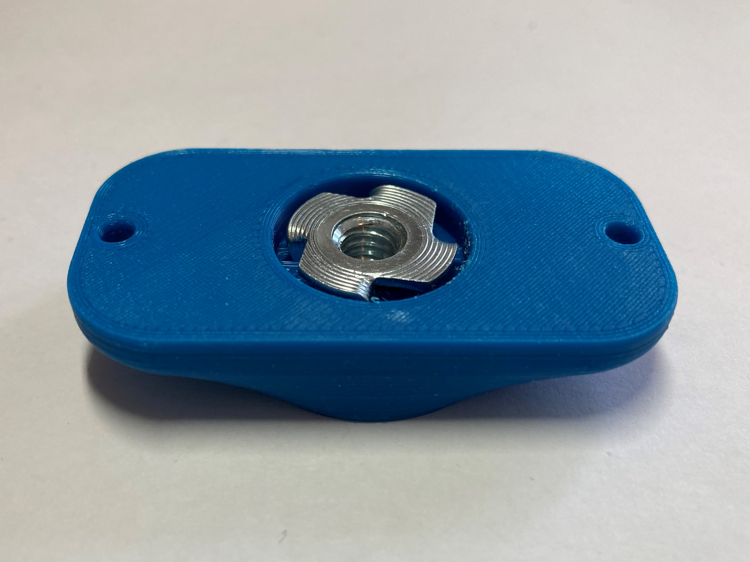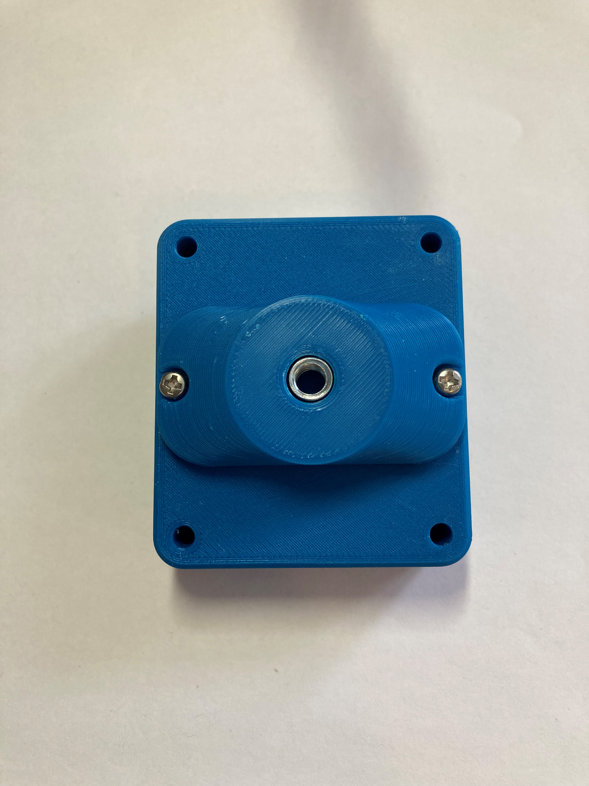
Now, the joystick can be mounted on a mount with ¼-20 thread, such as a typical camera mount.
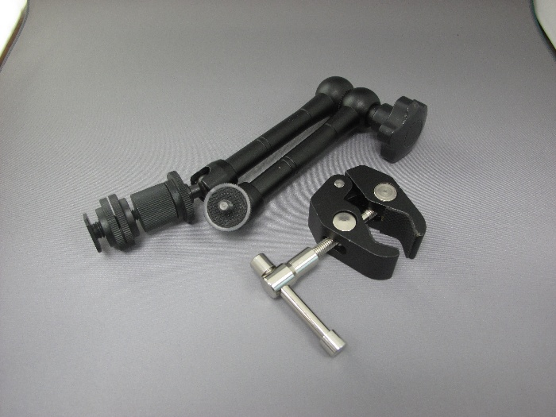

RAM Mount (1 inch/RAM B)
When mounting on a RAM B compatible mount, the RAM Mount Adapter can be attached to a joystick using two M3 screws that are at least 10 mm long.
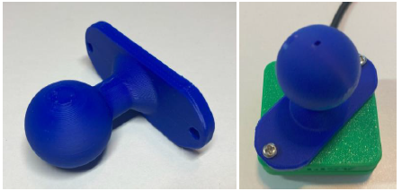

Specifications
Joystick Range of Motion | ± 30°
Joystick Range of Motion at Tip | ± 15 mm
Joystick Activation Force | 75 grams
Total height (with default topper) | 40 mm
Enclosure height | 27 mm
Enclosure width | 70 mm
Enclosure length | 70 mm

Cleaning
The Cedar USB Joystick can be wiped down with a damp cloth. Do not use hot water on this device or the plastic housing may warp. Do not submerge the device.

