Introduction
The Chatterbox is an Augmented and Alternative Communication (AAC) device that allows users to play pre-recorded messages using single or dual switch scanning. The Chatterbox provides auditory and visual feedback to indicate the message a user can play. The Chatterbox is meant for users with complex communication needs and visual impairment.
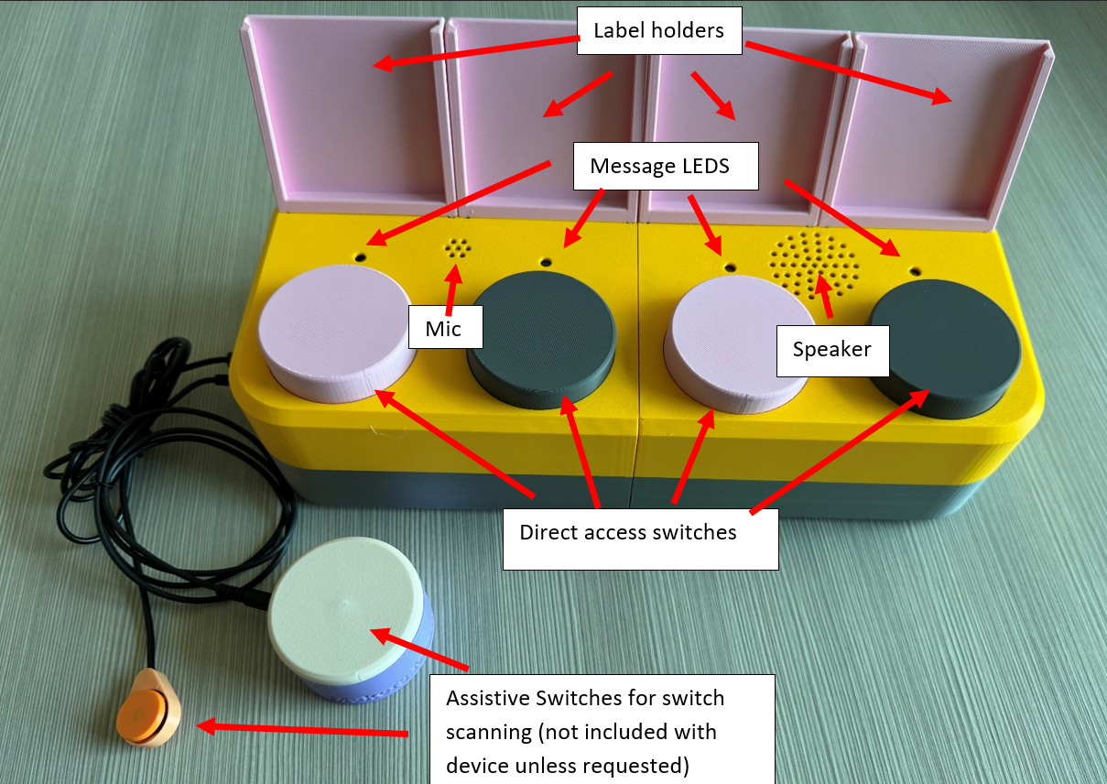 | 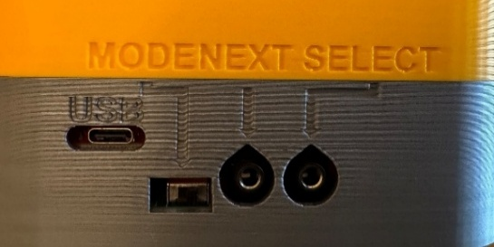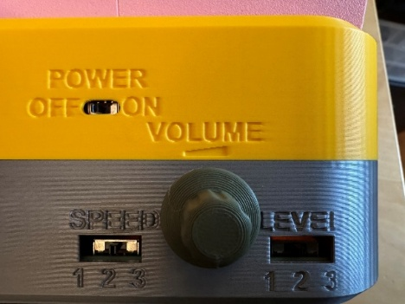
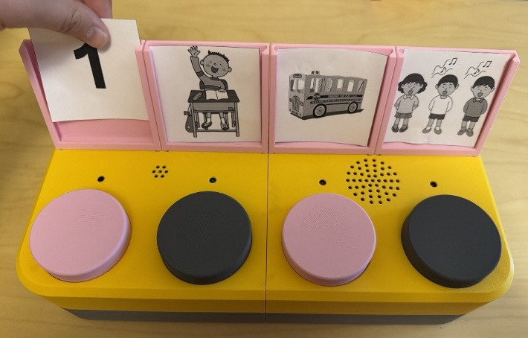

Basic Function
- Record your own messages at each message position, using the record mode and direct access switches
- Start switch scanning with the assistive switch connected to the “SELECT” port
- First message will start playing, followed by a delay (controlled by the “SPEED” switch
- After the delay, the next message will start playing, if the user does not select that message
- To select a message, activate the “SELECT” switch again anytime the message is playing or during the delay
- Playback stops after a message is replayed, or the delay times out after the last message

Using the Chatterbox
Slide the power switch to “ON” to turn the Chatterbox on. Slide the Mode switch to the desired mode (Record or Playback). The following table explains what each input does based on the mode the Chatterbox is in.
Input | Record Mode | Playback Mode
Slide Level switch | Select the message level to record or play back.
Press direct access switch | Play message recorded at that position.
Hold direct access switch (>1 second) | Delete existing message and record new message at that position.  Recording starts when only that LED starts blinking and continues while the switch is held. | Play back message recorded at that position after the switch is released.
Activate assistive switch in “SELECT” port | No function. | If not already switch scanning: Start switch scanning.  If already switch scanning: Replay current message.
Activate assistive switch in “NEXT” port | No function. | If not switch scanning: No function.  If switch scanning: Advance to the next message.
Slide “SPEED” switch | No function. | Change the delay between messages when switch scanning.  Preset delay times are 2, 4, and 6 seconds.
Turn volume knob | Change volume (counterclockwise = decrease, clockwise = increase)

LEDs
LED Behaviour | Meaning
All four LEDs blinking | Chatterbox is in Record mode
All LEDs off | Chatterbox is off or in Playback mode
One LED blinking | Recording message in the corresponding position
One LED on | Message playing in corresponding position, or indicating message position that will be played (during delay)
First two LEDs blinking | Micro SD card is not inserted into SD card reader

Troubleshooting
If the Chatterbox exhibits any unexpected behaviour, or is not responding to inputs, turn it off and on again.

Support
For support, contact the maker of your device or Makers Making Change at info@makersmakingchange.com

