**Title**

Customizable Beverage Can Opener

**Subtitle**

Customizable tool to open beverage cans, with different handle options for users with low strength and accuracy.

## Device Specifications

**Build Time:**

 < 1hr

1-4 hr

 5-10hr

 >10hr

**Cost:**

 $0 - $10

 $11 - $25

 $26 - $50

 $51 - $100

 $101 - $250

 $250+

**Stage**: Recently Added

**Skills**: 3D Printing

**Need**: Agility / Dexterity

**Disability:** Mobility/Physical

**Difficulty**: Beginner

**License**: Attribution-ShareAlike 4.0 International

**Usages**: Aids for Daily Living (ADL), Mobility

**Designer**: Neil Squire / Makers Making Change.

## Device Details

### Overview

### The Customizable Beverage Can Opener provides a way for those with arthritis, low finger dexterity, low vision, or other related disabilities to open beverage cans with little strength or accuracy required. There are three different handles available for use with this device, hence the name “customizable”:

**Base Can Opener:**

The Base Can Opener has a sloped hole which fits over almost all beverage can tabs. The device includes a graphic that describes which side should be facing upwards when opening the can and an arrow pointing towards the can opening. The device is designed to be used on its own or with the handle attached, as described below:

**Cylindrical Handle**

This handle is designed to fit the hand and is easy to grip for those with arthritis.

**Flat Handle**

The Flat Handle is designed for someone with limited hand function and uses the wrist or elbow to open the can once the can opener is placed on the pull-tab.

**Loop Handle**

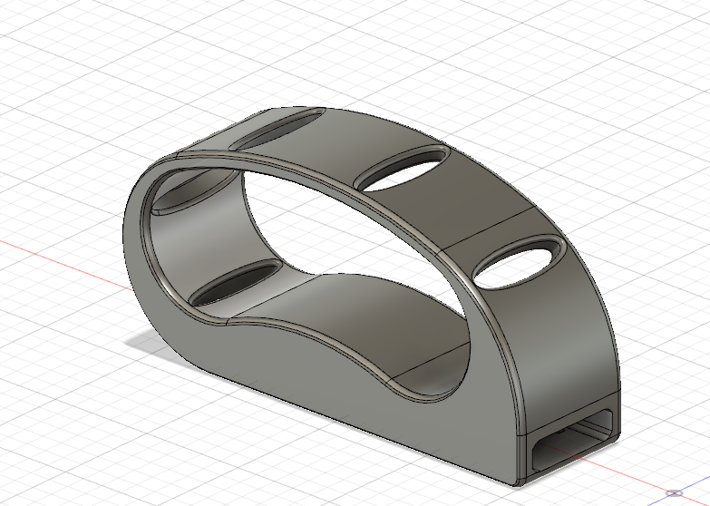

The Loop Handle is designed to open beverage cans without using fingers. The loop slides over the user’s hand, then the can opener can be used by lifting and twisting the hand.

**Similar Devices**

* Another device for opening beverage cans which is much smaller and can be printed very quickly can be found here: [https://makersmakingchange.com/project/beverage-can-opener/](https://makersmakingchange.com/?post_type=project&p=15048&preview=true).
* A device intended for tin cans that require pulling back the entire metal lid, such as pet food, canned tuna or canned beans, is available here: [https://makersmakingchange.com/project/pull-tab-tin-can-opener/](https://makersmakingchange.com/?post_type=project&p=15035&preview=true).

### Cost

The total material cost for the base can opener and all three of the handles is approximately $2.50 CAD. The total cost for the base can opener and one of the handles is slightly over $1 CAD.

### Build Instructions

The base can opener can be attached to any of the handles by sliding the base can opener into the hole in the handle. If the fit is too loose, add super glue into the hole.

#### Skills Required

* 3D Printing

#### Time Required

* 3D Printing:
  + Base Can Opener: 1 hour.
  + Handle: 3-4 hours each.

#### Tools

Super glue or five-minute epoxy.

#### Components

* Base Can Opener
* Cylindrical Handle
* Flat Handle
* Loop Handle

#### 3D Printing

Full instructions can be found in the 3D Printing guide in the linked GitHub repository.

### Attribution

Idea for base can opener based on the design of pop-top can opener by Thingiverse User VegasGuy under the Creative Commons license - Attribution - Non-Commercial - No Derivatives.

Idea for Flat Handle based on Can Opener Helper by Pole Ergo under the Creative Commons license - Attribution - Non-Commercial - No Derivative.

Full Design by Neil Squire / Makers Making Change under license.

Documentation by Neil Squire / Makers Making Change.