## Introduction



The Customizable Beverage Can Opener provides a way for people with arthritis, low finger dexterity, or low vision to open beverage cans, while requiring only low strength or accuracy. The “customizable” refers to the three handles which can be used with the same base can opener. The handles provide support for opening beverage cans in different ways.

## Features

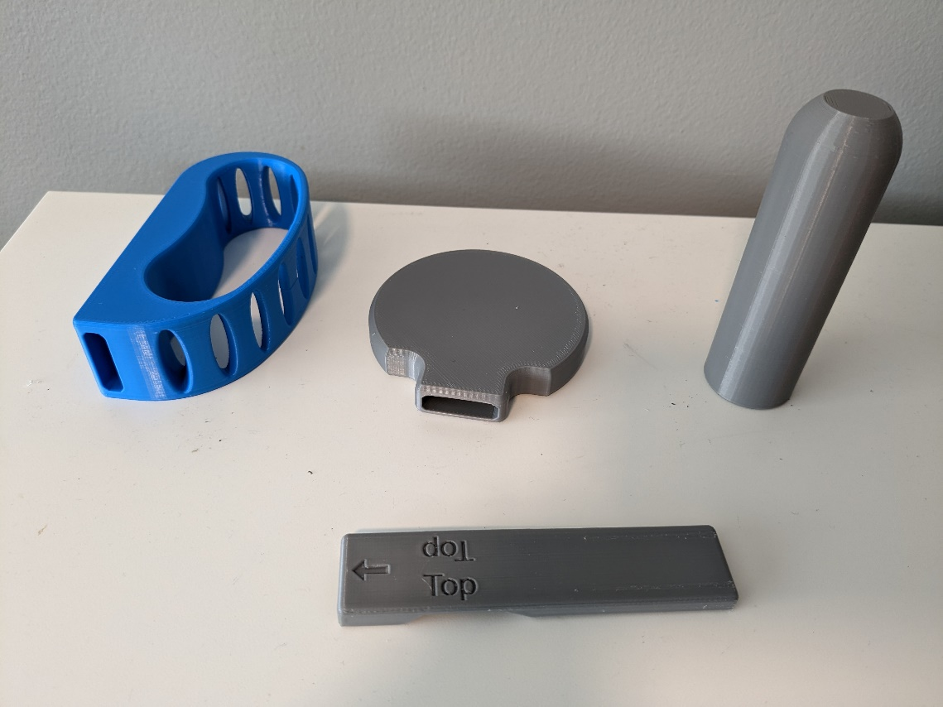



1. **Loop Handle:** Allows user to loop the can opener over their hand as they open the can.
2. **Flat Handle:** Allows the user to use their wrist or arm to lift the pull tab
3. **Cylindrical Handle:** Provides the user with an ergonomic grip which can be easily held by those with arthritis.
4. **Base Can Opener:** The part of the can opener which attaches to the can pull tab. The Base Can Opener can be used alone or with any of the three handles.

## Usage

**Step 1: Slide the Base Can Opener into the handle of choice.**

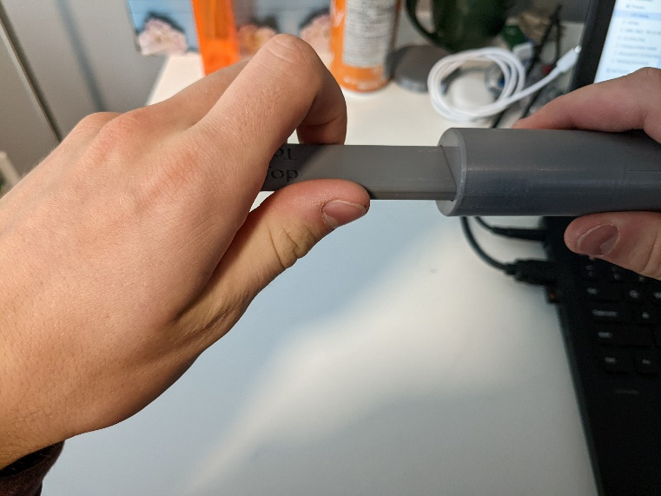

**Step 2: Slide the Can Opener over the pull-tab of your canned beverage and lift upwards to open the can.**

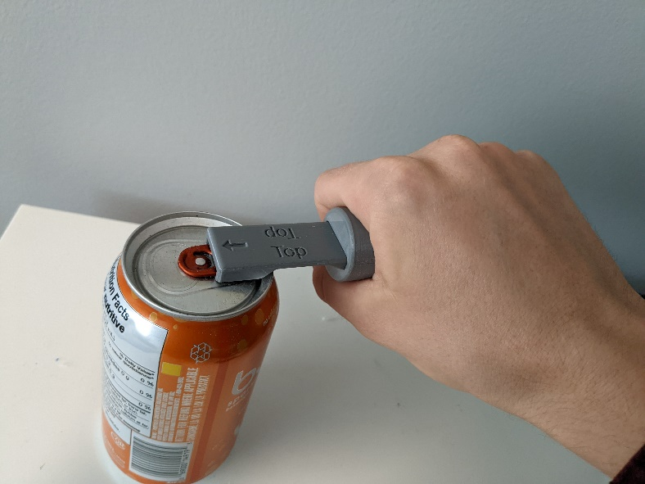

Compatibility

The Customizable Beverage Can Opener is compatible with any aluminum beverage can with a pull-tab.

## Cleaning

Wipe with sterilizing cloth or use sterilizing spray. Do not expose to high heat or dishwasher.