|  |  |
| --- | --- |
| Enabled-Controller-MINI INSTRUCTIONS Manual (V1.3) | An accessible switch adapter box for gaming  Milad Hajihassan  https://github.com/milador/Enabled-Controller-Mini |

**Contents**

Components List 2

Software 3

Installing Arduino IDE 3

Installing Arduino Libraries 3

USB Version 3

Board Support Packages 3

Required Software and libraries 4

Uploading Software 5

Joystick Version 6

Board Support Packages 6

Required Software and libraries 6

Uploading Software 7

Hardware Assembly 8

Printed circuit Board design 8

Enclosure design 8

Enabled-Controller-Mini Assembly 9

Joystick Assembly 21

# Components List

1. ADAFRUIT QT PY - SAMD21 DEV BOARD **x 1**
2. 7 POSITION HEADER **x 2**
3. CONN JACK STEREO 3.5MM R/A **x 4**
4. CONN JACK 4COND 3.5MM **x 1**
5. LIGHTPIPE PNL MT DOME 0.250" **x 1**

The bill of materials can also be downloaded from GitHub repository under main directory.

[https://github.com/milador/Enabled-Controller-Mini/blob/master/Components/Enabled_Controller_Mini_BOM.csv](https://github.com/milador/Enabled-Controller-Mini/blob/master/Components/Enabled_Controller_Mini_BOM.csv )

# Software

The Enabled-Controller-Mini softwarecan be downloaded from the GitHub repository under software directory.

<https://github.com/milador/Enabled-Controller-Mini/tree/master/Software/Arduino/>

There are two flavors of Enabled-Controller-Mini and each one requires different hardware. The Enabled-Controller-Mini software is offered in the following flavors:

1. USB Keyboard/Mouse Version
2. Joystick Version

## Installing Arduino IDE

The Arduino IDE is required to compile and upload the source code to the MCU in your Adafruit QT Py board. You can download and install the Arduino from official Arduino website that you can find using following link:

<https://www.arduino.cc/en/software>

## Installing Arduino Libraries

The following instructions on how to install additional Arduino libraries helps you to get started with setting up Arduino IDE with required libraries and dependencies.

<https://www.arduino.cc/en/guide/libraries>

## USB Version

### Board Support Packages

You can find the official instructions to install Board Support Packages on Adafruit website using following link:

<https://learn.adafruit.com/adafruit-qt-py/arduino-ide-setup>

Alternatively, you can perform following instructions to install Board Support Packages:

1. Open and start the Arduino IDE.
2. Go to ***File > Preferences***.
3. Add following link as a new line under ***Additional Board Manager URLs***
   * <https://adafruit.github.io/arduino-board-index/package_adafruit_index.json>
4. Restart the Arduino IDE
5. Open the ***Boards Manager*** option from the ***Tools > Board*** menu and install ***Adafruit SAMD Boards by Adafruit***
6. Wait until the IDE finishes installing the cross-compiling toolchain and tools associated with Board Support Package. This may take few minutes.
7. That’s it! The installation of Board Support Packages is finished.

### Required Software and libraries

The USB version of the software requires the following files and libraries:

* [StopWatch library](https://github.com/RobTillaart/Stopwatch_RT)
* [EasyMorse library](https://github.com/milador/EasyMorse)
* [Adafruit_NeoPixel library](https://github.com/adafruit/Adafruit_NeoPixel)
* [FlashStorage library](https://github.com/cmaglie/FlashStorage)
* [Enabled_Controller_Mini_USB_Software.ino](https://raw.githubusercontent.com/milador/Enabled-Controller-Mini/main/Software/Arduino/Enabled_Controller_Mini_USB_Software/Enabled_Controller_Mini_USB_Software.ino)

StopWatch library helps to calculate the reaction time and timeout in the morse code interface.

Enabled-Controller-Mini is using Adafruit_NeoPixel library to provide visual feedback using RGB LED.

You can use the following instructions to download and install the required libraries:

1. Visit the [StopWatch library](https://github.com/RobTillaart/Stopwatch_RT) github repository page.
2. Click on ***Code > Download Zip*** to download ***StopWatch*** library.
3. Extract ***Stopwatch_RT-master.zip*** file
4. Rename ***Stopwatch_RT-master*** folder to ***Stopwatch*** folder under ***Stopwatch_RT-master*** subdirectory.
5. Copy or move ***Stopwatch*** folder to Arduino installation library subdirectory. As an example: This is found under ***C:\Program Files (x86)\Arduino\libraries*** in windows 10.
6. Visit the [EasyMorse library](https://github.com/milador/EasyMorse) github repository page.
7. Click on ***Code > Download Zip*** to download ***EasyMorse*** library.
8. Extract ***EasyMorse-master.zip*** file
9. Rename ***EasyMorse-master*** folder to ***EasyMorse*** folder under ***EasyMorse-master*** subdirectory.
10. Copy or move ***EasyMorse*** folder to Arduino installation library subdirectory. As an example: This is found under ***C:\Program Files (x86)\Arduino\libraries*** in windows 10.
11. Visit the [FlashStorage library](https://github.com/cmaglie/FlashStorage) github repository page.
12. Click on ***Code > Download Zip*** to download ***FlashStorage*** library.
13. Extract ***FlashStorage-master.zip*** file
14. Rename ***FlashStorage-master*** folder to ***FlashStorage*** folder under ***FlashStorage-master*** subdirectory.
15. Copy or move ***FlashStorage*** folder to Arduino installation library subdirectory. As an example: This is found under ***C:\Program Files (x86)\Arduino\libraries*** in windows 10.
16. Visit the [Enabled_Controller_Mini_USB_Software.ino](https://raw.githubusercontent.com/milador/Enabled-Controller-Mini/main/Software/Arduino/Enabled_Controller_Mini_USB_Software/Enabled_Controller_Mini_USB_Software.ino) raw source code file under ***Enabled-Controller-Mini*** github repository page.
17. Right click on the source code or any place on this page and select ***Save Page As…***
18. Select the directory you would like to save the software in your computer.
19. Change ***File name*** from ***Enabled_Controller_Mini_USB_Software*** to ***Enabled_Controller_Mini_USB_Software.ino***
20. Change ***Save as type*** to ***All Files***.
21. Click on ***Save*** button.
22. Open the directory you selected in ***step 18.***
23. Double left click or open ***Enabled_Controller_Mini_USB_Software*** file
24. Arduino IDE will ask your permission to create a new sketch folder named ***Enabled_Controller_Mini_USB_Software*** and move ***Enabled_Controller_Mini_USB_Software.ino*** under this folder.
25. Click on the ***Ok*** button.
26. Arduino IDE should now open the ***Enabled_Controller_Mini_USB_Software.ino*** fileautomatically.

### Uploading Software

***Note: Make sure all files are included in your local copy of Software directory before uploading it to the Adafruit* QT PY *board. The libraries can be installed in Arduino libraries.***

You can go ahead and upload the downloaded ***.ino*** code to Adafruit **QT PY** board using Arduino IDE once all the necessary libraries are installed.

1. Start the Arduino IDE
2. Open ***Enabled_Controller_Mini_USB_Software.ino***
3. Select the Board under ***Tools > Board > Adafruit SAMD Boards*** as ***Adafruit QT PY (SAMD21)***
4. Select the correct port number under ***Tools > Port*** which should show ***COM XX (Adafruit QT PY)***

***Note: It’s very important to make sure the correct Board and port number are selected as selecting the wrong board may result problems with bootloader of Adafruit* QT PY *board.***

1. Press the ***Verify*** button to make sure there is no problem with the software and libraries.
2. Press ***Upload*** button

You can now go ahead and upload the software. Arduino IDE will show you a ***Done Uploading*** message indicating the software is uploaded to your Enabled-Controller-Mini.

The LED on the **QT PY** board blinks two times in ***teal*** to indicate the start of initialization process has been started and it will blink again two times in green to indicate end of the initialization process.

You can also open the Serial Monitor in Arduino IDE on 115200 baud-rate to read initialization information about the version of software.

## Joystick Version

### Board Support Packages

You can find the official instructions to install Board Support Packages on Adafruit website using following link:

<https://learn.adafruit.com/adafruit-qt-py/arduino-ide-setup>

Alternatively, you can perform following instructions to install Board Support Packages:

1. Open and start the Arduino IDE.
2. Go to ***File > Preferences***.
3. Add following link as a new line under ***Additional Board Manager URLs***
   * [*https://adafruit.github.io/arduino-board-index/package_adafruit_index.json*](https://adafruit.github.io/arduino-board-index/package_adafruit_index.json)
4. Restart the Arduino IDE
5. Open the ***Boards Manager*** option from the ***Tools > Board*** menu and install ***Adafruit SAMD Boards by Adafruit***
6. Wait until the IDE finishes installing the cross-compiling toolchain and tools associated with Board Support Package. This may take few minutes.
7. That’s it! The installation of Board Support Packages is finished.

### Required Software and libraries

The Joystick version of the software requires the following files and libraries:

* [XACGamepad.h header file](https://github.com/milador/Enabled-Controller-Mini/tree/main/Software/Arduino/Enabled_Controller_Mini_Joystick_Software/XACGamepad.h)
* [Adafruit_NeoPixel library](https://github.com/adafruit/Adafruit_NeoPixel)
* [Enabled_Controller_Mini_Joystick_Software.ino](https://raw.githubusercontent.com/milador/Enabled-Controller-Mini/main/Software/Arduino/Enabled_Controller_Mini_Joystick_Software/Enabled_Controller_Mini_Joystick_Software.ino)

The [XACGamepad.h header file](https://github.com/milador/Enabled-Controller-Mini/tree/main/Software/Arduino/Enabled_Controller_Mini_Joystick_Software/XACGamepad.h) is used to turn Enabled Controller Mini into a XAC Compatible joystick USB HID device which can be used for gaming. It uses TinyUSB USB stack instead of Arduino USB stack to create custom Gamepad USB descriptor.

Enabled-Controller-Mini is using Adafruit_NeoPixel library to provide visual feedback using RGB LED.

You can use the following instructions to download and install the required libraries:

1. Visit the [Enabled_Controller_Joystick_Software.ino](https://raw.githubusercontent.com/milador/Enabled-Controller-Mini/main/Software/Arduino/Enabled_Controller_Mini_Joystick_Software/Enabled_Controller_Mini_Joystick_Software.ino) raw source code file under ***Enabled-Controller-Mini*** github repository page.
2. Right click on the source code or any place on this page and select ***Save Page As…***
3. Select the directory you would like to save the software in your computer.
4. Change ***File name*** from ***Enabled_Controller_Mini_Joystick_Software*** to ***Enabled_Controller_Mini_Joystick_Software.ino***
5. Change ***Save as type*** to ***All Files***.
6. Click on ***Save*** button.
7. Visit the [XACGamepad.h header file](https://github.com/milador/Enabled-Controller-Mini/tree/main/Software/Arduino/Enabled_Controller_Mini_Joystick_Software/XACGamepad.h) raw source code file under ***Enabled-Controller-Mini*** github repository page.
8. Right click on the source code or any place on this page and select ***Save Page As…***
9. Select the same directory that you previously saved ***Enabled_Controller_Mini_Joystick_Software.ino*** in ***step 4.***
10. Change ***File name*** from ***XACGamepad*** to ***XACGamepad.h***
11. Change ***Save as type*** to ***All Files***.
12. Click on ***the Save*** button.
13. Open the directory you selected in ***step 4***.
14. Double left click or open ***Enabled_Controller_Mini_Joystick_Software*** file
15. Arduino IDE will ask your permission to create a new sketch folder named ***Enabled_Controller_Mini_Joystick_Software*** and move ***Enabled_Controller_Mini_Joystick_Software.ino*** under this folder.
16. Click on the ***Ok*** button.
17. Arduino IDE should now open the ***Enabled_Controller_Mini_Joystick_Software.ino*** fileautomatically.

### Uploading Software

***Note: Make sure all files are included in your local copy of Software directory before uploading it to the Adafruit* QT PY *board. The libraries can be installed in Arduino libraries.***

You can go ahead and upload the downloaded ***.ino*** code to Adafruit **QT Py** board using Arduino IDE once all the necessary libraries are installed.

1. Start the Arduino IDE
2. Open ***Enabled_Controller_Mini_Joystick _Software.ino***
3. Select the Board under ***Tools > Board*** ***> Adafruit SAMD Boards*** as ***Adafruit QT PY (SAMD21)***
4. Select the USB Stack ***Tools > USB Stack*** as ***TinyUSB***
5. Select the correct port number under ***Tools > Port*** which should show ***COM XX (Adafruit QT PY)***

***Note: It’s very important to make sure the correct Board and port number are selected as selecting the wrong board may result problems with bootloader of Adafruit* QT PY *board.***

1. Press the ***Verify*** button to make sure there is no problem with the software and libraries.
2. Press ***Upload*** button

You can now go ahead and upload the software. Arduino IDE will show you a ***Done Uploading*** message indicating the software is uploaded to your Enabled-Controller-Mini.

The LED on the **QT PY** board blinks two times in ***teal*** to indicate the start of initialization process has been started and it will blink again two times in green to indicate end of the initialization process.

You can also open the Serial Monitor in Arduino IDE on 115200 baud-rate to read initialization information about the version of software.

# USB Mouse and Gamepad Software

* 1. Download Arduino IDE for your operating system at <https://www.arduino.cc/en/software>
  2. Install Arduino IDE

1. Setup Core
   1. Open Arduino IDE
   2. Click on **File -> Preferences**
   3. Locate the text field that says **Additional Boards Manager URLs** beside it.
   4. Copy and paste the following link into the field as a new line:  
      [**https://adafruit.github.io/arduino-board-index/package_adafruit_index.json**](https://adafruit.github.io/arduino-board-index/package_adafruit_index.json)
   5. Click on **OK**
   6. Restart the Arduino IDE
   7. Open the **Boards Manager** option from the **Tools-> Board-> Boards Manager..., search for “Adafruit SAMD” and select “Adafruit SAMD Boards” by Adafruit**
2. **Install Libraries**
   1. Go to <https://github.com/cyborg5/TinyUSB_Mouse_and_Keyboard> and go to Code -> Download ZIP
   2. Click on **Sketch -> Include Library -> Add .ZIP Library**
      1. Select “TinyUSB_Mouse_and_Keyboard” from your downloads to add into your Arduino/libraries folder
   3. Go to **Tools -> Manage Libraries…,** search for “Flash Storage” and install the library “FlashStorage” by Arduino
   4. Go to **Tools -> Manage Libraries…,** search for “Adafruit NeoPixel” and install the library “Adafruit NeoPixel” by Arduino
3. Upload the Code to the joystick
   1. Open OpenAT_Joystick_Mouse_M0_Software_Enabled_Controller_Mini.ino with Open Arduino IDE.
   2. Edit the value of **Line 36: Mouse_Mode_Enabled**, to select either Mouse or Gamepad Mode. True for Mouse Mode, False for Gamepad Mode.
   3. **Select Adafruit QT Py M0 (SAMD21) from Tools -> Board -> Adafruit SAMD Boards**
   4. Click on **Tools -> USB Stack** and select **Adafruit TinyUSB**
   5. Connect the joystick using the USB cable to the computer.
   6. Select the correct port from **Tools -> Port** menu.
   7. Verify and upload the code.

# Hardware Assembly

## Printed circuit Board design

The printed circuit boards (PCB) can be downloaded from GitHub repository under Hardware directory.

<https://github.com/milador/Enabled-Controller-Mini/tree/master/Hardware/PCB>

## Enclosure design

The enclosure/housing files in STL format can be downloaded from GitHub repository under Hardware directory.

<https://github.com/milador/Enabled-Controller-Mini/tree/master/Hardware/Enclosure>

## Enabled-Controller-Mini Assembly

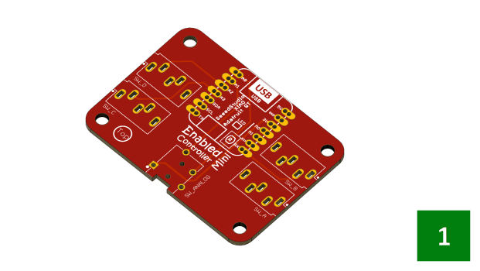

**Step 1: Enabled-Controller-Mini board x 1.**

**Step 2: Solder the first 7 position female headers over the Enabled-Controller-Mini board**

**Step 3: Solder the second 7 position female headers over the Enabled-Controller-Mini board**

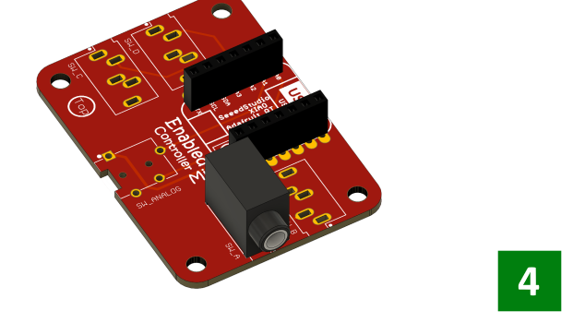

**Step 4: Position a 3.5mm jack on the A switch outline and solder the pins x 1.**

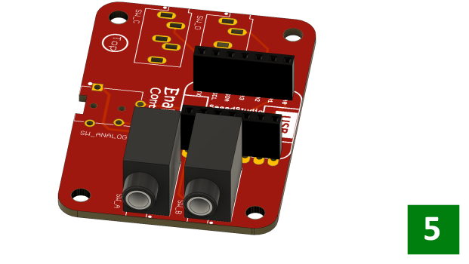

**Step 5:** **Position a 3.5mm jack on the B switch outline and solder the pins x 1.**

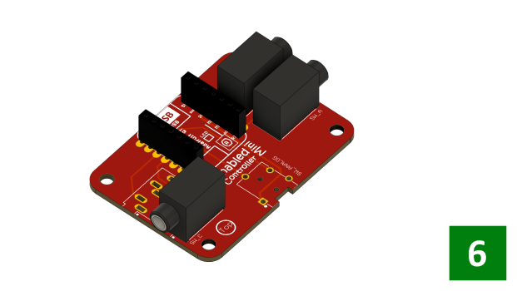

**Step 6: Position a 3.5mm jack on the C switch outline and solder the pins x 1.**

**Step 7: Position a 3.5mm jack on the D switch outline and solder the pins x 1.**

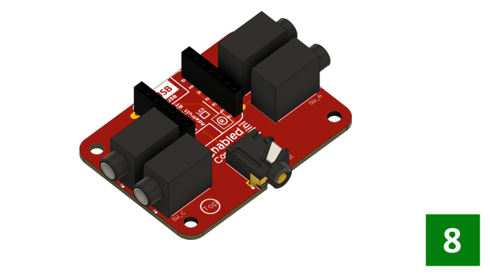

**Step 8: Position a 4 Conductor** **3.5mm jack on the AN switch outline and solder the pins x 1.**

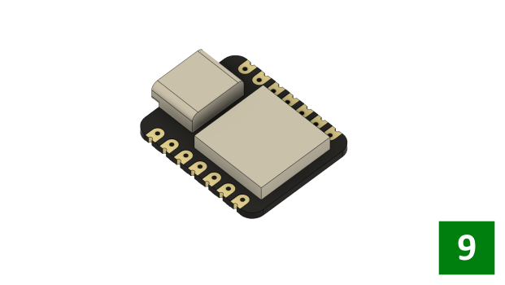

**Step 9: Position the QT Py on a breadboard or prepare it for soldering x 1.**

**Step 10: Position and solder the first 7 position male header under QT PY board x 1.**

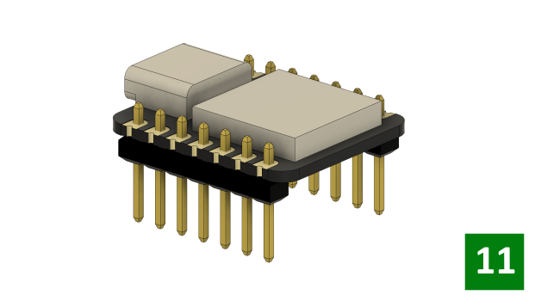

**Step 11: Position and solder the second 7 position male header under QT PY board x 1.**

**Step 12: Position the soldered QT PY board over Enabled-Controller-Mini board**

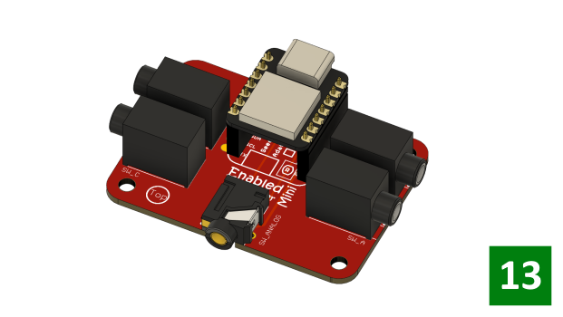

**Step 13: Stack the soldered QT PY board over Enabled-Controller-Mini board**

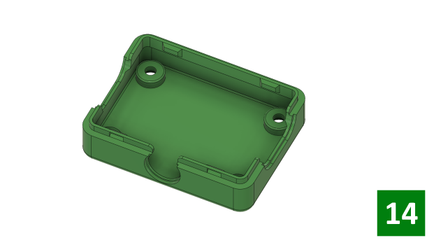

**Step 14: Take the bottom part of Enabled-Controller-Mini enclosure**

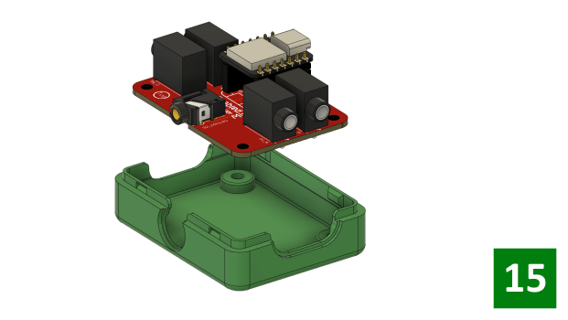

**Step 15: Position the assembled Enabled-Controller-Mini board in the bottom enclosure part.**

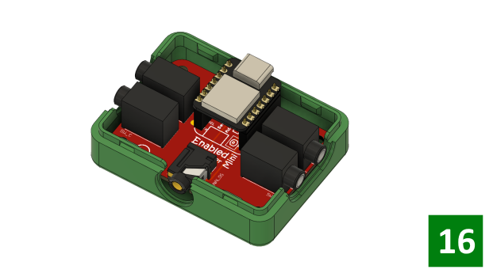

**Step 16: Position the PCB mounting holes on the 4 posts in the bottom enclosure.**

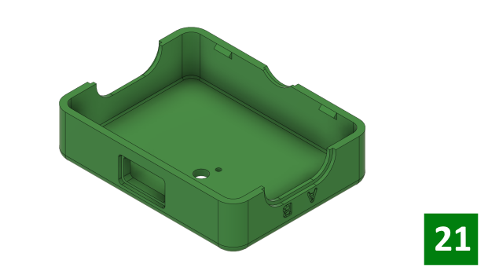

**Step 17: Enabled-Controller-Mini top enclosure x 1.**

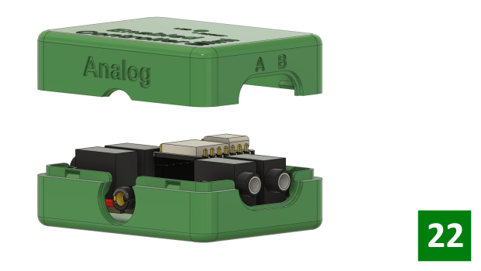

**Step 18: Insert the light pipe into the top enclosure from the outside and press it into place.**

**Step 19: Line up the top and bottom enclosure and snap them together.**

**Step 20 – That’s it! Your Enabled-Controller-Mini is fully assembled and ready to use.**

**ready to use.**

## Joystick Assembly

Enabled-Controller includes one 4 conductors input 3.5mm jack reserved to connect a dual axis joystick. The order of pins in joystick boards can vary depending on the brand but the following general configuration can be used to attach analog joystick. Enabled-Controller is designed to work with analog joystick which rated to work with 3.3V input voltage.

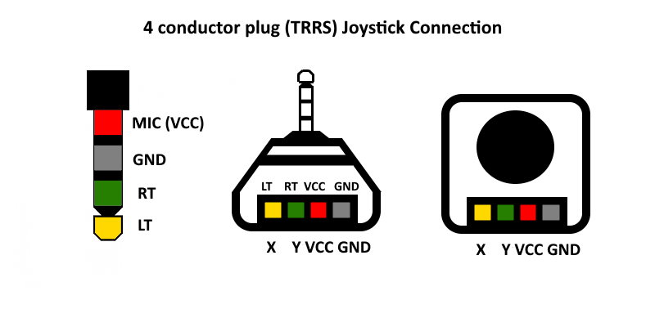

**Figure 1: 4 Conductor plug (TRRS) pin mapping**

The following table can summarize figure 1 as following:

|  |  |
| --- | --- |
| **PIN** | **FUNCTION** |
| 1 (Sleeve) | Microphone – VCC (3.3V) |
| 2 (Ring 2) | GND |
| 3 (Ring 1) | RT(Right Audio Channel) |
| 4 (Tip) | LT(Left Audio Channel) |

**Table 1: 4 Conductor plug (TRRS) pin mapping**