# Introduction

Needle felting requires a user to repeatedly insert and remove a metal felting needle into and out of the material. A holder is often used to hold one or more of the needles. Typical holders are quite narrow.

# Research

No commercially available ball shaped felting needle holders were found. A large variety of cylindrical wooden holders are available, and these are relatively cost effective (e.g., [10 for ~$20](https://www.amazon.ca/EXCEART-Needle-Handles-Felting-Needlework/dp/B09HV1QX2X))

# Requirements

## Goals

|  |  |
| --- | --- |
| G01 | A ball-shaped holder that is easier to grip. |
| G02 | No tools are required to insert, swap, and remove needle. |
| G03 | Minimal or no hardware. |

## Functional Requirements

|  |  |
| --- | --- |
| F01 | Device must securely hold one standard metal felting needle. |
| F02 | Device must allow for the needle to be swapped out for a replacement. |

## Non-functional Requirement

|  |  |
| --- | --- |
| NF01 | Design should allow for multiple sizes of holder. |

## Constraints

|  |  |
| --- | --- |
| C01 | Design released under open-source license. |
| C02 | Components must be manufacturable on consumer-grade FFF 3D printers. |
| C03 | Components must be manufacturable using commonly available FFF filaments such as PLA. |

# Detailed Design

## Felting Needle

The dimensions of a DIMENSIONS felting needle (<https://www.amazon.com/Dimensions-Needlecrafts-Feltworks-Replacement-Felting/dp/B004W8TGIS>) were measured with a pair of digital calipers. The needle has a diameter of 1.8 mm. The top portion is bent at a 90° angle and extends about 3.5 mm from the main portion. The overall length of the needle is 78 mm.

Figure 1: DIMENSION Felting Needle Dimensions.

## Architecture

The overall arrangement consists of four parts: Top, Bottom, Connector, and Cover. A Top and Bottom of a ball provide a larger gripping surface for the user. A Connector performs two functions: it connects the two parts of the ball together and is used to retain the needle. A Cover was later added so the ball could be stored with the needle inside with a reduce risk of either breaking the needle or the needle causing injury.

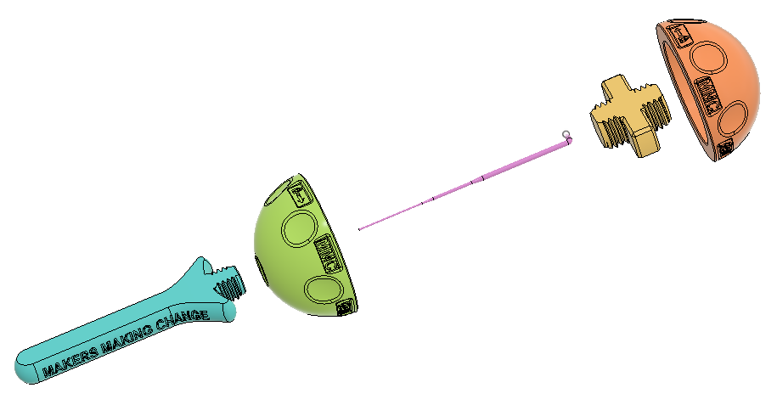

Figure 2. Exploded View.

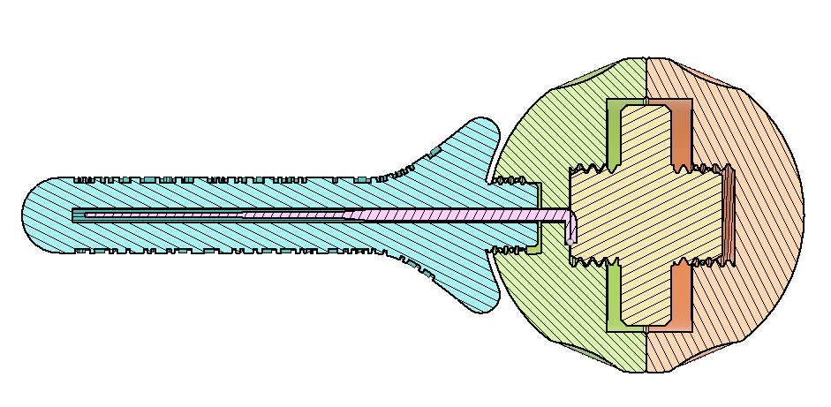

Figure 3. Felting Needle Holder Cross Section.

## Ball

The initial diameter of 50 mm for the ball was chosen based on recommendations for ergonomic handles. Additional user feedback would be helpful to determine a range of appropriate sizes for different users.

A pattern of divots was added around the ball to provide finger grips both during felting and opening and closing the ball.

Several labels were added to the ball. An arrow and a lock icon were added to provide visual indication of which direction the ball halves need to be rotated to lock it into place. An additional label was added to indicate the diameter of the ball (e.g., Ø50).

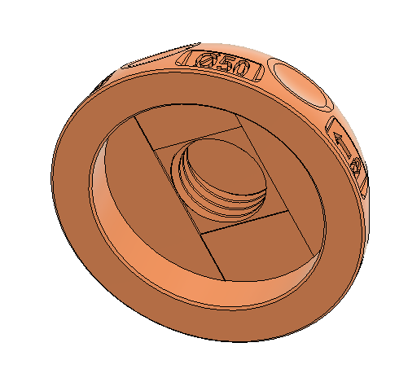

Figure 4. Top Portion of Ball.

Both the top and the bottom use a right-handed M16X2 ISO Metric thread profile for the internal threads. The internal thread surfaces are offset by 0.1 mm to provide additional clearance for 3D printing.

To print without support, the inner surface of the ball has two sets of cuts to force bridging. The longest section of this bridge is 33 mm so some printers may struggle. Since these surfaces are internal, any reduced print quality is probably acceptable; those with printers that struggle to reliably bridge this distance can also enabled support.

Figure 5. Bottom Portion of Ball.

The Bottom also has the internal thread for the connector and the corresponding bridging cuts. This side also has features for retaining and supporting the needle and connecting the cover.

The needle is retained using a cutout to fit the bent portion of the needle. This prevents the needle from rotating, and provides a surface that the Connector can compress the Needle into the Bottom. Bridging cuts were also added here to improve print quality.

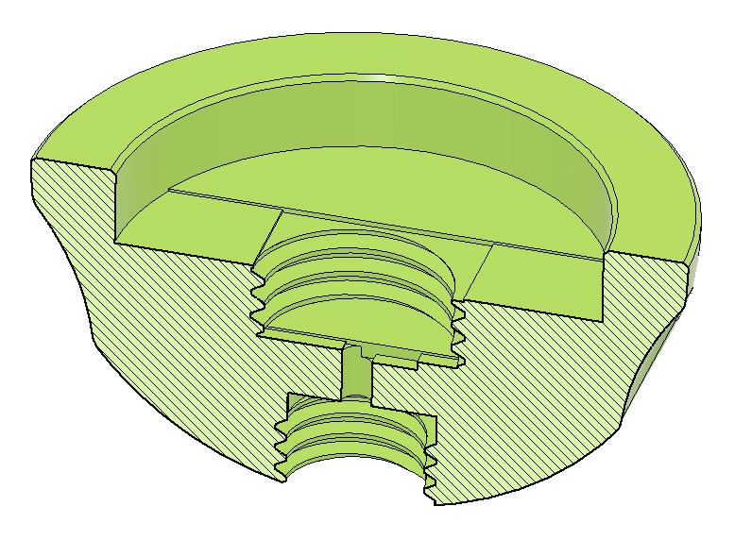

The bottom of the Bottom has a right-handed M12x1.75 ISO Metric internal thread to connect the Cover. These internal thread surfaces are also offset by 0.1 mm to provide additional clearance for 3D printing. The threads were made different sizes to match the smaller required size of the Cover as well as to ensure the parts can not be assembled incorrectly.

## Connector

The Connector retains the needle into the Bottom and connects the Top and Bottom. The Connector consists of two threaded portions for connecting to the top and bottom, and a middle section that can be used to tighten the connector without tools.

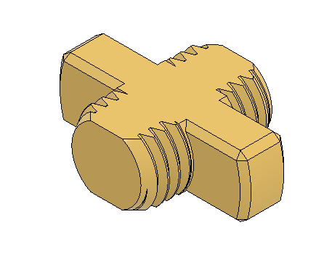

Figure 6. Connector.

The connector uses a right-handed M16X2 ISO Metric thread profile to match the threads on the ball parts. The cylindrical parts of the thread are truncated to allow the part to print on its side. Printing on the side improves print quality and strength.

## Cover

The Cover covers the needle when the holder is not in use. The Cover is an elongated truncated cylinder shape with an internal hole for the needle. One end of the Connector has external threads for connecting to the Bottom.

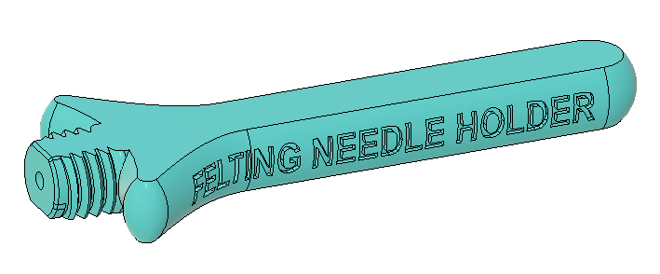

The threads on the Cover are a right-handed M12x1.75 ISO Metric external thread to connect with the corresponding threads in the Bottom. Like the Connector, these threads are truncated so the part can print on its side for strength and print quality.

The hole for the needle has additional cuts to improve print quality for this horizontally printed hole.

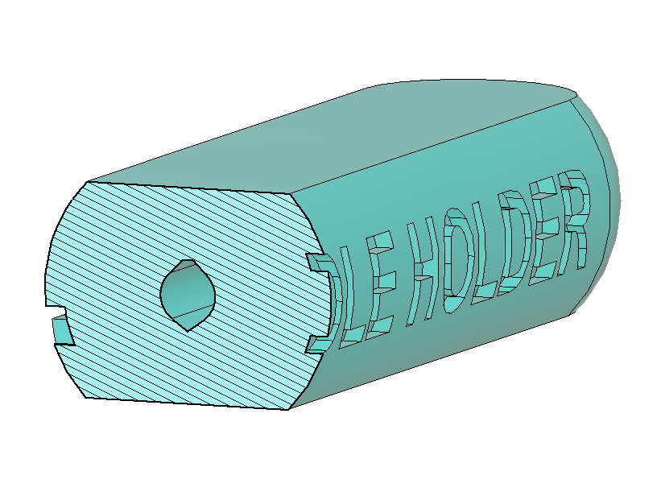

Figure 7. Connector Cross-Section Showing Modified Needle Hole.

# V1.0

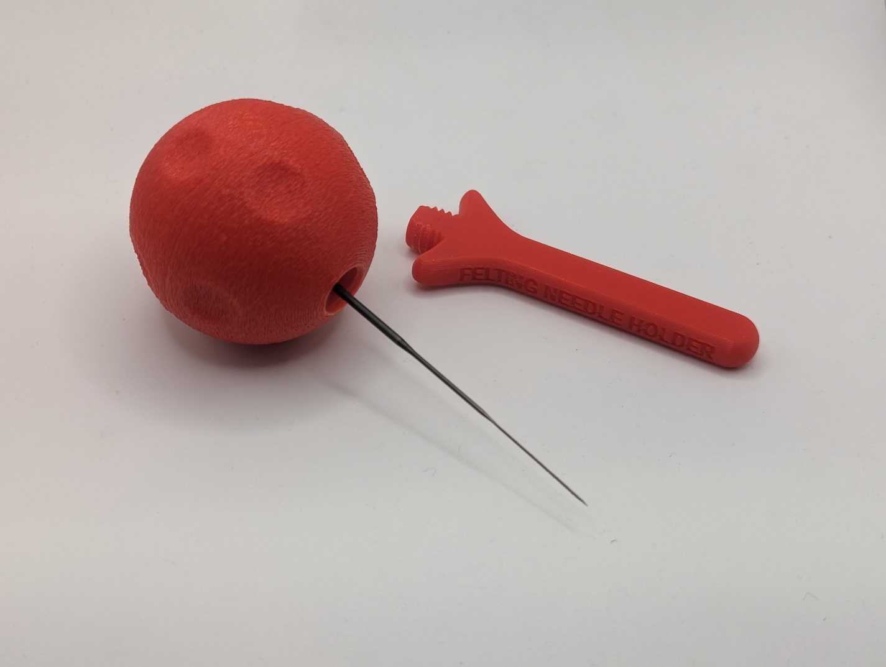

## Opportunities for Improvement

1. Determine a range of appropriate sizes and create corresponding versions (e.g., small, medium, large).
2. Create a version that can hold multiple needles.
3. Experiment with different textures.