## Introduction

The Felting Needle Holder is an aid to make it easier to hold and manipulate a felting needle. The aid is ball shaped and consists of three 3D printed parts that screw together: a top, a bottom, and a connector.

## Features

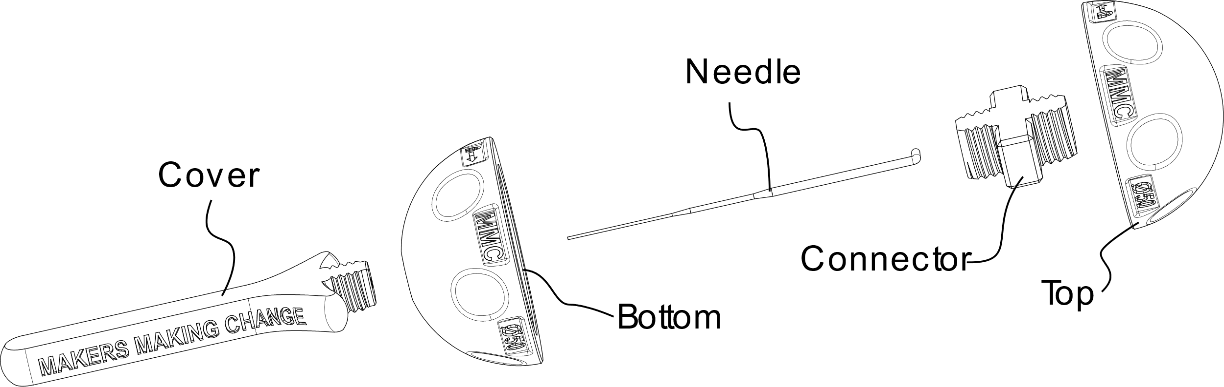

## Usage

To insert, replace, or remove the needle, the two halves of the ball need to be opened by twisting them. Once the needle is installed, the ball can be gripped within the hand for felting.

### Opening Ball

1. To open the ball, locate the half with the hole. Looking down on the top, hold the bottom half and turn the top half counter-clockwise.
2. Remove the connector by turning it counter-clockwise.

### Inserting Needle

1. Insert the felting needle into the bottom half. Insert the needle into the hole from the inside of the bottom half.
2. Rotate the needle so that the bent portion rests within the groove in the bottom half of the ball.
3. Thread the connector into the hole to secure the needle into place. The connector should be rotated clockwise until finger tight.

### Closing Ball

1. Thread the top half onto the connector. Looking down on the rounded part of the top half, rotate the top half counterclockwise to secure it to the bottom half.

## Compatibility

Designed for Felting Needles with a 1.8 mm diameter and a 3.5 mm L-shaped bend at the end (e.g., [DIMENSIONS 72-73664](https://www.amazon.ca/Dimensions-Needlecrafts-Feltworks-Replacement-Felting/dp/B004W8TGIS))

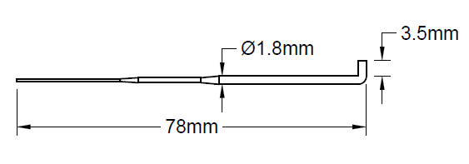

## Specifications

|  |  |
| --- | --- |
| Ball Size | 50 mm Diameter |

## Cleaning

The Holder can be wiped with a damp cloth. The Holder can also be cleaned by scrubbing with warm water and dish soap. Do not expose to high heat like a dishwasher. Do not use harsh cleaners.