# 3D Printing Summary

|  |  |
| --- | --- |
| **Metrics** |  |
| Total Print Time (min) | 1:23 |
| Total Number of Components | 6 |
| Typical Total Mass (g) | 7 |
| Typical Number of Print Setups | 1 |

# 3D Printing Settings

|  |  |  |  |  |  |  |  |
| --- | --- | --- | --- | --- | --- | --- | --- |
| **Print File Name** | **Qty** | **Total Print Time (hr:min)** | **Mass (g)** | **Infill (%)** | **Support(Y/N)** | **Layer Height/ Nozzle Diameter(mm)** | **Notes (orientation, special settings, etc.)** |
| Finger Lift Lever | 1 | 0:19 | 2 | 15 | N | 0.2/0.4 | * Print in orientation given in STL |
| Balance Screw Holder | 1 | 0:07 | 1 | 15 | N | 0.2/0.4 | * Print in orientation given in STL |
| Counterweight nut holder | 1 | 0:11 | 1 | 15 | N | 0.2/0.4 | * Print in orientation given in STL |
| Bearing Base & Bearing Base Cap | 1 | 0:29 | 2 | 15 | N | 0.2/0.4 | * Print in orientation given in STL |
| Reed Switch Plate | 1 | 0:10 | 1 | 15 | N | 0.2/0.4 | * Print in orientation given in STL |

# Customization Options

Specific colours are not a requirement for this device, so device (or components) may be printed in whichever colours the user desires.

# Post-Processing

Remove any stranding or excess material in holes with a hobby knife. Any parts of the Finger Lift Pad that feel rough or scratchy should be lightly sanded with fine sandpaper until smooth to touch.

# Examples of Quality Prints

**Finger Lift Lever**

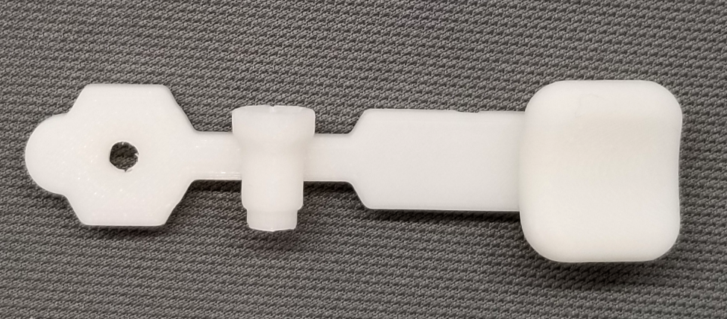

**Bearing Base**

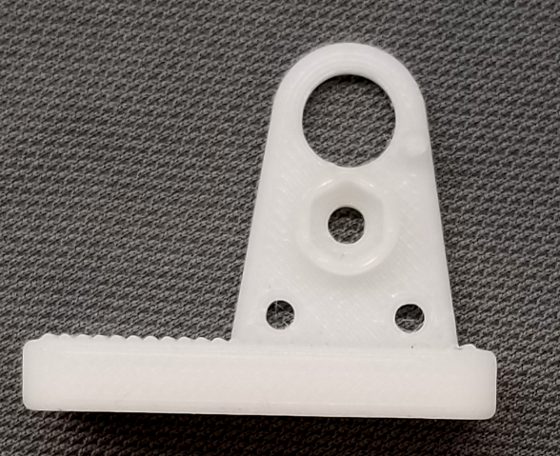

**Reed Switch Plate**

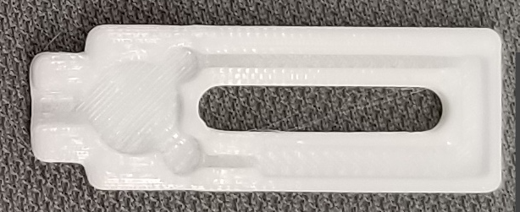

**Bearing Base Cap**

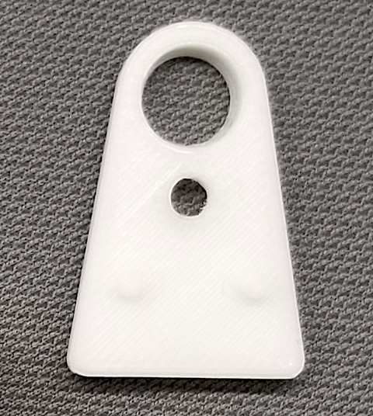

**Balance Screw Holder**

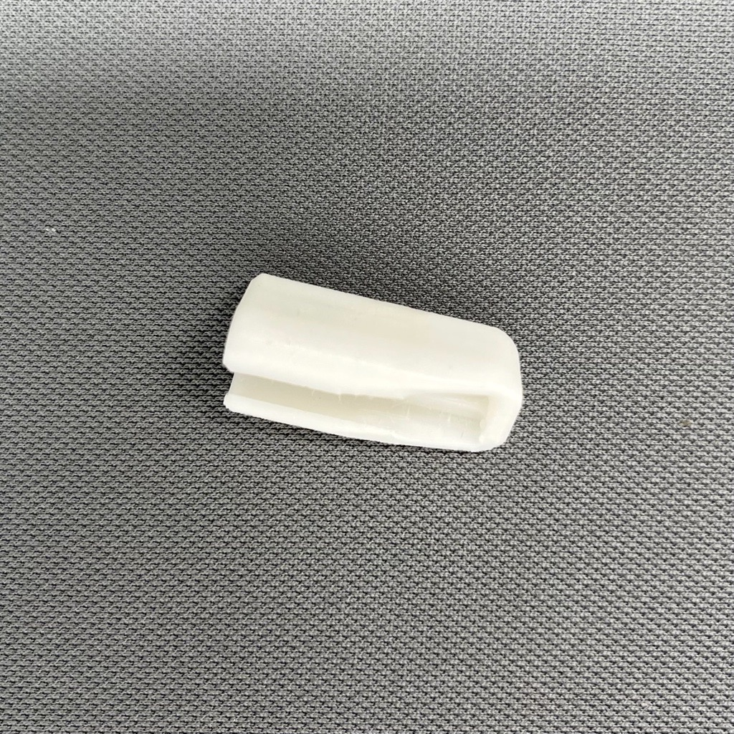

**Counterweight nut holder**

