**Flex Battery Interrupter: Quick Guide**

# Introduction

The flex battery interrupter is a simple, affordable device that enables you to switch adapt many battery-powered devices and toys. The battery interrupter is slipped in between the batteries or battery and battery terminal. This breaks the circuit (turning it off) until an external switch is attached and activated.

This device is a battery interrupter based on a flexible PCB with a mono/stereo 3.5mm audio jack.

# Features

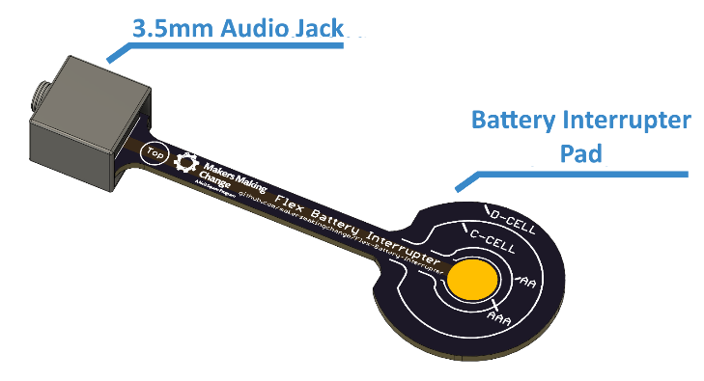

# Caution

The Plasma Globe used for demonstration in this guide is not a toy, and should only be used under adult supervision.

# Usage

1. Remove end battery positive terminal end.

1. Insert trimmed strip end against positive battery terminal.

1. Return battery tip end back into case, to hold the strip in place.

1. Return Battery cover.

1. The modification is complete.

1. Insert a switch with 3.5mm plug into the completed jack end.

1. If the device has an on/off switch turn it on. If the battery interrupter is working, the device should not turn on with using the switch connected to the strip.

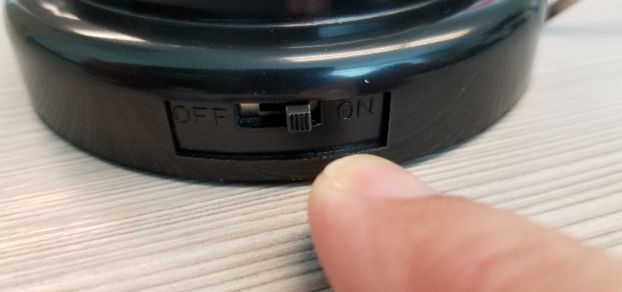

1. Activate the plugged-in switch, the device should turn on.

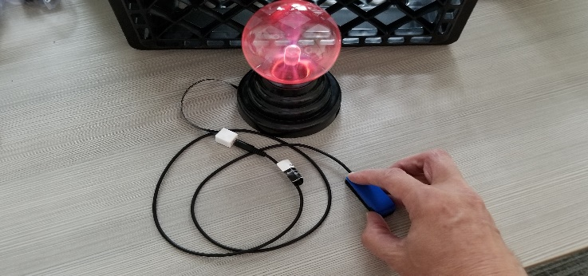

# Specification

|  |  |
| --- | --- |
| Specification | Details |
| Size | 100 mm x 34 mm x 6.2 mm (Model 100)  203.3 mm x 34.3 mm x 6.2 mm (Model 200) |
| Supported Batteries | D-Cell, C-Cell, AA, AAA |