Flex Battery Interrupter: Assembly Guide
Step 1: Insert 3.5mm Stereo Jack  First insert stereo jack on the Flex PCB side with the thin rectangular part outline, and press the Flex PCB strip onto the stereo jack.  Make sure the strip holes remain aligned with the jack pins. | 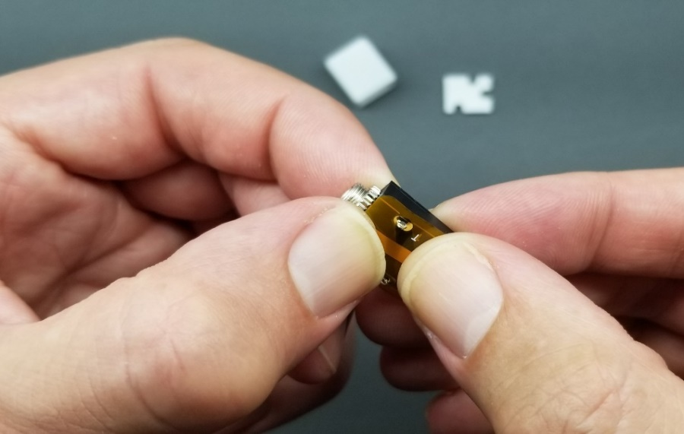
Step 2: Solder Stereo Jack Joints  Solder all three of the stereo jack joints. | 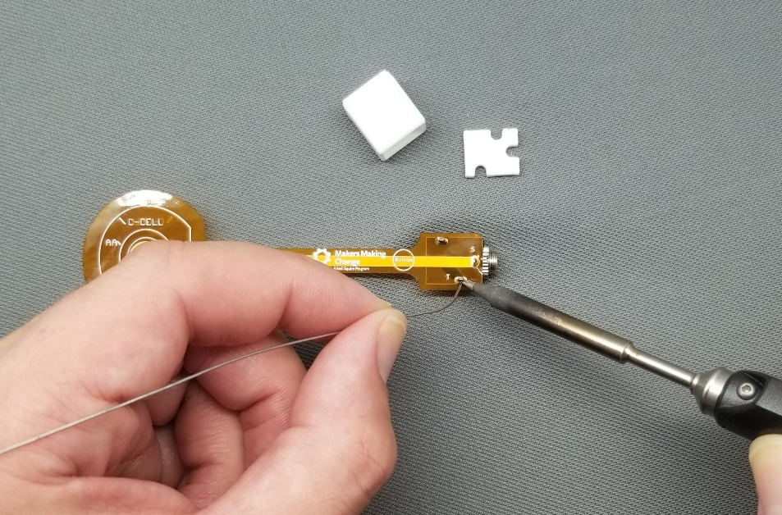
Step 3: Inspect Soldered Joints  Inspect all three solder joints, and make sure they have been properly soldered. | 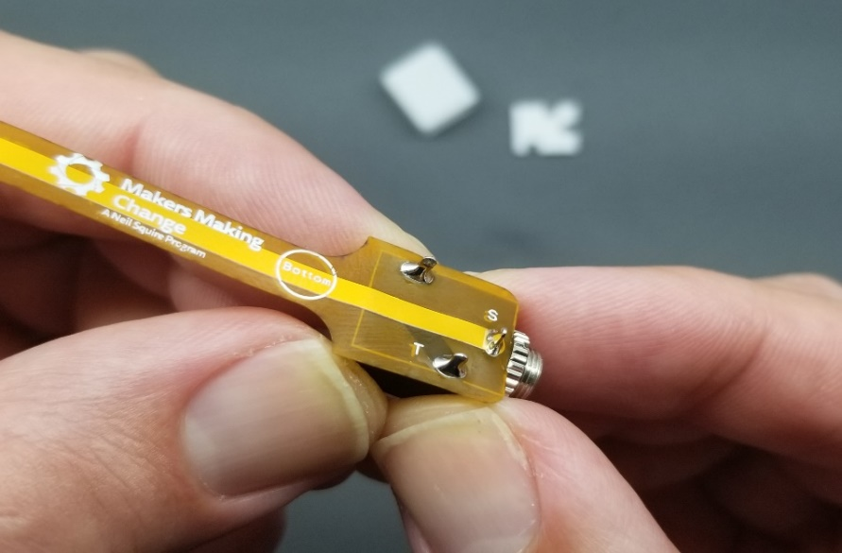
Step 4: Trim Stereo Jack Leads  Using flush cutters, trim the excess length off of the leads on the stereo jack. | 
Step 5: Insert Case Spacer  Hold the case spacer against the solder joint side of the Flex PCB strip, as shown. All solder joints should go through the slots, and the spacer should rest flat against the strip.  If the spacer can’t rest flat, remove any excess solder from any joint preventing a flat rest. | 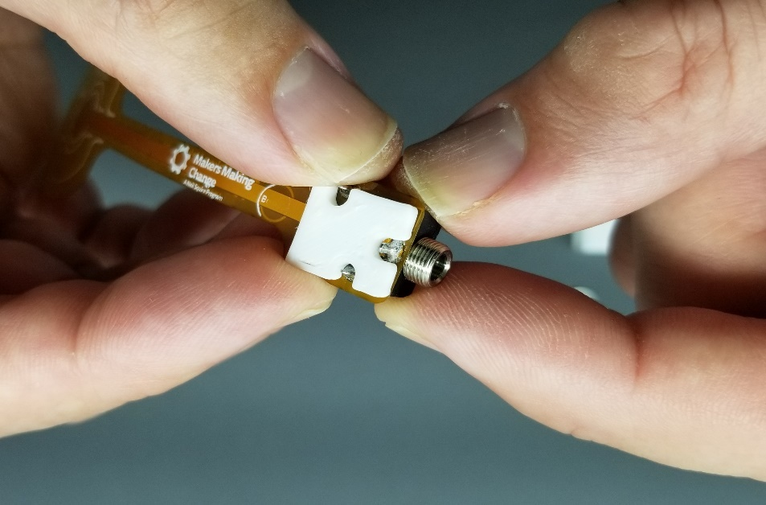

Step 6: Align Case Spacer  Make sure the 3.5mm stereo jack and the case spacer are correctly aligned.  The case hole should be on top, and the spacer side of the jack should be on the bottom. | 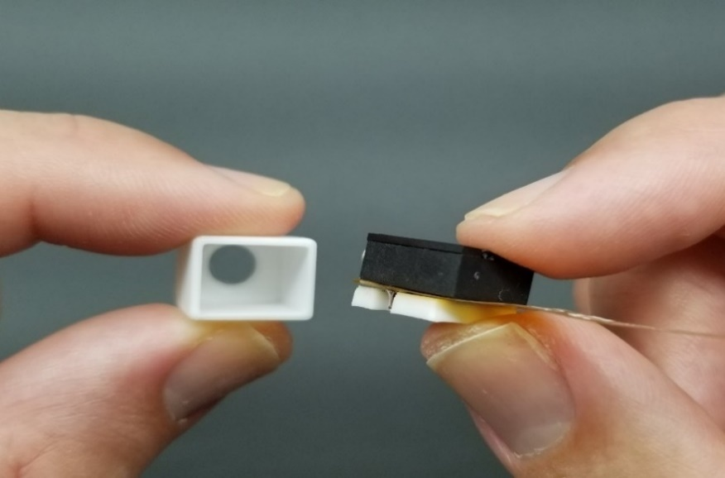
Step 7: Insert 3.5mm Stereo Jack  Slide the aligned 3.5mm stereo jack into the case. | 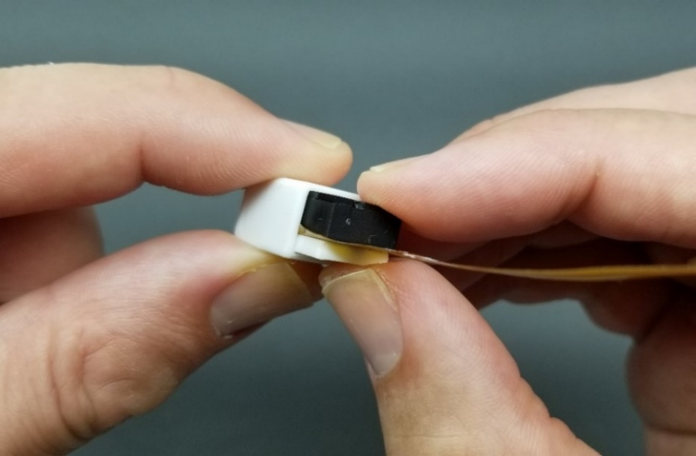
Step 8 (Optional): Use Assembly Tools to Fully Insert Jack  - Place the tool marked “AB” on a flat surface.  - Place the partially assembled jack and case into the tool marked “AB”, with the flex PCB facing up and the jack end facing down.  - Place the tool marked “AT” on top of the jack, with the flex PCB going through the slot.  - Push down on tool “AT” until the jack is all the way in the case. | 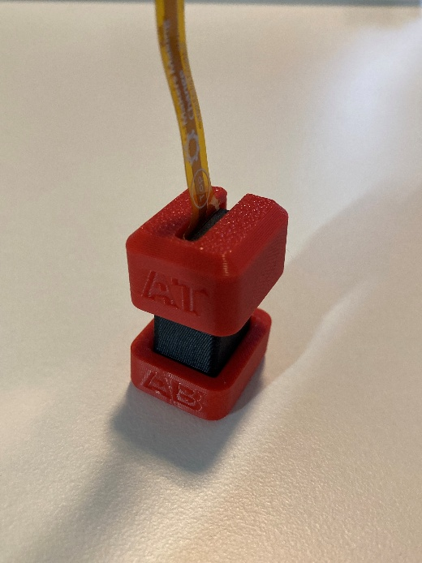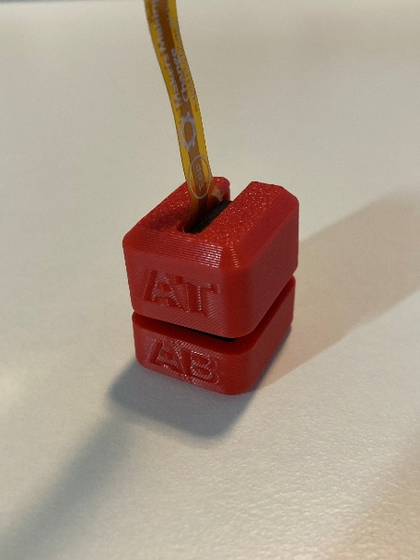
Step 9: Inspect Insertion of 3.5mm Stereo Jack  Make sure the 3.5mm stereo jack is fully inserted, and the jack end protrudes out of the case. | 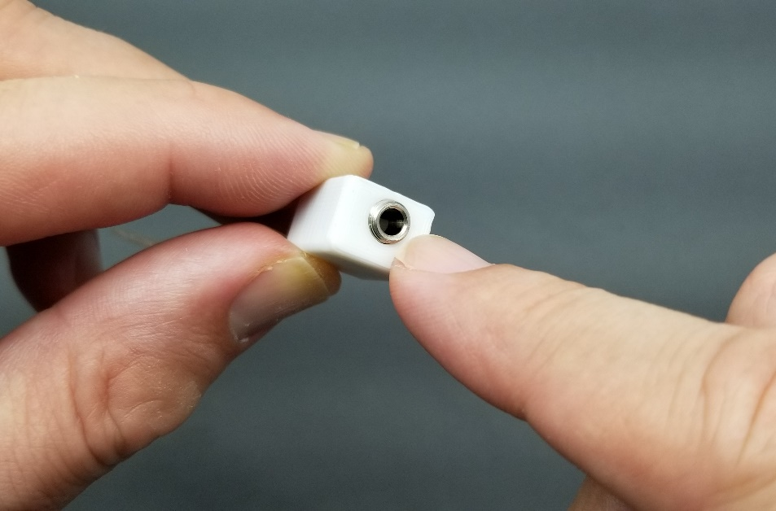
Step 10: Completion  The Flex Battery Interrupter is now fully assembled and is ready for usage. Happy Making! | 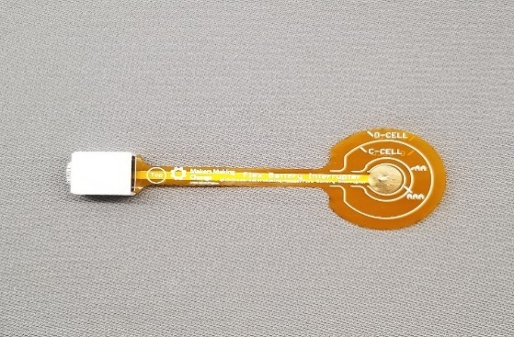
Troubleshooting  If you need to take the battery interrupter out of the case to fix it for any reason, you can use the removal tools.  - With tool RB on your work surface, place the jack in the case into tool RB, being careful of the orientation so the hole on the case lines up with the peg in tool RB.  - Put tool RT on top of the jack and case, with the tool pressing down on the lip of the case.  - Push down on tool RT, the case will slide down and the jack will stay up.  - Now remove the case the rest of the way by hand. | 