# Overview

This document contains the necessary information to build the device.

Contents

Overview 1

Maker Checklist 3

Maker To Do List 3

Items to Give to User 3

Tool List 4

Customization Guide 5

Contrasted Labels 5

Colored Labels 5

Custom PCB Guide 6

Ordering the Custom PCB 6

3D Printing Guide 7

3D Printing Summary 7

3D Printing Settings 7

Post-Processing 7

Examples of Quality Prints 7

Assembly Guide 8

Part A: PCB Assembly 8

Part A Components 8

Part A Tools 10

Part A Personal Protective Equipment (PPE) 10

Part A Steps 11

Part B: Firmware 19

Part B: Firmware Steps 19

Part C: Enclosure Assembly 21

Part C Components 21

Part C Steps 21

Testing 23

Testing using an Xbox Adaptive Controller 23

Testing using a PC 23

Troubleshooting 23

# Maker Checklist

This list provides an overview of the steps required to build and deliver the device.

## Maker To Do List

* Read through the Assembly Guide to become familiar with required components, tools, supplies, and safety gear and overall assembly steps.
* Talk to User about customization options (e.g., colour, any special requests, etc.)
* Ask user if any assistive switches are required.
* Ask user if any analog joysticks are required.
* Estimate cost of materials
* Order the custom PCB
* Order hardware components
* Print or obtain the 3D prints
* Gather tools, supplies, and safety equipment.
* Assemble the device
* Test device
* Print “User Guide”

## Items to Give to User

* Assembled, tested device
* “User Guide”

# Tool List

1. Soldering iron
2. Flush cutters
3. Phillips Head Screwdriver
4. Computer with USB port and Arduino IDE (or ability to install it)

# Customization Guide

The device can be printed in the user’s desired color.

## Contrasted Labels

A layer change can be done for the top and bottom enclosure to make the labels have greater contrast.

## Colored Labels

If you have access to a suitable multiple extruder or multiple color 3D printer, the labels can be printed in multiple colors.

# Custom PCB Guide

The Forest Hub uses one (1) custom circuit board.

The Custom PCB can be ordered from one of a variety of PCB Manufacturers. Typically, the minimum quantity for a custom PCB is five. Shipping options vary significantly in cost and shipping time. Plan on at least a week from the time of order to the PCBs arrival.

## Ordering the Custom PCB

1. Select a PCB Fabrication Company
   1. [JLPCB](https://jlcpcb.com/)
   2. [PCBWay](https://www.pcbway.com/)
   3. [OSH Park](https://oshpark.com/)
   4. [Seeed Fusion PCB](https://www.seeedstudio.com/fusion_pcb.html)
2. Create an account or use a guest login.
3. Upload the Gerber Files (e.g., Forest-Joystick-Mouse-Hub_YYY-MM-DD.zip).
4. Select the fabrication options:
   1. PCB Layers: 2 Layers
   2. PCB Quantity: 5
   3. PCB Thickness: 1.5 mm
   4. Surface Finish: HASL
   5. PCB Color: Choose what you like. Note that certain colors may impact build time.
   6. The default settings for the other settings should work.
5. Select shipping option.
   1. Shipping options and costs vary significantly. Select the best option based on your budget and timing.
6. Submit the order.

# 3D Printing Guide

## 3D Printing Summary

|  |  |
| --- | --- |
| **Metrics** | **Single Unit** |
| Total Print Time (min) | 3h52m |
| Total Number of Components | 3 |
| Typical Total Mass (g) | 40 |
| Typical Number of Print Setups | 1 |

## 3D Printing Settings

|  |  |  |  |  |  |  |  |
| --- | --- | --- | --- | --- | --- | --- | --- |
| **Print File Name** | **Qty** | **Total Print Time (hr:min)** | **Mass (g)** | **Infill (%)** | **Support(Y/N)** | **Layer Height/ Nozzle Diameter(mm)** | **Notes** |
| Forest_Hub_Top.stl | 1 | 2:40 | 24 | 15 | N | 0.2/0.4 |  |
| Forest_Hub_Bottom.stl | 1 | 0:51 | 13 | 15 | N | 0.2/0.4 |  |
| Forest_HUB_LED_Spacer.stl | 1 | 0:20 | 3 | 15 | N | 0.2/0.4 |  |

## Post-Processing

* Remove any stringing or blobs

## Examples of Quality Prints

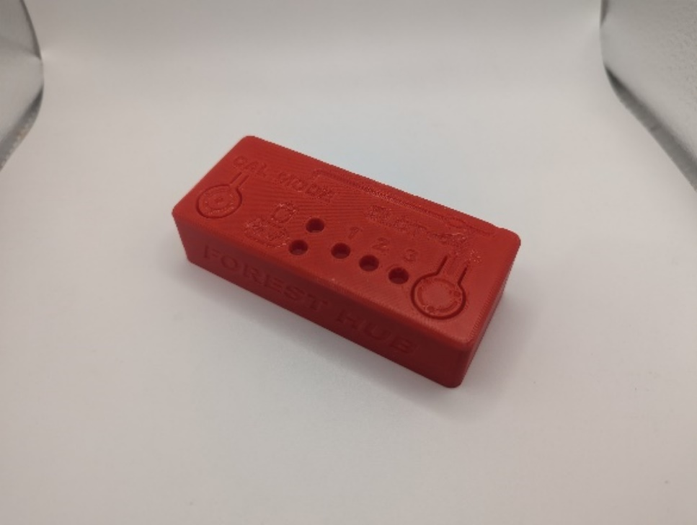 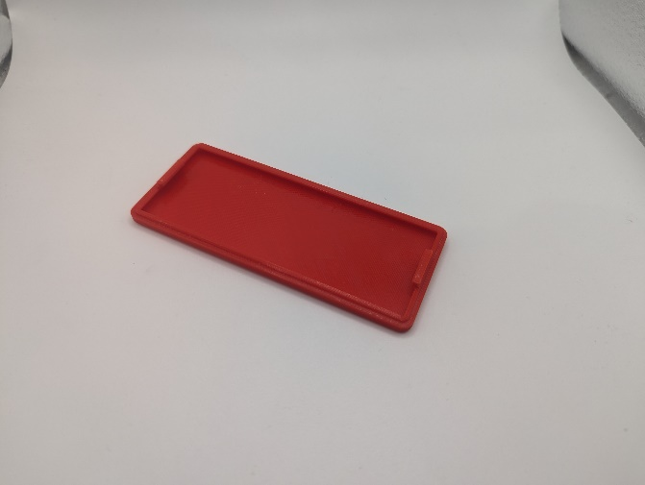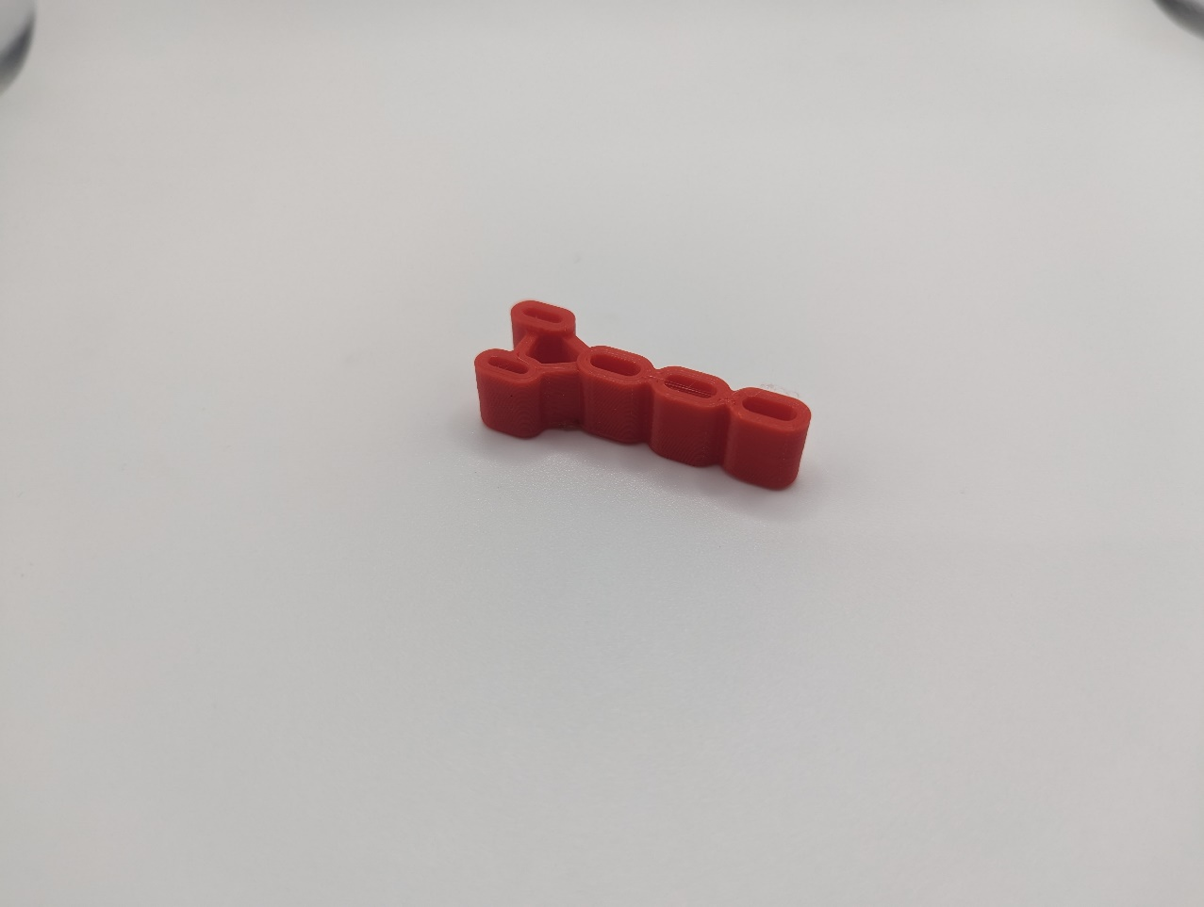

# Assembly Guide

The assembly of the Forest Hub is comprised of three parts:

1. Part A: PCB Assembly
2. Part B: Firmware
3. Part C: Enclosure Assembly

## Part A: PCB Assembly

### Part A Components

|  |  |  |  |  |  |  |  |  |  |  |  |  |  |  |  |
| --- | --- | --- | --- | --- | --- | --- | --- | --- | --- | --- | --- | --- | --- | --- | --- |
| **1** | | Forest Hub PCB | QTY 1 | | **2** | Capacitor, 10uF | | QTY 1 | | **3** | Resistor R1, 220Ω | | | | QTY 1 |
| Forest Hub PCB | | | | | A yellow capacitor with a white background. | | | | | A screenshot of a 220 ohm resistor colour banding.A photo of a resistor on a white background. | | | | | |
| **4** | | Resistor R3, 2.2KΩ | QTY 1 | | **5** | Resistor R4, 4.7KΩ | | QTY 1 | | **6** | Resistor R2/R6, 10KΩ | | | | QTY 2 |
| A screenshot of a 2.2 kilo ohm resistor colour banding.A photo of a resistor on a white background. | | | | | A screenshot of a 4.7 kilo ohm resistor colour banding.A photo of a resistor on a white background. | | | | | A screenshot of a 10 kilo ohm resistor colour banding.A photo of two resistors on a white background. | | | | | |
| **7** | | Resistor R5, 100Ω | QTY 1**19** | | **8** | Tactile Buttons | | | QTY 2 | **9** | | | Piezo Buzzer PS1240 | | QTY 1 |
| A screenshot of a 100 ohm resistor colour banding.A photo of a resistor on a white background. | | | | | A photo of 2 tactile buttons on a white background. | | | | | A photo of a piezo buzzer on a white background. | | | | | |
| **10** | | TRRS Jack | | **1** QTY 1**9** | **11** | Mono Switch Jacks | QTY 5**19** | | | **12** | | Modular Connector (RJ25) | | QTY 1**19** | |
| A photo of a TRRS jack on a white background. | | | | | A photo of two mono switch jacks on a white background. | | | | | A RJ11 jack | | | | | |
| **13** | | Adafruit Qt PY SAMD21 | | QTY 1 | **14** | Headers, Female, 7 Position | QTY 2 | | | **15** | | NeoPixel LEDs, 5 mm though hole | | QTY 5 | |
| A photo of an Adafruit QT Py SAMD21 microcontroller and two 7 pin male headers on a white background. | | | | | A photo of two 7 pin female headers on a white background. | | | | | A photo of five Neopixel LEDs on a white background. | | | | | |
| **16** | | Forest LED Spacer | | QTY 1 | **17** | Forest Enclosure Top | QTY 1 | | | **18** | | Screw, #4, 3/8” Length | | QTY 1 | |
| A photo of the Forest LED Spacer printed in red PLA on a white background. | | | | | A photo of the Forest enclosure top printed in red PLA on a white background. | | | | | A photo of a #4 3/8" metal screw on a white background. | | | | | |
| **19** | Forest Enclosure Bottom | | | QTY 1 | **20** | USB-C Cable | QTY 1 | | | **21** | | Solderless Breadboard | | QTY 1 | |
| A photo of the Forest enclosure bottom printed in red PLA on a white background. | | | | | A photo of a black USB-C cable on a white background. | | | | | A photo of a solderless breadboard on a white background. | | | | | |

### Part A Tools

* Soldering iron
* Flush cutters
* Phillips Head Screwdriver

### Part A Personal Protective Equipment (PPE)

* Safety glasses

### Part A Steps

#### Step 1: Insert and Solder Capacitor

|  |  |
| --- | --- |
| Take the capacitor and bend the metal leads on either side so they will line up with the holes labelled C1 on the PCB.  Insert the capacitor leads all the way into the C1 holes. Solder in place and trim the excess leads off. | PCB screenshot showing C1 location |

#### Step 2: Insert and Solder R1 Resistor

|  |  |
| --- | --- |
| Take the R1 resistor (220 Ω) and bend the metal leads on either side so they will line up with the holes labelled R1 on the PCB.  Insert the resistor leads all the way into the R1 holes.  Flip the board to the back, solder in place and trim the excess leads off. | A screenshot of a 220 ohm resistor colour banding.  PCB screenshot showing R1 location |

#### Step 3: Insert and Solder R2 Resistor

|  |  |
| --- | --- |
| Take the R2 resistor (10KΩ) and bend the metal leads on either side so they will line up with the holes labelled R2 on the PCB.  Insert the resistor leads all the way into the R2 holes.  Flip the board to the back, solder in place and trim the excess leads off. | A screenshot of a 10K ohm resistor colour banding.  PCB screenshot showing R2 location |

#### Step 4: Insert and Solder R3 Resistor (Component 4)

|  |  |
| --- | --- |
| Take the R3 resistor (2.2KΩ) and bend the metal leads on either side so they will line up with the holes labelled R3 on the PCB.  Insert the resistor leads all the way into the R3 holes. Solder in place and trim the excess leads off. | A screenshot of a 2.2K ohm resistor colour banding.  PCB screenshot showing R3 location |

#### Step 5: Insert and Solder R4 Resistor (Component 5)

|  |  |
| --- | --- |
| Take the R4 resistor (4.7KΩ) and bend the metal leads on either side so they will line up with the holes labelled R4 on the PCB.  Insert the resistor leads all the way into the R4 holes. Solder in place and trim the excess leads off. | A screenshot of a 4.7K ohm resistor colour banding.  PCB screenshot showing R4 location |

#### Step 6: Insert and Solder R5 Resistor (Component 7)

|  |  |
| --- | --- |
| Take the R5 resistor (100Ω) and bend the metal leads on either side so they will line up with the holes labelled R5 on the PCB.  Insert the resistor leads all the way into the R5 holes. Solder in place and trim the excess leads off. | A screenshot of a 100 ohm resistor colour banding.  PCB screenshot showing R5 location |

#### Step 7: Insert and Solder R6 Resistor (Component 6)

|  |  |
| --- | --- |
| Take the R6 resistor (10KΩ) and bend the metal leads on either side so they will line up with the holes labelled R6 on the PCB.  Insert the resistor leads all the way into the R6 holes. Solder in place and trim the excess leads off. | A screenshot of a 10K ohm resistor colour banding.  PCB screenshot showing R6 location |

#### Step 8: Insert and Solder Buzzer

|  |  |
| --- | --- |
| Take the Buzzer (Component 9) and insert the leads all the way into the PCB holes labelled with a speaker icon from the top. Solder in place and trim the excess leads. | PCB screenshot showing Buzzer location |

#### Step 9: Insert and Solder Calibration Button

|  |  |
| --- | --- |
| Take a button (Component 8) and insert the leads all the way into the PCB holes labelled CALIBR from the top. Solder a single pin, check that the component is fully flush to the PCB, and solder the remaining pins. | PCB screenshot showing Calibration Button location |

#### Step 10: Insert and Solder Mode Button

|  |  |
| --- | --- |
| Take a button (Component 8) and insert the leads all the way into the PCB holes labelled Mode from the top. Solder a single pin, check that the component is fully flush to the PCB, and solder the remaining pins. | PCB screenshot showing Mode Button location |

#### Step 11: Insert and Solder TRRS Jack

|  |  |
| --- | --- |
| Take the TRRS jack (Component 10) and insert the leads all the way into the PCB holes labelled SW_ANALOG from the top. Solder a single pin, check that the component is fully flush to the PCB, and solder the remaining pins. | PCB screenshot showing TRRS jack location |

#### Step 12: Insert and Solder SM Audio Jack

|  |  |
| --- | --- |
| Take an audio jack (Component 11) and insert the leads all the way into the PCB holes labelled SW_M from the top. Solder a single pin, check that the component is fully flush to the PCB, and solder the remaining pins. | PCB screenshot showing SM jack location |

#### Step 13: Insert and Solder S1 Audio Jack

|  |  |
| --- | --- |
| Take an audio jack (Component 11) and insert the leads all the way into the PCB holes labelled SW_S1 from the top. Solder a single pin, check that the component is fully flush to the PCB, and solder the remaining pins. | PCB screenshot showing S1 jack location |

#### Step 14: Insert and Solder S2 Audio Jack

|  |  |
| --- | --- |
| Take an audio jack (Component 11) and insert the leads all the way into the PCB holes labelled SW_S2 from the top. Solder a single pin, check that the component is fully flush to the PCB, and solder the remaining pins. | PCB screenshot showing S2 jack location |

#### Step 15: Insert and Solder S3 Audio Jack

|  |  |
| --- | --- |
| Take an audio jack (Component 11) and insert the leads all the way into the PCB holes labelled SW_S3 from the top. Solder a single pin, check that the component is fully flush to the PCB, and solder the remaining pins. | PCB screenshot showing S3 jack location |

#### Step 16: Insert and Solder S4 Audio Jack

|  |  |
| --- | --- |
| Take an audio jack (Component 11) and insert the leads all the way into the PCB holes labelled SW_S4 from the top. Solder a single pin, check that the component is fully flush to the PCB, and solder the remaining pins. | PCB screenshot showing S4 jack location |

#### Step 17: Insert and Solder Male Headers to QT Py

|  |  |
| --- | --- |
| Take the QT Py microcontroller and male headers (Component 13). If necessary, use the flush cutters to separate the male headers into two 7 position segments.  If you have a solderless breadboard:   * Insert the long leads of the male headers into the breadboard and insert the microcontroller on top. Solder the pins in place and remove the assembly. | Solderless breadboard with two 7 position male headers and Qt Py |
| If you do not have a solderless breadboard:   * Insert the male headers into the microcontroller board. * Use the female heads rotated 90 degrees to provide the correct spacing. * Solder a single male header pin to the microcontroller, ensuring the headers are perpendicular to the PCB and the microcontroller is parallel with the PCB. * Check that the male headers are flush and perpendicular to the microcontroller, solder the remaining male headers pins in place. |  |

#### Step 18: Insert and Solder Female Headers

|  |  |
| --- | --- |
| Insert the male headers into the female headers (Component 14) and insert the female headers into the PCB holes outlined with the microcontroller footprint from the top. Solder a single pin of one female header and check to ensure the female headers are flush and perpendicular with the PCB. Solder the remaining female header pins. | PCB screenshot showing Qt Py female headers location |

#### Step 19: Insert and Solder RJ25 Connector

|  |  |
| --- | --- |
| Take the RJ25 Modular connector and insert it into the PCB holes located between SW_S4 and SW_ANALOG. Solder a single pin, check that the component is fully flush to the PCB, and solder the remaining pins. | PCB screenshot showing RJ25 jack location |

#### Step 20: Space out NeoPixel LED Leads by Inserting into PCB

|  |  |
| --- | --- |
| Insert each of the NeoPixel LEDs into the PCB to correctly space out the NeoPixel leads, **then remove the NeoPixels** from the PCB. This will make the next step less difficult. The longer leads should be oriented towards the left. | NeoPixel LED inserted into green circuit board. |

#### Step 21: Insert NeoPixel LEDs using Forest LED Spacer

|  |  |
| --- | --- |
| Take the NeoPixel LEDs (Component 15) and the Forest LED spacer (Component 16). Line up and place the spacer over the PCB holes labelled L1, L2, L3, L4, and L5.  Ensuring that the flat side of the NeoPixel LEDs lines up with the outline on the PCB (all LED flat sides should face towards the Buzzer), insert the LEDs into the PCB. The longer leads should be oriented towards the left.  If needed, use a small tool such as a toothpick to guide the leads into the PCB.  Solder in place and trim the excess leads. | PCB screenshot showing NeoPixel locationNeoPixel LEDs inserted into PCB through 3D printed spacer |

#### Step 22: Doublecheck LED soldering

|  |  |
| --- | --- |
| **Visibly check for solder bridges** (solder going between and connecting the pads) on the pads for the NeoPixels LEDs. If there are any, remove the connecting solder. | Warning with solid fill |

#### Step 23: PCB is Fully Assembled

|  |  |
| --- | --- |
| The Forest Hub PCB is now fully assembled. Move to  Part B: Firmware. | Assembled PCB |

## Part B: Firmware

### Part B: Firmware Steps

#### Step B1: Setup Arduino IDE

1. Download Arduino IDE for your operating system at <https://www.arduino.cc/en/software>
2. Install the Arduino IDE.

#### Step B2: Setup Arduino IDE for QT Py Board

1. Open Arduino IDE.
2. Click on **File -> Preferences**.
3. Locate the text field that says **Additional Boards Manager URLs** beside it.
4. Copy and paste the following link into the field as a new line:  
   <https://adafruit.github.io/arduino-board-index/package_adafruit_index.json>
5. Click on **OK.**
6. Restart the Arduino IDE.
7. Open the **Boards Manager** option from the **Tools-> Board-> Boards Manager...,**
8. **Search for “Adafruit SAMD” and select “Adafruit SAMD Boards” by Adafruit.**
9. **Click Install to install the board.**

#### ****Step B3: Install Libraries****

1. In a web browser, go to <https://github.com/cyborg5/TinyUSB_Mouse_and_Keyboard> and go to Code -> Download ZIP.
2. In Arduino IDE, click **Sketch -> Include Library -> Add .ZIP Library.**
3. Navigate to the ZIP file downloaded in Step (a). Click **OK**.
4. Go to **Tools -> Manage Libraries…,** search for “Flash Storage” and install the library “FlashStorage” by Various.
5. Go to **Tools -> Manage Libraries…,** search for “Adafruit_Neopixel” and install the library “Adafruit_Neopixel” by Adafruit.
6. Go to **Tools -> Manage Libraries…,** search for “WiiChuck” and install the library “WiiChuck” by Kevin Harrington.

#### Step B4: Setup Local Code Directory

1. Download the Firmware_Files from the GitHub Repository: <https://github.com/makersmakingchange/Forest-Hub/blob/main/Build_Files/Firmware_Files/Forest_Hub_Firmware.zip>
2. Extract / unzip the folder to a known location.
3. Confirm that you have the following folder structure:

* Forest_Hub_Firmware (folder)
  + Forest_Hub_Firmware.ino
  + OpenAT_Joystick_Response.h
  + XACGamepad.h

#### Step B5: Upload the Code to the microcontroller

1. Open Forest_Hub_Firmware.ino with Arduino IDE.
2. **Select Adafruit QT Py M0 (SAMD21) from Tools -> Board -> Adafruit SAMD Boards**
3. Click on **Tools -> USB Stack** and select **TinyUSB**
4. Connect the Forest Hub using the USB cable to the computer.
5. Select the correct port from **Tools -> Port** menu.
6. Verify and upload the code.

## Part C: Enclosure Assembly

### Part C Components

|  |  |  |  |  |  |  |  |  |  |  |  |  |
| --- | --- | --- | --- | --- | --- | --- | --- | --- | --- | --- | --- | --- |
| **22** | Assembled Forest Hub PCB | QTY 1 | | **17** | Forest Enclosure Top | | QTY 1 | **18** | Screw, #4, 3/8” Length | | | QTY 1 |
| Assembled PCB | | | | Forest Hub Enclosure top | | | | A photo of a #4 3/8" metal screw on a white background. | | | | |
| **19** | Forest Enclosure Bottom | | QTY 1 | **20** | USB-C Cable | QTY 1 | |  | |  |  | |
| Forest Hub Enclosure Bottom | | | | USB-C Cable | | | |  | | | | |

### Part C Steps

#### Step C1: Insert PCB into Enclosure Top

|  |  |
| --- | --- |
| Insert the assembled PCB into the Enclosure Top. | PCB inserted into Enclosure Top |

#### Step C2: Secure PCB into place with Screw

|  |  |
| --- | --- |
| Secure the PCB in place with using the #4 screw and the Phillips screwdriver. | A screw used to affix PCB into enclosure |

#### Step C3: Snap Enclosure Bottom

|  |  |
| --- | --- |
| Position the Enclosure Bottom over the Enclosure Top and push down to snap in place. | Top enclosure with bottom enclosure snap-fit |

#### Step C4: Enclosure Finished

|  |  |
| --- | --- |
| Flip the device over. The Forest Hub is now complete. | Finished Forest Hub Enclosure |

# Testing

To test the Forest Hub, you will need an analog joystick and at least one (1), but up to preferably five (5) assistive switches.

## Testing using an Xbox Adaptive Controller

1. Connect the Forest Hub into the Left USB port for the left joystick or the Right USB port for the right joystick.
2. Connect the Xbox Adaptive Controller (XAC) using a USB-C cable to the computer.
3. If using Windows, open “Set up USB Game Controllers” from the Control Panel. You can find this by searching your computer in the search bar next to the Windows icon.
4. Select the Xbox Adaptive Controller from the list of controllers and go to “Properties”.
5. Move your joystick and observe the movement of the cross hatch in the “Axes” window. Ensure it moves in the proper directions when you move the joystick (the arrow points in the up direction). If not, open up the joystick and check your connections.

## Testing using a PC

1. Connect the joystick using the USB C cable to the computer.
2. If using Windows, open “Set up USB Game Controllers” from the Control Panel. You can find this by searching your computer in the search bar next to the Windows icon.
3. Ensure that the joystick is registered as a game controller and select your joystick from the list and go to “Properties”.
4. Move your joystick and observe the movement of the cross hatch in the “Axes” window. Ensure it moves in the proper directions when you move the joystick (the arrow points in the up direction). If not, open the joystick and check your connections.
5. Using assistive switches plugged into each mono jack, activate each switch, and ensure that one of buttons 1-4 light up when you press the switch, and stops when you release the switch. If not, open the joystick and check your connections.

# Troubleshooting

Nothing happens when I plug the device in.

* Double check to make sure there are no bridged connections. Double check the Neopixels and the RJ11 Connector.