# Introduction

The Forest Joystick Mouse Hub allows you to connect an analog joystick and up to four (4) assistive switches to use as a USB HID Mouse or USB HID Gamepad. An additional assistive switch can be used to cycle between 3 slots and switch between Mouse mode and Gamepad mode.

# Features

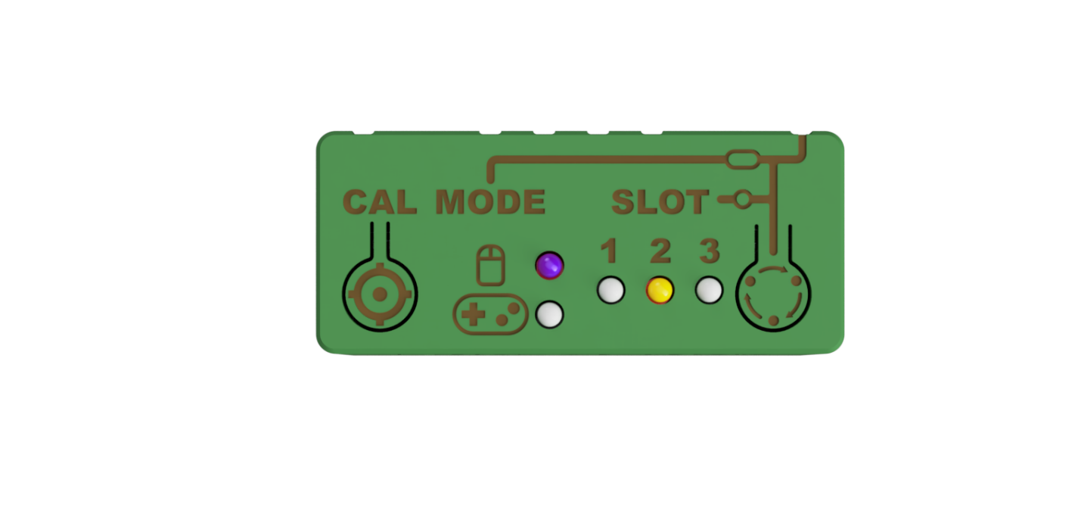

Calibration button

Mode Button

Output Mode Indicators

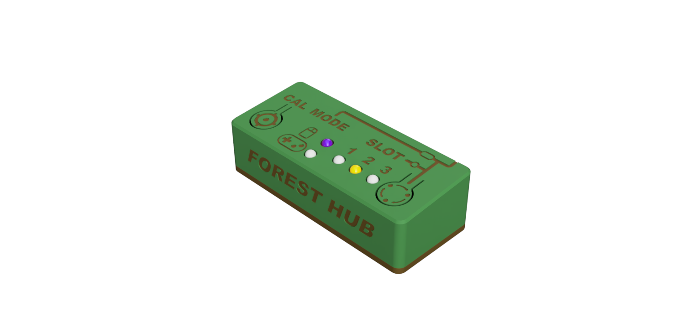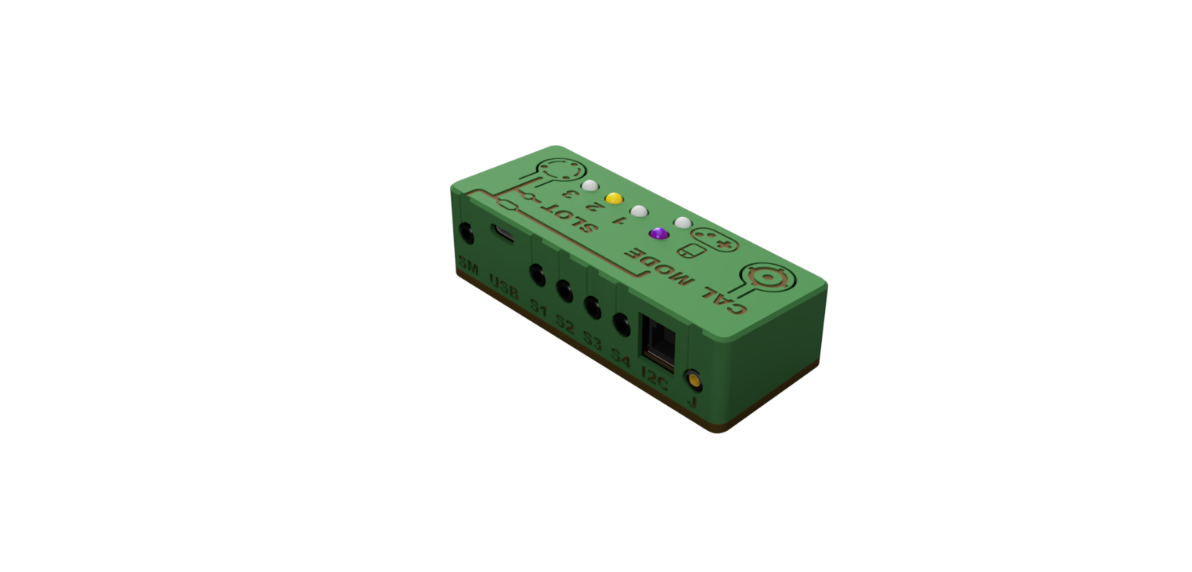

Slot Indicator

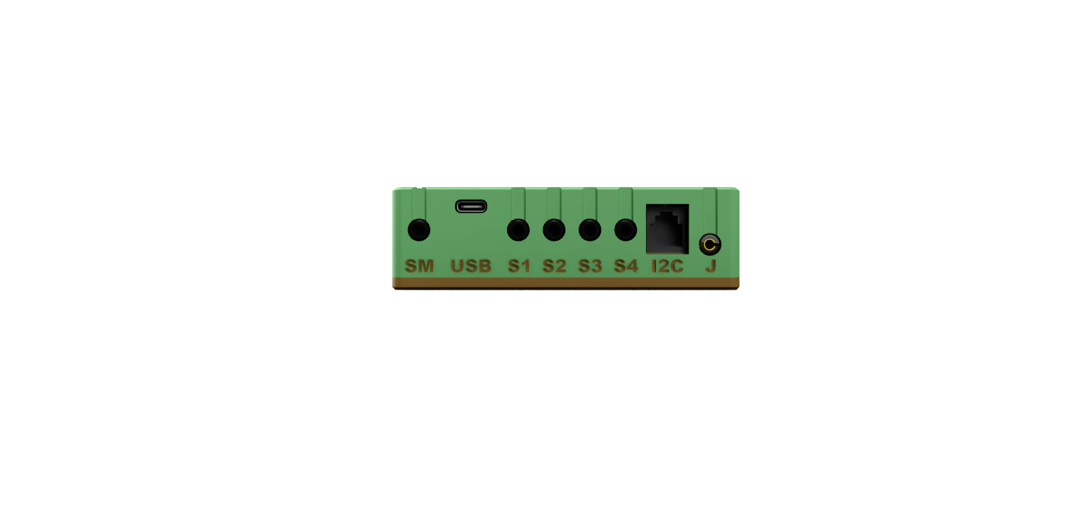

Mode Switch Port

Assistive Switch Ports

USB Port

Joystick Port

# Setting Up the Forest Hub

## Compatible Joysticks

The Forest Hub is compatible with any analog joystick that is designed to also work on the Xbox Adaptive Controller or Sony Access Controller. The connector on an analog joystick looks like a 4-conductor headphone jack (i.e. TRRS), as pictured below:

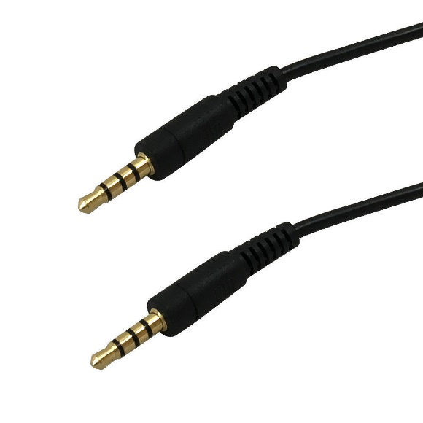

Some examples of analog joysticks made by Makers Making Change include the [Oak Compact Joystick](https://www.makersmakingchange.com/s/product/oak-compact-joystick/01tJR00000092x3YAA), the [Spruce Mini Joystick](https://www.makersmakingchange.com/s/product/spruce-mini-joystick/01tJR000000EHqbYAG), and the [Birch Mini Joystick.](https://www.makersmakingchange.com/s/product/birch-mini-joystick/01tJR0000009357YAA)

## Setup

1. Connect an analog joystick to the Joystick port (J).
2. Connect assistive switches to the Switch Input ports (S1, S2, S3, S4).
3. Connect an additional assistive switch to the Slot/Mode Input port (SM).
4. Connect the USB-C cable to the Hub, then to the Host Device.
5. Wait until the slot indicator light turns on, and the buzzer beeps to indicate mode and slot number, before moving the joystick.

## Connecting to Host Device

### Host Device Compatibility

* USB HID Mouse: PC, Mac, Android Smartphone, Apple Smartphone (iOS 13+)
* USB HID Gamepad: PC, Xbox Adaptive Controller

### Plugging Directly into a Computer or Laptop

If you have the appropriate cable, the Forest Hub can be directly plugged into the device’s USB port to work in Mouse or Gamepad mode. The Forest Hub port requires a USB-C plug, and most host devices will require either USB-A or USB-C plug types.

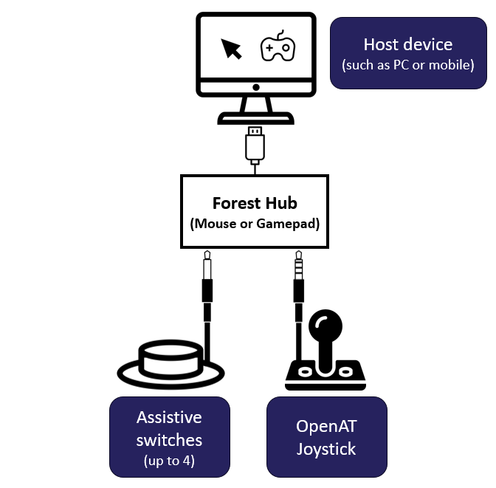

### Plugging Directly into an Android Mobile Phone or Tablet

The Forest Hub can be directly plugged into the device’s USB port to work in Mouse or Gamepad mode using the appropriate cable and/or adapter. The Forest Hub port requires a USB C plug, and most host devices will require either USB-C, USB-B Micro, or USB-A plug types.



### Plugging into an iOS or Android Mobile Device with an External Power Source

The Forest Hub cannot draw power from an iOS device, and therefore must have a powered USB hub or powered USB splitter to connect between the Forest Hub and iOS device. For an Android mobile device (phone or tablet), using an external power source is optional, but can extend the battery life of your device.

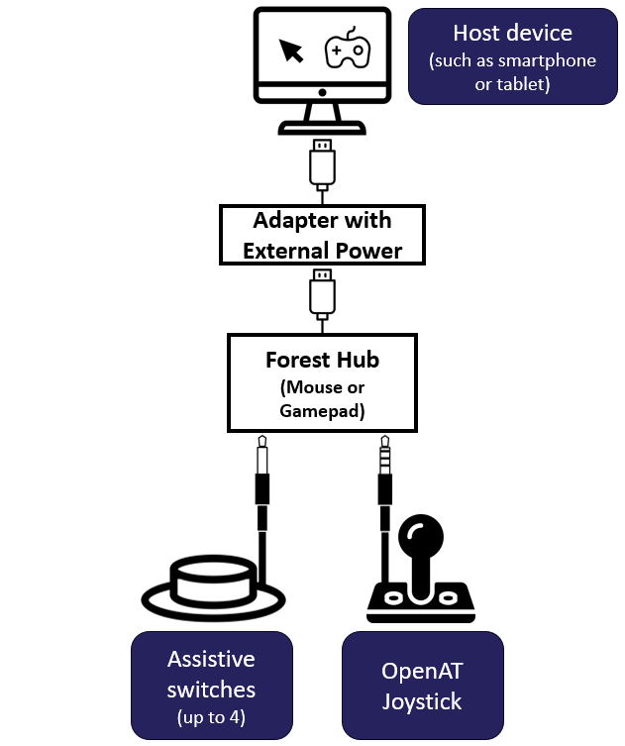

# Operating the Forest Hub

The Forest Hub is able to operate in two modes: Mouse Mode and Gamepad Mode.

* In Mouse Mode, the joystick controls the movement of the mouse cursor and the assistive switches are mapped to different mouse buttons.
* In Gamepad Mode, the joystick controls the analog movement of the gamepad joystick and the assistive switches are mapped to different gamepad buttons.

## Forest Hub Controls Mapping

### Device Controls

| Input | Mouse  (PC or Mobile) | Gamepad | | | |
| --- | --- | --- | --- | --- | --- |
| **PC** | **Mobile (Android)** | **XAC (Left USB)** | **XAC (Right USB)** |
| Joystick | Cursor movement | Joystick movement | Directional pad | Left Thumbstick | Right Thumbstick |
| S1 | Left click | Button 1 | Select | X1 (Left Stick Up) | View |
| S2 | Middle Click | Button 2 | Back | X2 (Left Stick Down) | Menu |
| S3 | Right Click | Button 3 | Select | Left Stick Press | Right Stick Press |
| S4 | Toggle Scroll On/Off | Button 4 | N/A | Left Bumper | Right Bumper |

### Hub Settings Controls

| Input | Mouse or Gamepad | |
| --- | --- | --- |
| **Short Press** | **Long Press** |
| SM Switch | Cycle Slot | Change Mode |
| Mode Button | Cycle Slot | Change Mode |
| Calibration Button | Center Reset | -- |

## Mouse Mode Controls

The Forest Hub is able to simulate most basic mouse functions, including mouse movement, left click, middle click, right click, and scroll.

### Mouse Movement

To move the mouse, move your joystick in the desired direction. Ensure your joystick is oriented properly. The amount you move the joystick correlates to the mouse speed, so moving the joystick further in one direction will move it faster.

### Mouse Clicks

For left click, middle click, and right click, while the corresponding assistive switch is pressed the mouse function will be pressed, and will be held until the assistive switch is released. Left click is conducted by activating assistive switch S1, middle click by activating assistive switch S2, and right click by activating assistive switch S3.

### Mouse Scroll

To simulate a mouse scroll wheel, press assistive switch S4 to enter scroll mode, and while in scroll mode, move the joystick up or down in the desired scroll direction. To exit scroll mode, press assistive switch S4 again. Note that moving the joystick left or right will not scroll sideways, to scroll sideways try either using middle click or using arrows on the screen.

When entering scroll mode, the mode LED beside the mouse will turn white and the buzzer will make a short high-pitched beep. When exiting scroll mode, the mode LED will go back to its original colour, and the buzzer will make another short high-pitched beep of a different tone.

## Gamepad Mode Controls

The Forest Hub is able to simulate an HID Gamepad, including joystick movement and gamepad buttons 1-4. These buttons represent different actions depending on if it is being used directly on PC, on mobile, or being used on the XAC. To see the mapping of the inputs see the table above under “Device Controls.” When the switch is activated the button will be pressed, and when the switch is released the button will release.

## Forest Hub Settings Controls

### Slot and Mode Change Overview

Changing the slot and operating mode of the Forest Hub can be done using the Mode button on the Hub itself or using the SM switch.

A slot change is done using a short press (< 3 seconds), and a mode change is done using a long press (> 3 seconds). This is indicated on the enclosure using a dot and a dash, shown below.

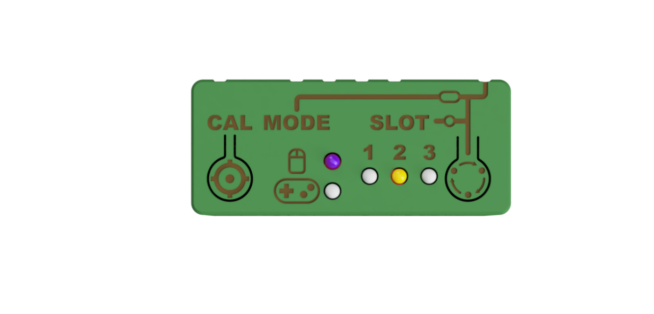

Mode Button

Short Press Icon

Long Press Icon

#### Cycle Slot

To change the slot, perform a short press (< 3 seconds) of either assistive switch SM or the Mode button on the Forest Hub. When the switch or button is released, the slot LED will change. The default is slot 0, which has no slot LEDs lit up. The slots will cycle from Slot 0 > Slot 1 > Slot 2 > Slot 3 > Slot 0 … repeating.

When in Mouse Mode, the slots will change the mouse cursor speed. When in Gamepad Mode, the slots currently do not have a function.

#### Change Mode

To change the mode, perform a long press (> 3 seconds) of either assistive switch SM or the Mode button on the Forest Hub until the mode LED changes. The Forest Hub will then change from the current mode to the other, either from Mouse Mode to Gamepad Mode or from Gamepad Mode to Mouse Mode. **When the mode is changed, the device will reset** and perform the startup sequence.

### Calibration - Center Reset

A Center Reset resets the neutral position of the joystick in its resting position. If the position of the cursor is moving when the joystick is released and stationary, a Center Reset can help resolve the cursor drift.

A center reset is automatically performed when the Forest Hub is first powered on, or can be started manually:

1. Release the joystick to neutral.
2. Perform a short press (< 3 seconds) of the calibration button on the Forest Hub.

After initiating a Center Reset, both Mode LEDs will light up white momentarily, and then return to indicating the current mode in the original colour. **Do not touch the joystick while both Mode LEDs are white.**

# Specifications

|  |  |
| --- | --- |
| Enclosure Height | 32 mm |
| Enclosure Depth | 46 mm |
| Enclosure Length | 108 mm |

# Cleaning

The outside of the enclosure can be cleaned with a damp cloth. Do not use hot water. Do not submerge.

# Troubleshooting

**Mouse cursor or gamepad joystick is drifting**

* Ensure there is an analog joystick plugged into the J port
* Initiate a center reset by either:
  + Performing a short press of the calibration button
  + Disconnecting and reconnecting power

**Mouse cursor is not visible**

* Make sure device is connected
* Make sure device is in proper operating mode (e.g., Mouse not Gamepad)
* Make sure the device has proper onscreen settings (e.g., AssistiveTouch on iOS)

**Mouse cursor is difficult to see**

* Adjust the size or color of the cursor on the host device

**Cursor movement is too slow or too fast**

* Change the slot on the Forest to adjust cursor speed
* Adjust the cursor speed on the host device

**Difficulty inputting a double-click**

* Adjust the double click rate setting on the host device(s).