# Overview

The Design Rationale is intended to provide designers and maker information about the design process and design decisions behind the development of the Interact Switch, a customizable assistive switch with a large activation area.

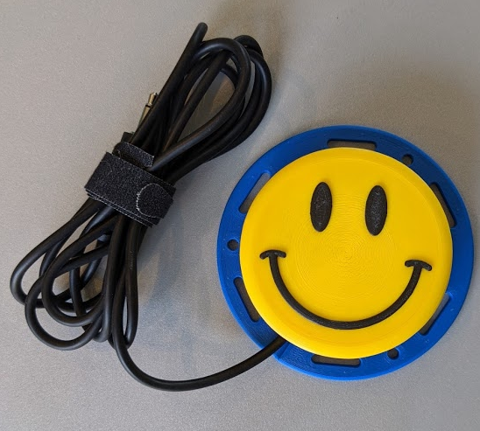

Contents

Overview 1

Introduction 3

Detailed Design 3

Initial Changes 3

Improvements over time 3

Base 3

Button Cap Holder 3

Opportunities for Improvement 4

# Introduction

The original design for the Interact Switch came from the design by Mark Turvey. (<https://github.com/mwturvey/InteractSwitch>)

# Detailed Design

## Initial Changes

The initial changes made to the original design were

* Increases the screw hole size in the ButtonCapHolder to accept both M2.5 screws as well as #4 3/8" screws.
* Lines up the holes in the base with the holes in the ButtonCapHolder.
* Deepens the countersink in the Base for the screws.
* Removes the need for supports on the Base piece.
* Decreases the required sanding by tapering the tabs on the ButtonCapHolder.

## Improvements over time

Further changes were made over time to the following components

### Base

#### Cable Routing

Changes were made to the cable routing path to make the cable align better to the position of the switch

#### Button Cap

#### Upside Down Print Issues

The filets and arcs on the bottom of the button cap caused print quality issues with bridging when printed upside down. For the textured caps this was not a large issue since it was not printed upside down, but did pose an issue for the plain cap. The arcs and filets were replaced with a straight line to improve the bridging when printed upside down.

### Button Cap Holder

#### Screw Insertion

When assembling the device, some users were having trouble aligning the screw with the holes in the Button Cap Holder, and the screws would sometimes screw into the wall of the holder instead of the hole.

A 0.6mm chamfer was added to the hole to catch and guide the screw into the hole.

#### Screw Torque

When using the #4 sheet metal screw, the torque required to tighten the screw broke some of the holders. The hole was loosened to 3.0mm to get a much better tightening torque, but this makes the base and the cap holder no longer backwards compatible with the original, as it no longer works with M2.5 screws.

## File Update

CAD files were updated and rebuilt into one central file. This corrected several minor errors, such as the screw holes on the base and the screw holes on the cap holder being misaligned by 0.5mm, as well as making heavy use of parameters. Because of this rebuild, changes can be made to one parameter, and the changes will propagate out to all connected parts.

## Soldering Jig

An opportunity for improvement for the Interact Switch that was identified was the creation of a soldering jig to prevent makers from soldering to the wrong terminals on the switch, and to prevent large blobs of solder that would make assembly difficult. After 4 iterations, a soldering jig was created that held the switch at a 90 degree angle to the cable, covers the wrong terminal, and holds the cable in place without tipping.

# Opportunities for Improvement

There are further opportunities for improvement that have been identified

* Better indicate the orientation of the switch when assembling the device
* Clarify how to use the base as a soldering jig
* Change the shape of the button cap for better bridging