# Overview

The Device Summary is intended to be a detailed summary of the device, product and maker information for the Interact Switch, making it easier to add to the Makers Making Change website. It is intended for anyone who will view the device listing.

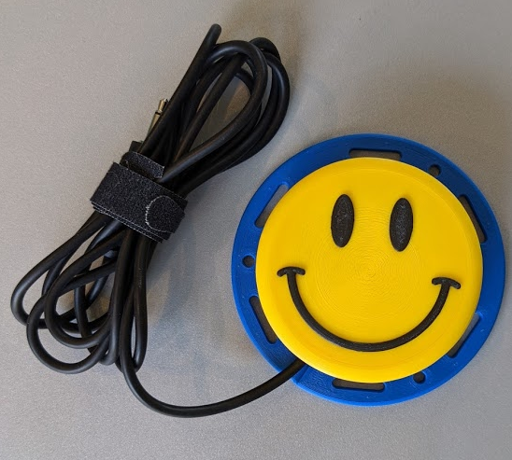

# Product Information

## Product Name

Interact Switch

## Device Category

Mark any relevant categories with an “X”:

|  |  |
| --- | --- |
|  | Adapted Toys |
|  | Aids for Daily Living (ADL) |
| X | Assistive Switches |
|  | Communication Aids (AAC) |
|  | Computer Access |
|  | Environmental Controls |
|  | Gaming |
|  | Keyguard |
|  | Kits |
|  | LipSyncs |
|  | Mounting |
|  | Recreation and Leisure |
|  | Seating and Positioning |
|  | Switch Interfaces |
|  | Writing Aids |

## User Value Statement

## The Interact Switch is a high quality, modular 3D printable switch design. The tactile feel of the switch is on par with commercial switches, coming in at about 35 g of activation force across the surface of the switch. The base has the same footprint as a Jellybean switch, and should work with any Jellybean switch mounts.

## Designer

[Original design by Mike Turvey](https://github.com/mwturvey/InteractSwitch)

Modifications to the design and additional documentation by Neil Squire Society / Makers Making Change.

# Device Information

## Overview

## The Interact Switch is a high quality, modular 3D printable switch design. The tactile feel of the switch is on par with commercial switches, coming in at about 35 g of activation force across the surface of the switch. The base has the same footprint as a Jellybean switch and should work with any Jellybean switch mounts.

## Disability Type

Select one or more disability types and mark with an “X”:

|  |  |
| --- | --- |
|  | Agility / Dexterity |
|  | Arthritis |
| X | Cognitive |
|  | Hearing |
| X | Mobility |
|  | Pain |
|  | SCI |
|  | Vision |
|  | Other |

## Disability Type Description

## The device is intended for users who have difficulty using small buttons or switches and need an accessible switch to operate them. This switch comes with different topper designs that can be 3D printed in contrasting colors which can be helpful to users with low vision.

## How To Use

## The Interact Switch can be connected to any 3.5mm switch-compatible assistive device, such as the Xbox Adaptive Controller. Press the switch to activate the device. Since the device has the same footprint as a Jellybean switch, it is compatible with any Jellybean switch mounts. It can be placed on a flat surface, bolted in place, or secured with hook and loop (ex., Velcro) straps.

## Estimated Cost

The estimated material cost of the device for a single build:

|  |  |
| --- | --- |
| X | $0 - $10 |
|  | $11 - $25 |
|  | $26 - $50 |
|  | $51 - $100 |
|  | $101 - $250 |
|  | $250+ |

## Attribution

Original Design by Mike Turvey

# Maker Information

## Project Skills

Mark the required project skills with an “X”:

|  |  |
| --- | --- |
| X | 3D Printing |
|  | Custom PCB |
| X | Electronics |
|  | Laser Cutting |
|  | Mechanics |
|  | Software |
| X | Soldering |
|  | Woodworking |
|  | Other |

## Skills Description

To build this device a maker needs to be able to 3D print and do basic soldering

## Tools Needed

|  |  |
| --- | --- |
| X | 3D Printer |
|  | Common Hand Tools |
|  | Common Power Tools |
|  | Laser Cutter |
| X | Soldering Iron |
|  | Specialized Tooling |

## Print time (hrs)

1hr8min

## Assembly time (hrs)

0hr10min

## Build Instructions

The parts are 3D printed and assembled with 3 screws. A mono cable is stripped and then soldered to the switch.

## Download Link

https://github.com/makersmakingchange/Interact-Switch/archive/refs/heads/main.zip

## Project Link

https://github.com/makersmakingchange/Interact-Switch

# License

BSD 2-Clause License

Copyright (c) 2020, Michael Turvey

All rights reserved.

Redistribution and use in source and binary forms, with or without

modification, are permitted provided that the following conditions are met:

1. Redistributions of source code must retain the above copyright notice, this

list of conditions and the following disclaimer.

2. Redistributions in binary form must reproduce the above copyright notice,

this list of conditions and the following disclaimer in the documentation

and/or other materials provided with the distribution.

THIS SOFTWARE IS PROVIDED BY THE COPYRIGHT HOLDERS AND CONTRIBUTORS "AS IS"

AND ANY EXPRESS OR IMPLIED WARRANTIES, INCLUDING, BUT NOT LIMITED TO, THE

IMPLIED WARRANTIES OF MERCHANTABILITY AND FITNESS FOR A PARTICULAR PURPOSE ARE

DISCLAIMED. IN NO EVENT SHALL THE COPYRIGHT HOLDER OR CONTRIBUTORS BE LIABLE

FOR ANY DIRECT, INDIRECT, INCIDENTAL, SPECIAL, EXEMPLARY, OR CONSEQUENTIAL

DAMAGES (INCLUDING, BUT NOT LIMITED TO, PROCUREMENT OF SUBSTITUTE GOODS OR

SERVICES; LOSS OF USE, DATA, OR PROFITS; OR BUSINESS INTERRUPTION) HOWEVER

CAUSED AND ON ANY THEORY OF LIABILITY, WHETHER IN CONTRACT, STRICT LIABILITY,

OR TORT (INCLUDING NEGLIGENCE OR OTHERWISE) ARISING IN ANY WAY OUT OF THE USE

OF THIS SOFTWARE, EVEN IF ADVISED OF THE POSSIBILITY OF SUCH DAMAGE.