# Overview

The Interact Switch is available with several different Switch Tops. Using different colors and textures can help a user distinguish between switches by sight or feel. The plain, ‘default’ button topper can be seen below, and the other options included in the Interact Switch Repository are listed in the table on the next page.

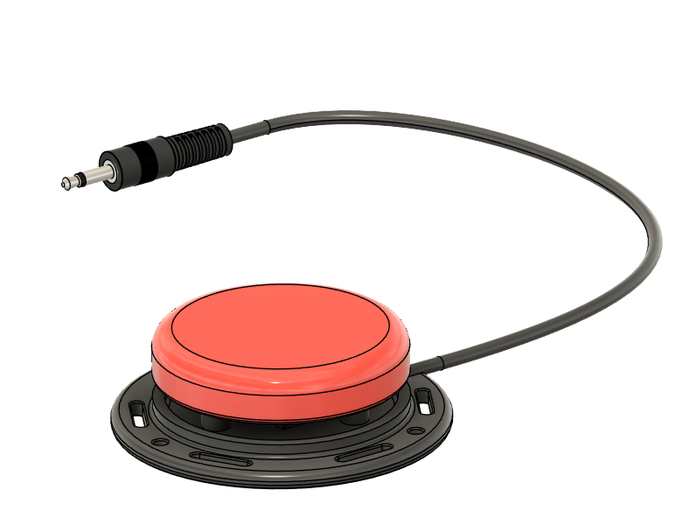

**Topper**

Generally, it is also possible and easy to print toppers in different colors. It is also possible to print a topper in multiple colors based on the height. This is illustrated below with a Smile Topper that has the main portion printed in orange and the raised portion printed in black.

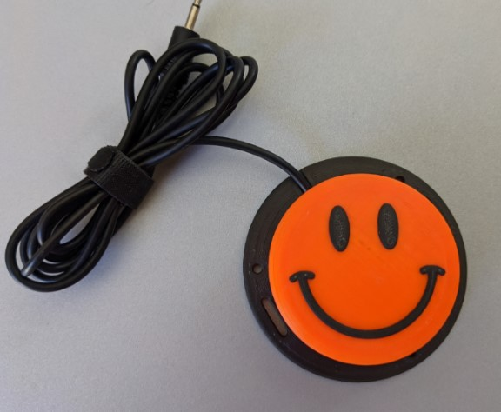

|  |  |  |
| --- | --- | --- |
| **Arrow** | **Circle** | **Dome** |
| 3D render of arrow Interact Switch cap | 3D render of circle Interact Switch cap | 3D render of domed Interact Switch cap |
| **Dots Circles** | **Dots Wide** | **Lines** |
| 3D render of Interact Switch cap covered in small dots | 3D render of Interact Switch cap covered in medium dots | 3D render of Interact Switch cap covered in fine lines |
| **Lines Very Wide** | **Lines Wide** | **Octagon** |
| 3D render of Interact Switch cap covered in heavy lines | 3D render of Interact Switch cap covered in medium lines | 3D render of Interact Switch cap with an octagon on top |
| **Rings** | **Rings Wide** | **Smile** |
| 3D render of Interact Switch cap covered in fine concentric circles | 3D render of Interact Switch cap covered in large concentric circles | 3D render of Interact Switch cap with a smiley face on top |