## Introduction

The Interact Switch is a highly customizable switch with a large activation area.

## Features

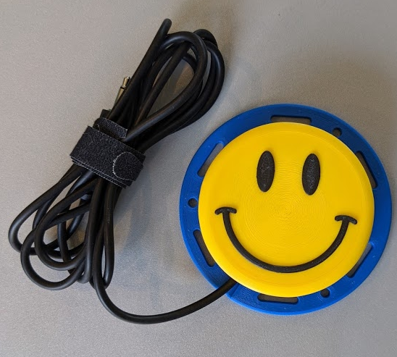

**Switch Surface**

**Cable**

**Mounting Slots**

## Specifications

|  |  |
| --- | --- |
| Item | Interact Switch |
| Size (Length x Width x Height) [mm] | 85x85x30 |
| Mass [g] | 60 |
| Press Force [g] | 35 |

## Compatibility

The Interact Switch is compatible with any accessible device that uses a standard 3.5mm mono jack switch.

## Usage

### Initial Setup

Place the Interact Switch where it works best for the user. Hook and loop fastener (e.g., VELCRO) or a non-slip mat (e.g., DYCEM) can be used to prevent it from sliding on a surface, and the holes and slots around the rim can be used to screw, cable tie, or otherwise fasten it into place.

### Regular Use

When the Interact Switch is connected to the device, a press of the switch will register as a button press on the connected port.

### Takedown / Storage

When not in use, the Interact Switch should be stored in a cool place out of direct sunlight.

## Care

The Interact Switch is made of 3D printed plastic. Exposure to high heat may cause warping and/or negatively affect function. Extended exposure to sunlight will also weaken the plastic on the device.

The Interact Switch contains electronics and is not waterproof. If the device becomes wet, make sure it is off and do not use it until it has completely dried. It may help to open any electronic enclosures to speed up drying and ensure it has completely dried.

### Cleaning

The Interact Switch can be wiped with a damp cloth. The Interact Switch can also be cleaned by scrubbing with warm water and dish soap, but should not be submerged in water. Do not use hot water or clean in a dishwasher.

## Disposal

PLA filament may be industrially compostable in your area. Check with your waste management company if PLA can be composted or must be thrown in the garbage.

Disassemble the Interact Switch and separate out the recyclable and compostable components, and those that must be thrown out. Electronics and batteries should be disposed of following your local waste management guidelines.