# Introduction

The Ivy Nunchuck Joystick Adapter enables a Nunchuck controller to be used as a USB HID Mouse or USB HID Gamepad. The Nunchuck Controller has a thumb joystick and two buttons. A light on the enclosure of the Ivy Nunchuck Joystick Adapter indicates which operating mode the device is in.

# Features

Status Light

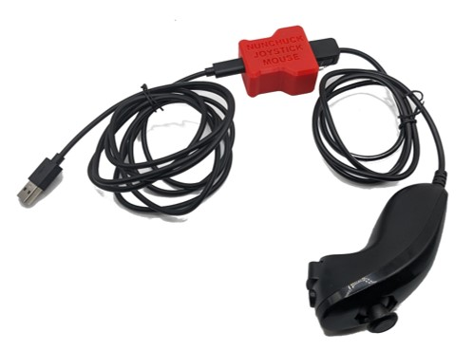

Nunchuck Controller

USB Cable

Ivy Nunchuck Joystick Adapter

Nunchuck Thumbstick

Nunchuck   
Z-Button

Nunchuck   
C-Button

Reset Button

# Setup

1. Plug the **Nunchuck Controller** into the **Ivy Nunchuck Joystick Adapter**.
2. Plug the USB-C end of the USB Cable into the **Ivy Nunchuck Joystick Adapter**.
3. Connected the other end of the USB cable to the Host Device (use a suitable adapter if necessary).

## Swapping between Mouse and Gamepad Mode

1. Reset the Adapter. Before the red light turns off, press and hold the two buttons on the Nunchuck until the light turns green, then release the two buttons.
2. Press the C button to toggle between modes. The light on the Adapter will indicate the current mode: USB HID Mouse - Yellow, USB HID Gamepad - Blue.
3. Press and release the Z button to set the mode. The light will blink.
4. Cycle the power by pressing the reset button or disconnecting and reconnecting USB cable.

# Usage

|  |  |
| --- | --- |
| Mouse Mode | Gamepad Mode |
| Status Light: Yellow | Status Light: Blue |
| * Move the joystick to control the cursor. * Press the C button to left click. * Press the Z button to right click. * Hold the Z button for 2 seconds to enter scroll mode. LED will turn purple. Move joystick to scroll. Press Z button again to exit scroll mode. | * Move the joystick to control the joystick. * Press the C button to activate Button 1. * Press the Z button to activate Button 2. |

## Mapping

|  |  |  |  |  |
| --- | --- | --- | --- | --- |
| **Nunchuck** | **Mouse** | **Joystick** | | |
| **PC** | **XAC (Left USB)** | **XAC (Right USB)** |
| Joystick | Cursor movement  (Scroll movement if in scroll mode (purple LED)) | Joystick movement | Left Thumbstick | Right Thumbstick |
| C | Left click | Button 1 | X1 (Left Stick Up) | View |
| Z | Right click (Long press -> enter scroll mode) | Button 2 | X2 (Left Stick Down) | Menu |

# Host Device Compatibility

* USB HID Mouse: PC, Mac, Android Smartphone, Apple Smartphone (iOS 13+)
* USB HID Gamepad: PC, Xbox Adaptive Controller

# Specifications

|  |  |
| --- | --- |
| Nunchuck Joystick Range of Motion | ±30° |
| Nunchuck Joystick Range of Motion | ± 15 mm |
| Nunchuck Joystick Activation Force | 100 grams |
| Nunchuck Weight | 68 grams |
| Enclosure Height | 25 mm |
| Enclosure Width | 45 mm |
| Enclosure Length | 51 mm |
| Enclosure Weight | 21 grams |

# Cleaning

The outside of the enclosure can be cleaned with a damp cloth. Do not use hot water. Do not submerge.