# Introduction

The Ivy Joystick is intended to be a wearable / graspable device for those with limited gross motor control and limited hand dexterity. This design is intended to add as additional cost-effective option for people with disabilities for adapted gaming or computer access.

# Requirements

## Who

Who will be using the device?

* The device is intended for use by people with disabilities that affect their ability to use traditional input devices like computer mice and video gaming controllers, especially those with limited gross motor control and limited hand dexterity.

Who will be affected by the device?

* The primary user.

## What

What must the device do?

* Act as a USB HID Mouse and/or USB HID Gamepad.
* The device is NOT intended to be used to control a mobility device.

What needs must the device serve?

* Users with limited dexterity
* Users with the following possible points of access:
  + Hand

## Why

Why will the device be used?

* Enable / improve ability for Digital Access (e.g., control mouse function on computer)
* Enable / improve ability for Adapted Gaming (e.g., control thumbstick on Xbox Adaptive Controller)

## Where

Where will the device be used?

* In a home.
  + At a desk
  + At a wheelchair
  + On a bed
  + On a couch
* In a physical rehab setting.

## When

When will the device be used?

* When using a computer or other compatible host device (e.g., gaming console).
* When testing out different gaming set-ups.

## Goals

|  |  |
| --- | --- |
| G01 | Achieve a material cost of less than $80 CAD. |
| G02 | Maker manufacturable in quantities of one. |
| G03 | The use of support material in 3d printed components should be minimized. |
| G04 | The number of different filament types should be minimized. |

## Functional Requirements

|  |  |
| --- | --- |
|  | Device must be operable in USB HID Mouse operating mode |
|  | Device must be operable in USB HID Gamepad operating mode |
|  | Device must be compatible with the Xbox Adaptive Controller. |
|  | Primary User should be able to switch operating mode. |
|  | Secondary User must be able to switch operating mode |
|  | The housing shall protect internal components from outside sources. |

## Non-functional Requirement

|  |  |
| --- | --- |
| NF01 | Device is releasable with open source license |
| NF02 | Device must be maker manufacturable. |
| NF03 | Documentation should be maintainable with the use of commonly available software. |
| NF04 | Documentation must be available in a digital format. |
| NF05 | Documentation should be printable. |

## Constraints

|  |  |
| --- | --- |
| C01 | Not for use with mobility devices. |
| C02 | 3D printed components shall be printable within a 180x180x180mm print volume. |
| C03 | 3D printed components should be printable on consumer-grade FFF printer |

# Research

## Existing Commercial Options

### Wii Nunchuck

<https://en.wikipedia.org/wiki/Wii>

<https://en.wikipedia.org/wiki/Wii_Remote>

Wii Nunchuck (RVL-004)

* Analog stick
* Octagonal movement restriction
* Two trigger buttons
* Three-axis accelerometer
* 113 mm long x 38 mm wide x 37 mm thick

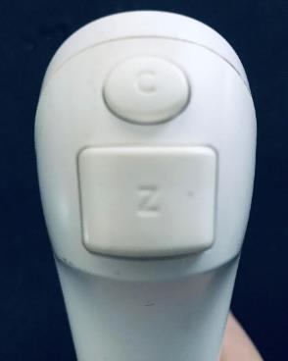

Figure Nintendo Wii Nunchuck. Born2BGod, CC BY-SA 4.0 <https://creativecommons.org/licenses/by-sa/4.0>, via Wikimedia Commons

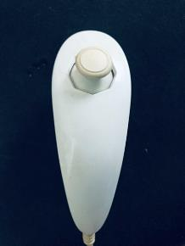

Figure . Wii Nunchuck top. Born2BGod, CC BY-SA 4.0 <https://creativecommons.org/licenses/by-sa/4.0>, via Wikimedia Commons

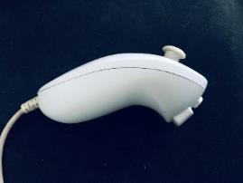

Figure . Wii Nunchuck Side. Born2BGod, CC BY-SA 4.0 <https://creativecommons.org/licenses/by-sa/4.0>, via Wikimedia Commons. <https://commons.wikimedia.org/wiki/File:Nunchuck_Side.jpg>.

The Nintendo Wii Nunchuk controller has a proprietary connector, and by default is only able to connect to the Nintendo Wii via a Nintendo Wiimote.

### PDP One-Handed Controller

|  |  |
| --- | --- |
| Title | PDP One-Handed Controller |
| Link | <https://www.microsoft.com/en-ca/d/pdp-one-handed-joystick-for-xbox-adaptive-controller/8qhw8mlwpp1l> |
| Cost | Discontinued |
| Notes | This is one of the only joystick accessories listed with the Xbox Adaptive Controller. Unfortunately it is no longer available. |

### Wii® Nunchuck Joystick Adapter MK2 For XBOX® Adaptive Controller

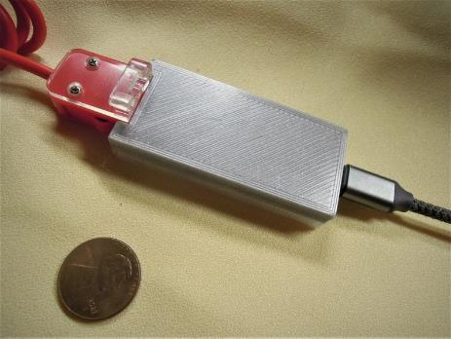

|  |  |
| --- | --- |
| Title | Wii® Nunchuck Joystick Adapter MK2 For XBOX® Adaptive Controller |
| Link | <https://www.etsy.com/ca/listing/1245123261/wii-nunchuck-joystick-adapter-mk2-for> |
| Cost | $50-70 CAD |
| Notes | An adapter for connecting a Wii Nunchuck / Nunchuck controller to the Xbox Adaptive Controller. |

## DIY Designs

### USB Mouse Made Out of a Wii Nunchuck

|  |  |
| --- | --- |
| Title | USB Mouse Made Out of a Wii Nunchuck |
| Link | <https://www.instructables.com/USB-Mouse-Made-Out-Of-A-Wii-Nunchuck/> |
| Author |  |
| License | CC BY-NC-SA |
| Cost |  |
| Notes | This build requires permanent modification of the Nunchuck. The built-in board on the Nunchuck is disconnected and removed and the buttons and joystick are connected to a Teensy microcontroller. |

### Nunchuck Mouse

|  |  |
| --- | --- |
| Title | Nunchuck Mouse |
| Link | <https://www.instructables.com/nunchuck-mouse/> |
| Author | Krayzi99 |
| License | CC BY-NC-SA |
| Cost |  |
| Notes | This build uses a Nunchuck with a Bluetooth adapter and software that translates the information into mouse commands. |

### USB Wiichuck Mouse Using an Arduino Leonardo

|  |  |
| --- | --- |
| Title | USB Wiichuck Mouse Using an Arduino Leonardo |
| Link | https://www.instructables.com/USB-Wiichuck-Mouse-Using-an-Arduino-Leonardo/ |
| Author |  |
| License | CC BY-NC-SA |
| Cost |  |
| Notes |  |

### Programmable ambidextrous joystick mouse

|  |  |
| --- | --- |
| Title | Programmable ambidextrous joystick mouse |
| Link | <https://hackaday.io/project/174547-programmable-ambidextrous-joystick-mouse> |
| Author | NDB |
| License | n/a |
| Cost | n/a |
| Notes | Early conceptual design. |

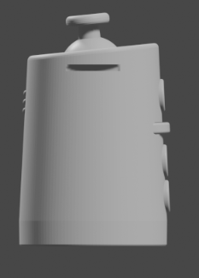

Figure . CAD Screenshot of Programmable ambidextrous joystick mouse.

* 3 buttons
* Vibration feedback
* Configuration application

### Joytojoy

|  |  |
| --- | --- |
| Title | Joytojoy |
| Link | <https://hackaday.io/project/186678> |
| Author | Julien Oudin |
| License |  |
| Cost |  |
| Notes | Gyro-based joystick intended to mount on top of a user’s powerchair joystick. |

### One Handed Keymouse

|  |  |
| --- | --- |
| Title | One Handed Keymouse |
| Link | https://hackaday.io/project/7254-one-handed-keymouse |
| Author | Patrick Tait |
| License | Software: BSD; CC-BY |
| Cost |  |
| Notes |  |

### 3D Printed Joystick

|  |  |
| --- | --- |
| Title | 3D Printed Joystick |
| Link | <https://hackaday.io/project/172309-3d-printed-joystick> |
| Author |  |
| License |  |
| Cost |  |
| Notes | Uses an LED, fiber optic cables, and a camera to measure different amounts of light that are transmitted in response to 3d printed joystick components. |

### Eyemech Controller

|  |  |
| --- | --- |
| Title | Eyemech Controller |
| Link | <http://www.nilheim.co.uk/latest-projects-and-blog/eyemech-controller> |
| Author | Will Cogley |
| License | Unknown |
| Cost |  |
| Notes | 3D printable, handheld device |

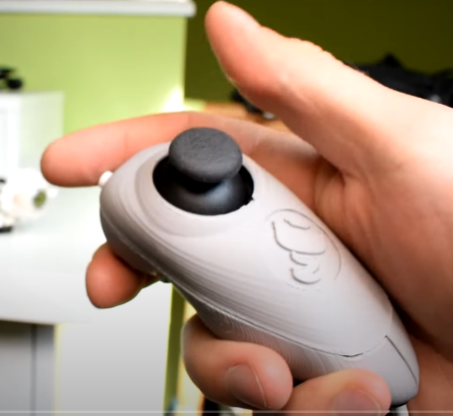

Figure Eyemech Controller. (C) Will Cogley.

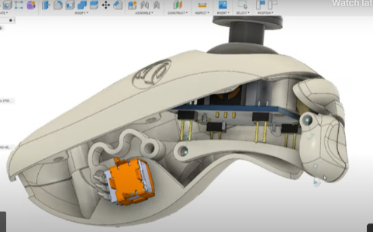

Figure . Eyemech controller CAD Model. (C) Will Cogley

### USB Nunchuck Mouse

|  |  |
| --- | --- |
| Title | USB Nunchuck Mouse |
| Link | <https://hackaday.io/project/188294-usbnunchuckmouse> |
| Author | Esp32beans |
| License | Unknown |
| Cost | Nunchuck: $12.50 USD; Breakout: $2.50 USD; $12.50 USD |
| Test Build (Y/N) | Y |
| Add to Library (Y/N) | TBD |
| Notes | Uses nunchuck clone and Adafruit interface board (<https://www.adafruit.com/product/4836>). |

## Research Summary

There are limited commercially available options that are capable of mouse control. There are a wide variety of DIY designs for handheld controllers that can be the basis for a design that has the ability to act both as a gamepad and a mouse, a feature that seems missing.

# Ideation

## Architecture

The inspiration for the name ‘Ivy’ came from the concept of using a reusable rubber twist tie / gear tie to connect to the handheld controller and wrap around the arm.

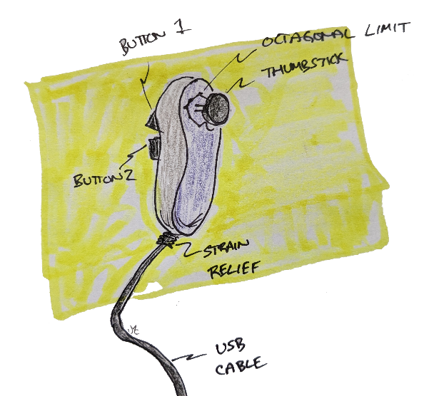

Figure . Handheld Controller Concept Sketch

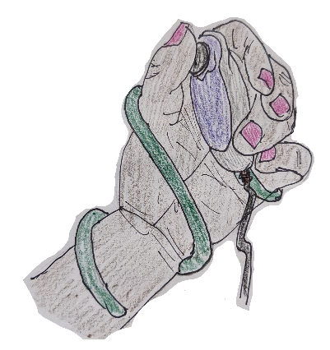

Figure . ‘Wearable’ Ivy Concept with Green Twist Tie

## Key Functions

1. Mode switching - Need a way to operate and switch between mouse mode and joystick mode, since compatibility with the XAC currently requires that the device only appears as a USB Gamepad.
2. Inputs
   1. Cursor/Joystick control + 2-3 inputs

## Commercially Available Joystick Modules

What type of joystick element makes the most sense?

Commercial joystick elements

* PS2 Thumbstick
* Sliding thumbstick
* Nintendo Joycon style thumbstick
* Custom Joystick Element

## Design Elements

* Removable handle
* Finger grooves / Grip
* How to accommodate different sized hands
  + Two part
  + Instamorph?
  + Shrink wrap?
  + Bike wrap?
  + Dycem
  + Uva foam
  + Foam sheets
* How to affix sheets?
  + Clamps
  + Glue

## Assembly

* Two piece clam shell
* Three piece
  + Right
  + Left
  + Top
  + Screws + a couple locating pins

Affixing joystick into enclosure

* Conical print
* Screws
* Snap-fit

## Tactile Feedback

Could a tactile feedback element be added here?

e.g., i2C Haptic Driver controller + Haptic motor.

## Button Options

* Integrated buttons
* Integrated switch jacks

## Mounting

* Flexible twist tie wrap mounting – e.g., wrapping around arm like ivy
* Modular – integration with cuff style
* Interface with Instamorph for custom fit

### Modular Mounting Connection

* separate handle portion
  + allows for customized sizes / colours / etc
  + more printable
* dove tail connection between main body and handle

# Conceptual Design

## Concepts

1. Utilizing commercially available Nunchuck controller from Nintendo or a knock-off.
2. Novel 3D printed Nunchuck-style controller

Nunchuck controllers and knockoffs are readily available via Amazon and electronics suppliers, are fairly cost effective ($12-15 CAD ea.), and may also be available at little to no cost used. The controller features a thumbstick, two buttons, and an embedded accelerometer.

## Nunchuck Controller Concept

Summary: Utilize an existing Nintendo Nunchuck or equivalent in addition to Adafruit Breakout board + Microcontroller.

### Architecture

1. Utilize Nunchuck (or knock-off) as-is, mount interface electronics in stand-alone box.
2. Open Nunchuck (or knock-off) and embed interface electronics within existing enclosure.
3. Extract electronics from Nunchuck (or knock-off) and incorporate into custom enclosure.

#### Stand-alone Box

This is the simplest approach. It does not require any modification to the existing controller. Basic assembly can also be completed without the use of soldering by utilizing a STEMMA QT cable with the Nunchuck Breakout board and a development board cwith a STEMMA QT connection (e.g., Adafruit SAMD21 QtPy).

#### Embedded Electronics

This approach requires the Nunchuck to be disassembled, permanently modified, and then reassembled.

Disassembling the Nunchuck requires a small Phillips screwdriver (i.e., No. 0) to remove the two small screws holding the two parts of the enclosure together. The existing cable assembly consists of 5 wires and a molded in strain relief. The wires would need to be cut and soldered either directly to the microcontroller development board or to the pads on the Nunchuck breakout board. The is some available space within the enclosure, but not quite enough to accommodate the QtPy board with a standard USB-C cable to use the existing cable hole. It looks like some of the inner support ribs could be cut to provide sufficient space for the dev board and cable.

The other option here would be to remove the existing i2C circuitry and connect the joystick and buttons directly to the microcontroller. It also unclear how much variation may exist between Nunchuck controllers from different manufacturers.

#### Incorporated components

This approach involves disassembling a Nunchuck controller, removing the electronics components and incorporating them into a different enclosure.

It’s not known how consistent the internals are between models of the Nunchuck from different suppliers.

### Nunchuck Mounting

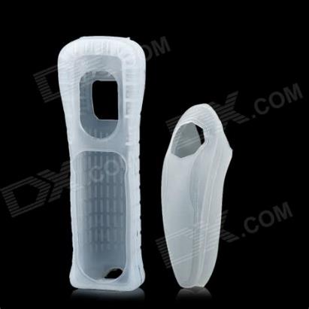

Figure . Commercially available controller sleeves.

Mounting Ideation

* Commercially available silicon sleeve
* 3D Printed Add-on?
* Interface with mounting screw
* Instamorph?

### Circuitry

The Nunchuck controller uses an i2C interface with a proprietary connector. Interfacing with the circuitry could happen within the Nunchuck enclosure, by cutting the cable, or by using a suitable adapter with the connector.

### Code

There is an existing open source library, the WiiChuck Library, for interfacing with the controller.

<https://github.com/madhephaestus/WiiChuck>

LGPL-3.0 License

## Novel 3D Printed Enclosure Concept

Summary: Create a novel enclosure with electronic elements like the Nunchuck controller.

### Components

#### Amazon Joycon Replacement Joystick

Jeylly Original 3D Analog Joystick Joy-Con Replacement Left/Right Repair Kit Thumb Sticks Sensor with 4 “Y” Screws for Nintendo Switch Joycon Controller and Switch Lite Console - 2 Pack White <https://www.amazon.ca/dp/B08B4K4NCV> - $11.23

* This is intended as a replacement for the thumbstick in the Joycon controller. It is not the same part as the [Adafruit PSP 3000 2-Axis Analog Thumb Joystick](https://www.adafruit.com/product/3103)
* The cable is intended to be used with a Zero Force Insertion (ZIF) connector it a 5P 0.5 mm pitch connector.
* The connector does not fit the [Adafruit Touch screen breakout board (0.5mm FPC)](https://www.adafruit.com/product/334)
* The connector does not fit the other 0,5mm FPC connector from Amazon.
* It has two two ~1.6 mm holes; M1.7 screws were too big; M1.4 screws fit okay; the joycon is connected to the joycon controller with two 3.5 mm Phillips #00 screws[1].
* Surface mount connector: <https://www.mouser.ca/ProductDetail/Amphenol-FCI/59453-051110ECHLF?qs=SqJKR5Mmryc5fGwXZgOgcA%3D%3D>
* It doesn’t appear as though any 0.5 mm pitch, 5 position connectors are available in thru hole format or as a breakout board.

### Electrical Connections

#### Protoboard

Universal Proto-board PCBs 4cm x 6cm - 3 Pack

* <https://www.adafruit.com/product/4785>
* 3 pack
* 4 cm x 6 cm

Universal Proto-board PCBs 3cm x 7cm

* 3-pack: <https://www.adafruit.com/product/4784>
* 3 cm x 7 cm
* Can score with hobby knife and ruler and break to size

#### 3D Printed Circuit Board

Flexible Protoboard

<https://www.adafruit.com/product/3904e.g>. <https://www.adafruit.com/product/3904>

20cm x 30 cm

Adafruit Flex Perma-Proto - Half-sized Breadboard Flex-PCB

* <https://www.adafruit.com/product/1518>
* 79 mm x 43 mm

## Mode Switching

1. Hardware-based mode switching (e.g., an additional button or switch on the device)
2. Software-based mode switching

## Concept Selection

The Nunchuck Concept with the Stand-alone box architecture was selected for development for the MVP. It provides a simple, solderless way to create a controller, the parts are readily available, and components are cost-effective. The biggest limitation is that standard Nunchuck controllers only have two buttons.

# Detailed Design

## Electronics

### Electronic Components

This approach requires an Adafruit Wii Nunchuck Breakout board and an i2C-compatible microcontroller. The Adafruit QTPY SAMD21 was selected as it is cost effective, readily available, has an interchangeable footprint with other microcontrollers and has a built-in STEMMA QT connector.

### Circuitry

This circuitry is simple; the Nunchuck Breakout board must be attached to the microcontroller via a STEMMA QT cable.

## Enclosure

The enclosure must securely hold the microcontroller and the Nunchuck breakout board.

### Nunchuck Controller Clearance / Knockout

The enclosure must have adequate clearance to allow the Nunchuck controller to be attached. See measured dimensions below.

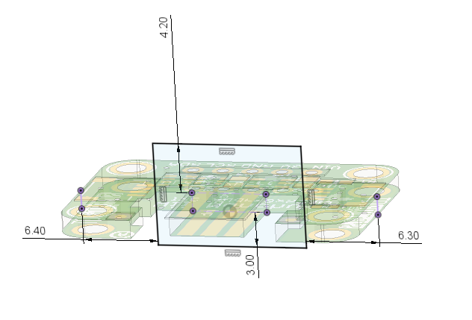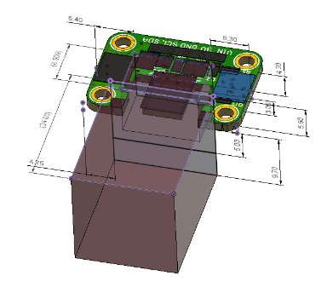

Figure . Nunchuck Connector Breakout Dimensions

### Component Arrangement

Two arrangements were considered: an inline arrangement with Nunchuck connection on one side and USB connection on the other side, and a single sided arrangement with both connections on the same side. The in-line arrangement was selected in attempt to better manage cables and provide a logical flow as an ‘Adapter’.

### Electronic Component Mounting

To reduce the number of components, cost, and build complexity, the electronics were attached into the enclosure without the use of fasteners. The Adafruit QTPY board was secured with snap fit elements and the Nunchuck breakout board was secured using posts through the mounting holes. Ideally only one method would be used, but QTPY board does not have mounting holes and there was insufficient room on the edges of the breakout board to allow for snap-fits.

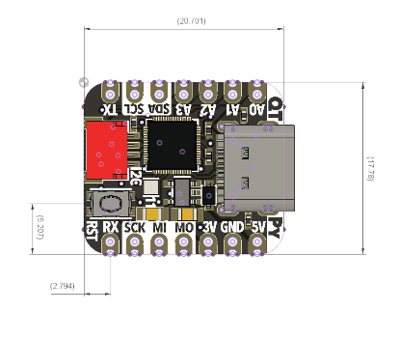

Figure . Adafruit QT Py Development Board Dimension.

### Enclosure Architecture

Again, to minimize the number of tools and components required, the enclosure was designed to use snap fits to attach the top part of the enclosure to the bottom part of the enclosure. A two-piece enclosure provides for easy assembly.

### Enclosure Features

The enclosure features a print-in-place flexible element for pressing the reset button on the microcontroller. It also features a hole for a light pipe so the LED on the microcontroller can be viewed from the outside of the enclosure.

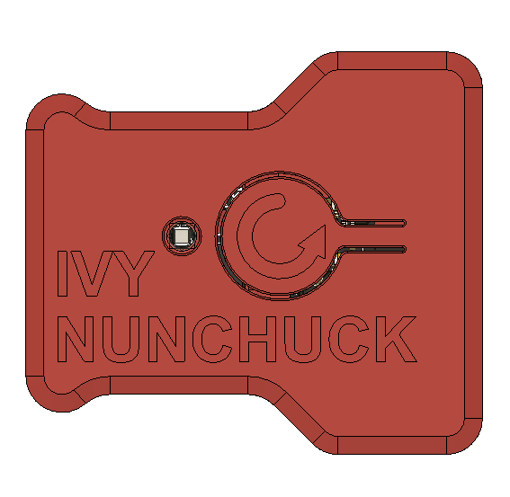

Figure V0.1 Enclosure Top View

#### Reset Button

The reset button is modelled after a typical reset button on a computer with a circular arrow shape.

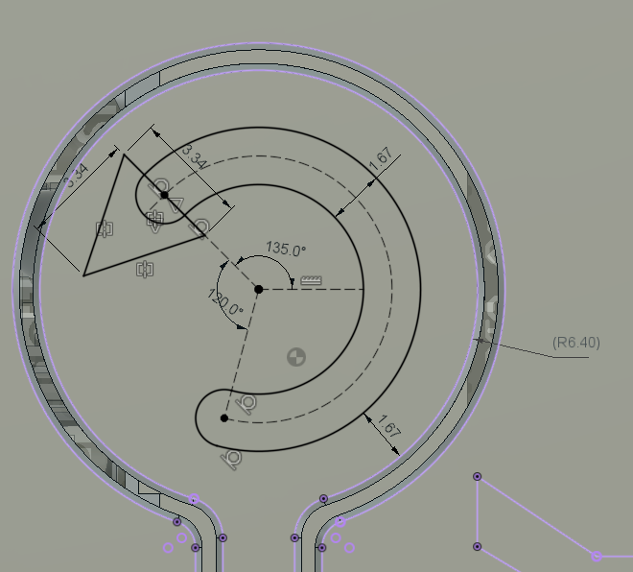

Figure . Reset Label

#### Enclosure Snap-Fit

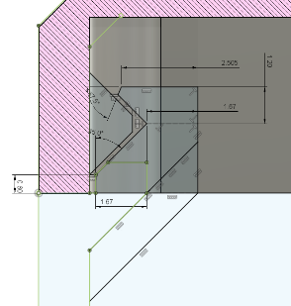

Figure . Enclosure Snap-fit dimensions.

#### Light Pipe

A light pipe was added to help increase the visibility of the LED light on the development board. The model was selected based on what has currently been used in other MMC projects.

Light Pipe

* Counterbore Diameter: 4 mm
* Counterbore Depth: 0.8 mm
* Press fit diameter: 2.8 mm

#### Overall Enclosure

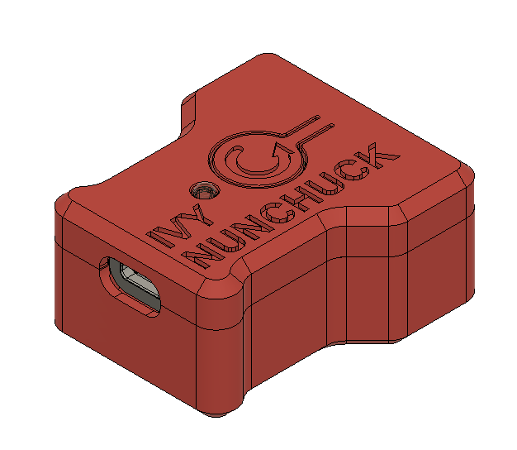

Figure . Isometric view of enclosure showing USB connection side.

## Software

The software was based on previous work developed for the OpenAT Joysticks. That software was modified to utilize the WiiChuck library for managing communication to the Nunchuck Controller.

Some progress was made towards an integrated object-oriented approach to managing different types of joystick sensors. A JoystickInput class was created with derived classes for different types of Joystick Input devices like potentiometers, Hall effect, and the Nunchuck.

## Naming

NUN-CHUCK and NUNCHUK are still registered trademarks in Canada owned by Nintendo. NUNCHUCK seems to be a commonly used term for the controllers and the breakout board. For that reason, Nunchuck seems like the better choice.

Adaptor vs Adapter are both used commonly and often interchangeably. Adaptor was initially chosen based on being more traditional, and referring to a device rather than a person, however Adapter is the more commonly used term in North America and would be a better choice.

# Ivy Nunchuck Joystick Adapter V0.1

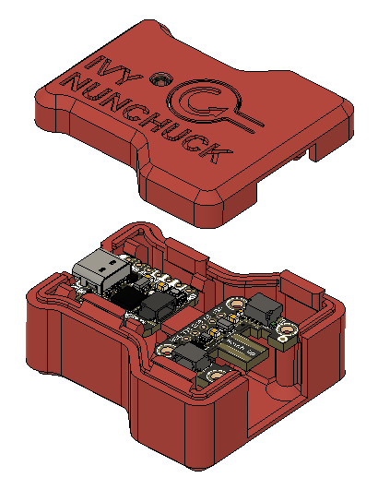

Figure . Exploded View (v0.1)

## Testing

### Research Questions

* Ability to switch between mouse and joystick
  + Different code / code flags
  + Add slide switch?
* Third button for mouse / scroll?
  + Accelerometer / gryo
  + Activated with both buttons
    - Toggle
  + Add switch jack to box
* Mounting?
* Do we need the USB cover component? Can this be made more printable?
* Need / alternatives for light pipe?

## Feedback

The USB-C cover component is quite small, and therefore challenging to print. It didn’t provide much benefit over an integrated cover portion.

Activating scroll mode via long-button press is annoying for flipping back and forth.

The timing of pressing the two buttons after a reset to enter the mode switching can be difficult.

Cycling between desired modes during mode switching is difficult (inadequate delay / switch debounce)

# Ivy Nunchuck Joystick Adapter V1.0

## Features

1. Simple assembly – no soldering or tools required.
2. Print-in-place reset button pusher

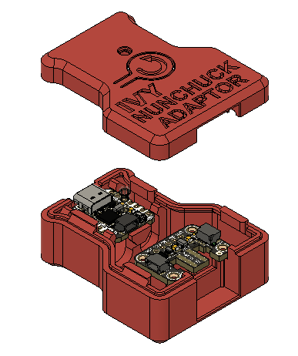

Figure . Exploded View (v1.0)

## Design Changes

1. The length of the enclosure was increased to increase the spacing and clearance for the STEMMA QT Cable.
2. The enclosure snap fit elements near the dev board were shifted so they didn’t interfere with the dev board snap fits.
3. Additional material was added near the Nunchuck breakout board to better enclose the Nunchuck connector.
4. The CAD model was cleaned up to remove earlier design elements that were no longer required (e.g., bosses for headers).

## Opportunities for Improvement / Future Work

1. Investigate methods to improve scroll functionality
   1. E.g., Button 1 and Button 2 simultaneously, Button sequence
2. Add additional control Modes (e.g. accelerometer based cursor control)
   1. IMU for cursor control; joystick for scroll (or buttons?)
3. Second joystick via i2c Seesaw?
4. Investigate additional mounting options
5. Consider capturing either USB cable, Nunchuck controller, or both
6. Research existing topper designs and/or develop toppers designs for Nunchuck Controller thumbstick
7. Detail and test the different adapter options for connecting to different consoles / host devices.
   1. Mayflash to connect with Nintendo Switch
8. Add code to handle disconnected Nunchuck
9. Code / physical method to disable mouse output in case something goes wrong with code.
10. Investigate options for creating an analog version of the Nunchuck.
    1. e.g., Nunchuck controller, TRRS cable, 2X mono cables.
11. Implement time-based mouse acceleration
12. Implement input switch debouncing
13. Add option for adding strap or cuff to Nunchuck Controller

1. <https://www.ifixit.com/Guide/Left+Joy-Con+Joystick+Replacement/113182>