# Overview

This document contains the necessary information to build the device.

Contents

Overview 1

Tool List 3

Customization Guide 4

Enclosure Colour 4

Multi-Color Enclosure 4

3D Printing Guide 5

3D Printing Summary 5

3D Printing Settings 5

Post-Processing 5

Quality Prints 5

Assembly Guide 7

Part A: Enclosure Assembly 8

Required Components 8

Required Tools 8

Required Personal Protective Equipment (PPE) 8

Part A Assembly Steps 9

Part B: Firmware Installation 12

Required Tools 12

Required Personal Protective Equipment (PPE) 12

Part B: Firmware Steps 12

Testing 14

Mouse 14

Gamepad 14

Switching Modes 14

This list provides an overview of the steps required to build and deliver the device.

**Maker To Do List**

* Read through the Maker Guide to become familiar with required components, tools, supplies, and safety gear and overall assembly steps.
* Talk to User about customization options (e.g., colour, any special requests, etc.)
* Order hardware components
* Print or obtain the 3D Printed Components
* Gather tools, supplies, and safety equipment.
* Assemble the device.
* Test device.
* Print “User Guide”.

**Items to Give to User**

* Assembled, tested device.
* “User Guide”.

# Tool List

A Computer with Arduino IDE for programming microcontroller.

# Customization Guide

## Enclosure Colour

The enclosure can be printed in the user’s desired colour.

## Multi-Color Enclosure

The enclosures can be printed in two colors with a filament swap at layer 5 / 1.00 mm to increase the contrast / visibility of the labels on the top (and bottom).

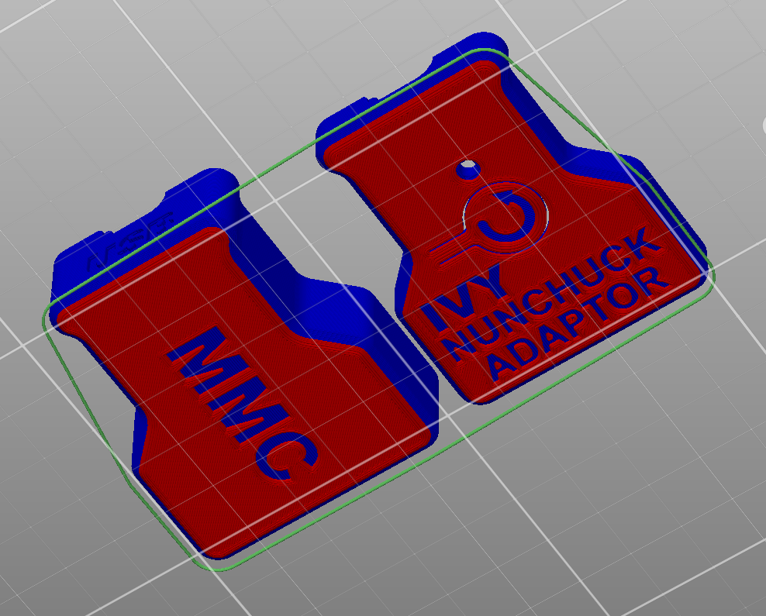

# 3D Printing Guide

## 3D Printing Summary

|  |  |
| --- | --- |
| **Metrics** | **Single Unit** |
| Total Print Time (min) | 2h06m |
| Total Number of Components | 2 |
| Typical Total Mass (g) | 22 |
| Typical Number of Print Setups | 1 |

## 3D Printing Settings

|  |  |  |  |  |  |  |  |
| --- | --- | --- | --- | --- | --- | --- | --- |
| **Print File Name** | **Qty** | **Total Print Time (hr:min)** | **Mass (g)** | **Infill (%)** | **Support(Y/N)** | **Layer Height/ Nozzle Diameter(mm)** | **Notes** |
| Ivy_Enclosure_Top.stl | 1 | 0:45 | 8 | 20 | N | 0.2/0.4 |  |
| Ivy_Enclosure_Bottom.stl | 1 | 1:20 | 15 | 20 | N | 0.2/0.4 |  |

## Post-Processing

* Make sure the button is free to move
* Remove any stringing or blobs.

## Quality Prints

|  |  |
| --- | --- |
| Inside of good quality Ivy Enclosure Bottom 3D print | Inside of good quality Ivy Enclosure Top 3D print |
| Bottom of good quality Ivy Enclosure Bottom 3D print | Top of good quality Ivy Enclosure Top 3D print |

# Assembly Guide

The assembly of the Ivy Nunchuck Joystick Adapter consists of two steps: the assembly of the electronics into the 3D printed enclosure and flashing the firmware to the microcontroller.

## Part A: Enclosure Assembly

### Required Components

|  |  |  |  |  |  |  |  |  |  |
| --- | --- | --- | --- | --- | --- | --- | --- | --- | --- |
| **1** | [Adafruit QT Py SAMD21 Dev Board](https://www.digikey.ca/en/products/detail/adafruit-industries-llc/4600/13543375) | QTY 1 | **2** | | [Adafruit Wii Nunchuck Breakout](https://www.digikey.ca/en/products/detail/adafruit-industries-llc/4836/13577615) | QTY 1 | **3** | [Qwiic Cable - 50 mm](https://www.digikey.ca/en/products/detail/sparkfun-electronics/PRT-14426/7652739) | QTY 1 |
| *Adafruit QT Py SAMD21 Dev Board* | | | *Adafruit Wii Nunchuck Breakout Board* | | | | *STEMMA QT Cable* | | |
| **4** | [6 ft USB C – USB A Cable](https://www.digikey.ca/en/products/detail/cvilux-usa/DH-20M50053/13177348) | QTY 1 | **5** | | [Light Pipe](https://www.digikey.ca/en/products/detail/dialight/51513030250F/4965201) | QTY 1 | **6** | Ivy Enclosure Top | QTY 1 |
| *USB-C Cable* | | | Light Pipe | | | | *Enclosure Top* | | |
| **7** | Ivy Enclosure Bottom | QTY 1 | **8** | | [Nunchuck Controller](https://www.amazon.ca/dp/B00FJ2LMGK) | QTY 1 |
| *Enclosure Bottom* | | | | *Nunchuck Controller* | | |

### Required Tools

* None required.

### Required Personal Protective Equipment (PPE)

* None required.

### Part A Assembly Steps

#### Step A1: Attach STEMMA QT Cable to Microcontroller

|  |  |
| --- | --- |
| Attach one end of the STEMMA QT Cable to the STEMMA QT connector on the Adafruit QT Py microcontroller. | An Adafruit QT PY development board with a STEMMA QT cable attached. |

#### Step A2: Attach STEMMA QT Cable to Nunchuck Breakout Board

|  |  |
| --- | --- |
| Attach the other end of the STEMMA QT Cable to one of the STEMMA QT connectors on the Nunchuck Breakout board. | The Adafruit QT PY Development board and the Adafruit Nunchuck Breakout board attached by a STEMMA QT cable. |

#### Step A3: Insert QT Py into Bottom Enclosure

|  |  |
| --- | --- |
| Align the QT Py USB connector into the corresponding opening in the **Enclosure Bottom**. Gently press on the board to lock it into place. | The Enclosure Bottom with the QT PY board inserted. |

#### Step A4: Insert Nunchuck Breakout Board into Bottom Enclosure

|  |  |
| --- | --- |
| Position the Nunchuck Breakout Board so the mounting holes align with the posts. Tuck the STEMMA QT Cable down into the Enclosure Bottom. | The Enclosure Bottom with the QT Py inserted, and the STEMMA QT cable tucked beside the posts.The Enclosure Bottom with both the QT Py and Nunchuck Breakout board inserted. |

#### Step A5: Connect Top Enclosure to Bottom Enclosure

|  |  |
| --- | --- |
| Position the **Top Enclosure** over top of the Bottom Enclosure and press down to engage the snap fit. | Assembled Ivy Nunchuck enclosure |

#### Step A6: Insert the Light Pipe

|  |  |
| --- | --- |
| Insert the **Light Pipe** into the hole in the Enclosure Top. | Assembled Ivy Nunchuck with Light Pipe inserted into top. |

#### Step A7: Plug in USB Cable and Nunchuck

|  |  |
| --- | --- |
| Plug in the **USB C Cable** on the side of the Enclosure labelled “USB-C”. | The USB connector side of the Ivy enclosure is labelled USB-C. |
| Plug the **Nunchuck** controller on the opposite side of the Enclosure. The notch on the connector must be oriented towards the top. | Nunchuck controller connection side of the enclosure with a rectangular-shaped opening. |

#### Step A8: Admire your Assembled Ivy Nunchuck Joystick Adapter

|  |  |
| --- | --- |
| The assembly is now complete. | Ivy Nunchuck Adaptor with USB cable and Red Nunchuck controller attached. |

## Part B: Firmware Installation

### Required Tools

* Computer with Arduino IDE to program microcontroller.

### Required Personal Protective Equipment (PPE)

* None required.

### Part B: Firmware Steps

#### Step B1: Setup Arduino IDE

1. Download Arduino IDE for your operating system at <https://www.arduino.cc/en/software>
2. Install the Arduino IDE.

#### Step B2: Setup Arduino IDE for QT Py Board

1. Open Arduino IDE.
2. Click on **File -> Preferences**.
3. Locate the text field that says **Additional Boards Manager URLs** beside it.
4. Copy and paste the following link into the field as a new line:  
   <https://adafruit.github.io/arduino-board-index/package_adafruit_index.json>
5. Click on **OK.**
6. Restart the Arduino IDE.
7. Open the **Boards Manager** option from the **Tools-> Board-> Boards Manager...,**
8. **Search for “Adafruit SAMD” and select “Adafruit SAMD Boards” by Adafruit.**
9. **Click Install to install the board.**

#### ****Step B3: Install Libraries****

1. In a web browser, go to <https://github.com/cyborg5/TinyUSB_Mouse_and_Keyboard> and go to Code -> Download ZIP.
2. In Arduino IDE, click **Sketch -> Include Library -> Add .ZIP Library.**
3. Navigate to the ZIP file downloaded in Step (a). Click **OK**.
4. Go to **Tools -> Manage Libraries…,** search for “Flash Storage” and install the library “FlashStorage” by Various.
5. Go to **Tools -> Manage Libraries…,** search for “Adafruit_Neopixel” and install the library “Adafruit_Neopixel” by Adafruit.
6. Go to **Tools -> Manage Libraries…,** search for “WiiChuck” and install the library “WiiChuck” by Kevin Harrington.

#### Step B4: Setup Local Code Directory

1. Download the Firmware_Files from the GitHub Repository: [https://github.com/makersmakingchange/Ivy-Nunchuk-Joystick-Adapter/blob/main/Build_Files/Firmware_Files/Ivy_Joystick_Mouse_Firmware.zip](https://github.com/makersmakingchange/Ivy-Nunchuk-Joystick-Adaptor/blob/main/Build_Files/Firmware_Files/Ivy_Joystick_Mouse_Firmware.zip)
2. Extract / unzip the folder to a known location.
3. Confirm that you have the following folder structure:

* Ivy_Joystick_Mouse_Firmware (folder)
  + Ivy_Joystick_Mouse_Firmware.ino
  + OpenAT_Joystick_Response.h
  + XACGamepad.h

#### Step B5: Upload the Code to the microcontroller.

1. Open OpenAT_Ivy_Joystick_Mouse.ino with Arduino IDE.
2. **Select Adafruit QT Py M0 (SAMD21) from Tools -> Board -> Adafruit SAMD Boards**
3. Click on **Tools -> USB Stack** and select **TinyUSB**
4. Connect the Adapter using the USB cable to the computer.
5. Select the correct port from **Tools -> Port** menu.
6. Verify and upload the code.

# Testing

To test the Ivy Nunchuck Joystick Adapter, you will need the device itself and a host device. The host device can be a computer or an Android or Apple smartphone or tablet. Note that the Android and Apple options will require an USB OTG adapter cable to connect.

## Mouse

1. Plug the USB cable into a USB port on the Host Device.
2. Confirm that the Adapter is in Mouse Mode (Yellow Status Light). If not switch modes (see below).
3. Confirm that the mouse cursor moves when the thumbstick is moved.
4. Confirm that the buttons produce a left and right click when pressed.

## Gamepad

1. Plug the USB cable into a USB port on the Host Device.
2. Confirm that the Adapter is in Gamepad Mode (Blue Status Light). If not switch modes (see below).
3. If using Windows, open “Set up USB Game Controllers” from the Control Panel. You can find this by searching your computer in the search bar next to the Windows icon.
   1. Otherwise use <https://hardwaretester.com/gamepad> to test.
4. Ensure that the joystick is registered as a game controller and select your joystick from the list and go to “Properties”.
5. Move your joystick and observe the movement of the cross hatch in the “Axes” window. Ensure it moves in the proper directions when you move the joystick (the arrow points in the up direction). If not, open the joystick and check your connections.
6. Activate each button. Ensure that buttons 1 and 2 light up when you press the button and stops when you release the button.

## Switching Modes

1. Reset the Adapter by pressing the Reset Button or removing and replacing the USB Cable.
2. When the Status Light turns red, press and hold both the C Button and the Z Button on the Nunchuck.
3. When the Status Light turns green, release the buttons.
4. Press the C button (round button) to toggle between modes. The light on the Adapter will indicate the current mode: USB HID Mouse - Yellow, USB HID Gamepad - Blue.
5. Press and release the Z button (square button) to set the mode. The light will blink in the selected mode colour.
6. Reset the Adapter by pressing the Reset Button or removing and replacing the USB Cable.