# Required Components

|  |  |
| --- | --- |
|  | **BOM**   1. One_Piece_Handle.stl x1 2. Magnet x4 |

# Required Tools

* Gorilla Glue

# Required Personal Protective Equipment (PPE)

* Safety glasses

# Assembly Instructions

## Step 1

Take 4 magnets and place them into the slots on the 3D printed handle. The magnets will hold themselves in place. Using a pea sized amount of gorilla glue, secure the magnets in place so they cannot be removed.

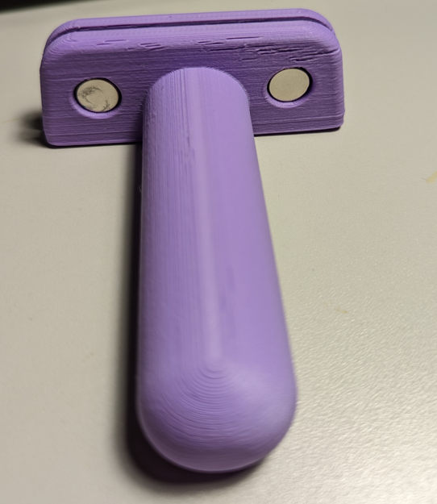

## Step 2

Place the assembled handle over the spine of the knife to complete the build.

