## Introduction

The Knife Guide Arthritis Aid is a handle that attaches to the back of a knife that allows a user to use both hands while cutting and requires less grip strength for the same amount of control.

## Features

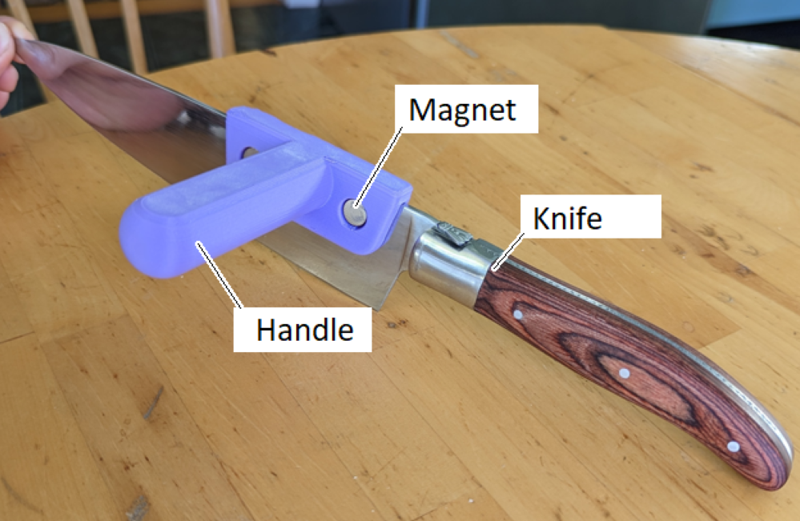

## Usage

To use, place the device over the back of the knife. The new handle can now be gripped at a more natural angle than the original handle, and the knife used as normal. However, at least one hand must remain on the original handle during use. Attempting to hold the knife with just the new handle could cause the knife to fall out of the handle.

## Compatibility

The device is compatible with any magnetic knife with a blade height of more than 3cm. The provided stl is designed for a knife with a blade thickness of 2.25mm, but the thickness can be adjusted in the provided Fusion 360 file.

## Specifications

Device weight: 31g

Handle diameter: 25mm

Length: 95mm

Width: 75mm

Slot depth: 30mm

Slot width: 2.25mm

## Cleaning

The device can be wiped clean with a damp cloth.