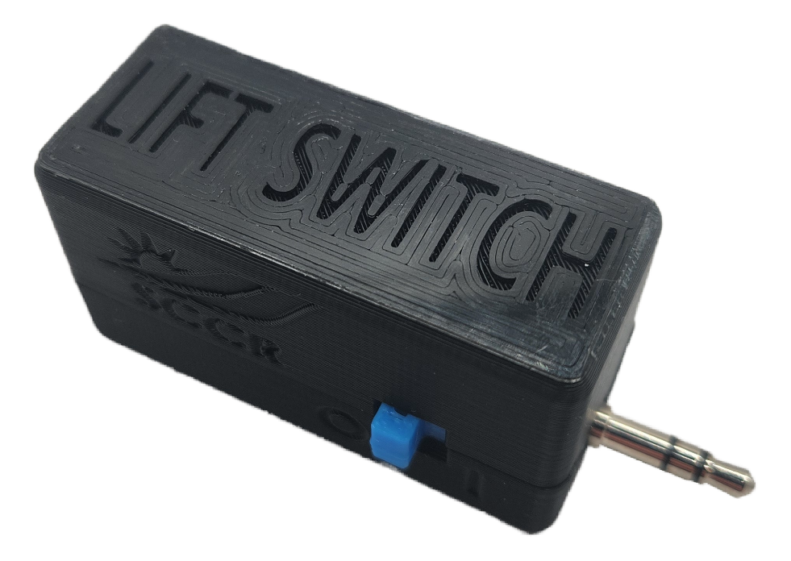

Lift Switch User Guide

V2.0 – March 2024

Contents

Disclaimer/Assumption of Risk 3

Introduction 4

Features 4

Usage 5

Setup 5

Charging Instructions 6

Operating Modes 6

Momentary Mode 7

Latching Mode 8

Timed Latch Mode 9

Reverse Acting Mode 9

Using the Lift Switch with a Computer or Tablet 10

Compatibility 11

Troubleshooting 11

Cleaning and Maintenance 12

Specifications 12

# Disclaimer/Assumption of Risk

**The Lift Switch device is not to be used in life support or life safety applications. Such use is entirely at the User’s risk, and the User agrees to defend, indemnify, and hold harmless the Stan Cassidy Center for Rehabilitation from any and all damages, claims, suits, or expenses resulting from such use.**

# Introduction

The Lift Switch is an accessibility device that enables specific switch output functions. For example, the user may rest a hand or foot on an adaptive switch, such as a Buddy Button™. Your adapted device is then activated by lifting off the adaptive switch, hence the name “Lift Switch”.

The Lift Switch has 4 modes of operation that can offer a variety of solutions to switch-adapted devices. These modes will be described in more detail below.

# Features

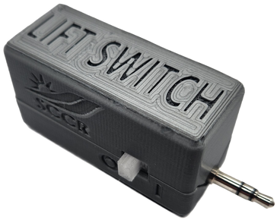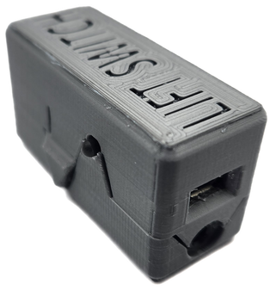

**Output Plug**

**Power Switch**

**Mode Button**

**Indicator Light**

**Micro-USB Port**

**Assistive Switch Port**

# Usage

## Setup

**Step 1**: Begin by inserting your adaptive switch’s connector into the assistive switch input (the 1/8” jack) located on the end of the Lift Switch.

Some examples of assistive switches are pictured below:

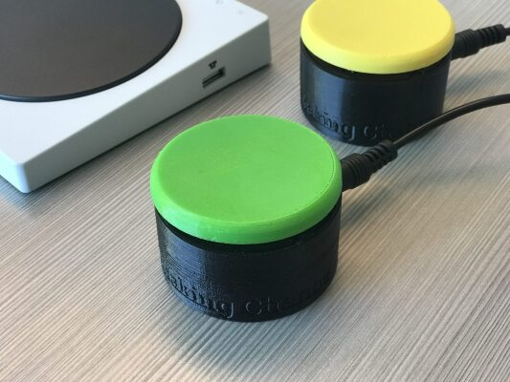 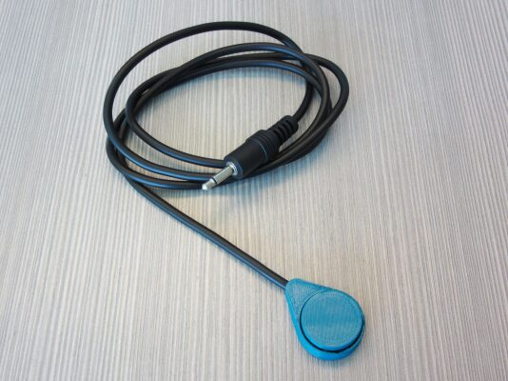

**Step 2:** Next, insert the output plug into the adapted device to be controlled, such as an adapted doorbell, light switch or toy.

In this guide, the adapted device will be represented by the Switch Tester (shown below). The red light on the front of the Switch Tester indicates when the device is activated.

**Step 3:** Turn on the Lift Switch by sliding the power switch located on the side into the ON position. The light located on the other side of the Lift Switch module will flash purple intermittently, then will flash green, red, or blue once to indicate the mode the device is in (see page 10 for modes).

If the light does not blink at all, this indicates a low battery. The device will need to be charged before use; see page 9 for charging instructions.

**Step 4:** Initialize the Lift Switch by pressing and releasing your adaptive switch once.

## Charging Instructions

To charge your device, plug the micro-USB cable into your USB wall adapter or other USB outlet such as on your desktop or laptop, then connect the other end to the micro-USB port of your Lift Switch.

## Operating Modes

The Lift Switch has 4 modes: **Momentary**, **Latching**, **Timed Latch**, and **Reverse Acting**. To change modes, press the Mode button located on the side of the Lift Switch (refer to Figure 2). The selected mode is indicated by the light colour, as described in the following table:

|  |  |  |
| --- | --- | --- |
| Operating Mode | Mode Indicator Light Colour | Mode Overview |
| Momentary | Green | Lift Switch output will turn **on momentarily** when you **lift off** of the assistive switch. |
| Latching | Blue | Lift Switch output **toggles between on/off** when you **lift off** of the assistive switch. |
| Timed Latch | Yellow | Lift Switch output will turn **on for a set amount of time (7s)** when you **lift off** of the assistive switch. |
| Reverse Acting | Red | Reverses the action of an assistive switch. Assistive switch off **(not activated) = Lift Switch on**, Assistive switch on **(activated) = Lift Switch off.** |

Please ensure you have completed the setup guide, and that your device is on and charged before trying the different modes. The device will power up in the last mode used.

### Momentary Mode

**Step 1:** Press the Mode button on the Lift Switch repeatedly until the light is green.

**Step 2:** Rest on your assistive switch. Your Lift Switch will turn OFF.

**Step 3:** Lift off of your assistive switch. Your Lift Switch will turn ON for **half of a second**, activating your adapted device.

**Step 4:** Return to resting on your adaptive switch.

**Step 5:** Repeat steps 2-4 as necessary.

Note that Lift Switch will activate for half of a second **only** regardless of how long you remain lifted off of your assistive switch.

### Latching Mode

**Step 1:** Press the Mode button on the Lift Switch repeatedly until the light is blue.

**Step 2:** Rest on your adaptive switch. Your Lift Switch will turn OFF.

**Step 3**: Lift off your adaptive switch. Your Lift Switch will turn ON, activating your adapted device.

**Step 4:** Return to resting on your adaptive switch. Note that your adapted device will stay on.

**Step 5:** Lift off your adaptive switch again. Your Lift Switch will turn OFF, deactivating your adapted device.

**Step 6:** Return to resting on your adaptive switch. Note that your adapted device will stay off.

**Step 7:** Repeat steps 2-6 as necessary.

### Timed Latch Mode

**Step 1:** Press the Mode button on the Lift Switch repeatedly until the light is yellow.

**Step 2:** Rest on your adaptive switch. Your Lift Switch will turn OFF.

**Step 3:** Lift off of your adaptive switch. Your Lift Switch will turn ON for **seven seconds**, activating your adapted device. Your Lift Switch will turn OFF automatically after seven seconds, deactivating your adapted device.

**Step 4:** Return to resting on your adaptive switch.

**Step 5:** Repeat steps 2-4 as necessary.

### Reverse Acting Mode

**Step 1:** Press the Mode button on the Lift Switch repeatedly until the light is red.

**Step 2:** Rest on your adaptive switch. Your Lift Switch will turn OFF.

**Step 3:** Lift off of your adaptive switch. Your Lift Switch will turn ON, activating your adaptive device.

**Step 4:** Return to resting on your adaptive switch. Your Lift Switch will turn OFF again.

**Step 5:** Repeat steps 2-4 as necessary.

Notice your Lift Switch will turn on and stay on for the amount of time that you are lifted off your adaptive switch.



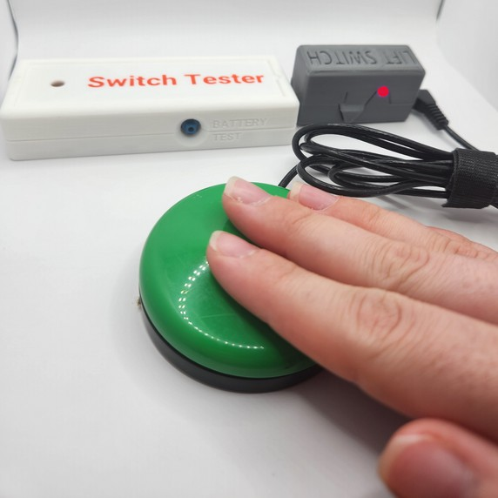

The adapted device will remain OFF when resting on the adaptive switch.

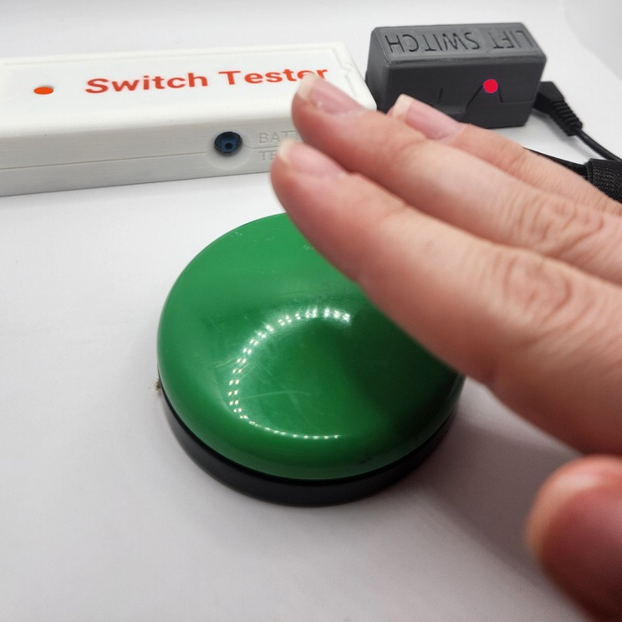

The adapted device will remain ON when lifted off of the adaptive switch.

## Using the Lift Switch with a Computer or Tablet

You may use your Lift Switch as a mouse-click on your electronic devices. To use the Lift Switch with a computer, simply plug a micro-USB cable into a USB port of your computer and connect the other end to the micro-USB port of your Lift Switch. Note that the output plug is not used with a computer.

If you are using the Lift Switch on a tablet device, you may need to provide your own USB adapter for your specific tablet.

If using an Apple™ product, you will need to connect your micro-USB cord to the appropriate USB adapter for the Lift Switch to function properly as a mouse click device. Some potential adapters are pictured below:

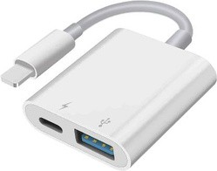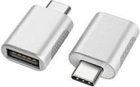

If you are using an Apple™ device, refer to the online instructions found here: https://support.apple.com/en-us/HT211008 for mouse functions, and   
https://support.apple.com/en-ca/HT201370 for Switch Control functions.

This function pairs nicely with switch scanning software or a head mouse device that you would need to acquire on your own.

Below are photos of an iPad set up for accessible use with the Lift Switch using adaptors (left) and a switch-adapted mouse (right):

# Compatibility

The Twitch Switch is compatible with Windows and Mac computers, and both Apple and Android mobile devices.

# Troubleshooting

|  |  |  |
| --- | --- | --- |
| Problem | Possible Cause | Solution |
| Won’t turn on; no response when using adapted device | Battery is dead | Charge device |
| Device is defective | Contact Makers Making Change |
| Mouse click is not working on tablet/computer | Connection is bad; cable(s) are defective | Inspect connections and condition of cables; try different cables |
| Device is not installed | Under Settings, locate the Lift Switch and allow installation |
| Tablet not configured for mouse operation | Configure tablet for mouse input |

# Cleaning and Maintenance

To clean your Lift Switch, wipe with a damp cloth or disinfecting wipe.

The Lift Switch is NOT WATERPROOF – DO NOT IMMERSE IN WATER. This would cause permanent damage to the device.

Ensure device is powered OFF after each use to maintain battery life. Charge device between uses of over one hour.

# Specifications

|  |  |
| --- | --- |
| Dimension | Value |
| Mass | 31 g |
| Height | 2.9 cm |
| Length (without plug) | 5.3 cm |
| Length (with plug) | 6.8 cm |
| Width | 2.2 cm |