**Title**

Light Switch Extension Lever

**Subtitle**

The Light Switch Extension Lever allows the user to flip a light switch without needing any grip strength or nearly as much precision.

## Device Details

### Overview

For some users with arthritis, limited grip strength or finger dexterity, it can be difficult to use a light switch. The Light Switch Extension Lever allows the user to flip the switch without needing any grip strength or nearly as much precision.

### Usage

To use, place over the existing toggle switch on the light switch. The lever extends it and allows it to be bumped on and off with a hand or elbow. This works with all toggle style light switches that have a lever arm style toggle, as seen in the photo below.

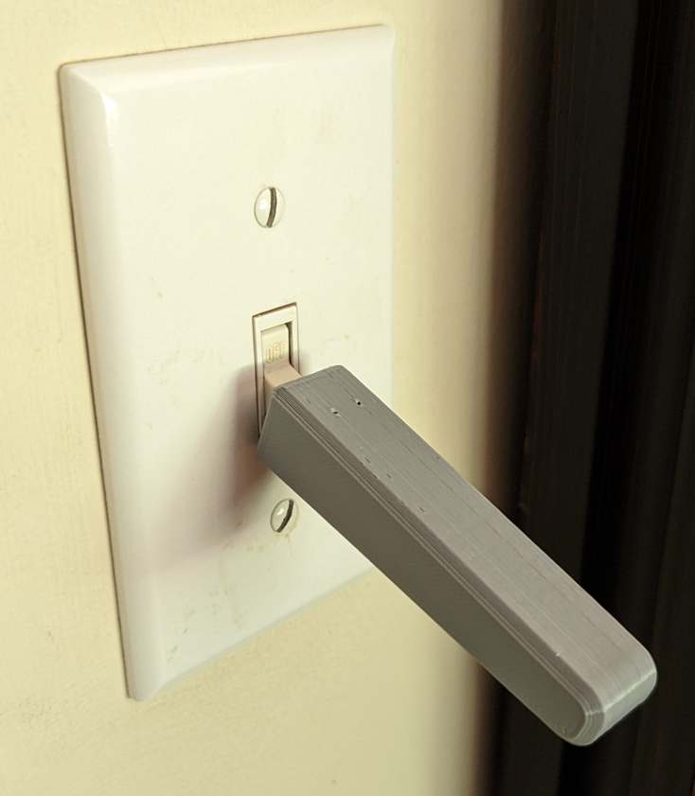

### Cost

<$1.00

### Build Instructions

No build required, print and go.

#### Skills Required

-Basic 3D printing

#### Time Required

3D printing time: 1 hour 3 minutes

Assembly Time: <5 minutes

#### Tools

-3D printer

#### Components

-Light Switch Extension Lever.stl

### Attribution

- The [Light Switch Extension Lever design](https://www.myminifactory.com/object/3d-print-77490) was created by [Devon Smith](https://www.myminifactory.com/users/Devon_Smith) and made available using a MyMiniFactory-Credit-Remix-Noncommercial license.

-Further design and documentation by Neil Squire Society/Makers Making Change