## Introduction

For some users with arthritis, limited grip strength or finger dexterity, it can be difficult to use a light switch. The Light Switch Extension Lever allows the user to flip the switch without needing any grip strength or nearly as much precision.

## Features

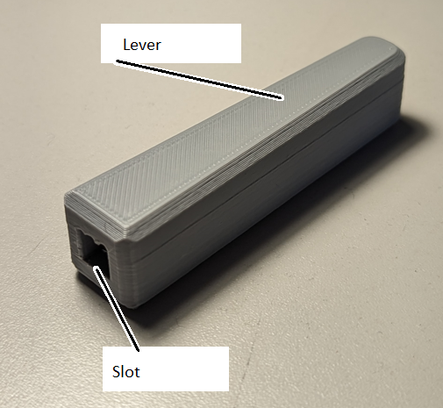

## Usage

To use, place the slot over the existing toggle switch on the light switch. The lever can then be toggled the same way as the existing switch, but with a much larger arm needing less force and less dexterity.

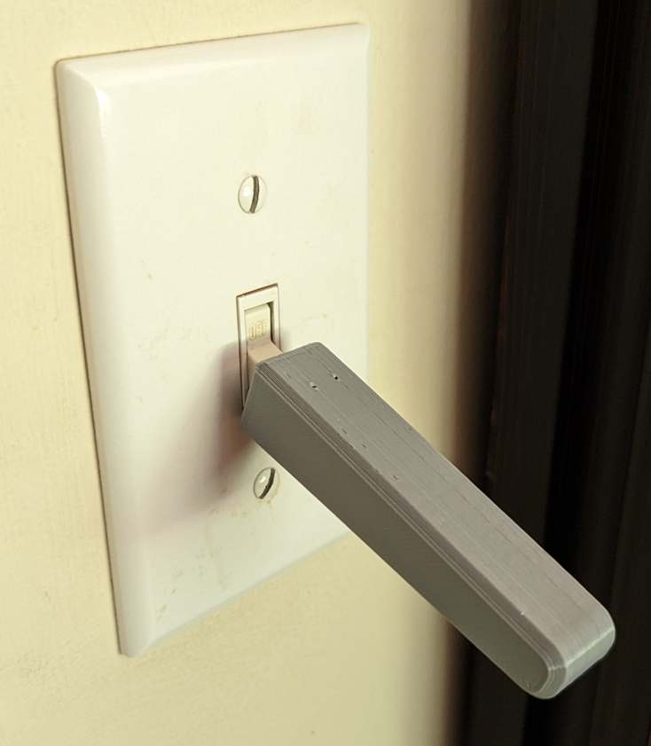

## Compatibility

This switch extension is compatible with any toggle style light switch and has adjustable CAD parameters to accommodate any thickness of switch toggle.

## Specifications

Length: 78 mm

Thickness: 18 mm

Weight: 10 g

## Cleaning

The device can be wiped clean with a damp cloth.