# Overview

The Design Rationale is intended to provide designers and maker information about the design process and design decisions behind the development of the Light Touch Switch, a cost-effective 3D printable accessibility switch for people with physical disabilities.

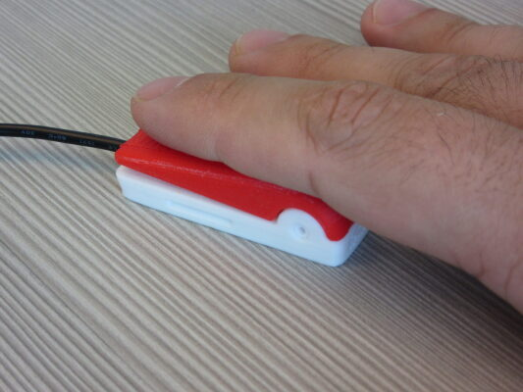

Contents

Overview 1

Introduction 4

Requirements 4

Goals 4

Functional Requirements 4

Non-functional Requirement 4

Constraints 4

Research 4

Commercially Available Options 4

AbleNet Mini Cup Switch 5

AbleNet Micro Light Switch 5

Enabling Devices Compact Switch 6

DIY / Maker-Friendly Options 6

Crafty Button Switch 7

Interact Switch 7

MMC60 Switch 8

Ideation 9

Prototyping 9

Low cost / force buttons 9

Physical Components 9

Electrical Components 10

Prototype Decisions 11

Modifications 11

Testing 11

Detailed Design 11

Physical Component / Enclosure 12

Electrical Components 12

Opportunities for Improvement 13

Physical Components 13

Electrical Components 13

# Introduction

This device was originally created by [Kevin Cross](https://www.thingiverse.com/davross/designs) as a DIY, low-cost assistive switch alternative to commercially available switches which would work with the [Xbox Adaptive Controller (XAC)](https://www.xbox.com/en-CA/accessories/controllers/xbox-adaptive-controller). The Light Touch Switch is well-suited for use with one finger. It can be used with any switch controlled device that has a 3.55 mm mono cable jack.

The Light Touch Switch is a low-force switch for controlling electronic devices, such as phones / tablets, computers, adapted toys, and video games.

The Light Touch Switch is suitable for people with physical disabilities who may have limited strength and / or movement.

# Requirements

## Goals

|  |  |
| --- | --- |
| G01 | Simple to build |
| G02 | Low force |
| G03 | Compatible with multiple switch adapted devices |

## Functional Requirements

|  |  |
| --- | --- |
| F01 | Low force switch (less than 200 grams of force (gf) to activate) |
| F02 | Uses 3.5 mm mono cable to interface with most switch adapted devices |
| F03 | Small footprint to allow multiple switches to be mounted together |

## Non-functional Requirement

|  |  |
| --- | --- |
| NF01 | Must be makeable by a volunteer maker |

## Constraints

|  |  |
| --- | --- |
| C01 | A volunteer must be able to make the device |
| C02 | Switch must require less than 200gf to activate |
| C03 | Must cost less than other commercially available options |

# Research

A Google search for small, low-force assistive switches was conducted in June, 2024 to find options for assistive switches similar to the Light Touch Switch.

## Commercially Available Options

Options that can be purchased but not made by a maker.

### AbleNet Mini Cup Switch

|  |  |
| --- | --- |
| **Title / Name of device** | Mini Cup Switch |
| **Link** | <https://www.ablenetinc.com/mini-cup-switch/> |
| **Author** | AbleNet |
| **Cost** | $85.00 USD (~$115.00 CAD) |

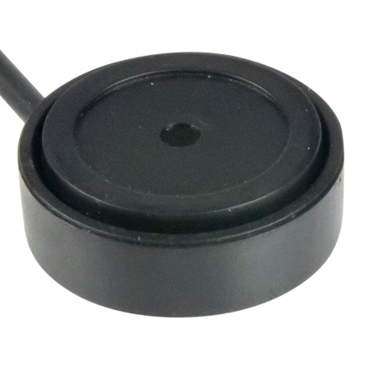

The Mini Cup Switch is a small (1 inch diameter), low-force (140gf) switch with a standard 3.5 mm mono cable connection. It also meets the IP67 rating, which means it is resistant to dirt and dust, and can be submerged under 1 meter of water for up to 30 minutes.

|  |  |
| --- | --- |
| **Requirements Met** | **Requirements Unmet** |
| * Low force * Uses 3.5 mm mono cable * Small footprint | * Not able to be made by a maker |

#### Useful Design Features

* Size and shape are useful for mounting multiple switches close together

### AbleNet Micro Light Switch

|  |  |
| --- | --- |
| **Title / Name of device** | Micro Light Switch |
| **Link** | <https://www.ablenetinc.com/micro-light-switch/> |
| **Author** | AbleNet |
| **Cost** | $95.00 USD (~128.00 CAD) |

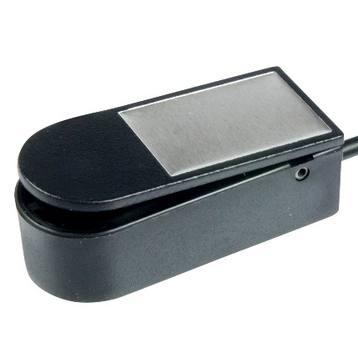

The Micro Light Switch is a small (1.7 x 1.3 cm), low-force (11.3gf) switch with a standard 3.5 mm mono cable connection.

|  |  |
| --- | --- |
| **Requirements Met** | **Requirements Unmet** |
| * Low force * Uses 3.5 mm mono cable * Small footprint | * Not able to be made by a maker |

#### Useful Design Features

* Size and shape are useful for mounting multiple switches close together
* Mounting connection in the base

### Enabling Devices Compact Switch

|  |  |
| --- | --- |
| **Title / Name of device** | Compact Switch |
| **Link** | <https://enablingdevices.com/product/compact-switches/> |
| **Author** | Enabling Devices |
| **Cost** | $77.95 USD (~105 CAD) for three ($35 CAD each) |

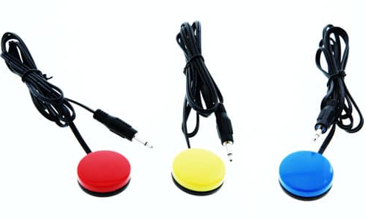

The Compact Switch is a small (1-1/4 inch diameter), low-force (35gf) switch with a standard 3.5 mm mono cable connection.

|  |  |
| --- | --- |
| **Requirements Met** | **Requirements Unmet** |
| * Low force * Uses 3.5 mm mono cable * Small footprint | * Not able to be made by a maker |

#### Useful Design Features

* Size and shape are useful for mounting multiple switches close together

## DIY / Maker-Friendly Options

Options that can be made by a maker.

### Crafty Button Switch

|  |  |
| --- | --- |
| **Title** | Crafty Button Switch |
| **Link** | <https://www.thingiverse.com/thing:5331247> |
| **Author** | [Jon Turnquist](https://www.thingiverse.com/otandat/designs) |
| **License** | Creative Commons – Attribution License |
| **Cost** | ~$5.00 USD (~7.00 CAD) |
| **Test Build (Y/N)** | N |
| **Add to Library (Y/N)** | N |

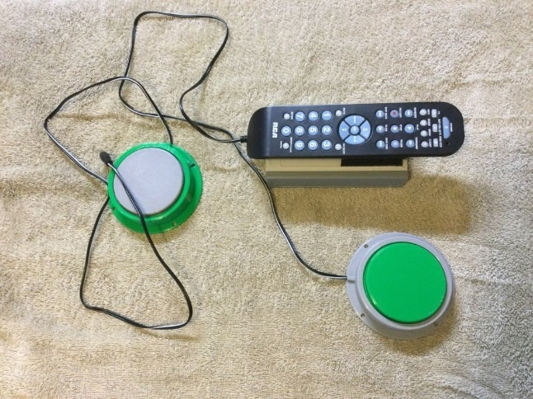

A 3D printed assistive switch that uses three tactile switches and a single 3.5 mm mono cable.

|  |  |
| --- | --- |
| **Requirements Met** | **Requirements Unmet** |
| * Uses 3.5 mm mono cable | * Low force (three switches will triple activation force) * Small footprint |

#### Useful Design Features

* Using three switches to hold up and stabilize the switch cap is an interesting idea

### Interact Switch

|  |  |
| --- | --- |
| **Title** | Interact Switch |
| **Link** | <https://github.com/mwturvey/InteractSwitch> |
| **Author** | [Michael Turvey](https://github.com/mwturvey) |
| **License** | Creative Commons - Attribution |
| **Cost** | ~$10 CAD |
| **Test Build (Y/N)** | Y |

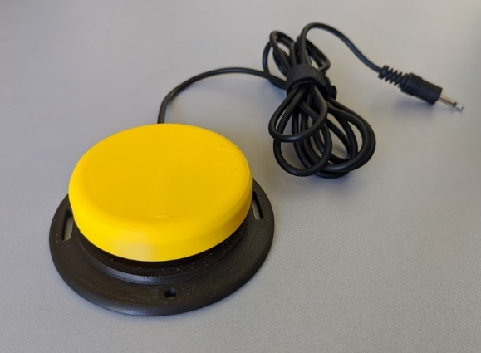

The Interact Switch is a 3D printed switch with a limit switch (153gf) to activate a switch adapted device. There is a holder and insert for the button cap, which support the button cap and hit the switch when a user presses the button cap.

|  |  |
| --- | --- |
| **Requirements Met** | **Requirements Unmet** |
| * Low force * Maker-friendly * Uses 3.5 mm mono cable | * Small footprint |

#### Useful Design Features

* Multiple mounting options on base (holes and slots for screws / bolts).

### MMC60 Switch

|  |  |
| --- | --- |
| **Title** | MMC60 Switch |
| **Link** | <https://www.makersmakingchange.com/s/product/mmc60-switch/01tJR000000693rYAA> |
| **Author** | Neil Squire Society’s MMC Prgoram |
| **License** | Attribution – ShareAlike 4.0 |
| **Cost** | ~$10 CAD |
| **Test Build (Y/N)** | Y |

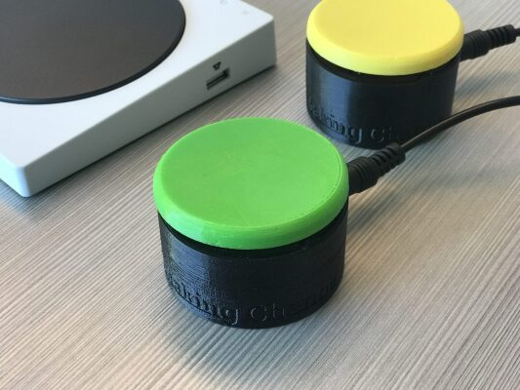

A 3D printed assistive switch that uses a limit switch (153gf) and includes a mono jack for plugging in 3.5 mm mono cables.

|  |  |
| --- | --- |
| **Requirements Met** | **Requirements Unmet** |
| * Low force * Maker-friendly | * Small footprint |

#### Useful Design Features

* ¼-20 T-nut in the base for mounting
* 3D printed flexure piece to hold the cap and activate the switch

# Ideation

The ideation behind this design is unknown. The maker did not provide further detail on how they came up with the original design.

# Prototyping

## Low cost / force buttons

A DIY, low cost / force assistive switch. This is the original design created by [Kevin Cross](https://www.thingiverse.com/davross/designs).

### Physical Components

#### Button Base

The base of the button that holds the tactile switch and mono cable. There are holes that allow someone to insert a pin to create a hinge for the top. There are also slots to hold the tactile switch and cable in place when assembling.

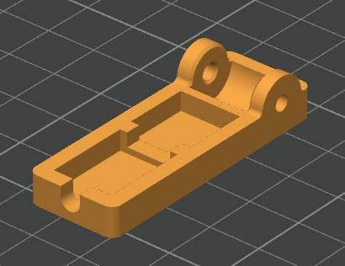

#### Double Button Base

There was also a double button base created to build and mount two switches at once. It is two of the button bases connected to each other to make one piece with two switches.

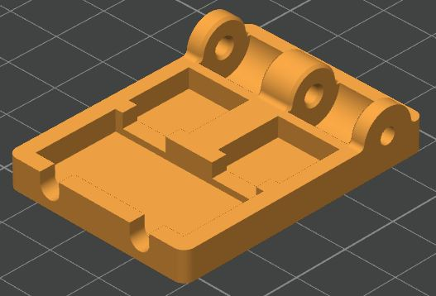

#### Button Cap

The button cap is the top of the button which a user would press. It has holes for a pin to be inserted to allow it to rotate relative to the base and press the tactile switch. There is a cutout with a bump that touches and activates the tactile switch. The cutout exists to create clearance and reduce the required travel of the button cap when activating the switch.

The tactile switch is located between the pin and where a user would press to increase mechanical advantage and reduce the activation force of the switch without greatly increasing the size or travel of the switch.

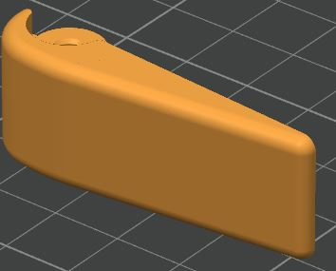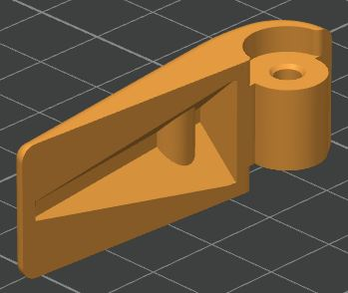

#### Pin

The original design calls for cutting a 3 mm carbon rod to length for the pin, or using an M3 screw.

### Electrical Components

#### Mono Cable

The design uses a 3.5 mm male-male mono cable, cut in half. This method allows a maker to purchase one cable and make the double button. No length is specified in the original.

#### Tactile Switch

The design uses a small tactile PCB mount switch. The base fits a switch that is up to 12 x 12 mm, and 7.3 mm tall. There are many options for this type of switch, which include the [Omron B3F 5050 tactile switch](https://www.digikey.ca/en/products/detail/omron-electronics-inc-emc-div/B3F-5050/368377?s=N4IgTCBcDaIPYFsBOcB2ACARgZgGboFYAGYkAXQF8g).

## Prototype Decisions

There were a few ideas to modify this design before it was added to the Makers Making Change library, but the overall design was taken forward.

|  |  |  |
| --- | --- | --- |
| **Prototype** | **Decision (Abandon, Modify, Proceed)** | **Justification** |
| Low Cost / Force Buttons | Modify | * Simple and effective design for printing and assembly |

### Modifications

The modifications proposed were to:

* Add texture to the button top
* Modify the pin holes in the base to increase printability
* Modify the base to reduce print material and increase tolerance for error in making
* Not include double button base option by default
* Create a 3D printed pin

The texture was added to the top to indicate where to press and make it easier for a user to press that portion of the switch. The pin holes were made teardrop shaped to increase printability. A slot in the base which held the switch in place was removed to increase tolerance of maker error, and the double button base was not included as users could mount two switches side by side with the same result. The 3D printed pin was created to reduce overall cost and make it easier for volunteer makers to make the switch.

# Testing

No additional testing was completed on this design, other than adjusting tolerances to ensure parts fir together when printed on different printers.

# Detailed Design

The current Light Touch Switch design includes three 3D printed parts, a 3.5 mm mono cable, and a tactile switch. It is compatible with any device that is controllable with a standard assistive switch. Users press the switch however works well for them to activate their switch adapted device.

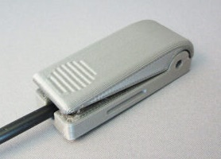

The completed Light Touch Switch meets all the requirements and goals of the design. It is simple for a volunteer to build, small, requires 30-40gf to activate, and uses a 3.5mm mono cable.

### Physical Component / Enclosure

#### Button Base

The button base has a recess that holds the tactile switch and the cable coming out of the switch. There are also holes for a pin to create a hinge for the top to rotate around when a user presses the switch. The base is meant to be printed on its flat side, so the holes were changed to be teardrop shaped. The shape helps improve printability by reducing the overhang angle at the top of the hole.

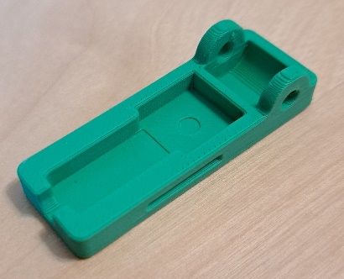

#### Button Top

The button top is flat on top and has a hole for the pin of the hinge. There is also a textured section near the end to indicate where a person should press, and increase friction at that point to make it easier to press. The top is designed to print on its side, with supports that need to be removed before assembly.

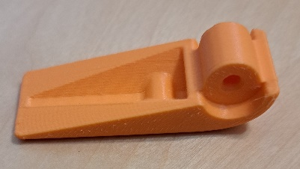

#### Button Pin

A 3D printed pin was created to hold the top and base together. The pin is printed as a U shape where the two upright sections have different diameters. There are two different diameters to account for differences in 3D printing tolerances, make them easier to insert, and print more reliably. When assembling, people can use the side of the pin that fits best, and trim the excess off.

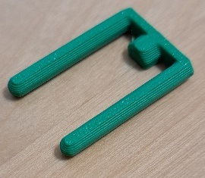

### Electrical Components

#### Mono Cable

The mono cable is any 3.5 mm mono cable, as this is the standard for switch adapted devices. You can buy a male-male cable and cut it in half, or get a pre-cut cable. If you can only source a stereo cable, those work as well, but require some additional preparation. [There are resources available on the MMC website which may help with this.](https://www.makersmakingchange.com/s/managed-content-news/3-5-mm-1-8-inch-cable-basics-MCXYVB2HC6I5BJFPDOGEYXLQ3MAQ)

#### Tactile Switch

The tactile switch used is the [Omron B3F-5050](https://omronfs.omron.com/en_US/ecb/products/pdf/en-b3f.pdf) switch, although the same sized switch could be used if the B3F-5050 is not available. Relevant information is summarized below:

|  |  |
| --- | --- |
| Switch Parameter | Technical Specifications |
| Dimensions (L x W x H mm) | 12.00 x 12.00 x 7.3 |
| Activation Force (gf) | 130 |
| Activation Distance (mm) | 0.3 |
| Contact Rating | 0.05 A @ 24 VDC |

Note that with the mechanical advantage from the button top, the activation force from the user is only 30-40gf.

# Opportunities for Improvement

### Physical Components

#### Button Top

The design of the button top could be changed to make it better to print on the flat top. Printing in that orientation would reduce the need for supports, but would also decrease the strength of the top.

#### Button Pin

A single pin could be created for makers with known tolerance and good build plate adhesion on their printer. A single pin would reduce waste, but also be harder to insert if the fit is very tight.

### Electrical Components

A different tactile switch could be selected and used to decrease the activation force even further.