# Overview

This document contains the necessary information to build the Light Touch Switch, a cost-effective 3D printable accessibility switch for people with physical disabilities.

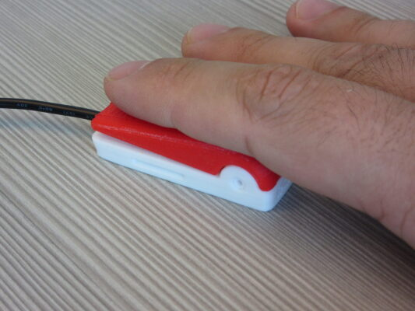

Contents

Overview 1

Maker Checklist 2

Maker To Do List 2

Items to Give to User 2

Tool List 3

Customization Guide 5

3D Printing Guide 6

3D Printing Summary 6

3D Printing Settings 6

Post-Processing 6

Examples of Quality Prints 6

Assembly Guide 8

Required Components 8

Required Tools 8

Required Personal Protective Equipment (PPE) 8

Assembly Instructions 9

Step 1 9

Step 2 9

Step 3 9

Testing 10

# Maker Checklist

This list provides an overview of the steps required to build and deliver the Light Touch Switch.

## Maker To Do List

* Read through the Maker Guide to become familiar with required components, tools, supplies, safety gear, and overall assembly steps.
* Talk to the User about customization options
  + What colour they would like the switch to be
  + If they would like different parts to be different colours
  + How they would like to receive the “User Guide” (PDF or physical copy)
* Order hardware components
* Gather tools, supplies, and safety equipment.
* Assemble the device
* Test the Light Touch Switch
* Print “User Guide” (if the User would like a physical copy)

## Items to Give to User

* Built and tested Light Touch Switch
* “User Guide”

# Tool List

## Tools / Equipment

|  |  |  |  |
| --- | --- | --- | --- |
| Tool ID | Description | Required / Recommended | Notes |
| T01 | Wire cutters / strippers | Required | Cutting and stripping the mono cable wires. |
| T02 | Flush cutter | Required | Trimming the tactile switch and button pin. |
| T03 | Soldering iron and stand | Required | Soldering the mono cable to the tactile switch. |
| T04 | Hot glue gun | Required | Securing the tactile switch and mono cable to the button base. |
| T05 | Needle nosed pliers | Required | Removing support material from 3D prints. Wrapping wires from mono jack around switch leads. |
| T06 | 3D printed switch jig | Recommended | A 3D printed jig that holds the switch and mono cable while soldering. |
| T07 | Switch testing device | Required | A device to test if the switch works. This could be a [switch tester](https://github.com/makersmakingchange/Simple-Switch-Tester), a continuity tester, or a working switch adapted device. |

## Supplies

|  |  |  |  |  |
| --- | --- | --- | --- | --- |
| Supplies ID | Description | Quantity | | Notes |
| S01 | Solder | A small amount | Soldering the mono cable to the tactile switch. | |
| S02 | Hot glue | A small amount | Holds the tactile switch in place and provides strain relief on the cable. | |

## Personal Protective Equipment (PPE)

|  |  |  |
| --- | --- | --- |
| PPE ID | Description | Notes |
| P01 | Safety glasses | Eye protection while trimming parts and soldering. |

# Customization Guide

The device can be printed in the user’s desired colour. The user may want specific colours, and may want the 3D printed parts in different colours.

# 3D Printing Guide

The device was originally printed on an Ender 3-S1 using Cura as the slicer software using the standard printer profile. Print time and the number of print setups may differ significantly, depending on your printer.

## 3D Printing Summary

|  |  |
| --- | --- |
| Metrics | Single Unit |
| Total Print Time (min) | 1h 09m |
| Total Number of Components | 3 |
| Typical Total Mass (g) | 8 |
| Typical Number of Print Setups | 1 |

Note that the above summary does not include the optional switch jig.

## 3D Printing Settings

All parts should be printed in the orientation they appear when imported into the slicer.

|  |  |  |  |  |  |  |  |
| --- | --- | --- | --- | --- | --- | --- | --- |
| Print File Name | Qty | Total Print Time (hr:min) | Mass (g) | Infill (%) | Support(Y/N) | Layer Height/ Nozzle Diameter(mm) | Notes |
| LTS_Base_v1.0.stl | 1 | 00:33 | 3 | 20 | N | 0.2/0.4 |  |
| LTS_Top_v1.0.stl | 1 | 00:33 | 4 | 20 | Y | 0.2/0.4 |  |
| LTS_Pin_v0.1.stl | 1 | 00:04 | 1 | 20 | N | 0.2/0.4 |  |
| Optional Parts | | | | | | | |
| Switch_Jig_12mm_  V1.0.stl | 1 | 00:35 | 4 | 20 | N | 0.2/0.4 |  |

## Post-Processing

Inspect the 3D printed parts for any printing defects, sharp edges, or burrs. Sharp edges and burrs can be removed with sanding or deburring tools.

## Examples of Quality Prints

Compare your 3D prints to the images here. If there are significant differences, you may need to reprint the part.

|  |  |  |
| --- | --- | --- |
| Light Touch Switch | | |
| LTS_Base_v1.0.stl | LTS_Top_v1.0.stl | LTS_Pin_v0.1.stl |
| A picture of the current Light Touch Switch base. | A picture of the current Light Touch Switch top. | A picture of the current Light Touch Switch pins. |
| Switch_Jig_12mm_V1.0.stl |
| A picture of the switch jig. |

# Maker Component List

|  |  |  |  |  |  |  |  |  |  |  |  |  |
| --- | --- | --- | --- | --- | --- | --- | --- | --- | --- | --- | --- | --- |
| Light Touch Switch Parts | | | | | | | | | | | | |
| A01 | Tactile switch | | | QTY: 1 | A02 | Mono cable | | | QTY: 1 | A03 | Button base | QTY: 1 |
| A photo of 1 tactile buttons on a white background. | | | | | A picture of a 3.5 mm mono cable. | | | | | A picture of the current Light Touch Switch base. | | |
| A04 | | Button cap | QTY: 1 | | A05 | | Button pin | QTY: 1 | |
| A picture of the current Light Touch Switch top. | | | | | A picture of the current Light Touch Switch pins. | | | | |

# Assembly Guide

## Required Components

## Required Tools and Supplies

* Wire cutter / stripper
* Flush cutter
* Soldering iron and stand
* Hot glue gun
* Needle nosed pliers
* Switch jig (optional)
* Switch testing device ([switch tester](https://github.com/makersmakingchange/Simple-Switch-Tester), a continuity tester, or a working switch adapted device)

## Required Personal Protective Equipment (PPE)

* Safety glasses

## Assembly Steps

### Step 01: Remove print supports

Remove the support material from the button cap (A04). Use needle nosed pliers, if necessary.

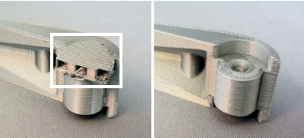

### Step 02: Trim switch leads

Use a flush cutter to trim off the leads on one side of the tactile switch. Make sure the leads are cut flush against the side of the switch and do not extend below the bottom of the switch.

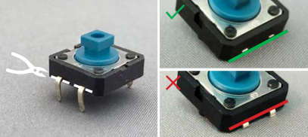

### Step 03: Straighten remaining switch leads

Straighten the remaining switch leads, ensuring they stick straight out from the side of the switch. Use the needle nosed pliers, if necessary.

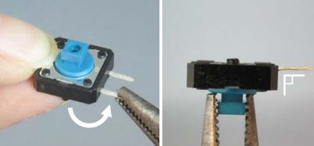

### Step 04: Trim mounting lugs

Use the flush cutters to trim the plastic mounting lugs (the plastic cylinders) off the bottom of the switch. Make sure the lugs are cut flush, with no remaining bumps.

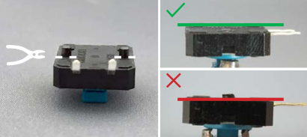

### Step 05: Cut mono cable

If using a two-ended mono cable, cut it in half. If the mono cable only has one end, skip this step.

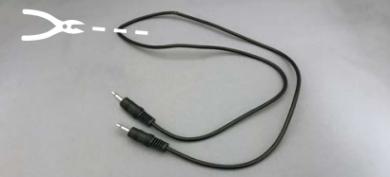

### Step 06: Strip the mono cable

Use the wire strippers to strip about 2 cm from the end of the mono cable, exposing the inner two wires. Twist the stranded wire together.

The inner wire colours may differ depending on the mono cable. Some may have one stranded wire and one coated wire, or have two coated wires. If you have two coated wires, do not twist any wires together at this step.

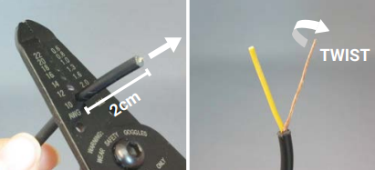

### Step 07: Strip the inner wire(s)

Strip about 1.5 cm of insulation from the end of the inner coated wire. Twist the wire strands from that wire together. Repeat this for the other coated wire, if both inner wires were coated.

The wire strands from each inner wire should not be touching each other or twisted together.

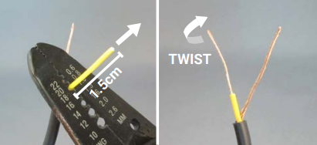

### Step 08: Wrap wires around switch leads

Hold the mono cable behind the switch and wrap one wire around one switch lead and the other wire around the other switch lead. Which wire is connected to which lead does not matter, just make sure the wires and leads do not touch each other, or the switch will be short circuited. Needle nosed pliers may help with wrapping the wires.

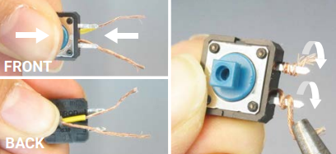

### Step 09: Fix orientation of cable

Hold the switch in place and bend the mono cable around so it sits between the leads of the switch.

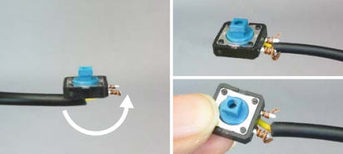

### Step 10: Solder switch joints

Place the switch and cable into the switch jig, then use a soldering iron to solder the wires to the switch leads, indicated in the white rectangle. Once soldered, the wires should not slip off the switch leads.

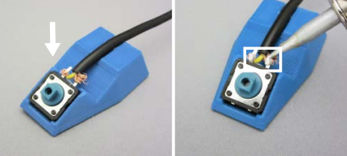

### Step 11: Test the switch

Test that the switch works properly. The switch should consistently activate only when it is pressed (when the blue part of the tactile switch is pressed down).

Potential methods for testing the switch works include using a dedicated switch tester, using a continuity tester, or using a switch adapted device you know works.

Detailed testing and troubleshooting information can be found in the Testing and Troubleshooting sections.

### Step 12: Apply glue to button base

Use a hot glue gun to add a **small** drop of glue on the inside of the square recess in the button base.

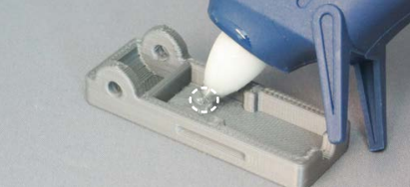

### Step 13: Place switch in button base

Place the tactile switch and mono cable into the button base, with the switch sitting on the drop of glue from the previous step. Make sure the switch sits flat and level inside the button base.

If the switch is not level, push it down while the glue is still warm. If it cannot be set level, remove the switch, check to see the mounting lugs and leads were trimmed flush, remove any leftover glue, and glue it back in with a smaller drop of glue.

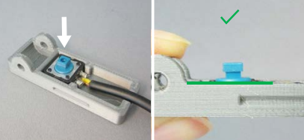

### Step 14: Seal the cable with glue

Fill the recess around the mono cable with hot glue to seal the cable. Do not overfill or the switch may not function properly. The glue should not come past the top edge of the button base.

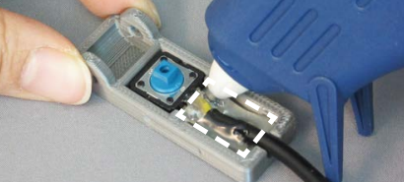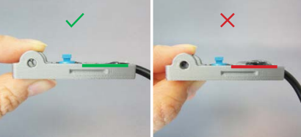

### Step 15: Insert the button top and pin

Slide the button top onto the base. Test which side of the button pin fits best, then insert it all the way in. The pin should be snug so it does not fall out, but not too tight to prevent the top from moving or be inserted.

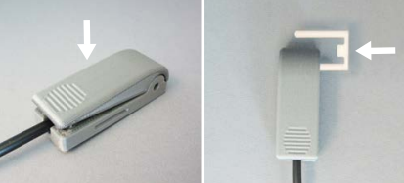

### Step 16: Trim the pin

Use the flush cutters to trim the pin flush with the side of the base. If the cut edge of the pin is sharp, or the pin feels like it will slip out, secure it with a small drop of hot glue.

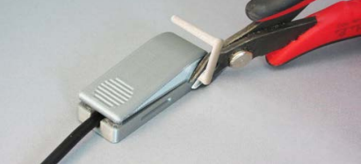

Congratulations, your Light Touch Switch is now complete!

# Testing

Testing the switch involves checking that it only activates the device it is controlling when the user presses it, and that the switch activates consistently. To test this, use a [switch tester](https://github.com/makersmakingchange/Simple-Switch-Tester), a continuity tester, or a working switch adapted device. Whichever option you use, the device should only be “on” when the switch is pressed, and it should consistently turn on when pressed.

There should not be noticeable stiffness or resistance when pressing the switch, and you may be able to hear a click when the tactile switch activates.

# Troubleshooting

**The switch is always “On”.**

This is often caused by a short circuit. Check to see if the wires from the mono cable are touching, or if solder is connecting the leads of the tactile switch together.

If the wires are touching, separate them and make sure they will not touch again by soldering, gluing, or removing excess wire. If the solder is touching, remove any excess solder.

The switch may also be sitting too high in the button base, so the button top is always pressing it. If that is the case, disassemble the switch and make sure the mounting lugs and second set of leads have been trimmed flush. Reassemble the switch, using a very small amount of glue to hold the tactile switch in place.

**The switch is always “Off” or is inconsistent when pressed.**

This is often caused by incomplete solder joints. Check the solder joints to ensure the solder has connected to both the wire and the leads of the switch. The wire should not slide on the lead if pulled gently.

This may also be cause by too much glue in the base, preventing the top from moving when it is pressed. Make sure the glue covering the mono cable in the base of the switch does not come above the edge of the recess in the base. If it does, remove the excess glue.