# Overview

The Device Summary is intended to be a detailed summary of the device, product and maker information for the Light Touch Switch, making it easier to add to the Makers Making Change website. It is intended for anyone who will view the device listing.

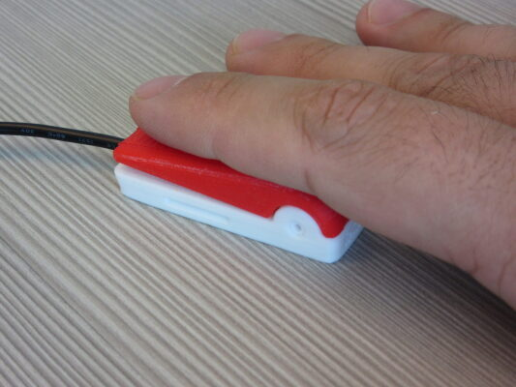

# Product Information

## Product Name

Light Touch Switch

## Device Category

|  |  |
| --- | --- |
|  | Adapted Toys |
|  | Aids for Daily Living (ADL) |
| X | Assistive Switches |
|  | Communication Aids (AAC) |
|  | Computer Access |
|  | Environmental Controls |
|  | Gaming |
|  | Keyguard |
|  | Kits |
|  | LipSyncs |
|  | Mounting |
|  | Recreation and Leisure |
|  | Seating and Positioning |
|  | Switch Interfaces |
|  | Writing Aids |

## User Value Statement

The Light Touch Switch is a simple, DIY assistive switch with a low activation force (30-40 grams of force). It is well suited for use with a finger and can be used with standard AT equipment.

## Designer

Modified by the Neil Squire Society’s Makers Making Change Program from the design by [Kevin Cross](https://www.thingiverse.com/davross/designs).

# Device Information

## Overview

The Light Touch Switch is a low cost, low force, 3D printed assistive switch. It can be used for switch access with any standard AT equipment, switch adapted toy, or any other standard switch adapted device.

## Disability Type

|  |  |
| --- | --- |
| X | Agility / Dexterity |
|  | Arthritis |
| X | Cognitive |
|  | Hearing |
| X | Mobility |
|  | Pain |
|  | SCI |
|  | Vision |
|  | Other |

## Disability Type Description

This switch is suitable for anyone who needs a small, low force assistive switch.

## How To Use

To use, plug the switch into the switch adapted device. Press the textured portion on the top of the switch to activate the switch and the device. The switch will be “on” while it is pressed and “off” when it is not.

## Estimated Cost

The estimated material cost of the device for a single build:

|  |  |
| --- | --- |
| X | $0 - $10 |
|  | $11 - $25 |
|  | $26 - $50 |
|  | $51 - $100 |
|  | $101 - $250 |
|  | $250+ |

## Attribution

Original Design: [Xbox adaptive controller low cost/force buttons](https://www.thingiverse.com/thing:3211154) by [Kevin Cross](https://www.thingiverse.com/davross/designs).

Original License: [Creative Commons - Attribution](https://creativecommons.org/licenses/by/4.0/)

Design modified by the Neil Squire Society’s Makers Making Change Program.

# Maker Information

## Project Skills

|  |  |
| --- | --- |
| X | 3D Printing |
|  | Custom PCB |
|  | Electronics |
|  | Laser Cutting |
|  | Mechanics |
|  | Software |
| X | Soldering |
|  | Woodworking |
|  | Other |

## Skills Description

This design requires 3D printing, soldering, using common hand tools (wire cutters / strippers, flush cutters), and hot glue.

## Tools Needed

|  |  |
| --- | --- |
| X | 3D Printer |
| X | Common Hand Tools |
|  | Common Power Tools |
|  | Laser Cutter |
| X | Soldering Iron |
|  | Specialized Tooling |

## Print time (hrs)

1 hour, ten minutes (1 hour 40 minutes if printing the optional switch jig).

## Assembly time (hrs)

0.5 hours

## Build Instructions

1. 3D print the necessary parts
2. Prepare the tactile switch and mono cable
3. Solder the cable to the switch
4. Glue the switch in place
5. Fix top to the base

## Download Link

<https://github.com/makersmakingchange/Light-Touch-Switch/archive/refs/heads/main.zip>

## Project Link

# <https://github.com/makersmakingchange/Light-Touch-Switch>

# License

## License

Hardware: [Attribution - Share Alike 4.0 International](https://creativecommons.org/licenses/by-sa/4.0/)

Documentation: [Attribution - Share Alike 4.0 International](https://creativecommons.org/licenses/by-sa/4.0/)