# Overview

This document contains the necessary information to use the Light Touch Switch, a cost-effective 3D printable accessibility switch for people with physical disabilities.

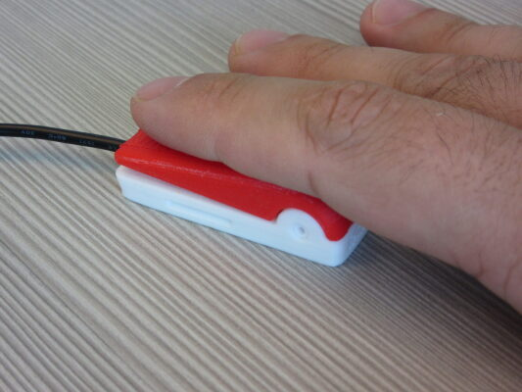

Contents

Overview 1

Introduction 3

Features 3

Specifications 3

Compatibility 3

Usage 4

Takedown / Storage 4

Cleaning 4

Care 4

Disposal 4

## Introduction

This device was originally created by [Kevin Cross](https://www.thingiverse.com/davross/designs) as a DIY, low-cost assistive switch alternative to commercially available switches which would work with the [Xbox Adaptive Controller (XAC)](https://www.xbox.com/en-CA/accessories/controllers/xbox-adaptive-controller). The Light Touch Switch is well-suited for use with one finger. It can be used with any switch controlled device that has a 3.55 mm mono cable jack.

The Light Touch Switch is a low-force switch for controlling electronic devices, such as phones / tablets, computers, adapted toys, and video games.

The Light Touch Switch is suitable for people with physical disabilities who may have limited strength and / or movement.

## Features

The Light Touch Switch uses a 3.5 mm mono cable to activate switch adapted device, and has a textured portion on the top to indicate where to press the switch for users with visual impairment. The mono cable end and textured portion of the cap are circled in the image below.

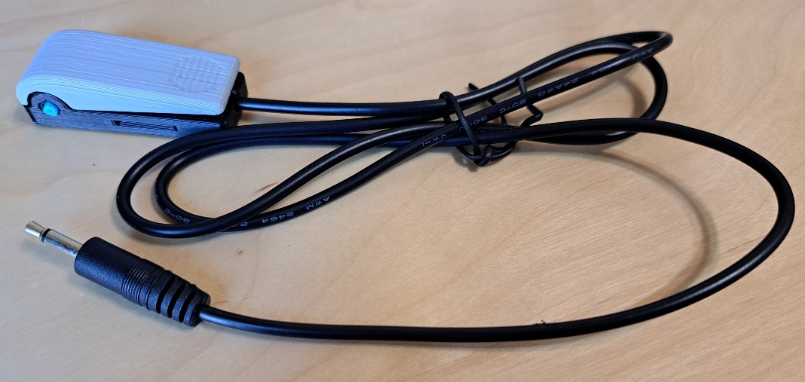

## Specifications

|  |  |
| --- | --- |
| Item | Light Touch Switch |
| Size (Length x Width x Height) [mm] | 50 x 17 x 15 |
| Mass [g] | 30 |
| Operating force [grams of force] | 30-40 |
| Activation distance [mm] | 0.7 |
| Cable type | 3.5 mm mono cable |

## Compatibility

The Light Touch Switch is compatible with any standard switch adapted device, such a switch adapted toys; switch interfaces for computers, smart phones, and tablets; and adapted gaming devices.

## Usage

Plug the Light Touch Switch into the jack on a switch adapted device, and press the textured portion on the top of the switch to activate it. The switch will be “on” while it is pressed, and “off” when it is not. You may hear and feel a click when the tactile has been pressed.

### Takedown / Storage

When not in use, the Light Touch Switch should be stored in a cool place out of direct sunlight. Extended exposure to sunlight will affect the plastic, and exposure to high temperatures will cause the plastic to warp.

## Cleaning

The 3D printed parts and cable of Light Touch Switch can be wiped with a damp cloth. Do not submerge the Light Touch Switch in water as this may destroy the electronics. Do not use hot water or clean in a dishwasher.

## Care

The Light Touch Switch is made of 3D printed plastic. Exposure to high heat may cause warping and/or negatively affect function. Extended exposure to sunlight will also weaken the plastic on the device.

The Light Touch Switch contains electronics and is not waterproof. If the device becomes wet, do not use it until it has completely dried.

## Disposal

PLA filament may be industrially compostable in your area. Check with your local waste management if PLA can be composted or must be thrown in the garbage.

Disassemble the Light Touch Switch and separate out the recyclable and compostable components, and those that must be thrown out. Electronics and batteries should be disposed of following your local waste management guidelines.