**LipSync: User Guide**

# Introduction

The LipSync is a sip-and-puff joystick that allows a user with limited or no arm mobility to control their computer. It emulates a computer mouse and can perform left click, right click, scroll, and other mouse functions.

This assistive device is suitable for users with spinal cord injury, MS, ALS, and other disabilities that restrict arm movement.

# Device Compatibility

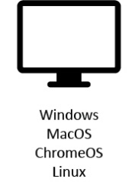

**Phone**  
Android 4.0+  
iOS13+  
Windows

**Computer & Laptop**  
Windows  
MacOS

**Tablet**  
Android 4.0+  
iPadOS+  
Windows

# Powering the LipSync

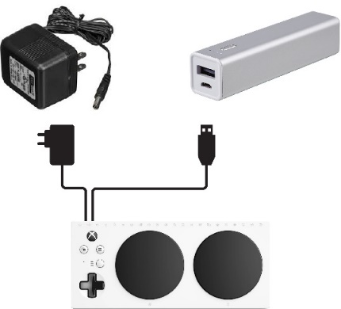The LipSync does not have an internal battery so it needs to be powered at all times with an external power source. Users can draw power off of the device (except on iOS devices) or use a power bank.



or

Power bank  
(>2700 mAh)

USB  
adapter

Device

# Initialization

Allow 3 seconds for the LED initialization sequence to flash

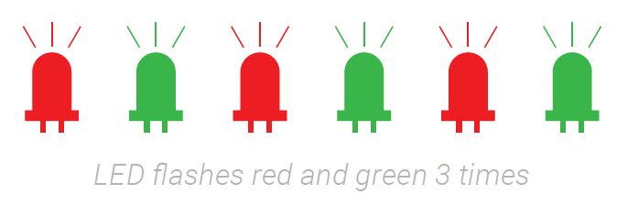**each time** the LipSync is plugged into a device.

# Cursor Speed Control

Fastest

Default level

Slowest



1 2 3 4 5 6 7 8 9 10 11

Press the button to increase and the button to decrease the cursor speed on the rear of the LipSync.

# Connecting to a Device

**For computers and Android & Windows devices**, connect the LipSync USB into the device. Use an adapter if necessary.

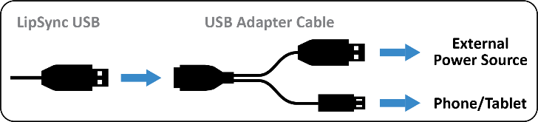

**For iOS devices**, connect the LipSync USB into a USB hub. Use a USB to USB C/Lightning (depending on the device used) to connect the USB hub to your device.

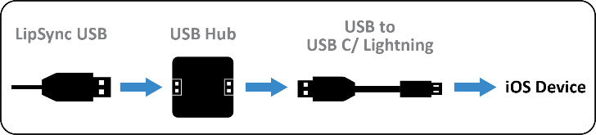

For more information, see *LipSync: Setup Guide*.

# Cursor Setup on iOS Devices

1. Open your device’s ***Settings*** > ***Accessibility*** > ***Touch*** > ***AssistiveTouch*** > Turn it on.
2. Turn off ***Always Show Menu***

# Functions for Mobile or Tablet

|  |  |  |
| --- | --- | --- |
| **FUNCTION** | **ACTION** | **ACTION TIME (SECONDS)** |
| Tap | Puff | 1 |
| Back button1 | Sip | 1 |
| Drag2 | Puff | 1 each |
| Scrolling3 | Puff | 3 |
| Cursor drift reset | Sip | 3 |
| Home button1 | Puff | 5 |

1 If the device uses on-screen icons, move the cursor over the icon to tap.2The red LED will stay on at all times in this mode  
3 The green LED will stay on at all times in this mode

# Functions for Computer

|  |  |  |
| --- | --- | --- |
| **FUNCTION** | **ACTION** | **ACTION TIME (SECONDS)** |
| Left click | Puff | 1 |
| Right click | Sip | 1 |
| Double-click | Puff | 1 each |
| Drag | Puff | 3 |
| Scrolling (↑ ↓) | Sip | 3 |
| Cursor drift reset | Puff | 5 |
| Scrolling (↑ ↓ ← →) | Sip | 5 |