# Quality Check Guide

# Device: Switch Input Module

**Version: V1.0 Date: 5/12/2021**

## Introduction:

When the switch input module build has been completed is important to run through the following quick checks to mitigate any future component failures. This document contains the common checks that makers can do to ensure that their build is of an acceptable quality.

Fig 1:

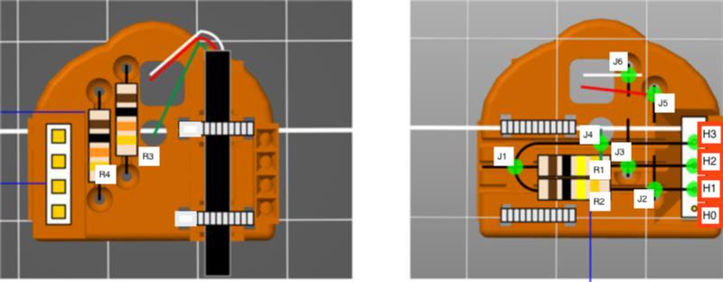

## Quality Checks:

Below is the set of quality checks to do after the build is complete:

**3D Printed Housing:**

* After printing the circuit housing be sure to check the part for any obvious flaws, such as the following:
  + Stringing
  + Extra filament left over from print such as support or small globs
  + Gaps in the print causing structural errors
  + Messy print quality resulting in a brittle component
* All of the unwanted filament has been removed. Such as some residue from a brim or any support, use a blade or plyers to scrape/pull away any of this excess carefully.

**Solder Points:**

* Ensure all solder points are smooth and shiny. Make sure they don’t blob together with other solder joints, which can form short circuits.

**Wires:**

* The wires don’t have stray strands sticking out, and touching component leads, or other wires.
* Wire length is not excessive, otherwise, the adaptor may not fit into the LipSync shell.

**Assembly:**

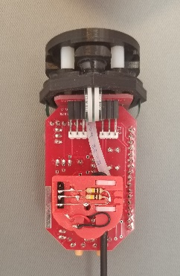

* The module is orientated correctly on the LipSync board as shown in the instructions.
* The connection is secure, making sure the module has been placed on all the way.
* The strain relief precautions have been added to the model such as adding the zip ties as explained in the instructions.

**Circuit:**

* Confirm that the appropriate connections have been made by reviewing the instructions and reviewing the circuit diagram below. If you are unsure if the component is wired correctly, there are two different tests one can do, described below as well.

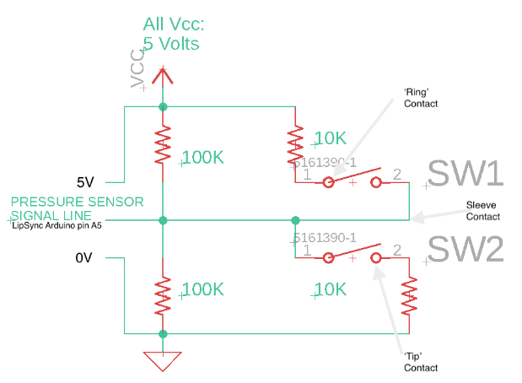

**Testing the circuit electrically:**

**If you have access to a multimeter**, you can test by setting the meter to the 1M (1 mega ohm) ohm range. Note that if your multimeter is auto ranging, then you’ll only need place it on the ohms (resistance) setting. Strip the wire end of the leftover male cable end, so you have the conductive metal strands exposed ‘tip', 'ring’ and ‘sleeve’ wires. Insert the male cable end into the Switch Module’s female jack. Make sure the LipSync is unpowered at this point. Using the meter, measure the resistance between the ‘tip’ and ‘ring’ wires (Tip is usually white, though may be black. Ring is almost always red). You should get a reading of 220 K ohms (within a range of 10%). This loop test confirms the overall integrity of the circuit, with the exception of power. To ensure the circuit is powered, set the multimeter to DC volts (use 5 or ten volt range, if not auto ranging). Turn on the LipSync, and measure the voltage between the same ‘tip’ and ‘ring’ contact points you measured in the previous test. You should see a reading of 5V.

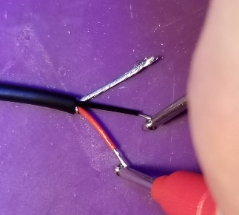

**If you don’t' have access to a multimeter**, you can test using a standard 3-5mm red LED, attaching the positive lead (usually the longest) to the ‘ring’ contact (usually red wire) and the negative lead to the ‘tip’ contact (usually white, though may be black). The Switch Adaptor will need to be installed in the LipSync, and turned on. If the LED turns on, though it may appear to be a bit dimmer than normal.

