# User Quick Guide

# Device: Switch Input Module

Version: 1.0 Date: 05/17/2021

## Introduction:

The LipSync is a sip and puff joystick that emulates a computer mouse. When the switch input module is added to a LipSync it allows switches to be used in place of regular the sip and puff functionality. This means that left and right mouse clicks can be controlled by switch interfaces. This adaptation is suitable for LipSync users who have low lung capacity or those who can’t form their lips around the joystick mouthpiece.

## Features:

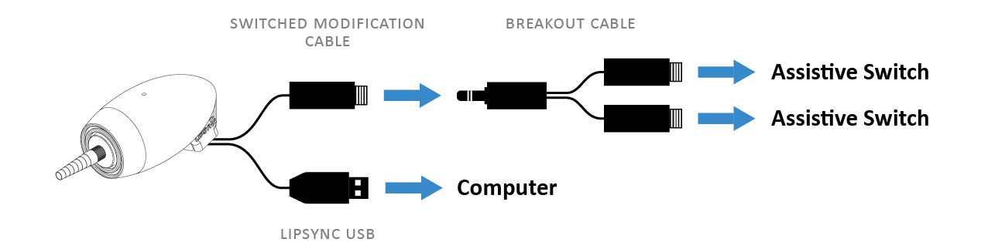

The switch module features a USB cable and a break-out cable. The USB cable is used to connect the LipSync to the desired device, and the break-out cables allow for two switches to be connected to control sip and puff.

## Device Setup:

**If this is a new LipSync:** The LipSync has its own set up process that must be referred to first. The LipSync start-up guide can be found here: <https://github.com/makersmakingchange/LipSync/blob/master/LipSync_Startup_Guide.pdf>

Once the LipSync has been calibrated and setup, the switch module setup can now begin:

1. Connect the LipSync USB to an electronic device (except on iOS devices) with a USB adapter if applicable) or a power bank.

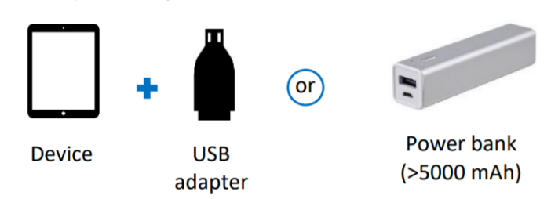

1. After plugging the LipSync to a power source, initialization will begin automatically. Do not touch the LipSync while the LED blinks red and green. Wait until the LED stops flashing before moving the mouthpiece. Initialization will occur every time the LipSync is plugged into a device.

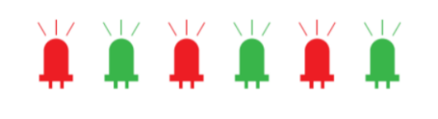

1. Insert the male end of the breakout cable into the female end of the Switched LipSync Modification cable.   
   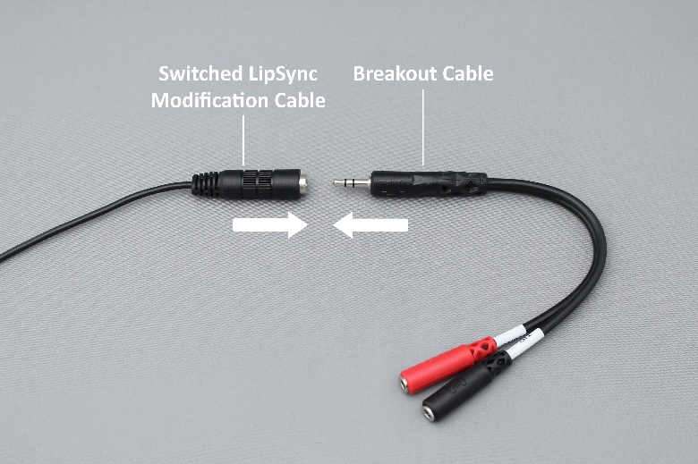
2. Insert the first assistive switch into the ‘Left Click’ connector of the breakout cable labelled “TIP”. This female cable end is usually black or white.  
   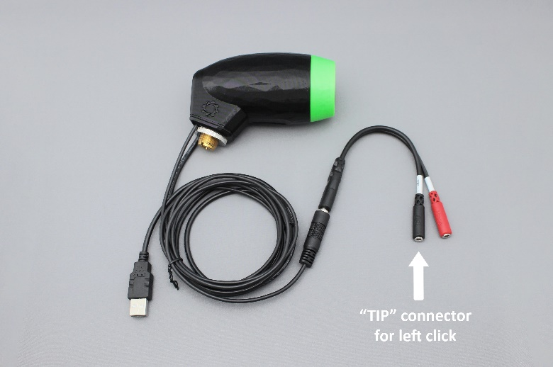
3. Insert the second assistive switch into the ‘Right Click’ connector of the breakout cable labelled “RING”. This female cable end is usually red.  
   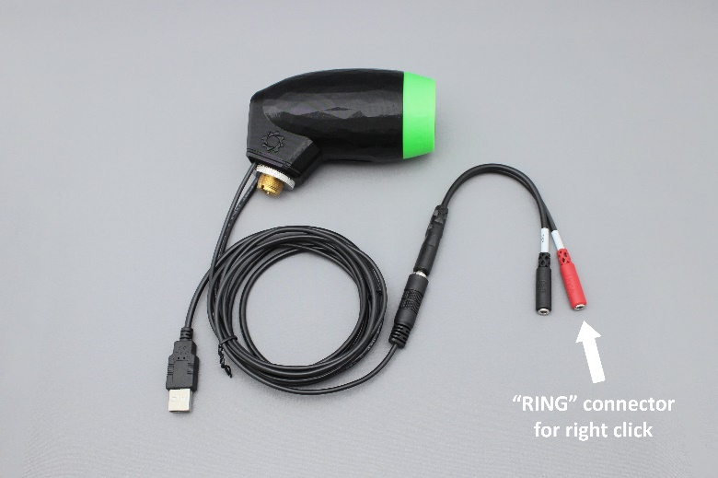
4. The Switched LipSync should look like this with two assistive switches connected:  
   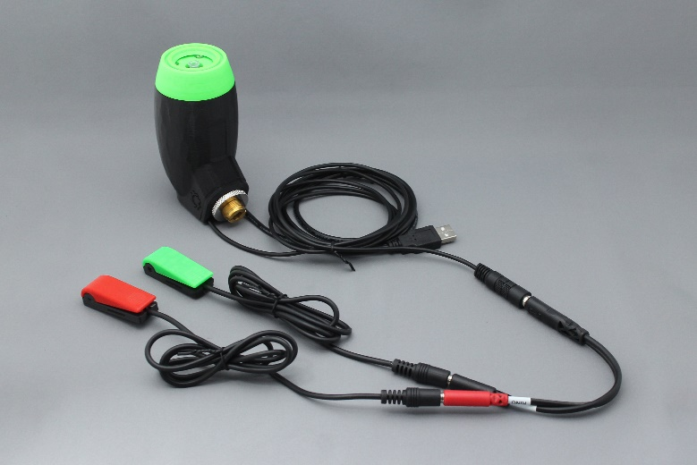

## Usage:

Ensure the LipSync USB is connected to a phone, tablet, or computer; and 2 switches are connected to the LipSync breakout cable. After that the following can be used as such:

|  |  |  |
| --- | --- | --- |
| **Device Action** | **Action Time** | **Function** |
| Moving the mouthpiece joystick | <1 second | Moves mouse cursor around the screen |
| Activating the “**TIP**” connected switch | < 1 second | Left mouse click |
| Activating the “**TIP**” connected switch twice | < 1 second each | Double left click |
| Activating the “**RING**” connected  switch | < 1 second | Right mouse click |
| Activating the “**TIP**” connected  Switch | 3 seconds 1 | Toggle |
| Activating the “**RING**” connected  Switch | 3 seconds 2 | Scrolling |
| Cursor home reset | 5 seconds | Helps to alleviate mouse cursor drift |

1 The **red** LED will stay on at all times in Toggle mode. Deactivate mode by doing a 1 second sip or puff.  
2 The **green** LED will stay on at all times in Scrolling mode. Deactivate mode by doing a 1 second sip or puff.

## Compatibility

Any assistive switch that uses a 3.5 mm mono cable or has a built in 3.5 mm mono cable jack. Wireless switches will not be able to connect to this switch module.

## Specifications

Mass: Approx. 25 grams (Switch Input module with cable, without adaptor cable or switches).

Dimensions: 25 x 27 x 11 mm

## Cleaning

Only the cable will need to be cleaned periodically, as the Switch Module resides internally within the LipSync, and should not normally require cleaning. However, both the cable and module are cleanable with 90% purity (or greater) isopropyl alcohol.