# Overview

This document contains instructions on how to update the firmware on a LipSync.

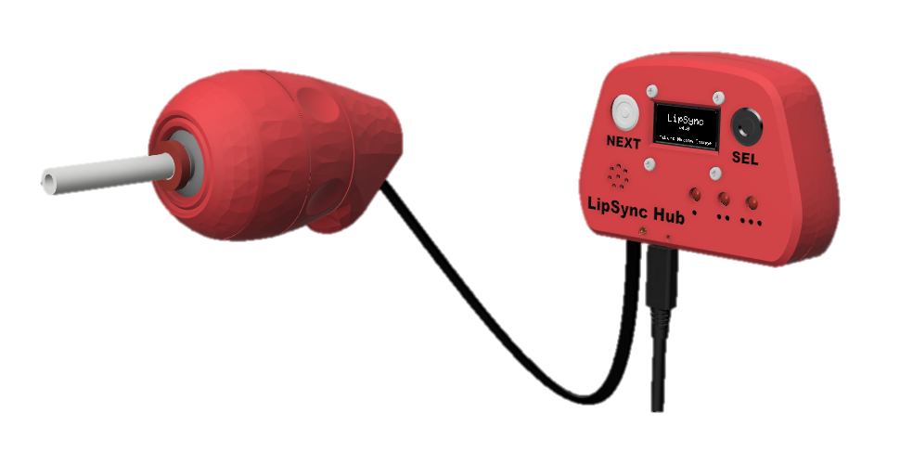

Contents

Overview 1

Firmware Update Checklist 3

To Do List 3

Tool List 4

Tools/ Equipment 4

Supplies 4

Firmware Update Guide 5

Firmware Update 5

Components 5

Tools 5

Part A: Firmware Flashing Preparation 6

Part B: Firmware Flashing Steps 7

Part C: Verify Operation 9

Troubleshooting 11

# Firmware Update Checklist

This list provides an overview of the steps required to build and deliver the device.

## To Do List

* Read through the Firmware Update Guide to become familiar with required components, tools, supplies, safety equipment, and overall steps.
* Confirm that the LipSync has V4 hardware.
* Download the latest firmware from the GitHub repository
* Set up the Arduino IDE on the computer
* Connect the LipSync to the Computer
* Note down the current settings
* Flash updated firmware to the LipSync
* Perform factory reset
* Restore settings

# Tool List

## Tools/ Equipment

|  |  |  |  |
| --- | --- | --- | --- |
| Tool | Description |  | Notes |
| T07 | Computer with Arduino IDE | Required | For flashing firmware to microcontroller |

## Supplies

|  |  |  |  |
| --- | --- | --- | --- |
| Supplies ID | Description | Quantity | Notes |
| n/a |  |  |  |

# Firmware Update Guide

## Firmware Update

### Components

|  |  |  |  |  |  |  |  |  |
| --- | --- | --- | --- | --- | --- | --- | --- | --- |
| **A1** | LipSync Hub | QTY 1 | **A2** | LipSync Joystick | QTY 1 | **A3** | LipSync Interface Cable (RJ11) | QTY 1 |
| An assembled LipSync Hub | | | An assembled LipSync joystick without the mouthpiece | | | A black RJ11 cable | | |
| **A4** | USB-C-USB-A Cable |  | **A5** | Computer | QTY 1 |  |  |  |
| A black USB-C USB-A cable on a white background. | | | Laptop outline | | |  | | |

### Tools

* Computer with Arduino IDE to flash firmware

Part A: Firmware Flashing Preparation

Step A-01: Connect the LipSync Hub to the Computer using the USB Cable

Plug in the Hub (A1) to a computer using the USB Cable (A4).

Step A-02: Activate the Hub Menu

1. Activate the Hub Menu by briefly pressing, and then releasing both the Next and Select Buttons simultaneously. (Alternatively, press and hold the Select button for a very long press (> 3 second, or until Hub Light one turns on and then turns off again).

Step A-03: Note down the user’s settings

|  |  |
| --- | --- |
| Setting | Value |
| Cursor Speed |  |
| Sound Mode |  |
| Light Brightness |  |
| Scroll Speed |  |
| Sip Threshold |  |
| Puff Threshold |  |

Part B: Arduino IDE Setup

This part sets up the computer to be able to flash the firmware. Some of these steps can be skipped if you already have the Arduino IDE installed or have previously worked with the same board.

Step B-01: Setup Arduino IDE on Computer

1. Download Arduino IDE for your operating system at <https://www.arduino.cc/en/software>
2. Install the Arduino IDE.

Step B-02: Open Arduino IDE

1. Open Arduino IDE.

Step B-03: Setup Arduino IDE for Seeed Studio Xiao nRF52840 Development Board

1. Click on **File -> Preferences**.
2. Locate the text field that says **Additional Boards Manager URLs** beside it.
3. Copy and paste the following link into the field as a new line:
   1. <https://files.seeedstudio.com/arduino/package_seeeduino_boards_index.json>
4. Click on **OK.**

Step B-03: Restart Arduino IDE

1. Close and reopen the Arduino IDE.

Step B-03: Install the Board Drivers

1. Open the **Boards Manager** option from the **Tools-> Board-> Boards Manager...,**
2. **Search for “Seeed nrf52” and select “Seeed nRF52 Boards” by Seeed Studio.**
3. **Click Install to install the board.**

****Step B-03: Install Libraries****

1. In the Arduino IDE, go to **Tools -> Manage Libraries…**
2. For each of the libraries in the table below, search for the name, and click Install.
3. If prompted to install any dependent libraries, click OK.

|  |  |
| --- | --- |
| Name | Author |
| Adafruit_LPS2X | Adafruit |
| Adafruit_LPS35HW | Adafruit |
| Adafruit_SSD1306 | Adafruit |
| ArduinoJson | Benoit Blanchon |
| TLV493D-A1B6 | Infineon Technologies |
| Adafruit_TinyUSB | Adafruit |

Step B-04: Download the latest firmware

1. Download the Firmware_Files from the GitHub Repository: <https://github.com/makersmakingchange/LipSync/blob/main/Build_Files/Firmware_Files/LipSync_Firmware.zip>

Step B-04: Extract the firmware

1. Extract / unzip the folder to a known location. Confirm that you have the following folder structure:

* LipSync_Firmware (folder)
* LipSync_Firmware.ino
* LSAPI.ino
* LSTest.ino
* LSBLE.h
* LSBuzzer.h
* LSCircularBuffer.h
* LSConfig.h
* LSInput.h
* LSJoystick.h
* LSMemory.h
* LSOutput.h
* LSPressure.h
* LSScreen.h
* LSTimer.h
* LSUSB.h
* LSUtils.h
* LSWatchdog.h

Step B-03: Open LipSync_Firmware.ino in Arduino IDE

Open LipSync_Firmware.ino with Arduino IDE. The files listed above should appear as tabs.

Step B-03: Set the target Board

**Select Seeed Xiao NRF52840 from Tools -> Board -> Seeed NRF52 Boards**

#### Step B-03: Select the Port

Select the correct port from **Tools -> Port** menu.

#### Step B-03: Compile and Verify the Code

Verify the code.

#### Step B-03: Connect the LipSync Hub to the computer

Connect the LipSync Hub using the USB cable to the computer.

#### Step B-06: Confirm that the firmware uploaded correctly.

Check the Output panel of the Arduino IDE to confirm that the firmware has been uploaded correctly. The output should say ‘Device programmed’.

#### Step B-06: Disconnect and reconnect the USB cable from the Hub

Disconnect the USB cable from the Hub. Wait 15 seconds, and then reconnect the power.

#### Step B-06: Perform a factory reset.

Activate the Hub Menu by short simultaneous press then release on both Hub buttons. Navigate down to the More Menu, then navigate down to the Factory Reset.

#### Step B-06: Restore any user settings

Disconnect the USB cable from the Hub. Wait 15 seconds, and then reconnect the power.

Part C: Verify Operation

#### Step B-06: Verify the PCB and Sensors work as expected.

When the USB cable is connected, a green LED should illuminate on each of the sensors and the back of the display.

Once the code is uploaded, confirm that:

* The LipSync plays the startup noise
* The 3 LEDs on the Hub turn on briefly
* The multicoloured mode LED turns on
* The display should shows the splash screen
* There are no error messages on the display

If all goes well, proceed to the next step. If there are any problems, unplug the USB cable and proceed to troubleshooting.

#### Step B-09: Verify functionality with Joystick

Ensure that the joystick is in USB mouse mode and confirm the following:

* Does mouse move when you move joystick?
* Does mouse stop moving when you release the joystick (i.e., no drift)?
* Can you perform left and right clicks with Next and Sel buttons?
* Plug in assistive switches - can you perform left, right, and middle clicks with assistive switches?

# Troubleshooting

1. **My Arduino IDE is stuck when uploading code to the board.**

You can first try to reset the board by clicking the "Reset Button" once. If that does not work, rapidly click it twice to enter bootloader mode. If that also doesn't work, disconnect the board from the PC, and connect the board again.

1. **My board is not showing up as a serial device on Arduino IDE.**

You can first try to reset the board by clicking the "Reset Button" once. If that does not work, rapidly click it twice to enter bootloader mode.

If neither of those options work, make sure your USB-C cable is securely connected on both ends, and that it is a data transfer cable, not a power only cable.

1. **The LipSync plays an error tone and then lists an error in Safe Mode.**

First, unplug the LipSync Hub from power for 15 seconds, and then plug it back into the host device or power. If the error persists, refer to the User Guide to resolve the error.