|  |
| --- |
| **LipSync User Guide PDF QR Code**[User Guide](https://github.com/makersmakingchange/LipSync/blob/main/Documentation/LipSync_User_Guide.pdf) |

# Introduction

The LipSync is a mouth-operated sip-and-puff joystick that allows a user with limited or no arm mobility to control a computer, gaming console, smart phone, or tablet. This Quickstart Guide is meant to briefly introduce the functions and use of the LipSync. For more detailed information, please consult the User Guide.

# Features

LipSync Interface Cable

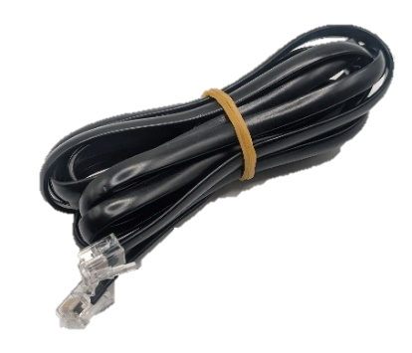

USB-C to USB-A Cable

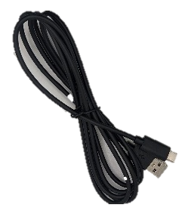

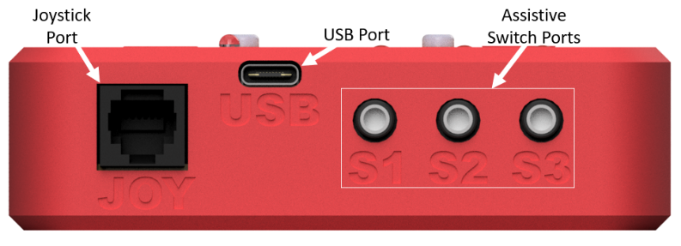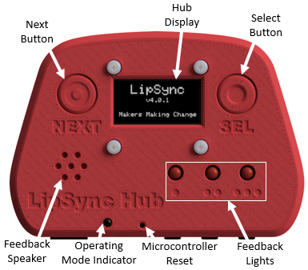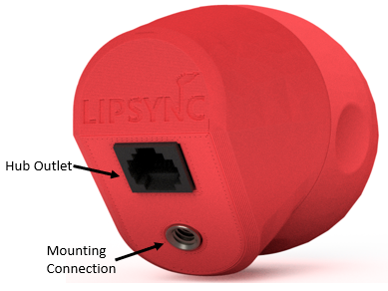

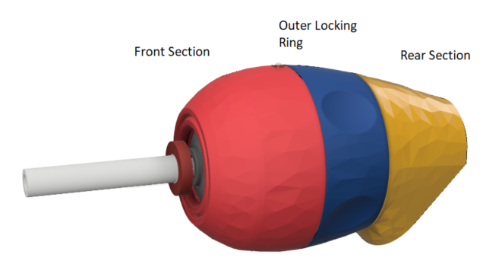

Filtered Mouthpiece

Power and Orientation LED

# Setting up the LipSync

The following are the general steps needed to setup your LipSync device:

1. Mount LipSync Joystick
2. Mount LipSync Hub
3. Connect LipSync Interface Cable
4. Optional: Connect up to 3 Assistive Switches
5. Connect the LipSync Hub to the Host Device
6. Once powered, wait until device initializes before moving joystick.

## Connecting the LipSync to the Host Device

### USB Connections

**For direct USB connection** **to the host device,** connect the appropriate USB cable from the LipSync Hub into the host device. Use an adapter if necessary.

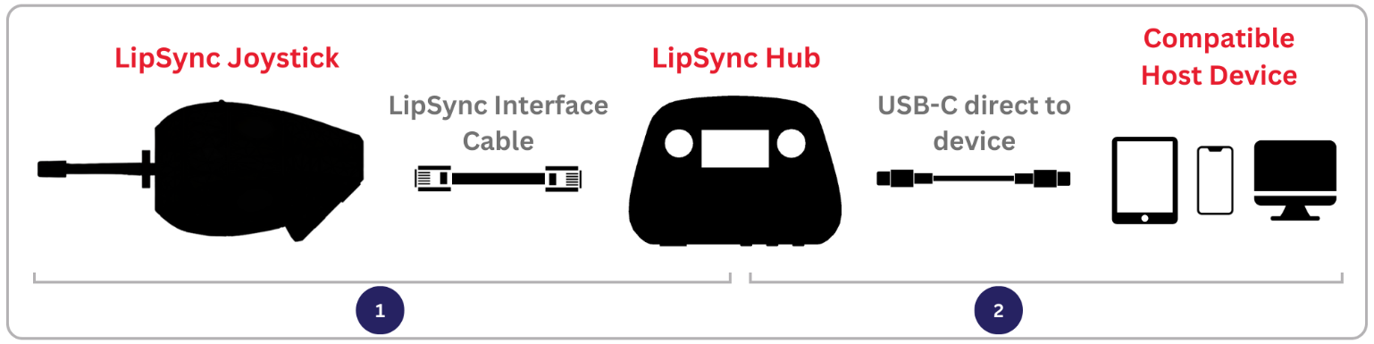

**For connection to the host device with an external power source,** plug a power splitting adapter into the host device and connect the LipSync Hub and external power source to the splitter. Use an Adapter if necessary. **Required for iOS USB connection.**

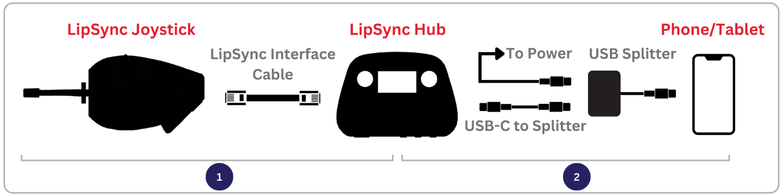

### Wireless Connections

For wireless connection to the host device, plug the LipSync Hub directly into any power source using the appropriate adapter as required. Change the operating mode to BT Mouse through the Hub Menu   
Find “LS_(DeviceID)” in the host device Bluetooth menu to pair and connect.

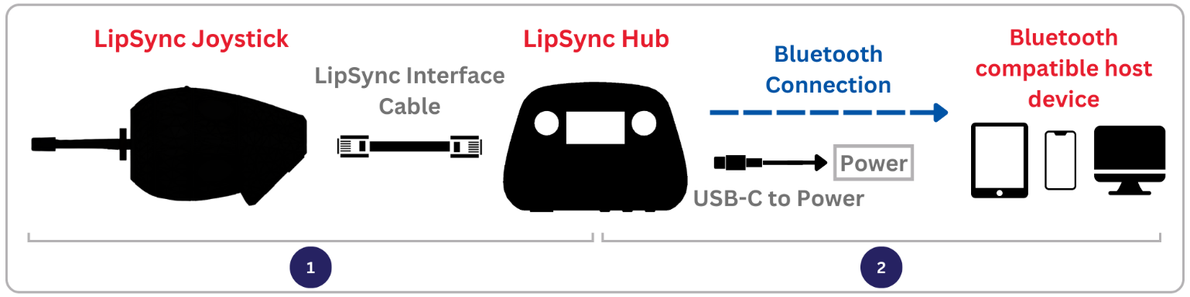

Cursor Setup on iOS Devices

Open your device’s ***Settings*** > ***Accessibility*** > ***Touch*** > ***AssistiveTouch*** >Turn it on.

## Input Actions

| Input | | | Input Duration | Output (based on Operating Mode) | | |
| --- | --- | --- | --- | --- | --- | --- |
| Sip and Puff | Assistive Switches | Hub Buttons | Mouse | Gamepad | Hub Menu |
| Puff | S1 | Select | < 1 sec | Left click | Button 1 | Select |
| 1-3 sec | Start Drag Mode | Button 3 | - |
| > 3 sec | Enter Hub Menu | Enter Hub Menu | Exit Hub Menu |
| - | S2 | - | < 1 sec | Middle Click | Button 5 | - |
| 1-3 sec | N/A | Button 6 | - |
| > 3 sec | Perform Center Reset | Perform Center Reset | - |
| Sip | S3 | Next | < 1 sec | Right click | Button 2 | Next |
| 1-3 sec | Start Scroll Mode | Button 4 | - |
| > 3 sec | Middle Click | Button 5 | - |
| - | S1 + S3 | Next + Select | < 1 sec | Enter Hub Menu | Enter Hub Menu | Exit Hub Menu |
| Joystick | | | - | Cursor movement | Joystick movement |  |

## Hub Menu Settings

The Menu on the Hub Display provides a way to changing operating modes, adjusting settings, activate calibrations, and reset the LipSync device. See the Input Action table for how to access and navigate the menu. See the User Guide for more details.

## Troubleshooting

### Cursor Issues

If you are experiencing cursor drift, perform a center reset in one of the following ways:

|  |  |
| --- | --- |
| Option A: Trigger Center Reset  Either by:   * Activate the Hub Menu and navigate to **Center Reset** * Using a very long press of assistive switch 2 | Option B: Turn it off and then on again.  Do not touch the joystick until “Ready to use” is displayed on the Hub Display.   * Disconnect/Reconnect the USB cable from the LipSync Hub. * Restart the device through the Hub Menu.. |

### Error Messages

If a hardware error is detected on startup, the LipSync will enter Safe Mode and display an error code. Refer to the User Guide for how to resolve the error. If issues persist, contact Support.

## Support

For support, contact the maker of your device or Makers Making Change at [info@makersmakingchange.com](mailto:info@makersmakingchange.com)