# Version 1.0 | Date 05/13/2022

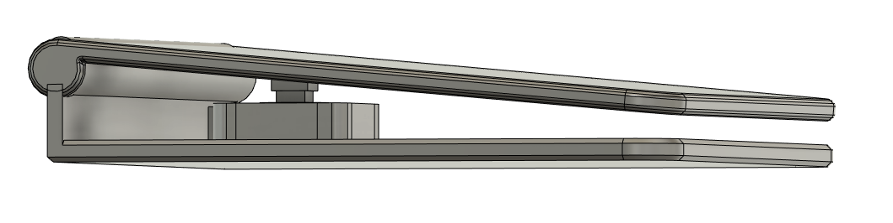

* Initial version
* Designed by Kerilyn Kennedy – Makers Making Change
* Documentation by Neil Squire/Makers Making Change