## Introduction

This is a cost-effective 3D printable accessibility switch that only requires the user to lift their finger or hand as high as 8 mm to use it. The switch measures 65 mm L x 65 mm W x 13 mm H and is built using a standard 3.5 mm cable. Using the specified model of tactile switch, the activation force to use the switch is low and is comparable to the force required to activate the light touch switch.

## Usage

The switch is well-suited for use by a finger or hand. This switch would be beneficial for someone who may have a limited range of motion and would benefit from using a switch that has a large activation area with a minimum switch height. This switch can be plugged into any standard AT interface that uses a 3.5mm cables, including the Xbox Adaptive Controller (XAC).

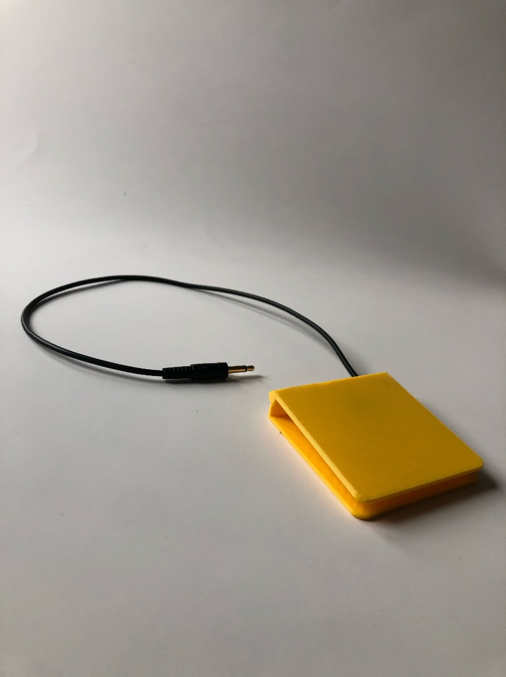

## Compatibility

The switch can be plugged into any standard assistive technology interface that uses a 3.5 mm cable.

## Specifications

|  |  |  |  |
| --- | --- | --- | --- |
| **Length (mm)** | **Width (mm)** | **Height (mm)** | **Mass (g)** |
| 65 | 65 | 8 | 23 |

## Cleaning

The Low Profile Switch can be wiped down with sanitizing cleaners. Do not wash the Low Profile Switch in high heat as it may cause it to melt or break. (i.e., do not put it in the dishwasher, the washing machine, or soak it in hot water).