Overview
This document shows the ten custom tops MMC has designed for the MMC60 Assistive Switch. The names of each button cap are the names of the files makers will access. Please note, the multiple colours in the images are for ease of distinguishing the textures on the buttons, but buttons will be printed in a single colour unless otherwise requested.
MMC60 Assistive Switch Custom Tops
MMC60_Button_Cups.stl | MMC60_Button_Hex4.stl | MMC60_Button_Hex8.stl
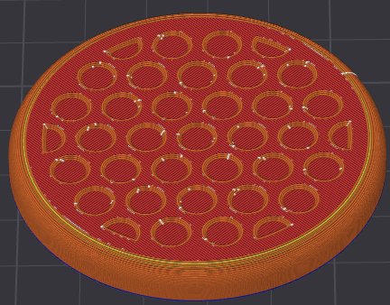 | 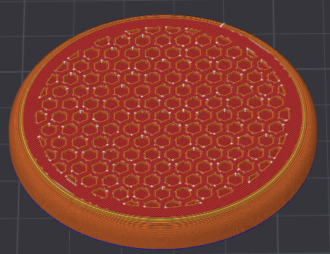 | 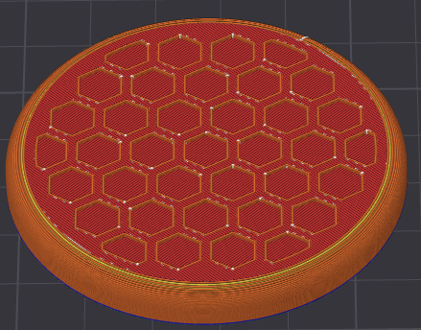
MMC60_Button_Rings.stl | MMC60_Button_Rings2.stl | MMC60_Button_Spiral.stl
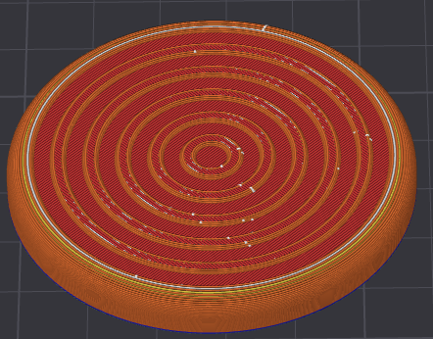 | 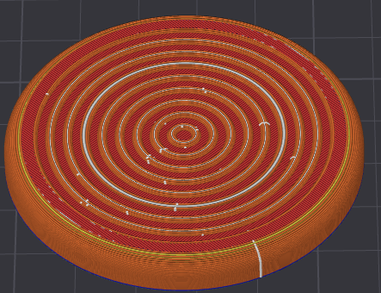 | 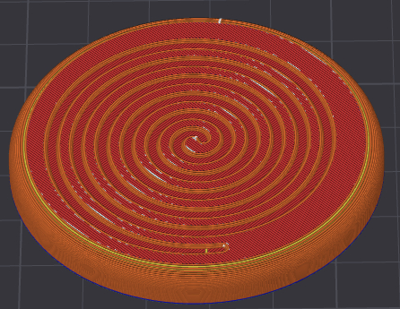
MMC60_Button_Gaming_A.stl | MMC60_Button_Gaming_B.stl | MMC60_Button_Gaming_X.stl
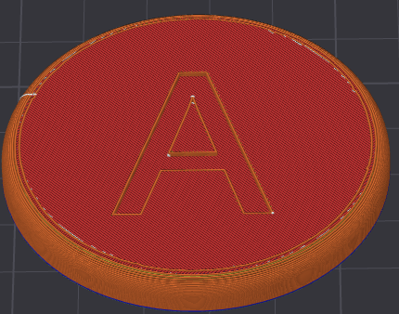 | 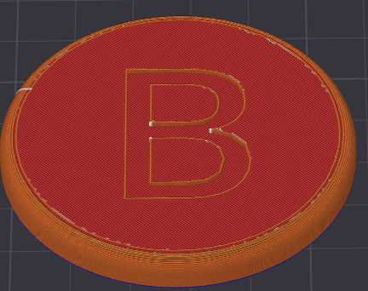 | 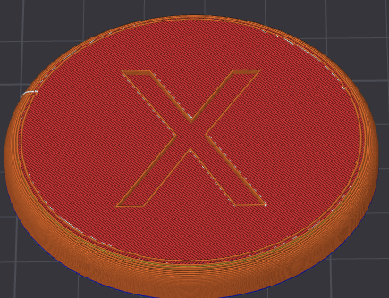
MMC60_Button_Gaming_Y.stl
