Overview
This document contains the necessary information to build the MMC60 Assistive Switch. The MMC60 is an assistive switch with a 60 mm diameter top. It is meant to be a robust switch with an integrated ¼-20 mounting option for users who require a large, robust switch.
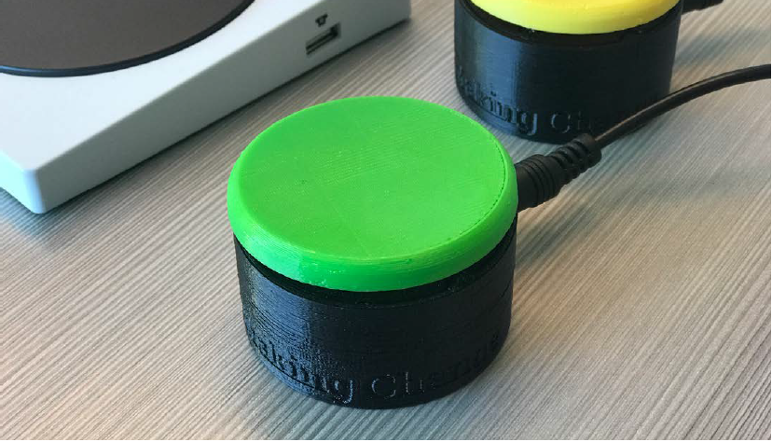

Contents
Overview 1
Maker Checklist 3
Maker To Do List 3
Items to Give to User 3
Tool List 4
Tools / Equipment 4
Supplies 4
Personal Protective Equipment (PPE) 4
Customization Guide 5
3D Printing Guide 6
3D Printing Summary 6
3D Printing Settings 6
Post-Processing 6
Examples of Quality Prints 6
Maker Component List 8
Assembly Guide 8
Part A: Required Components 8
Part A: Required Tools and Supplies 8
Part A: Required Personal Protective Equipment (PPE) 8
Testing 8
Troubleshooting 8

Maker Checklist
This list provides an overview of the steps required to build and deliver the MMC60 Assistive Switch.

Maker To Do List
- Read through the Maker Guide to become familiar with required components, tools, supplies, safety gear, and overall assembly steps.
- Talk to the User about customization options
  - Colour of the MMC60 base bottom and button top
  - Which button top they would like
    - The standard button top is a flat disk on top.
    - You can send the Custom Top Guide to the user to choose custom top from.
  - How they would like to receive the “User Guide” (PDF or physical copy)
- Order hardware components
  - Please see the Bill of Materials (BOM) for links to places to purchase the components
- Gather tools, supplies, and safety equipment.
- Assemble the MMC60 Assistive Switch
- Test the MMC60 Assistive Switch
- Print “User Guide” (if the User would like a physical copy)

Items to Give to User
- Completed MMC60 Assistive Switch
- 3.5mm mono cable
- “User Guide”

Tool List

Tools / Equipment

Tool ID | Description | Required / Recommended | Notes
T01 | Wire cutter/stripper | Required | Cutting wires to length and stripping insulation from wires.
T02 | Soldering iron | Required | Soldering wires to switch and jack.
T03 | Phillips Head screwdriver | Required | Tightening screws.
T04 | Adjustable wrench or wrench/ratchet that fits hex bolt | Recommended | Seating the T-nut in the button base bottom correctly.

Supplies
Supplies ID | Description | Quantity |  | Notes
S01 | Solder | Small amount | Soldering wires to switch and jack.

Personal Protective Equipment (PPE)
PPE ID | Description | Notes
P01 | Safety glasses/goggles | We recommend using eye protection while assembling the switch.

Customization Guide
The device can be printed in the user’s desired colour.
We have also designed ten custom switch tops, which are shown in the table below.
MMC60 Assistive Switch Custom Tops
MMC60_Button_Cups.stl | MMC60_Button_Hex4.stl | MMC60_Button_Hex8.stl
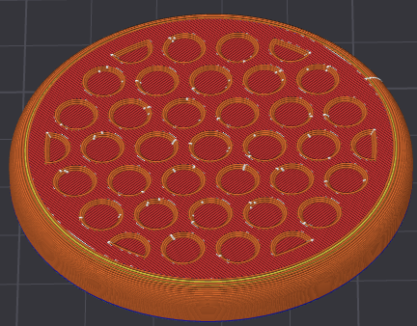 | 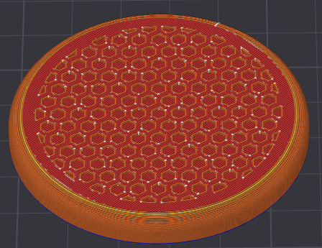 | 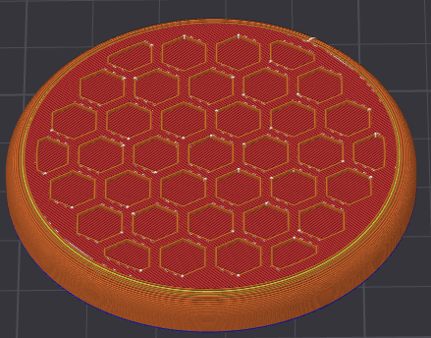
MMC60_Button_Rings.stl | MMC60_Button_Rings2.stl | MMC60_Button_Spiral.stl
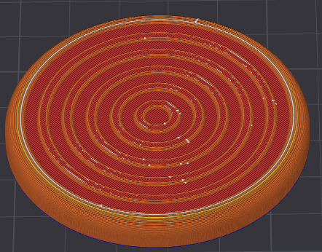 | 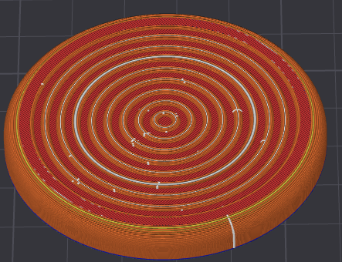 | 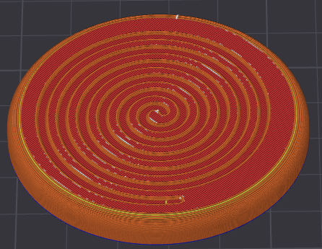
MMC60_Button_Gaming_A.stl | MMC60_Button_Gaming_B.stl | MMC60_Button_Gaming_X.stl
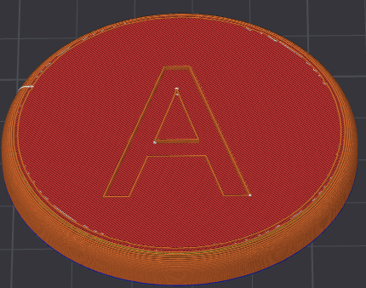 | 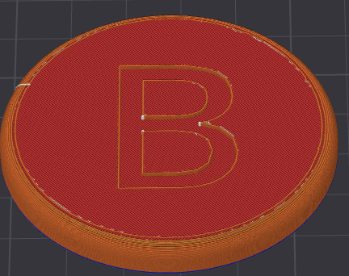 | 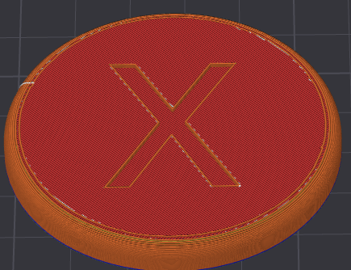
MMC60_Button_Gaming_Y.stl
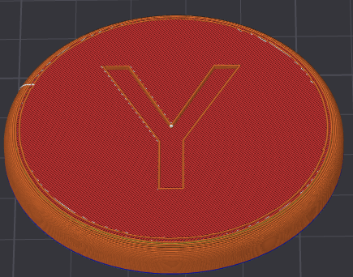

3D Printing Guide
The device was originally printed on a Bambu P1S using the Bambu Studio slicer, with a generic slicer profile for PLA filament.

3D Printing Summary
Metrics | Single Unit
Total Print Time (hour min) | <PrintTime (e.g. 1h10m)>
Total Number of Components | <NumberOfComponents>
Typical Total Mass (g) | <TotalMassOfAllParts>
Typical Number of Print Setups | <NumberOfPrintSetups>

3D Printing Settings
Note that the 3D printing material should be assumed to be PLA unless otherwise noted in the table below.
Print File Name | Qty | Total Print Time (hr:min) | Mass (g) | Infill (%) | Support(Y/N) | Layer Height/ Nozzle Diameter(mm) | Notes
<Device_Name>_<Component>.stl | <Qty> | <Time> | <Mass> | <Infill> | <If supports are needed> | <layer Height/Nozzle diameter>

Post-Processing
Inspect the 3D printed parts for any printing defects, sharp edges, or burrs. Sharp edges and burrs can be removed with sanding or deburring tools.
<Add any additional processes that must be done after print, such as removing supports>

Examples of Quality Prints
Compare your 3D prints to the images here. If there are significant differences, you may need to reprint the part.
<The table below can be expanded (adding rows), or compressed (removing columns) as needed, depending on the number of parts in the device>
<Sub-Assembly Name>
<Device_Name>_<Component>.stl | <Device_Name>_<Component>.stl | <Device_Name>_<Component>.stl
<INSERT IMAGE OF PART> | <INSERT IMAGE OF PART> | <INSERT IMAGE OF PART>

Maker Component List
<Fill in the table below. Continue the labeling convention for other added parts. Copy the table for another sub-assembly, if required, and label the parts as B<PartNumber>.>
<Sub-Assembly Name>
A01 | <Part Name> | QTY: <#> | A02 | <Part Name> | QTY: <#> | A03 | <Part Name> | QTY: <#>
<INSERT IMAGE OF PART> |  |  | <INSERT IMAGE OF PART> |  |  | <INSERT IMAGE OF PART>

Assembly Guide

Part A: Required Components
<Copy and paste the first sub-assembly table from the Maker Component List section>.

Part A: Required Tools and Supplies
<Add a bullet list of the required tools and supplies for this sub-assembly>

Part A: Required Personal Protective Equipment (PPE)
<Add a bullet list of the required PPE for this sub-assembly>

Testing
<Explain any testing the maker will have to complete to make sure the device is working properly>

Troubleshooting
<Include any common errors / issues the maker may encounter and suggestions how to solve them.>

