# Introduction

Intentional grasp is an important developmental milestone for children. Toys that reward intentional grasping and holding could help with developing intentional grasping in various situations. An end-user requested a device which would reward grasping and holding the device, particularly by playing music while it is being held and stopping when it is put down.

This device can be for any user who is learning unimanual or bimanual coordination and grasping.

# Research

## Existing Commercial Options

|  |  |
| --- | --- |
| Title | Baby Einstein Take Along Tunes |
| Link | <https://www.amazon.ca/stores/BabyEinstein-Canada/page/9536BE3F-2738-48D2-830A-5A402E28861F?ref_=ast_bln> |
| Author | https://www.kids2.com/pages/baby-einstein |
| License | Proprietary (Not open source) |
| Cost | $14.99 CDN (Amazon) |
| Notes | This toy does not sense when it is being held, just when buttons are pressed. |

## DIY Designs

No comparable DIY designs were located.

# Requirements

## Goals

|  |  |
| --- | --- |
| G01 | To motivate someone to pick up and hold an object by playing music while the object is being held. |
| G02 | Lightweight |
| G03 | Robust |

## Functional Requirements

|  |  |
| --- | --- |
| F01 | The device must be completely self contained (sound comes out of the device) |
| F02 | The device must play music when being held and stop when not being held |
| F03 | Users must be able to load their own music onto the device. |
| F04 | The device must be small enough for a child to hold (no larger than a toilet paper roll) |
| F05 | The device must be light enough for a child to hold |

## Non-functional Requirement

|  |  |
| --- | --- |
| NF01 | The device should be rugged enough to handle being dropped and possibly thrown by small children |

## Constraints

|  |  |
| --- | --- |
| C01 | Battery must deliver 5V (or just over) as lower voltages will be incapable of producing sufficient volumes in an audio amplifier, or audio module. |

# Initial Design – Musical Toy

This design was originally taken on as a community design project. An initial design was created.

|  |  |
| --- | --- |
| Title | Musical Toy |
| Link | <https://github.com/dbhaig/Musical_Toy> |
| Author | Don Haig |
| License | GNU GPL v3.0 |
| Cost | Not given |
| Notes | This design is the basis for the musical toy and was used as the initial proof of concept and design. |

The initial design was created by Don Haig and was uploaded to [GitHub](https://github.com/dbhaig/Musical_Toy). MMC staff built and tested a prototype. This version was not sent to the original requestor. The original design used an Arduino Nano, a 9V battery, a small speaker, a DFPlayer, and a wire inserted into a 3D printed enclosure. The design was made using parts the original designer had on-hand or could order quickly online.

## Touch Sensing

The device worked by using a wire wound around the enclosure as a capacitive sensor. When the device was touched/picked up, lights would turn on and music would play. When it was released, the music and lights would stop.

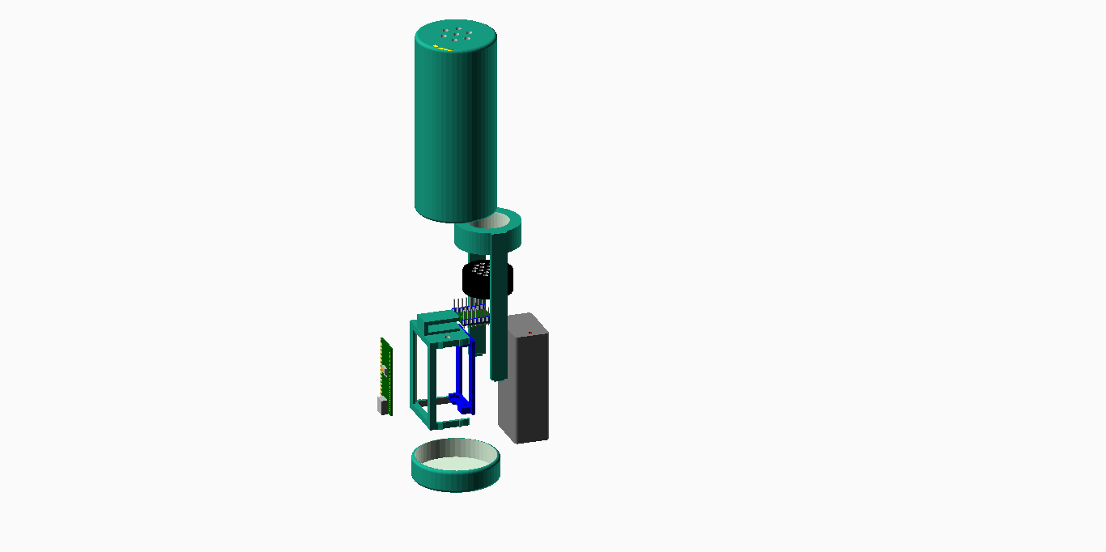

Figure 1. Exploded View

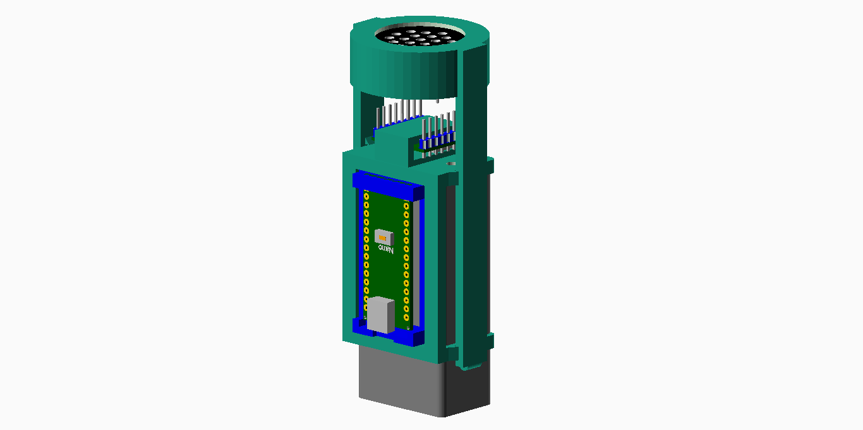

Figure 2. Inner Assembly

## Musical Toy Testing

The toy played music when activated, and would stop when deactivated, but the touch sensing did not work reliably. Depending on the sensitivity set within the code, it would activate before being touched (e.g., hand in proximity) or would not activate at all.

## Opportunities for Improvement

1. Use a smaller / less expensive microcontroller.
2. Using a smaller, more efficient power source than a 9V battery.
3. Inserting the wire into the case was difficult.
4. The outer enclosure is quite thin and may not be very durable.
5. Utilize a more reliable touch sensing method.

# Conceptual Design

The initial concept of the Conductive Music Player was to have a classic handheld flashlight tube shape. This tube would be small enough to be held by children, but big enough to hold batteries capable of powering the toy, for at least several hours.

## Key Functions

1. Plays Sound
2. Senses when gripped / lifted

## Playing Sound

1. DF Player Mini

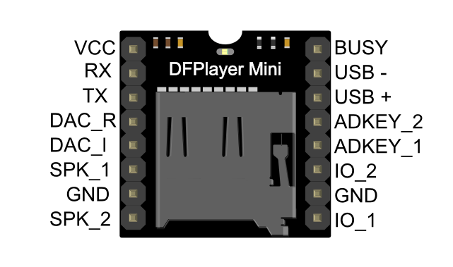

* + Integrated amplifier, microSD card
  + Fully supports FAT16, FAT32 file system, maximum support 32G of the TF card, support 32G of U disk, 64M bytes NORFLASH
  + A variety of control modes, I/O control mode, serial mode, AD button control mode
  + advertising sound waiting function, the music can be suspended. when advertising is over in the music continue to play
  + audio data sorted by folder, supports up to 100 folders, every folder can hold up to 255 songs
  + Low impedance speaker for good volume, with plastic cone/diaphragm for water resistance
  + Requires specific file naming

1. SD Player + Amplifier module (e.g., Open Playback Switch)
2. Adafruit Audio BFF Add-on for QT Py and Xiao
   * <https://www.adafruit.com/product/5769>
   * Has a built in amplifier and SD card but requires the analog pin from the microcontroller.
   * Product was not available when the project was started, but could be a good option for future improvements to the design

## Grip Sensing Method

### Capacitive Touch

1. Internal Microcontroller
2. Dedicated Module

The conductive music toy utilizes the Adafruit FreeTouch Arduino Library, which in turn, utilizes Atmel Q touch at the hardware level, on the micro controller chip.

Excerpt below, from: <http://ww1.microchip.com/downloads/en/DeviceDoc/atmel-42195-qtouch-library-peripheral-touch-controller_user-guide.pdf>

“Atmel® QTouch® Peripheral Touch Controller (PTC) offers built-in hardware for capacitive touch measurement on sensors that function as buttons, sliders, and wheels. The PTC supports both mutual and self-capacitance measurement without the need for any external component. It offers superb sensitivity and noise tolerance, as well as self-calibration, and minimizes the sensitivity tuning effort by the user.

The PTC is intended for autonomously performing capacitive touch sensor measurements. The external capacitive touch sensor is typically formed on a PCB, and the sensor electrodes are connected to the analog charge integrator of the PTC using the device I/O pins. The PTC supports mutual capacitance sensors organized as capacitive touch matrices in different X-Y configurations, including Indium Tin Oxide (ITO) sensor grids. In mutual capacitance mode, the PTC requires one pin per X-line (drive line) and one pin per Y-line (sense line). In self-capacitance mode, the PTC requires only one pin with a Y-line driver for each self-capacitance sensor.

Atmel® QTouch Features:

* Implements low-power, high-sensitivity, environmentally robust capacitive touch buttons, sliders, and wheels
* Supports mutual capacitance and self-capacitance sensing
* Up to 32 buttons in self-capacitance mode
* Up to 256 buttons in mutual capacitance mode
* Supports lumped mode configuration
* One pin per electrode - no external components
* Load compensating charge sensing
* Parasitic capacitance compensation for mutual capacitance mode
* Adjustable gain for superior sensitivity
* Zero drift over the temperature and VDD range
* No need for temperature or VDD compensation
* Hardware noise filtering and noise signal de-synchronization for high conducted immunity
* Atmel provided QTouch Library firmware and QTouch Composer tool”

#### Conductive Sensing Surface

Several options were considered for the conductive sensing material:

1. Conductive Cloth
2. Copper Tape
3. Embedded wire
4. Conductive paint
5. Conductive filament
6. Copper Foil

**Conductive Cloth**

The conductive cloth is a square of cloth plated with conductive material, such as silver. When someone touches the cloth, the capacitive touch library detects a change in capacitance of the cloth. The cloth offers low resistance (1 Ohm per foot of cloth), so the circuit can be more sensitive to touch. Additionally, the large surface area of the cloth allows the circuit to be more sensitive and reliable, as it is less likely that outside electromagnetic noise will influence the circuit than with embedded wires, which act like antennae. The conductive cloth also provides a soft surface for someone to touch, which may be desirable for some users. The cloth can be washed and cleaned as necessary.

**Copper Tape**

The copper tape is a roll of adhesive copper tape that will be stuck on the outer surface of the device to sense touch. When someone touches the tape, the capacitive touch library detects a change in capacitance of the tape. The copper tape is very thin and flexible allowing it to follow the surface shape.

**Embedded Wire**

The embedded wire follows a similar design to the copper tape, however, instead of being a flat adhesive strip it is a wire. The wire is sturdier and not as fragile as the tape, so it is more durable and can take on rough handling. The embedded wire would be attaches through small grooves into the device enclosure. Strips of wire can be attached to create a larger activation surface; however, it is important to be cautious that the embedded wire does not act like an antenna.

**Conductive Paint**

The conductive paint is a mixture of paint and carbon which creates a conductive coating on a surface. The paint is easy to apply with a brush, however, is difficult to clean and may chip away with long term use and rough handling.

**Conductive Filament**

Conductive filament is 3D printing filament that has combines a base plastic such as PLA with conductive additives to create a 3D printed conductive material. Unlike the other options listed, the conductive filament does not require anything to be attached to the outer surface of the device, as the enclosure itself will be conductive. The change in capacitance is sensed from the large activation surface of the device body. As conductive filament is not very common, this is reflected in the higher price point per roll of filament.

**Copper Foil**

Similar to the copper tape, the copper foil is a thin and flexible copper surface however, it does not have an adhesive surface. As the copper foil is a large copper sheet, it can be cut to the desired size and even wrapped along the entire outer surface if needed to. To attach the copper foil to the device, glue or another securing method will need to be used.

The conductive cloth offered a larger sensing surface area, which also increases sensitivity of the capacitive sensing.

### Linear soft potentiometer

A linear soft potentiometer was also considered for sensing touch. The potentiometer worked as a voltage divider and would output a different voltage based on where along its length the user was touching. The output voltage was 1/3 to 2/3 VCC.

<https://www.adafruit.com/product/178>

### Accelerometer

An accelerometer

#### LIS3DH

* Three axis sensing
* ±2g/±4g/±8g/±16g selectable scaling
* Both I2C (2 possible addresses) and SPI interface options
* Interrupt output
* Multiple data rate options 1 Hz to 5Khz
* As low as 2uA current draw (just the chip itself, not including any supporting circuitry)
* Tap, Double-tap, orientation & freefall detection

#### Accelerometer Additional Use Cases

As the accelerometer can sense varied motions with angle positions, and the micro controller can differentiate between them, it becomes possible to change device settings and behaviours based on this. As an example, the angle at which the device is positioned upon start up, can allow a user to set the sound to a specific volume. This can save parts in the product design, and the associated space and monetary costs those entail.

The ability to sense different user motion types should allow for various product behaviors, including:

* Setting volume (angle on device startup).
* Changing to a new song (shaking the device)
* Stepping up or down through a song list, or other list. (tilting device left or right)

Note that while using these methods can reduce device complexity and parts count, investments in software development, both in time and money, will be required upfront.

### Power Source

The toy was designed to be powered by battery, so it was portable. Disposable batteries were chosen for the initial design for simplicity. To meet the voltage demands of the electronics, four AAA batteries were used to supply 6V, and a voltage regulator was used to step this down to 5V for the electronics.

## Concept A: DF Player Mini + Accelerometer

Concept A used the DF Player Mini to read the SD card and play songs, and an accelerometer (Adafruit LISD3H) to sense when the toy was being held. The idea was to have the firmware track the stability of the readings from the accelerometer to differentiate between the toy sitting or lying stationary on a surface or being held. The assumption would be that even when a user was holding the toy still that the readings from the accelerometer would be more variable than when it was sitting or lying on a surface.

## Concept B: DF Player Mini + Capacitive Touch

Concept B was most similar to the original design by Don Haig but changed the method of capacitive sensing. Rather than using a wire wrapped around the case, a strip of copper tape and/or a conductive cloth is used for capacitive sensing.

## Concept C: DF Player Mini + Linear Soft Potentiometer

Concept C used a linear soft potentiometer to sense touch. The potentiometer worked as a voltage divider and would output a different voltage based on where along its length the user was touching. The output voltage was 1/3 to 2/3 VCC.

## Concept D: DF Player Mini + Capacitive Touch +Accelerometer

Concept D built off the original design by Don Haig. It used the DF Player Mini to read the SD card and play songs, and used capacitive touch sensing to detect when it was being held, and an accelerometer for extended options (such as changing songs). The accelerometer was used with tilting to change to the next or previous song based on how the accelerometer was tilted.

## Concept Selection

Concept D was selected for the prototype. We chose to include the accelerometer and capacitive touch sensing to increase future capabilities of the toy. The software for the capacitive touch sensing was simpler to develop and troubleshoot than it would have been to create the touch sensing with the accelerometer, but the accelerometer will allow for more complex controls and use cases in future developments with updates to the firmware.

The capacitive touch system was chosen over the linear soft potentiometer to increase the sensing surface of the toy. Either the soft potentiometer or using only a strip of copper tape would require a user to touch a smaller area of the toy to start it playing music. Using the conductive cloth allowed us to wrap more of the toy and decrease the likelihood of a user grasping the toy without activating it by missing the sensor. Additionally, the larger surface area increased the sensitivity and reliability of the capacitive sensing. The large piece of cloth was also the same price as the single linear soft potentiometer, and required only one resistor instead of three, decreasing the complexity of the circuitry and potential for errors when building the toy.

# Detailed Design

## Schematic

Add wire for conductive cloth (or copper tape) and a player busy line, to limit microcontroller interruptions.

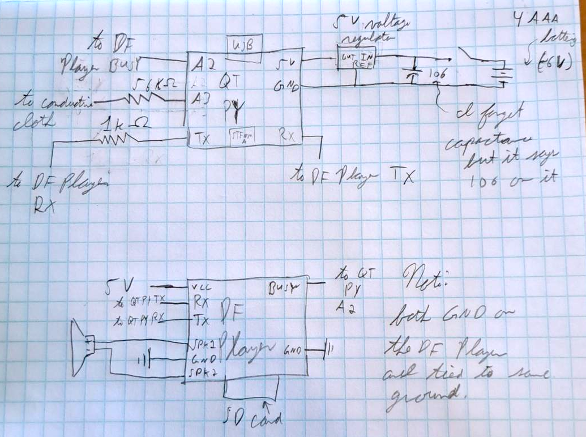

Figure 3. Schematic Sketch. Stephan Dobri.

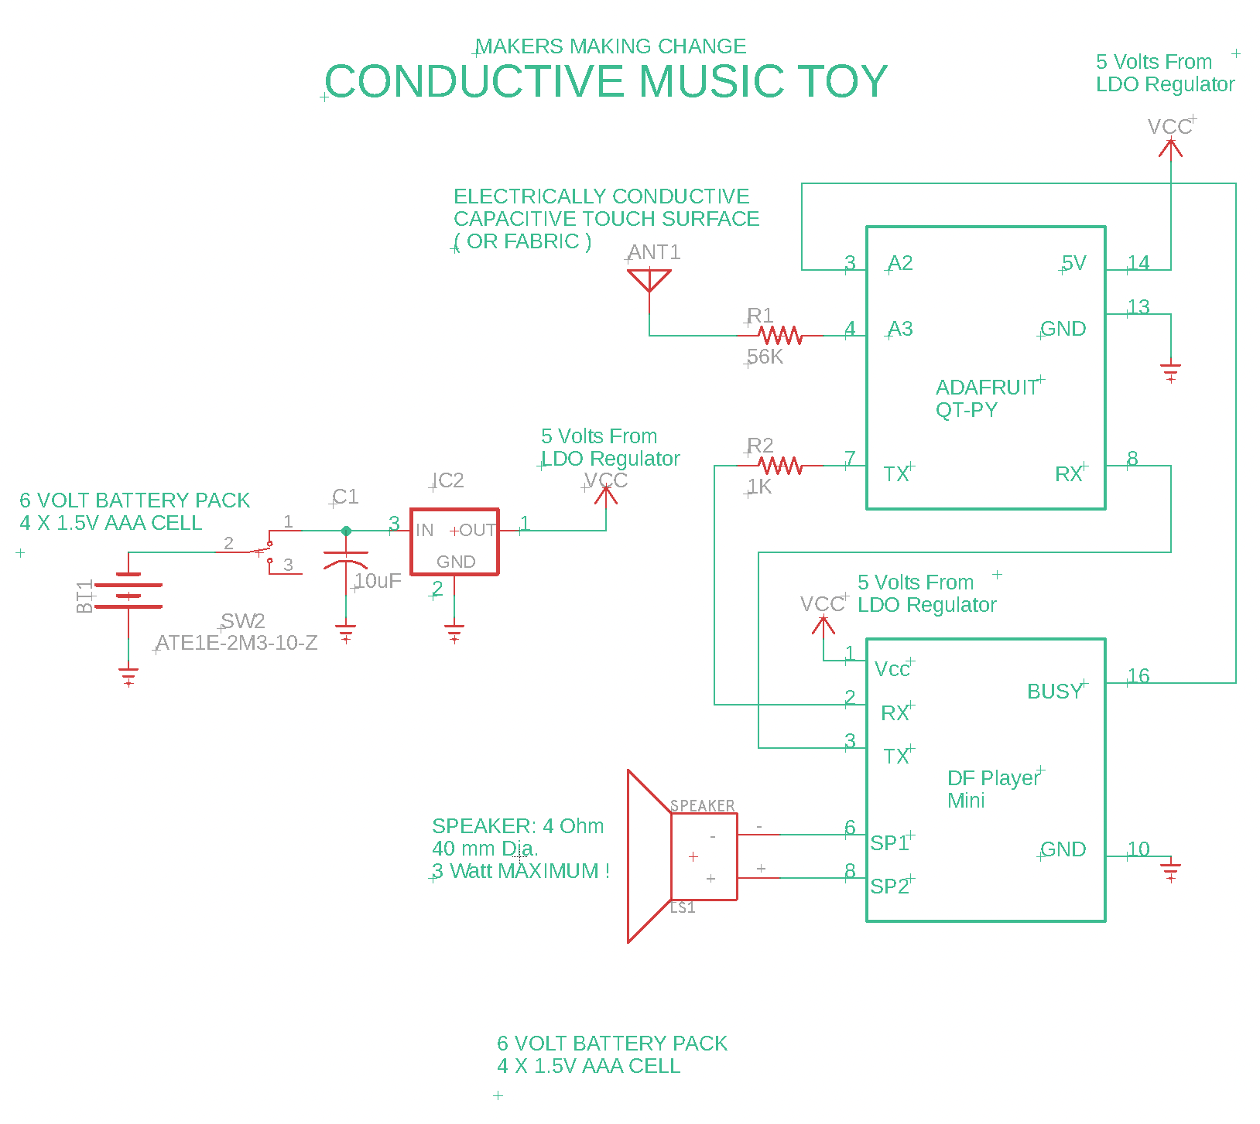

Figure 4. Electrical Schematic.

## Component Selection

### Microcontroller

Adafruit QTPY SAMD21

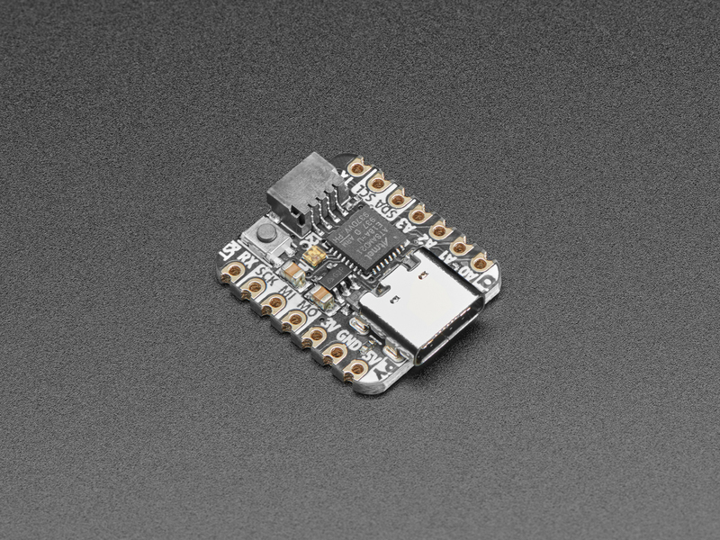

Figure 5. Adafruit QTPy SAMD21. CC SA-BY. <https://learn.adafruit.com/assets/95170>

### Speaker

Choosing the speaker for this design was relatively straightforward as the battery constraints and low voltage circuitry necessitates the use of low impedance speakers. Low impedance speakers are typically only available in 4 ohms, and 8 ohms from manufacturers. For a design, running on 3 to 5 V circuitry, 4 ohms is clearly the best choice, as higher voltages are required to drive 8 ohm speakers to a suitable volume level. As for physical size, a 40 mm speaker was chosen, as larger speakers would mean the toy would become too large for handheld use. The final choice was to use a plastic cone speaker rather than a paper cone, as a plastic cone can withstand water, and water-based, cleaners.

### Sound Module

The DFPlayer mini was chosen due to its sub miniature size, built-in 3 W audio, amplifier, and ability to be controlled by Arduino type microcontrollers. Additionally, the DFPlayer mini can except a microSD card within its own microSD card slot. This means that no external SD card reader is required. Finally, the DFPlayer is a very low cost, coming in at under $10.

The Sound Module connects to the microcontroller using a serial connection.

### Power Source Selection

The choice was made to go with a 6 V battery pack comprised of four AAA batteries. Batteries were an obvious choice, as the design is for a toy that will be carried around by small children. AAA batteries are available from most shops in both rechargeable and non-rechargeable types and are considered safer than lithium type batteries. Other readily available batteries, such as C and D type cell, are too large and heavy for a small carry around toy. The quantity of cells needed is determined by the volt, the voltage requirement of the circuitry. In this case, both the micro controller and the DFPlayer mini can be powered by 5 V. While the microcontroller can be driven by as little as 3 V, the DFPlayer requires a minimum of 5 V. Furthermore, battery ageing needs to be considered, so it’s better to start with a slightly higher voltage and regulate down to the desired voltage. In this manner, the circuit voltage remains stable. A small three pin 5V LDO regulator was chosen to trim the small excess voltage from the battery. An LDO (Low Drop Out) type regulator was chosen, as traditional voltage regulators usually stop working when the input voltage drops below the regulated output voltage. This allows the battery voltage to drop down to 4.5 V (the minimum required by the DFPlayer module) before the circuit stops working

### On/Off (power) switch

The slide switch was chosen to be as small as possible to be operated by a human finger. A 1-amp switch was chosen, as the circuitry in the Conductive Music Toy uses less than an amp. Larger switches would only be heavier and more expensive. An SPDT (Single Pole Dual Throw) type switch was selected, as it has a minimum of contacts to solder, while still being able change which side of the switch is considered as on or off.

### Accelerometer

The LISDH accelerometer from Adafruit was chosen for its low cost (under $10), small form, factor and ready availability from both Digi Key and Mauser electronics suppliers. While there are many suppliers that provide accelerometers with this description, we found that only the Adafruit version allows the device to be connected to a microcontroller via a solderless STEMMA type cable. This saves eight solder joints and the associated chance of wiring mistakes being made.

## **Enclosure Design**

### Shape

12 -sided

* Prevents rolling
* Feels more like a rounded handle

## Conductive Sensor

### Conductive Cloth Physical Attachment

The first design for attaching the cloth to the enclosure was to use metal snap fasteners. Two snaps would be attached to the enclosure, and the other snaps would be sewn onto the cloth. A wire was soldered to one of the snaps and ran into the enclosure to the 56k Ohm resistor in the above schematic, providing the electrical connection to the cloth. While the electrical connection worked with this method, the snaps could not hold two layers of cloth between them and would pop open very easily, so this method was abandoned.

The second method was to use adhesive backed hook and loop fasteners to attach the cloth to the enclosure. The adhesive backing was used to attach the fastener to the enclosure and onto the cloth. The cloth could then be attached to and wrapped around the enclosure. Since the cloth is difficult to solder, the electrical connection is created by a strip of copper tape on the outside of the enclosure to which the wire leading to the resistor is soldered. This method proved effective for the time being and is implemented in the prototype. There needs to be some long-term testing to assess how well the adhesive sticks to the cloth over time.

### Conductive Cloth Electrical Attachment

Wires soldered to snap

### Clothes vs. Tape

Cloth

* More to difficult to attach to handle
* More difficult to attach the electrical connection
  + Punch and snap required specialized hardware
  + Stainless steel conductive cloth hard to solder to
* Need to wrap around the enclosure – harder to open two-part split enclosure
* More difficult to clean

## Firmware

### Capacitive Touch Calibration

1. Sets baseline when first powered
2. Compares current value to adjustable threshold
3. Adjusting Volume

# V0.1 – Minimum Viable Product

## Summary

1. Total cost
2. Total print time / total number of printed components
3. (estimated assembly time)

## Features

1. Slide switch for controlling power
2. 4 internal AA batteries for power
3. 4 M3 screws to secure enclosure
4. Code adjustable volume
5. Supports 32GB SD card
6. Grasp and Play Operating Mode

### User Interface

Primary User

1. Lift to play music

Secondary User

1. Control power
2. Add / change songs by opening and modifying files on SD Card

Code

1. Adjust volume
2. Adjust capacitive touch sensitivity

### Operating Modes

1. Grasp and Play
   1. Cycling power resets to first file
   2. Grasping toy will cause music to play
   3. If grasped long enough, will cycle to next song
   4. If dropped, music will pause
   5. If grasped again, music will un-pause

## Internal testing

Testing while on battery power.

## Testing

(Any specific questions to address testing?)

1. Volume? Is there a need to adjust the volume
2. Adjusting volume with a potentiometer feeding an analog input.

## Opportunities for Improvement

1. Recess power switch?
2. Consider more secure cloth attachment method (integration into case, copper tape, glue, etc)
3. Recess enclosure-fastening screws
4. Simplify method / number of screws for opening enclosure
5. Investigate printability of sliding rails
6. Add accelerometer functionality

# V0.2 – Third Party Capacitive Touch Chip

Touch Sensor –

## Testing

1. Works on battery
2. Works by attaching wire from third party breakout board to copper tape on holder
3. (40 second recalibration time?)

# V0.3 – Third Party Capacitive Touch Chip

## Component Selection

### Touch Sensor – Adafruit MPR121 Module

The Adafruit MPR121 is a 12-channel capacitive touch sensor module with an I2C interface. The module is based on the MPR121 IC by Freescale Semiconductor. Intended for MP3 players, and other low-power, hand-held electronics. Power consumption for this chip is extremely low, coming in at 29 μA average supply current.

MPR121 Fact sheet: <https://www.nxp.com/docs/en/fact-sheet/MPR121FS.pdf>

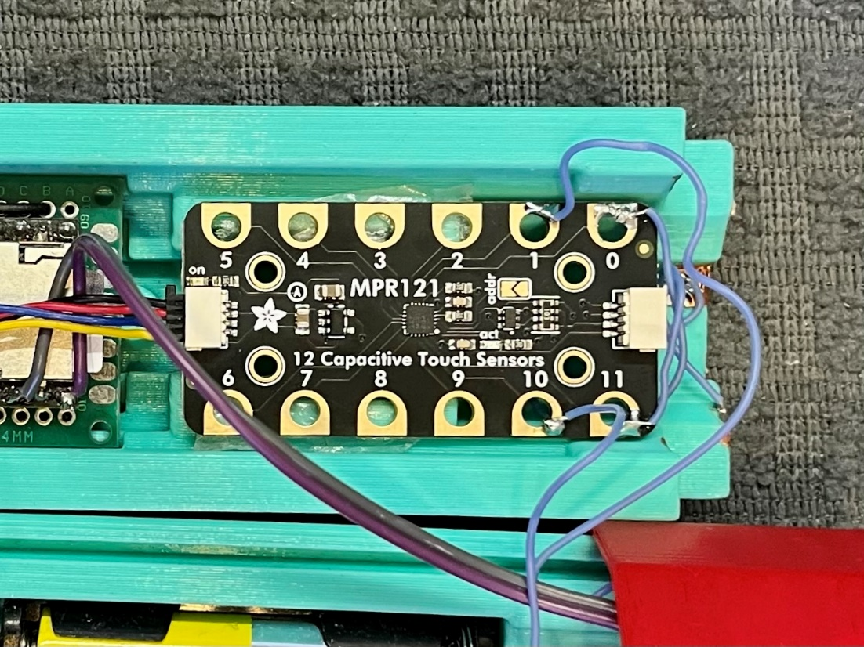

MPR 121 Module wiring:

The Adafruit MPR 121 module is connected to the QT-PY micro via a standard Stemma cable, which carries the basic I2C bus wires (Black=GND, Red =VCC Blue = Data Yellow = CLKor clock) The music toy has a set of 12 adhesive copper strips for touch sensing. The strips are wired together in four sets of three. A wire from each quadrant is then connected to one of the 4 input pads of the MPR-121.

Testing Questions

1. Activation on touch vs proximity? The Adafruit module activates, only on touch based on the testing that was done with the conductive music toy. This was done by approaching a finger to a capacity sensor pad and noting that the sensor did not trigger, even when the finger was within a millimeter of the touchpad. It was found that activation could occur through very thin paper or plastic material, however this this still “physical contact” sensation for a human finger.
2. Activation on contact vs grasp vs lifting? It is expected to be possible to differentiate between touching and grasping by taking advantage of multiple sensor, input, lines of the MPR 121. A single touch is unlikely to trigger multiple input lines simultaneously. A single touch is unlikely to trigger multiple input lines simultaneously. Therefore, grasping by hand can be assumed, if multiple input lines are triggered.

### Opportunities for Improvement

1. Modify enclosure
2. Add On/off label
3. External / easier access for MicroSD card?
4. Add accelerometer to better determine between grasping and lifting

### User Testing

The most recent version of the Conductive Music Toy was built and sent to the original requester, 4 years after the request was made. In the interest of getting, it to the tester as soon as possible, no changes were made to the SCAD enclosure to increase makeability. The existing enclosure was altered with a Dremel after printing to accommodate the parts, and it had to be fully glued shut once assembled.

A quick, basic, software implementation was written that covers the basic operating loop that the tester asked for, without any advanced grip detection or other advanced features.

### Maker Feedback

* Solder joints to copper tape are difficult and fragile
* Enclosure needs more room for wires/connections between components
* Enclosure needs a bit more tolerance between parts, especially when things such as copper taper are being inserted between them

### User Feedback

Emily Lee from Nurture Society for Learning and Development

“Hi,

I'm sending a quick update with some feedback on the fun conductive music toy you've sent us for trial with my client - thank you again so much for hearing me out, finding a way to make this crazy idea happen and being open to feedback along the way.

Key observations so far:

-the size and shape seem pretty good. The diameter works fine for her hand - it's about the size of her hand railing on the stairs so works pretty well. I was initially a little worried it might be heavy for her but thus far she's not holding it independently and I suspect she can navigate it okay once she's really sustaining her grasp longer to carry it with her. Probably wouldn't want it to be too much heavier.

-sound level: it's a bit loud - we stuck a sock on the end at times to lower the volume

-music loaded: it took us a little while to realize that we could just hold it for a long time to get the songs to advance and change. Seems that when we turn it off, it resets to the first song. Now that we know this, we can play around with it and hold it for awhile to get it to a new song that lights up her reaction!

-touch functionality: for some reason when it's initially turned on it takes a little time to warm up and feel good about its existence - it helps to have an adult muck about with it for a few minutes to help it warm up and be responsive to her touch

wish list items:

-stand system: I'm going to try (?) to make a little stand for it to keep it in a vertical upright position as this makes it easier for her to grasp - like a docking system that allows her to pick it up in that vertical orientation. I'll probably try a little foam or cardboard - a 3D printed thingy in the future that fits would be cool. Right now, she holds it best when we hold the end portions (VERY HELPFUL feature - as this allows us to hold it up in place and NOT activate it, waiting for just HER touch to activate it).

She's most often using her hands to grasp it well when she is using it to stabilize herself - so picture that she's on a physio ball with some hands on help from me - I challenge her balance a little and she reaches out to the conductive toy to stabilize herself - I'm holding it up in the air for her to grab - she had some GREAT visual looks to it and smiles when the music activated. She needs lots of time with this to keep building her recognition of it and understanding of its cause/effect function.

-long term usage: as noted when you sent it, being able to charge the battery and change the music stored on it through a port would be great

-it'd also be great to have a way to advance the songs with a single button (for the adult to do, so not needed to be special for kid) - thinking here that her music interests change quickly and it's really helpful for her when we change the song up!

Again - I want to send a really big thank you to the team for this opportunity - it feels really good to have a new idea to support this kid, help her light up and teach her something new with something that literally does not exist out there in the world.

THANK YOU!

### Follow Up User Meeting

Brief follow up meeting with the user to talk about the feedback given and get some more detail

* Song skip button to keep it fresh
* Made a stand to hold the device upright
* Want the volume turned down a bit, but user volume adjustment is not a priority
* Startup issues may be due to users touching the tape while turning it up and skewing initial calibration

### Next Steps

* Improve enclosure
* Add ability to change batteries/charge the device
* Add the ability to change songs loaded on the device
* Add a recessed switch to skip to the next song without letting it play all the way through
* Secondary-user accessible volume control

# V1.0 Musical Grasping Training Aid

## Proposed Changes

1. Improve make ability and usability of enclosure
   1. Add ability to change batteries
      1. Integrating a commercially available battery holder
      2. Creating a 3d printed battery holder and use commercially available battery contacts
         1. Copper tape?
   2. Power switch
   3. Add a recessed switch so secondary user can skip to the next song
      1. (Currently the only way to advance the song is to activate the device and wait until the entire song plays)
   4. Secondary user access to the SD card to change songs
      1. Sufficient instructions for reasonably tech savvy user to remove SD card, connect to computer, load songs using specified numbered file format, replace SD card
   5. Consider adding secondary user accessible control for adjusting volume
      1. 1 button
         1. toggle through levels
         2. short press / long press
      2. 2 two buttons – volume up / volume down
      3. Potentiometer?
      4. Using the touch sensor / other existing input to control volume
   6. Ensure sufficient clearance for cables, etc.
   7. Maintain diameter
   8. Maintain or reduce weight
2. Documentation
   1. User Guide
3. Component Changes
   1. Bluetooth-enabled microcontroller (e.g., XIAO nrf52840)
      1. Training Aid + Smartphone App
      2. Training Aid + Bluetooth Microcontroller
   2. Alternate Music Player
      1. Adafruit Audio BFF Add-on for QT Py and Xiao (<https://www.adafruit.com/product/5769>)

## Requirements

### Goals

|  |  |
| --- | --- |
| G01 | To motivate someone to pick up and hold an object by playing sounds while the object is being held. |
| G02 | Lightweight |
| G03 | Robust |
| G04 | The ability to continue to motivate the user |
|  | A secondary user (e.g., therapist, aide, caregiver, parent) must be able to adjust some settings on the device. |

### Functional Requirements

|  |  |  |
| --- | --- | --- |
| F01 | The device must be completely self contained (sound comes out of the device) |  |
| F02 | The device must play music when being held and stop when not being held |  |
| F03 | Users must be able to load their own music onto the device. |  |
|  | User must be able to periodically change the music on the device. |  |
| F04 | The device must be small enough for a child to hold (no larger than a toilet paper roll) |  |
| F05 | The device must be light enough for a child to hold. |  |
|  | A secondary user must be able to control the power state of the device. |  |
|  | A secondary user should be able to control the volume of the device |  |
|  | A secondary user should be able to skip to the next song. |  |
|  | A secondary user should be able to access the device controls without the use of tools. |  |
|  | The primary user should not be able to access the controls. |  |
|  | The secondary user must be able to change the batteries. |  |
|  | The primary user must not be able to access the batteries. | Safety |
|  | The secondary user should be able to access the batteries without tools. | Convenience |

### Non-functional Requirement

|  |  |
| --- | --- |
| NF01 | The device should be rugged enough to handle being dropped and possibly thrown by small children |

### Constraints

|  |  |
| --- | --- |
| C01 | Battery must deliver 5V (or just over) as lower voltages will be incapable of producing sufficient volumes in an audio amplifier, or audio module. |
| C02 |  |
| C03 |  |

## Design Features

|  |  |  |
| --- | --- | --- |
|  | Version V0.3 (MVP) | Version V1.0 |
| User Interface | On/Off Button | On / Off Button Volume Control  Ability to skip songs |
| Battery Access | None (enclosure glued shut) | Accessible by secondary user |
| Capacitive Sensor Calibration | Auto-calibration (Just on startup or continuously?) | Auto-calibration |
| SD card Access | None (enclosure glued shut) | Accessible by secondary user |

### User Interface Brainstorm

V0.3

* Power switch accessible on the end cap
* Power switch is partially recessed into the end cap

V1.0

* User interface elements

User Interface Options

1. Recessed / partially recessed into the enclosure or end cap
2. Removable or openable panel or cover that prevents the primary user from accessing them
3. ~~(Wireless / secondary device)~~

### Music Control

V0.3

* Always starts at the beginning of the playlist of songs when the device is turned on.
* There is no user control to skip songs.
* When activated, current song plays. When let go, music pauses. When unit is re-activated, music continues to play

V1.0

Song Control Options

1. No control – starts at first song, only way to advance is to activate it
2. One additional control for skipping songs
3. Two additional controls for skip ahead / go back.
4. ~~(accelerometer-based gesture / shake)~~

### Volume Control

V0.3

* Volume is adjustable by code
* Volume is limited by physically covering the speaker (e.g., with a sock)

V1.0

* Secondary user volume control

Volume Control Options

1. Single tactile button that cycles through volume levels
2. Capacitive touch area (i.e., utilize one of the channels on the cap-sense board)
3. Potentiometer that is adjusted by screwdriver
4. Potentiometer that is adjustable by hand

### Music Loading

V0.3

* MicroSD card is pre-loaded with set of music and then glued into the enclosure

V1.0

* User-accessible method for changing the set of songs that are loaded on the device

Music Loading Options

1. MicroSD card is removable by the secondary user
2. Some method for attaching the device via USB cable
3. Wireless loading of music

### Battery Access

V0.3

* Sliding enclosure; requires complete disassembly
* (Glued shut)

V1.0

* Accessible by secondary user with up to one screw

Battery Access Options

1. Flashlight-style slide-in
2. Remote-control style side insertion / sliding / snap fit cover
   1. Challenging with need for capacitive copper tape on the outside
3. ~~(Built-in / non-removable Lithium batteries)~~

### Architecture

V0.3

* Two hollow cylinder halves
* Sliding connection
* Speaker cap press fit on
* Switch cap attached with screws

V1.0

* Two hollow cylinder halves
* Sliding connection
* Speaker cap press to fit on
* Switch cap attached with screw

Architecture Options

1. Two halves + end caps
2. Hollow tube + insert.

## Features

* On/off switch to control device
* Two push buttons (one for volume control and another for song skipping)
* Removable cap to allow for battery access

## User Interface

### Primary User

* Grasp to play music

### Secondary User

* Sliding power on/off switch
* Change volume
* Skip song
* Change Batteries
* Change songs on microSD

### Code

* Adjust capacitive touch sensitivity
* Adjust volume level presets

## Operating Modes

1. Grasp and Play
   1. Cycling power resets to first file
   2. Grasping toy will cause music to play
   3. If grasped long enough, will cycle to next song
   4. If dropped, will pause
   5. If grasped again, music will un-pause
   6. If left button is pressed, the volume will cycle through presets
   7. If right button is pressed, the song will be skipped, and the next one will play

## Testing

1. Skip Button works
2. Volume Button works and cycles through 6 volume settings (1 press = next volume setting and it starts at the lowest volume, 5)

## Touch Sensing

### Copper Tape

The device uses 12 strips of copper tape along the edges of the outer surface of the device enclosure. The 12 strips are split into four quadrants (3 strips attached together per quadrant) and soldered into pins 0-3 of the MPR121 capacitive touch sensor module. To play music, two or more of the four capacitive touch sensor pins must be activated above the defined threshold value. This helps differentiate when the device is grasped as opposed to just being touched. Grasping the device requires more than one of the copper quadrants to be activated at the same time whereas, touching actives just one quadrant. Of course, if the device is being touched with multiple fingers to activate multiple quadrants, then this may cause the device to play music when it is not grasped. This is an area with room for improvement for future versions which can incorporate an accelerometer to further distinguish between grasp and touch.

## Detailed Design

## Concept Sketch

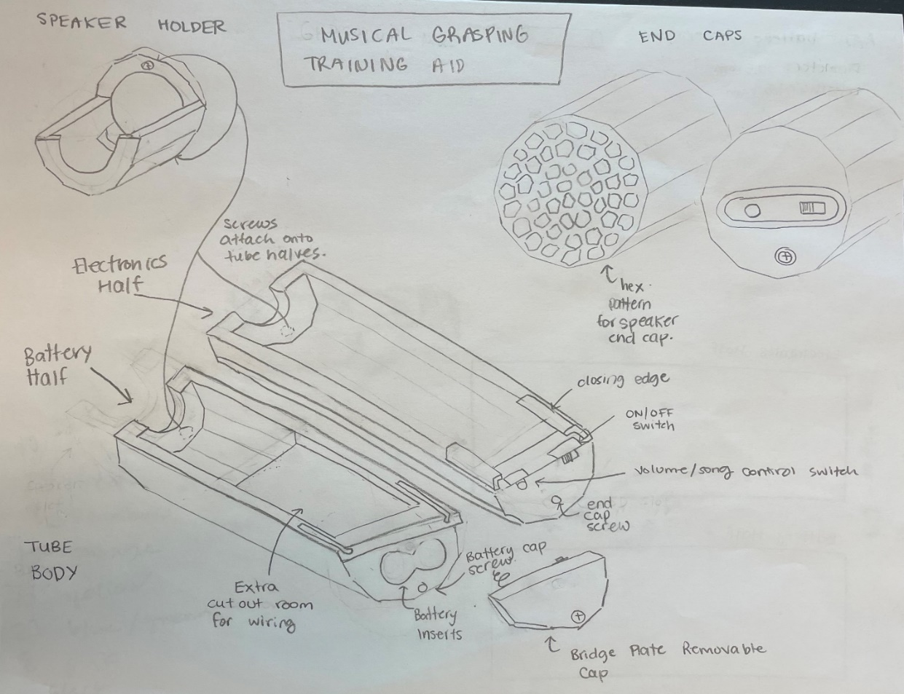

## Schematic

## Component Selection

### Battery Clips

The battery clips in this new version replace the two AAA battery holders. They will be used to create a built-in battery compartment within the device to let the user replace the batteries when needed. The bridged endplate will be place on the cap that closes the compartment while the other two will be attached to the inside of the battery compartment. These clips are small and lighter than the battery holders and allows for easy access to the batteries, like a flashlight.

### Updated Adafruit MPR121 module

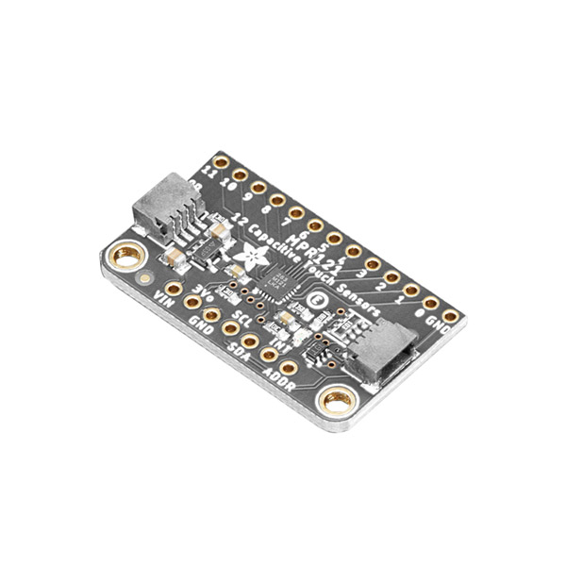

The MPR121 capacitive touch sensor module was updated with this new version, which has the same functionality as before but is significantly smaller. The board’s small size increases the room inside the device which will help make additional room for wiring. The capacitive touch sensor is still connected to the QT-PY microcontroller using a standard Stemma cable. The copper tape attached to the outer surface of the device enclosure is split into four quadrants, each quadrant being attached with a wire from pins 0-3 on the MPR121 module.

## Enclosure Design

### Battery Compartment

### MicroSD Card Slot

### Volume Control and Skip Buttons

## Firmware

### Capacitive Touch Calibration

1. Sets baseline when first powered
2. Compares current value to adjustable threshold

### Adjusting Volume

1. Choose 6 different volume levels to cycle through using push button. The volume levels are 5, 8, 11, 14, 17, 20 but can be modified, and restart once fully cycled through.
2. The volume that the device starts playing music at is 5 when turned on.

## User Feedback

Hi!

Sorry for my slow response. Nothing happens quick over here it seems. Thank you for your continuing work on this cool project!

I'll answer your questions as best as I can here: (questions are bolded and answers are normal)

1. **How are you finding the stand that was designed for the Conductive Music Toy? Does it work well with the device or does the size, shape and/or orientation need to be modified?** I think the stand works well. Because of its lightweight I think it needs some Velcro to attach it to the surface of where it lives. Indigo's gross motor movements are pretty aggressive sometimes when reaching for things, so she knocks it over regularly if reaching for it. But I think some Velcro will work great.
2. **Do you think the battery access design will improve your user experience with the device? If not, do you have any alternative recommendations to the proposed design?** I think battery access would be great or if it’s a rechargeable battery, then having a USB charging port would be good as well. Either system would work well, I think.
3. **Do you think the microSD card access design will improve your user experience with the device? If not, do you have any alternative recommendations to the proposed design?** Yes, I think microSD would certainly help us as the need to continually update the music is integral as Indigo's music preferences change often. Alternatively, a USB port that could allow the device to be connected to a computer to delete and upload new music files directly would be potentially easier and less steps for the user.
4. **Do you think the volume button feature will improve your user experience with the device? If not, do you have any alternative recommendations to the proposed design?** A volume button would be most useful as different environments pose different listening challenges. In a quiet room the current volume of the unit is too loud.
5. **Do you think the song skipping button feature will improve your user experience with the device? If not, do you have any alternative recommendations to the proposed design?** Yes, I think having the ability to skip tracks and find the most motivating music on the playlist quickly would be ideal.

I think that covers all the notes we had for it. Excited to see the next version!

Thanks again to everyone working on this. Very cool!

## Opportunities To Improvement / Future Work