# Overview

The Device Summary is intended to be a detailed summary of the device, product and maker information for the Musical Grasping Training Aid, making it easier to add to the Makers Making Change website. It is intended for anyone who will view the device listing.

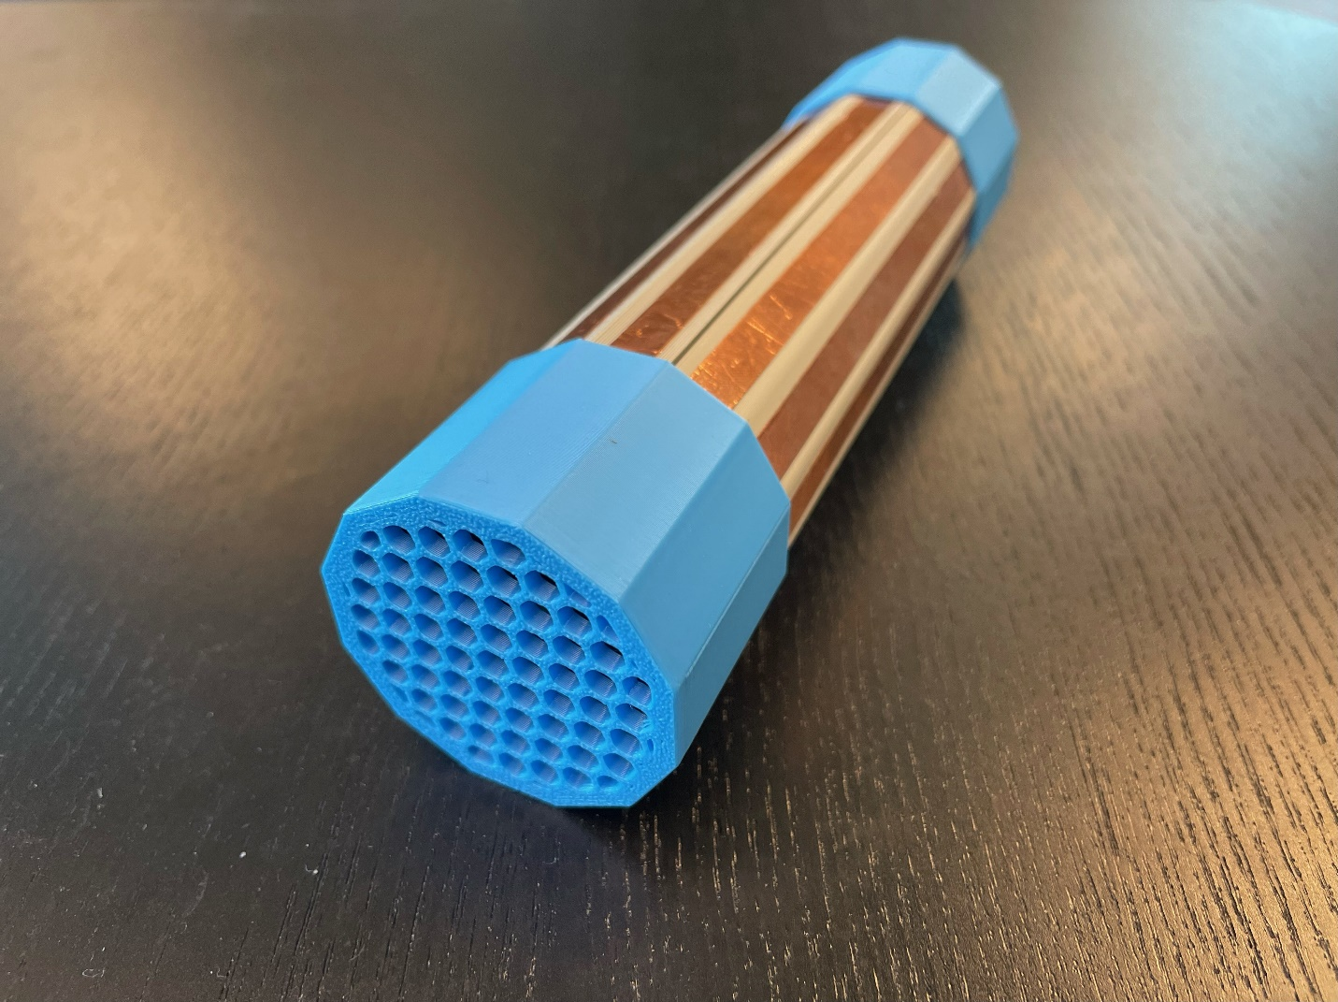

# Product Information

## Product Name

Musical Grasping Training Aid

## Device Category

Mark any relevant categories with an “X”:

|  |  |
| --- | --- |
|  | Adapted Toys |
|  | Aids for Daily Living (ADL) |
|  | Assistive Switches |
|  | Communication Aids (AAC) |
|  | Computer Access |
|  | Environmental Controls |
|  | Gaming |
|  | Keyguard |
|  | Kits |
|  | LipSyncs |
|  | Mounting |
| X | Recreation and Leisure |
|  | Seating and Positioning |
|  | Switch Interfaces |
|  | Writing Aids |

## User Value Statement

Encourages individuals with neurodevelopmental differences to use hands and learn cause and effect through grasp activated musical play.

## Designer

Makers Making Change

# Device Information

## Overview

The Musical Grasping Training Aid is designed to encourage grasping and holding and learn cause and effect. When a user holds the device, it plays music and when the device is not being held, it pauses the music. Users can upload their own music onto a microSD card inside the device and upload new or additional songs when they are no longer motivated by the current selection of songs.

## Disability Type

Select one or more disability types and mark with an “X”:

|  |  |
| --- | --- |
|  | Agility / Dexterity |
|  | Arthritis |
| X | Cognitive |
|  | Hearing |
|  | Mobility |
|  | Pain |
|  | SCI |
|  | Vision |
|  | Other |

## Disability Type Description

This device is intended for people with neurodevelopmental differences and individuals who are trying to learn the concept of cause and effect.

## How To Use

**Power On**

To power on the device, flip the switch on the side of the device from OFF to ON.

**Setup**

After turning on the power switch, wait a few minutes for the device to calibrate. To properly calibrate the device, make sure it is placed in the stand, and it is not being touched.

**Musical Grasping**

After calibration, the device is ready to be used. The device senses grasp through the copper tape along the tube of the body and will only play music if it is being grasped along this surface. To play the music loaded onto the device, grasp the copper tape activation surface on the device. Note, the device will not play music if it is being grasped by the end caps.

Once the device is no longer held and let go, the music will pause and stop playing. To continue playing music, the user must grasp the device again.

**Volume Control**

To change the volume of the music being played, press the left button on the side of the device (above the VOL label). The device has six volume levels (5, 8, 11, 14, 17, 20), and each press cycles to the next volume setting. When calibrated, the device starts at level 5 and will cycle through the remaining levels. If the volume button is pressed while the device is playing music at the last level, it will restart to play music at the first volume level.

**Song Skip**

To skip a song, press the right button on the side of the device (above the SKIP label). This will skip to the next song loaded onto the microSD card inside the device. If the skip button is pressed while the last song is played, the device restarts the song list and plays the first song.

## Estimated Cost

The estimated material cost of the device for a single build:

|  |  |
| --- | --- |
|  | $0 - $10 |
|  | $11 - $25 |
|  | $26 - $50 |
| X | $51 - $100 |
|  | $101 - $250 |
|  | $250+ |

## Attribution

Designed by Neil Squire / Makers Making Change. An [initial design](https://github.com/dbhaig/Musical_Toy) was created by Don Haig.

Contributors:

* Didi Dimitrova
* Derrick Andrews
* Stephan Dobri
* Brad Wellington
* Jake McIvor

This design incorporates several commercially available open source hardware components from [Adafruit](https://www.adafruit.com/) and [DFRobot](https://www.dfrobot.com/). The Musical Grasping Training Aid firmware utilizes the [Arduino](https://www.arduino.cc/) development platform, and multiple libraries developed and shared by the open source community. Full details are available on [GitHub](https://github.com/makersmakingchange/Musical_Grasping_Training_Aid).

# Maker Information

## Project Skills

Mark the required project skills with an “X”:

|  |  |
| --- | --- |
| X | 3D Printing |
|  | Custom PCB |
| X | Electronics |
|  | Laser Cutting |
|  | Mechanics |
| X | Software |
| X | Soldering |
|  | Woodworking |
|  | Other |

## Skills Description

This is an advanced build that requires careful soldering of components to a protoboard and flashing firmware.

## Tools Needed

|  |  |
| --- | --- |
| X | 3D Printer |
| X | Common Hand Tools |
|  | Common Power Tools |
|  | Laser Cutter |
| X | Soldering Iron |
|  | Specialized Tooling |

## Print time (hrs)

3.90

## Assembly time (hrs)

4.00

## Build Instructions

This build consists of a number of off-the-shelf electronic components that are soldered onto a protoboard and assembled into a 3D printed enclosure. Firmware is then flashed to the microcontroller.

For full instructions, please refer to the Maker Guide.

## Download Link

## <https://github.com/makersmakingchange/Musical_Grasping_Training_Aid/archive/refs/heads/main.zip> Project Link

<https://github.com/makersmakingchange/Musical_Grasping_Training_Aid>

# License

## License

- Everything needed or used to design, make, test, or prepare the Open Playback Recorder is licensed under the [CERN 2.0 Weakly Reciprocal license (CERN-OHL-W v2)](https://cern.ch/cern-ohl) or later .

- All software is under the [GNU General Public License v3.0 (GPL-3.0)](https://www.gnu.org/licenses/gpl.html).

- Accompanying material such as instruction manuals, videos, and other copyrightable works that are useful but not necessary to design, make, test, or prepare the Open Playback Recorder are published under a [Creative Commons Attribution-ShareAlike 4.0 license (CC BY-SA 4.0)](https://creativecommons.org/licenses/by-sa/4.0/).