# Overview

This document contains the necessary information to use the Musical Grasping Training Aid, a device that motivates an individual to pick up and hold it by playing music while the object is being held.

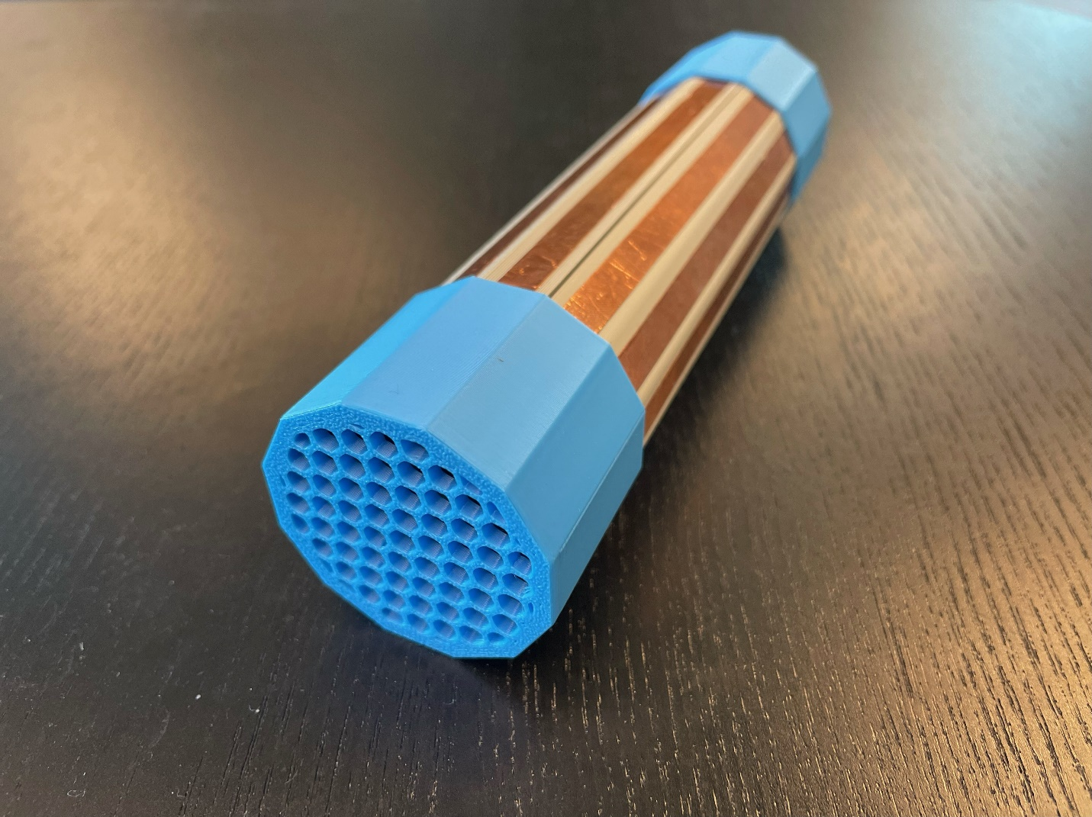

Contents

Overview 1

Introduction 3

Features 3

Specifications 4

Compatibility 5

Usage 5

Power On 5

Calibration 5

Playing Music 5

Volume Control 5

Song Skip 5

Uploading Songs 5

Changing Batteries 6

Care 7

Cleaning 7

Troubleshooting 7

Music Not Playing 7

Disposal 7

## Introduction

The Musical Grasping Training Aid is designed to promote grasping and holding. When a person holds the device, it plays music and when the device is not being held, it pauses the music. Users can upload their own music onto a microSD card inside the device and upload new or additional songs when no longer motivated by the current selection of songs.

The training aid senses when it is being grasped using a conductive activation surface created by strips of copper tape along the device’s outer surface. Users must be touching the copper tape for the device to play music.

## Features

|  |  |  |
| --- | --- | --- |
| Number | Feature | Functionality |
| 1 | Speaker | Plays music |
| 2 | Speaker End Cap | Covers the speaker |
| 3 | Conductive Tape | Senses grasp and activates music (activation surface) |
| 4 | Volume Button | Cycles through volume levels |
| 5 | On/Off Switch | Turns device on/off |
| 6 | Switch End Cap | Covers switch, buttons, battery cap and microSD card slot |
| 7 | Skip Button | Skips through the music files uploaded on microSD card |
| 8 | Battery Cap | Provides access to device batteries |
| 9 | MicroSD Slot | Provides access to microSD card for music file upload |

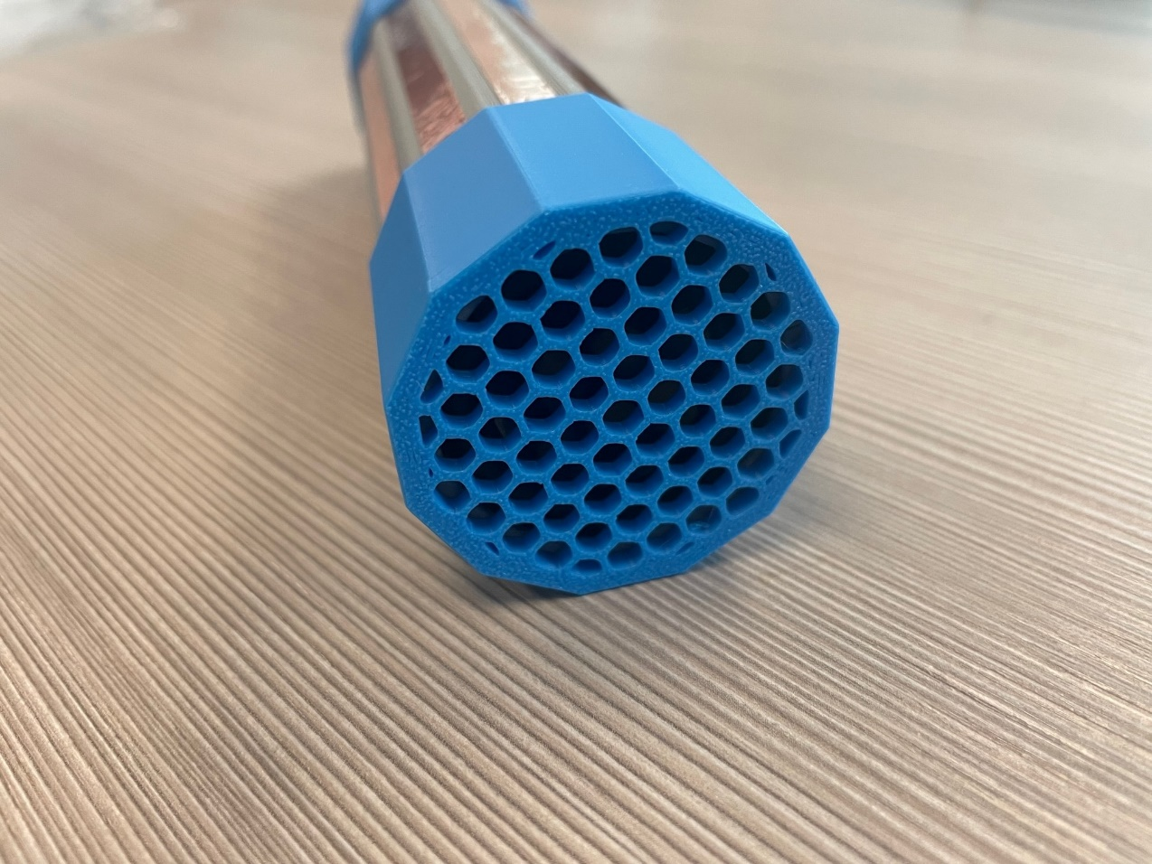

2

3

1

1

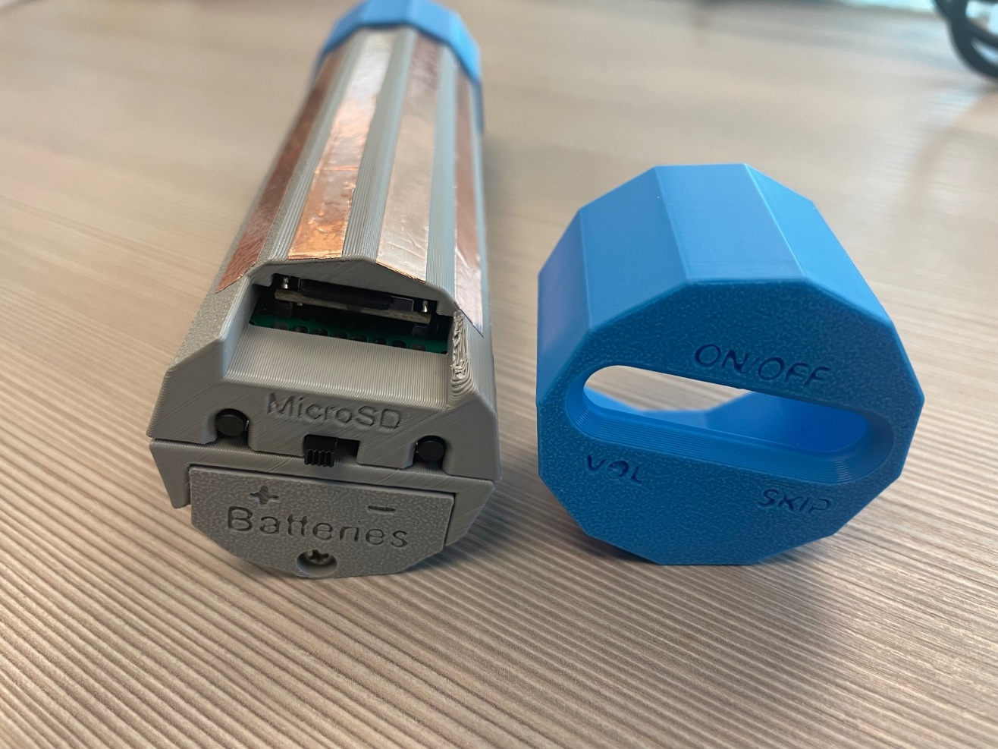

6

8

4

7

5

9

The Musical Grasping Training Aid is a long tube, with two capped ends. The speaker is located on the end with the honeycomb pattern, and there is a power switch, a volume and song skip button on the other end cap. Underneath this switch end cap, there is battery cap which provides access to the batteries. There are twelve strips of copper tape along the outside of the device enclosure which forms the activation surface for song play. When the training aid is on and someone is touching the copper tape activation surface, the device will start playing the first song that was uploaded to the microSD card. When you stop touching the copper tape activation surface, the device will stop playing music.

The device will always start playing the first song loaded onto the microSD card after it is turned on. If the toy is held for the entire duration of the first song, it will start playing the next song uploaded to the microSD card. The toy will continue to loop through all the songs on the microSD card, resetting anytime it is turned off and on again.

The buttons located on the side of the device allow for volume control and song skip feature. The left volume button will cycle through different volume settings and the right song skip button allows you to play the next song onto the microSD card.

## Specifications

|  |  |
| --- | --- |
| Item | Musical Grasping Training Aid |
| Length | 165 mm |
| Diameter | 43 mm |
| Music Upload | microSD card (different storage options available) |
| Mass [g] | 200 g |
| Power | 4 x AAA Batteries |

## Compatibility

The Musical Grasping Training Aid currently has no compatibility with other devices and is used as a standalone device.

## Usage

### Power On

To power on the device, flip the switch on the side of the device from OFF to ON.

### Calibration

After turning on the power switch, wait 10 seconds for the device to calibrate. To properly calibrate the device, make sure it is placed in the Musical Grasping Training Aid stand or held by the two end caps, and it is **not** being touched.

### Playing Music

To play music, the device needs to be grasped along the copper tape along the tube body. The toy will play music while it is being held and stop playing music when it is no longer being held. Once the device is grasped again, the music will resume playing where it stopped.

Use the slide switch to turn the toy off when not in use.

### Volume Control

To change the volume of the music being played, press the left button on the side of the device (above the VOL label). The device has six volume levels (5, 8, 11, 14, 17, 20), and each press of the button cycles to the next volume setting. When calibrated, the device starts at level 5 and will cycle through the remaining levels. If the volume button is pressed while the device is playing music at the last level, it will restart to play music at the first volume level.

### Song Skip

To skip a song, press the right button on the side of the device (above the SKIP label). This will skip to the next song loaded onto the microSD card inside the device. If the skip button is pressed while the last song is played, the device restarts the song list and plays the first song.

### Uploading Songs

To upload songs onto the device, turn off the power switch and gently pull off the switch end cap. Once the end cap is removed, gently push the card from the reader as indicated by the arrow until you hear/feel a click. The microSD card will then slightly pop out of the reader, and you can gently pull it out. Connect the microSD card to your computer (microSD card adapter may be required).

When uploading songs, the files must be uploaded using a specific format, order and naming convention to work properly.

**Step 1.** Ensure that the songs are in .mp3 format. If your music files are not in.mp3 format, you can use an online mp3 converter to correctly format your music files.

**Step 2.** Upload songs one at a time. The order in which the songs are uploaded is the order the device will play the songs (i.e. the first song uploaded will be the first song to play).

**Step 3.** Name the song files using the correct naming convention. The DFPlayer Mini requires that all files follow a specific naming convention to play in the correct order. First, create a folder labeled “mp3” on a microSD card. Then copy the music files one by one inside the folder in the desired playing order. Each song file must be renamed to start with 4 digits, ranging from 0001-9999. After the last number, the song file may be named (i.e. a song file named “[SongName].mp3” would need to be titled “0001[SongName].mp3”).

Note: It is important that the songs are named in ascending order from 0001 to 9999 in the order they were uploaded onto the microSD card. When copying the files into the folder, time stamps are created which may result in no music being played if the timestamps do not match with the track numbers.

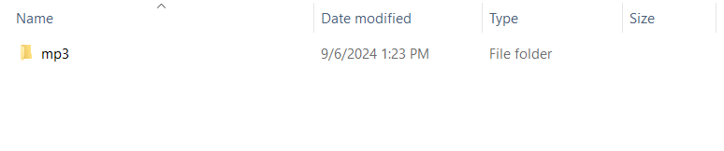

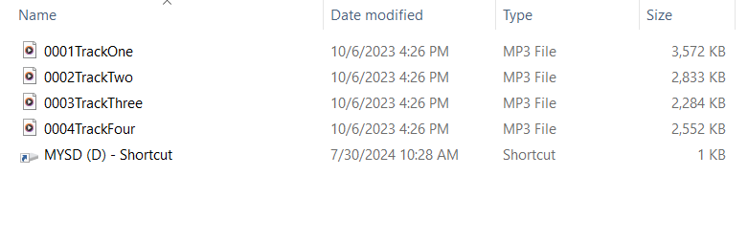

After uploading all the song files, hover your computer mouse over the USB tab along the left side of the panel in File Explorer. Press and hold the left mouse key and drag it into the “mp3” folder and let go of the mouse key. This will create a shortcut to the USB which will allow the songs to loop once they have been played. Once all songs are uploaded, insert the card back into the training aid by pressing it into the reader until it clicks and locks back in place. Turn the toy back on and grasp the device to play the new music.

### Changing Batteries

The replace the batteries, turn the device off and remove the switch end cap. Once the end cap is removed, use a Philips screwdriver to remove the battery cap allowing access to the four AAA batteries inside. Tilt the device to slide out the old batteries and insert the new batteries. Pay attention to the positive and negative label on the battery cap to ensure that batteries are correctly placed inside the device. Secure the battery cap back on using the screw and put the end cap back on.

## Care

The Musical Grasping Training Aid is made of 3D printed plastic. Exposure to high heat may cause warping and/or negatively affect function. Extended exposure to sunlight will also weaken the plastic on the device.

The device contains electronics and is not waterproof. If the device becomes wet, make sure it is off and do not use it until it has completely dried. It may help to open any electronic enclosures to speed up drying and ensure it has completely dried.

### Cleaning

The Musical Grasping Training Aid can be wiped with a damp cloth. Do not use hot water or clean in a dishwasher. The device is not waterproof and will be damaged if submerged under water.

## Troubleshooting

### Music Not Playing

Music doesn’t play when device is grasped.

* Double check to make sure the song files are uploaded to the microSD card using the correct naming convention. Refer to the “Uploading Songs” section above.
* Double check speaker connections inside the device. To do this, pull the endcaps off the device and unscrew the four screws located along the body of the device. Once removed, gently open the device, making sure not to pull apart any wiring and lay the two halves side by side on a flat surface. Gently remove the power switch and two pushbuttons from their inserts and then remove the protoboard, MPR121 sensor and speaker out of the device enclosure. Place all the electrical components on a flat service, making sure you can see the circuit. Note that the battery connections will still be attached to one side of the device enclosure and do not need to be removed. Double check all the solder joints and wiring connections as shown in the Maker Guide.
* Make sure microSD card is inserted.

## Disposal

Disassemble the Musical Grasping Training Aid and separate out the recyclable and compostable components, and those that must be thrown out. Electronics and batteries should be disposed of following your local waste management guidelines.

PLA filament may be industrially compostable in your area. Check with your waste management company if PLA can be composted or must be thrown in the garbage.