# 3D Printing Summary

|  |  |
| --- | --- |
| **Metrics** | **Enclosure** |
| Total Print Time (hr:min) | 3:52 |
| Total Number of Components | 2 |
| Typical Total Mass (g) | 47.86 |
| Typical Number of Print Setups | 1 |

Note that the optional topper prints are parametric and come in three initial sizes. The print times below are given for the medium sized toppers.

# 3D Printing Settings

|  |  |  |  |  |  |  |  |
| --- | --- | --- | --- | --- | --- | --- | --- |
| **Print File Name** | **Qty** | **Total Print Time (hr:min)** | **Mass (g)** | **Infill (%)** | **Support**  **(Y/N)** | **Layer Height/ Nozzle Diameter(mm)** | **Notes (orientation, special settings, etc.)** |
| Enclosure_Top v0.9.stl | 1 | 2:10 | 27.52 | 20 | N | 0.2/0.4 | * Print in given orientation |
| Enclosure_Bottom v0.9.stl | 1 | 1:42 | 20.34 | 20 | N | 0.2/0.4 | * Print in given orientation |
| Optional Prints | | | | | | | |
| Joystick_Camera_Mount_  Adapter v0.2.stl | 1 | 0:54 | 8.50 | 20 | Y | 0.2/0.4 | * Print in given orientation |
| Collet.stl | 1 | 0:17 | 1.00 | 20 | N | 0.2/0.4 | * Print in given orientation |
| Topper_Nut.stl | 1 | 0:27 | 5.1 | 20 | N | 0.2/0.4 | * Print in given orientation. * 4 perimeters |
| Medium_Ball_Topper.stl | 1 | 2:33 | 42.58 | 10 | N | 0.2/0.4 | * Print in given orientation * 4 perimeters |
| Medium_Concave_Topper.stl | 1 | 1:58 | 28.03 | 10 | N | 0.2/0.4 | * Print in given orientation * 4 perimeters |
| Medium_Convex_Topper.stl | 1 | 1:11 | 17.03 | 10 | N | 0.2/0.4 | * Print in given orientation * 4 perimeters |
| Medium_Goalpost_Topper.stl | 1 | 2:17 | 32.60 | 10 | N | 0.2/0.4 | * Print in given orientation * 4 perimeters |
| Medium_Stick_Topper.stl | 1 | 2:26 | 25.33 | 10 | N | 0.2/0.4 | * Print in given orientation * 4 perimeters |

# Post-Processing

* Remove any bumps or zits from the surface where the enclosure meets the lid.
* Remove any supports from the camera mount if printed.

# Customization Options

* Joystick housing can be printed in multiple colours.
* The joystick camera mount adapter is an optional add-on for mounting using ¼-20 threads
* The optional topper prints can be used to customize the joystick to users. Extra materials such as foam, felt, instamorph, etc. can also be added to further customize the joystick toppers.

# Examples of Quality Prints

**Photos of the Enclosure**

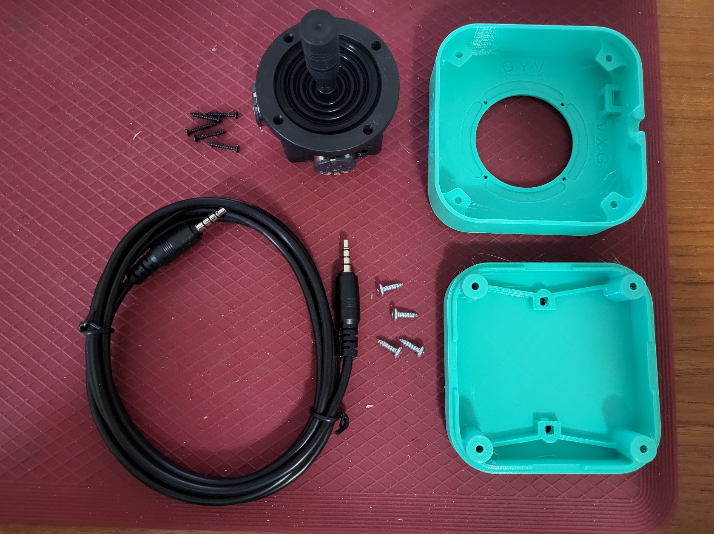

**Photos of Toppers**

**Photos of Camera Mount**

