# What is a topper?

A topper is any support, grip, or other structure added to the joystick to make it easier and more comfortable to use the joystick. Toppers can be made of a variety of materials and be customized to the user.

The Oak Joystick has a modular topper that can be easily swapped. There are three parts to the modular topper: the topper, a collet, and a nut. A variety of topper styles are available and different sizes of each. It is also possible to create a topper with a custom style or size. A wrench tool is available to make it easier to tighten and loosen the nut.

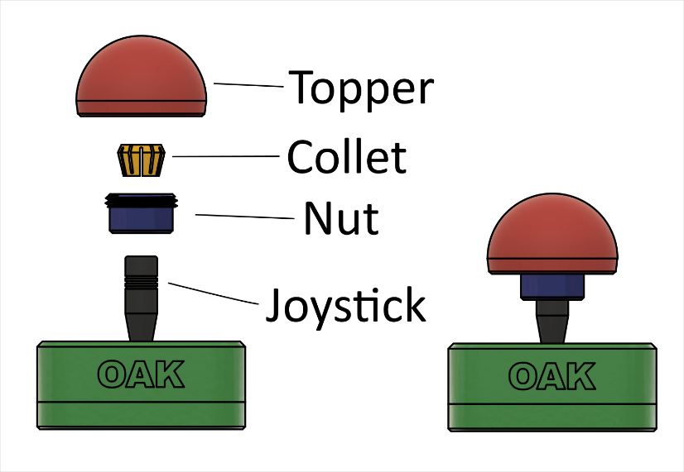

# What styles of toppers are there?

There are currently five styles of 3D printable topper: a hemispheric ball topper, a concave disc topper, a convex disc topper, a goalpost topper, and a stick topper.

Table . Topper Styles

|  |  |  |  |  |
| --- | --- | --- | --- | --- |
| **Ball** | **Concave** | **Convex** | **Goalpost** | **Stick** |
| A photo of the ball, concave, convex, goalpost, and stick toppers from left to right printed in teal PLA. | A photo of the ball, concave, convex, goalpost, and stick toppers from left to right printed in teal PLA. | A photo of the ball, concave, convex, goalpost, and stick toppers from left to right printed in teal PLA. | A photo of the ball, concave, convex, goalpost, and stick toppers from left to right printed in teal PLA. | A photo of the ball, concave, convex, goalpost, and stick toppers from left to right printed in teal PLA. |

# Which topper will be best for me?

The five topper styles are available in small, medium, and large sizing. Dimensions and scaled printouts are available to select which size is best for you.

## Ball Topper

The ball topper is ideal for someone who wants a large grip or larger target to hit to move the joystick. Note that this topper is the top half of a ball, not a full ball.

|  |  |  |  |  |  |
| --- | --- | --- | --- | --- | --- |
| Topper | Dimension | Small | Medium | Large | Image |
| Ball Topper | Diameter [mm] | 40 | 50 | 60 | **Ball topper showing diameter dimension** |

## Concave Disc Topper

That concave disc is best for someone without the capability to grip the joystick or other toppers. This topper is like a small cup that you can push on from the inside. It would be ideal for users who want to use their chin, or heel.

|  |  |  |  |  |  |
| --- | --- | --- | --- | --- | --- |
| Topper | Dimension | Small | Medium | Large | Image |
| Concave Topper | Diameter [mm] | 40 | 50 | 60 | Concave topper diagram showing |

## Convex Disc Topper

|  |  |  |  |  |  |
| --- | --- | --- | --- | --- | --- |
| Topper | Dimension | Small | Medium | Large | Image |
| Convex Topper | Diameter [mm] | 40 | 50 | 60 | Convex topper showing diameter dimension. |

The convex disc is ideal for someone with low grip capabilities but has good gross motor control and can rest their hand independently on the topper.

## Goalpost Topper

The goalpost topper is ideal for users who may not be able to independently put their hand on the topper, as the sidewalls will help to keep their hand on the joystick.

|  |  |  |  |  |  |
| --- | --- | --- | --- | --- | --- |
| Topper | Dimension | Small | Medium | Large | Image |
| Goalpost Topper | Width [mm] | 70 | 85 | 100 | Goalpost topper showing width, depth, and wall height dimensions. |
| Depth [mm] | 31 | 31 | 31 |
| Wall Height [mm] | 15 | 18 | 20 |

## Stick Topper

The stick topper is a traditional joystick grip that essentially extends the existing stick of the joystick. It features a brim around the base to keep the user’s hand from slipping down the joystick as well.

|  |  |  |  |  |  |
| --- | --- | --- | --- | --- | --- |
| Topper | Dimension | Small | Medium | Large | Image |
| Stick Topper | Grip diameter [mm] | 30 | 35 | 40 | Stick topper showing diameter, height, and base brim dimensions. |
| Height [mm] | 70 | 85 | 100 |
| Base Brim [mm] | 15 | 20 | 25 |

## Custom Topper Sizes

If none of the pre-configured options works, the toppers can be further modified through the original CAD files (Fusion 360) if different dimensions are desired.

## Custom Topper Design

Custom toppers can be designed through CAD programs such as Fusion 360 to create a topper specific to you. The [Design Rationale](https://github.com/makersmakingchange/Oak-Compact-Joystick/blob/v1.0/Documentation/Oak_Compact_Joystick_Design_Rationale.pdf) for the Oak Joystick contains all the relevant information to create a topper that will work with the current topper interface system, or to create a simple press-fit topper. The Collet.f3d file can also be expanded upon by designing a topper on and around the “Topper_Side” component.

Alternatively, other materials such as Instamorph, wood, clay, etc. can be used to create a custom topper.

# Topper Sizing Printouts

The following sheets can be printed out to see the actual size of the available toppers.