## Introduction

The One-Handed Xbox One Controller Mods are intended to give more independent use of an Xbox controller for users with limited function in one of their hands. There is both a left and right-handed model available. This [YouTube video](https://www.youtube.com/watch?v=d1hht2D5cvE&t=1s) by the original designer, Akaki, also demonstrates the usage of each device.

## Features

Left-Hand Thumbstick Arm Right-Hand Trigger Extender

Right-Hand Dpad Extender

Left-Hand Trigger Extender

Left-Hand Button Extenders Right-Hand Thumbstick Arm

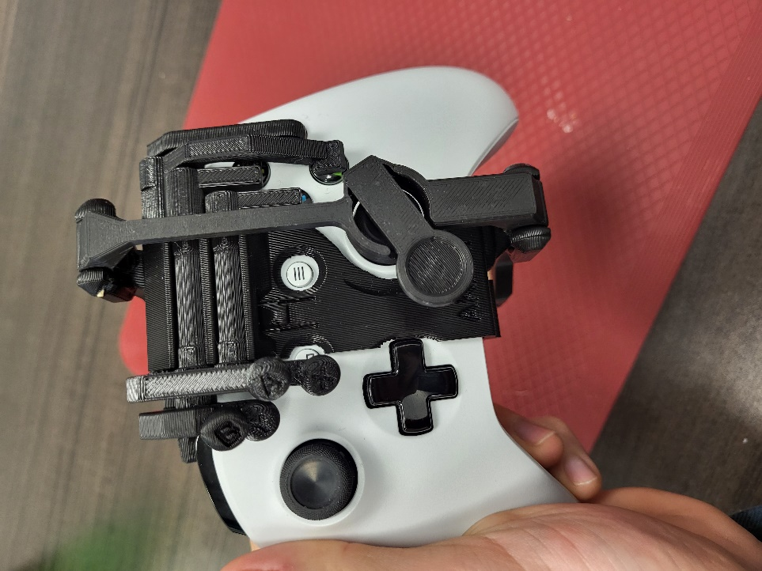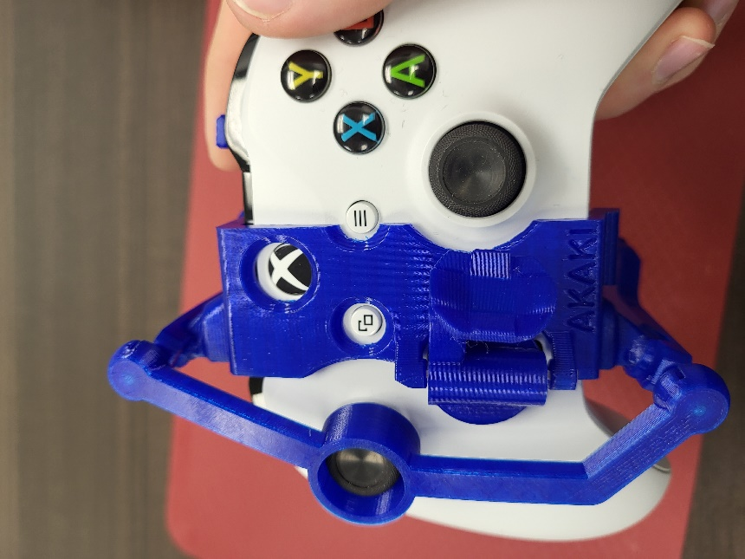

## Usage

To put the controller mods on, line up the top of the main housing piece with the center of the controller so the button holes line up with the buttons. Then push on the bottom part of the main housing piece to snap it into place. Ensure the thumbstick is centred properly in the circle over the top face of the controller mod. Lastly, latch the arm on the back of the controller mod.

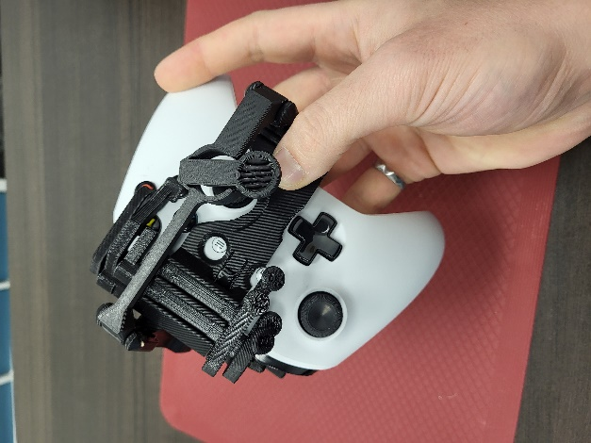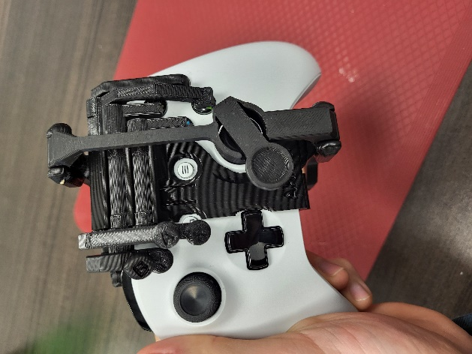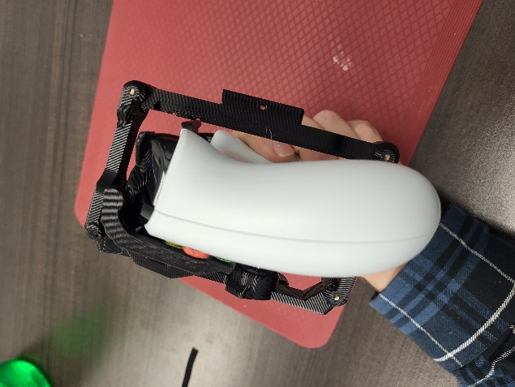

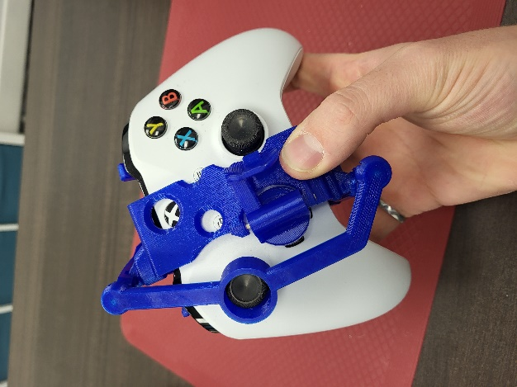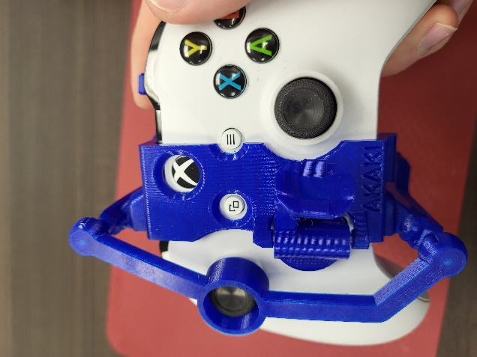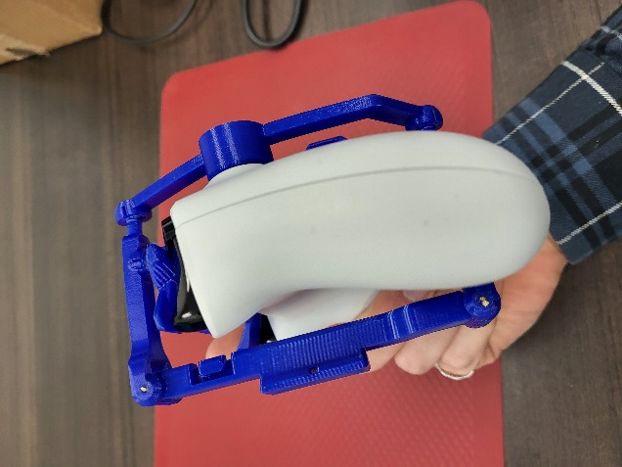

In addition to the mods, there are two mounting methods available. These mounting options both require a pin to fasten them to the controller mod. Extra filament, or a toothpick with glue can be used, or even a bent paperclip for ease of removal. The shoe is a more mobile option, while the leg mount straps the device to the user’s leg in a stationary spot. Moving the controller in respect to this anchor point is what moves the thumbstick, while the button and trigger extenders allow easier reach to the opposite side buttons and triggers.

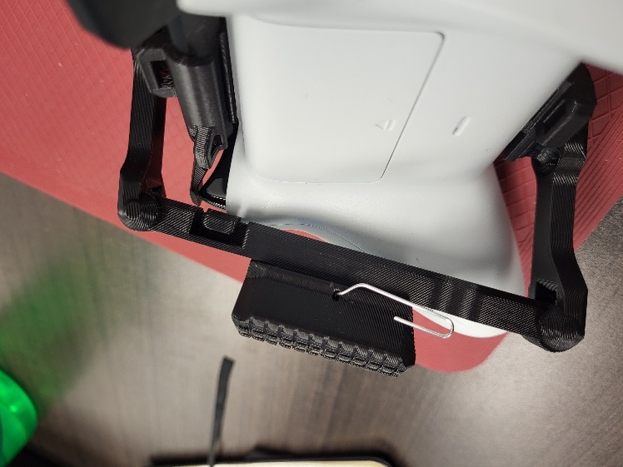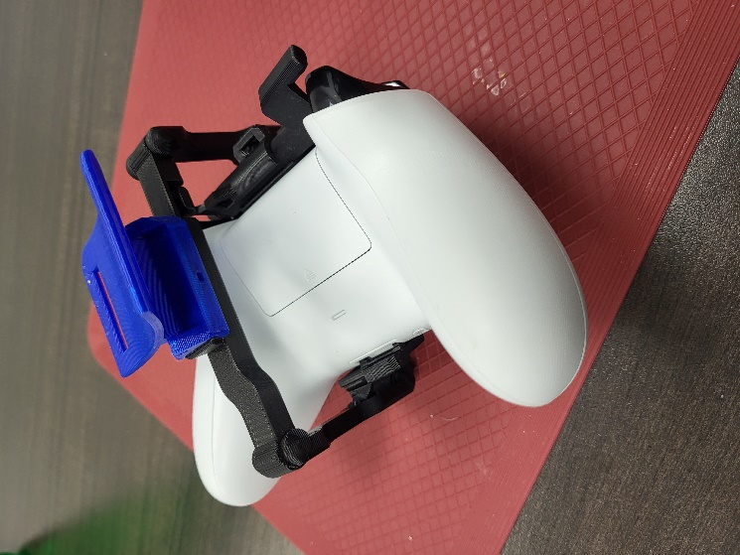

Note: The leg mount requires some type of strap (Velcro, elastic webbing, etc.) to fix it to the user’s leg.

## Compatibility

These mods are compatible with the Xbox One controller, which is in turn compatible with the following systems:

* Xbox Series X|S
* Xbox One
* Xbox 360
* PC
* Nintendo Switch (with an appropriate [adapter](https://www.amazon.ca/Mayflash-Magic-NS-Wireless-Controller-Nintendo/dp/B079B5KHWQ/ref=asc_df_B079B5KHWQ/?tag=googleshopc0c-20&linkCode=df0&hvadid=292937839648&hvpos=&hvnetw=g&hvrand=11899347943701197930&hvpone=&hvptwo=&hvqmt=&hvdev=c&hvdvcmdl=&hvlocint=&hvlocphy=9000712&hvtargid=pla-487335326322&psc=1))

## Cleaning

This device can be wiped down with lukewarm water and soap. Do not use hot water as it could cause the plastic to reform.