# Required Components

|  |  |
| --- | --- |
| A screenshot showing the Prusaslicer rendering of the 7 components of the right-handed mod for the Xbox One controller.  7  6  5  4  3  2  1 | **BOM**   1. Trigger Extender 2. Bottom Ball n Socket Connector 3. Top Ball n Socket Connector 4. Thumbstick Arm 5. Main Housing Piece 6. Rear Connecting Arm 7. Dpad Extender 8. Pins (extra filament) |

# Required Tools

* Glue

# Required Personal Protective Equipment (PPE)

* Safety Glasses

# Assembly Instructions

## Step 1

Take the trigger/bumper extender and snap it into the remaining slot on the back of the main housing piece. Ensure the larger side is on the right when looking from the front or top.

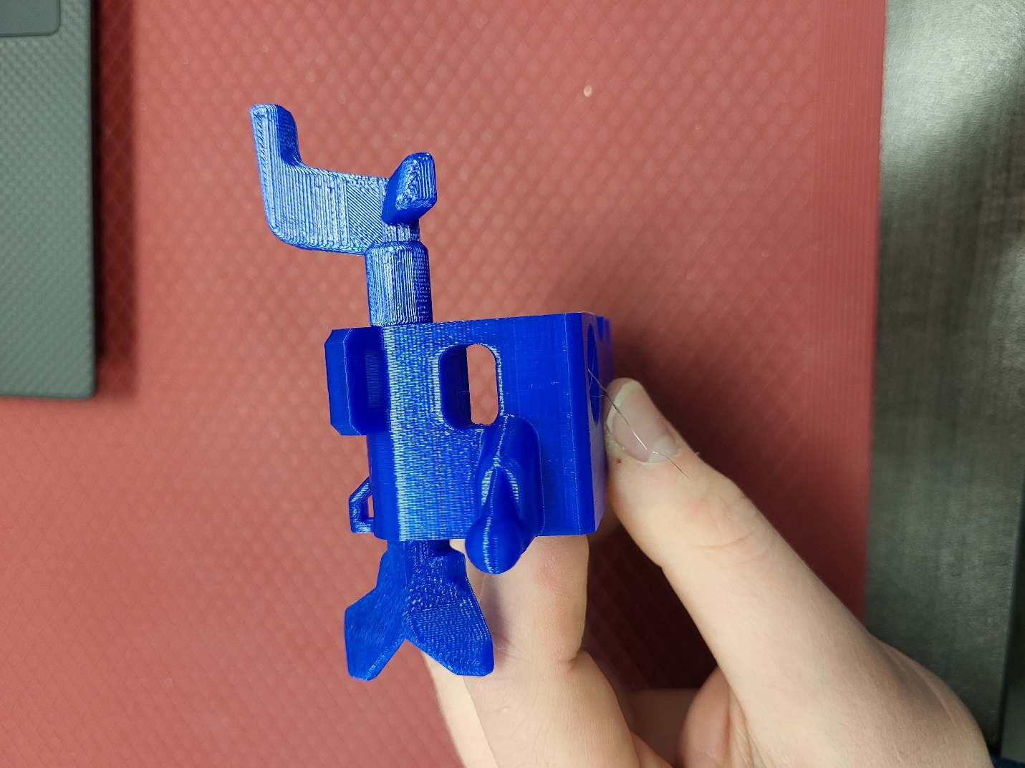

## Step 2

Take the pieces with socket joint connections on them. Notice that the two pieces are slightly different, the left-hand one being lined up, while the right-hand side one has the two ends offset from each other. The left-hand piece pictured gets snapped onto the ball joint on the top side of the controller mod, and the right-side piece is snapped onto the ball joint along the bottom of the controller mod, such that the longer ends point toward the back of the controller.

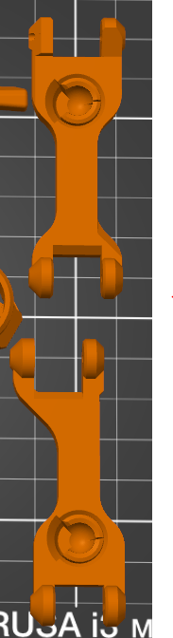

Offset

Lined Up

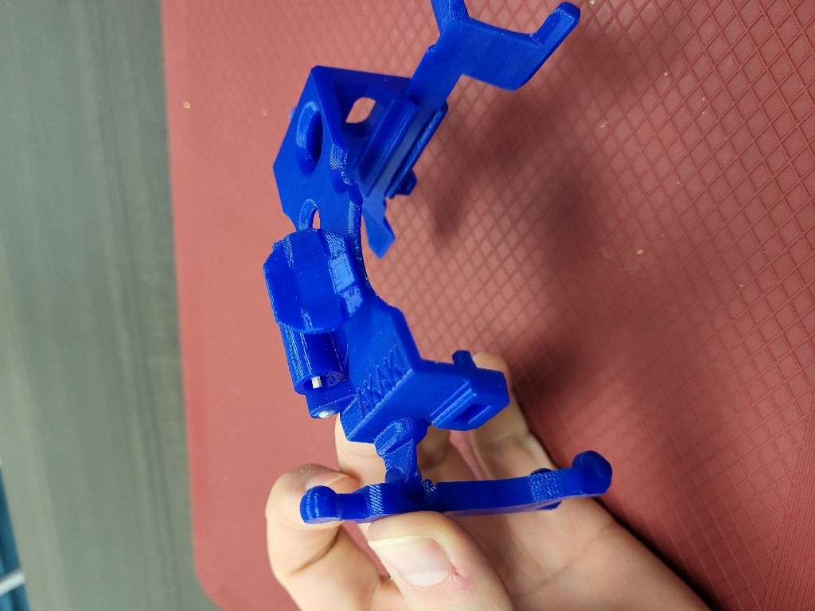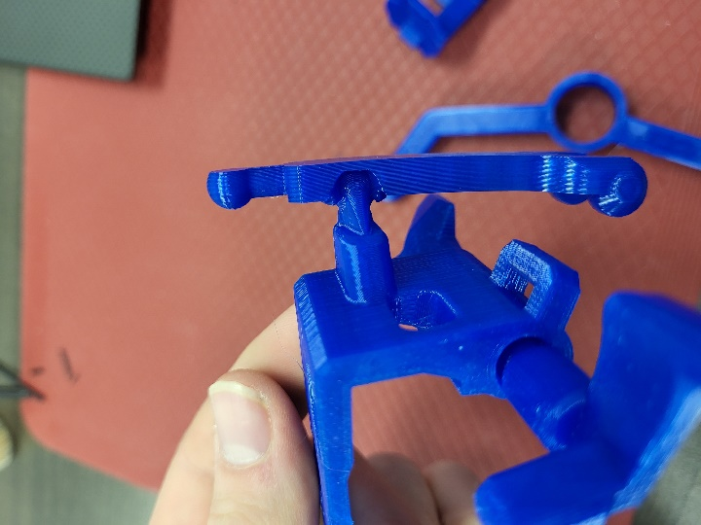

## Step 3

Clip the thumbstick arm sockets to the ball joints sticking up from Step 2. Ensure the circle lines up with the left thumbstick and is situated toward the top of the controller while the “elbow” corner in this piece is toward the bottom.

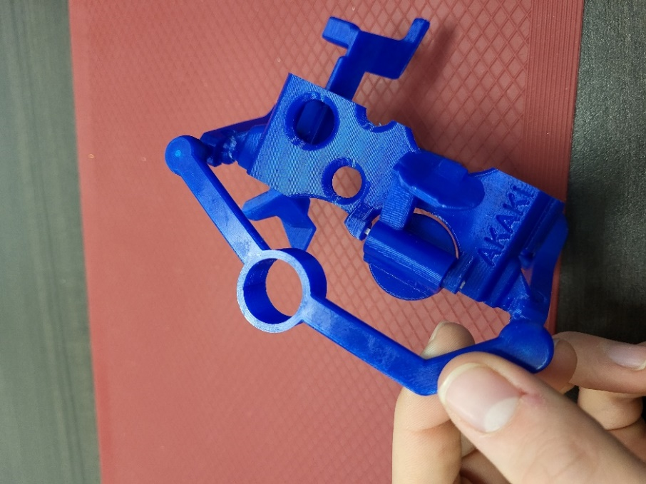

## Step 4

Attach the remaining connecting arm along the back of the controller such that the open latch end swings to the bottom of the controller. Use shaved down toothpicks or extra filament and glue to attach the connecting rod.

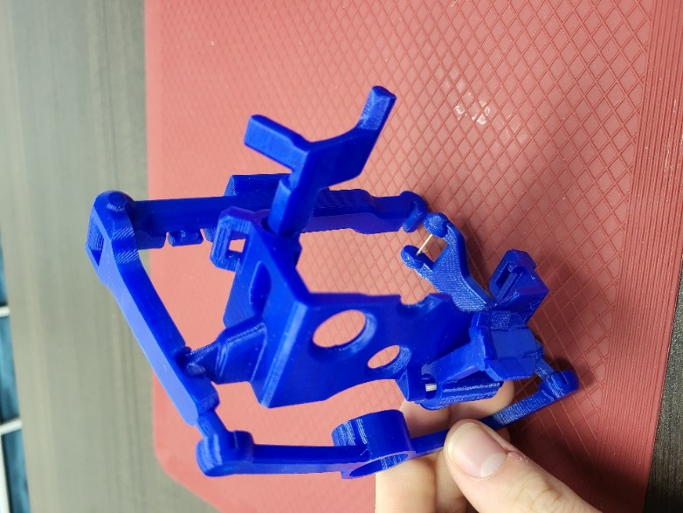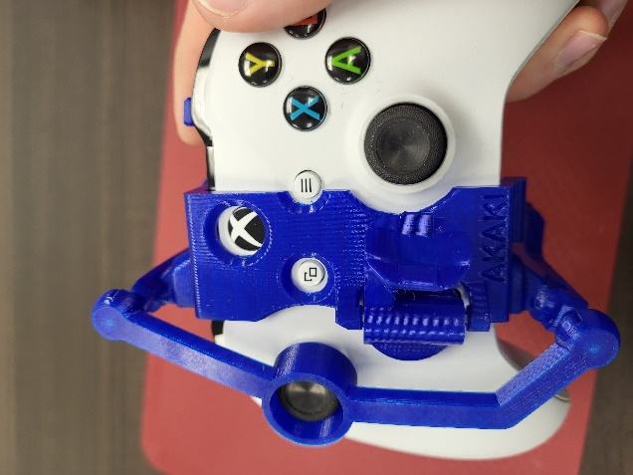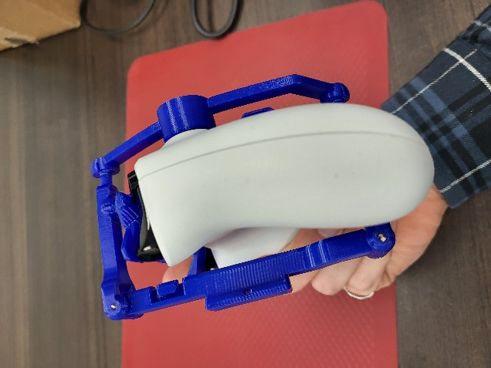

Latch