# Required Components

|  |  |
| --- | --- |
| *A picture containing the 10 black 3D printed components for a left-handed Xbox One controller mod.* | **BOM**   1. 3D printed components 2. Pins (toothpicks or extra filament) |

# Required Tools

* Glue

# Required Personal Protective Equipment (PPE)

* Safety Glasses

# Assembly Instructions

## Step 1

Take the button extenders and push the rods onto the outward facing slots on the main housing piece. From bottom to top, the order is X, Y, A, B. Note: The second photo shows the main housing piece on the controller, this is not required, but may aid in situating the pieces in the correct order. The mod will have to be removed from the controller for Step 2.

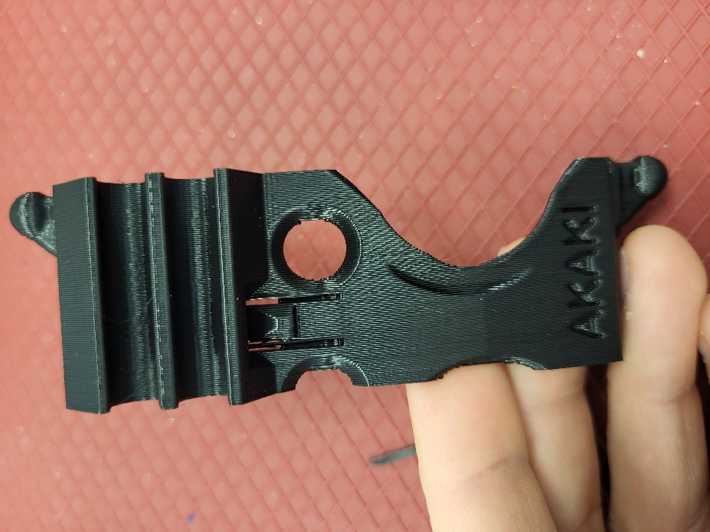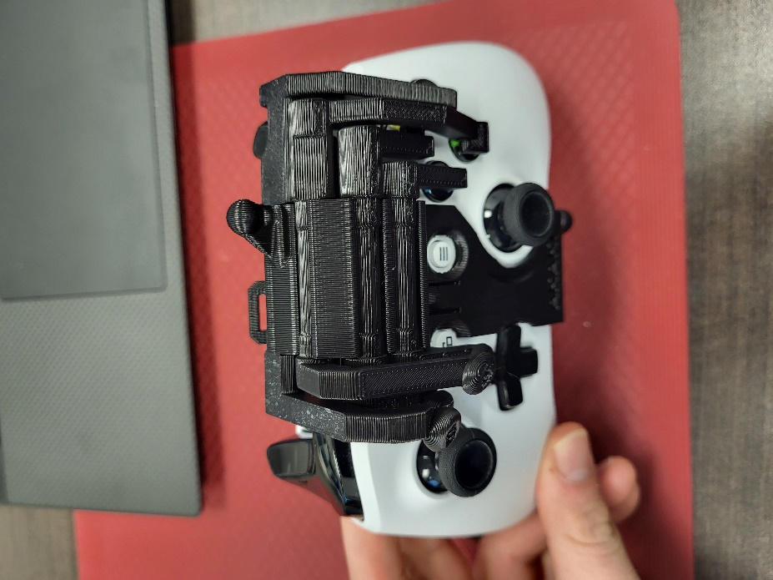

## Step 2

Take the trigger/bumper extender and snap it into the remaining slot on the back of the main housing piece. Ensure the larger side is on the left when looking from the front.

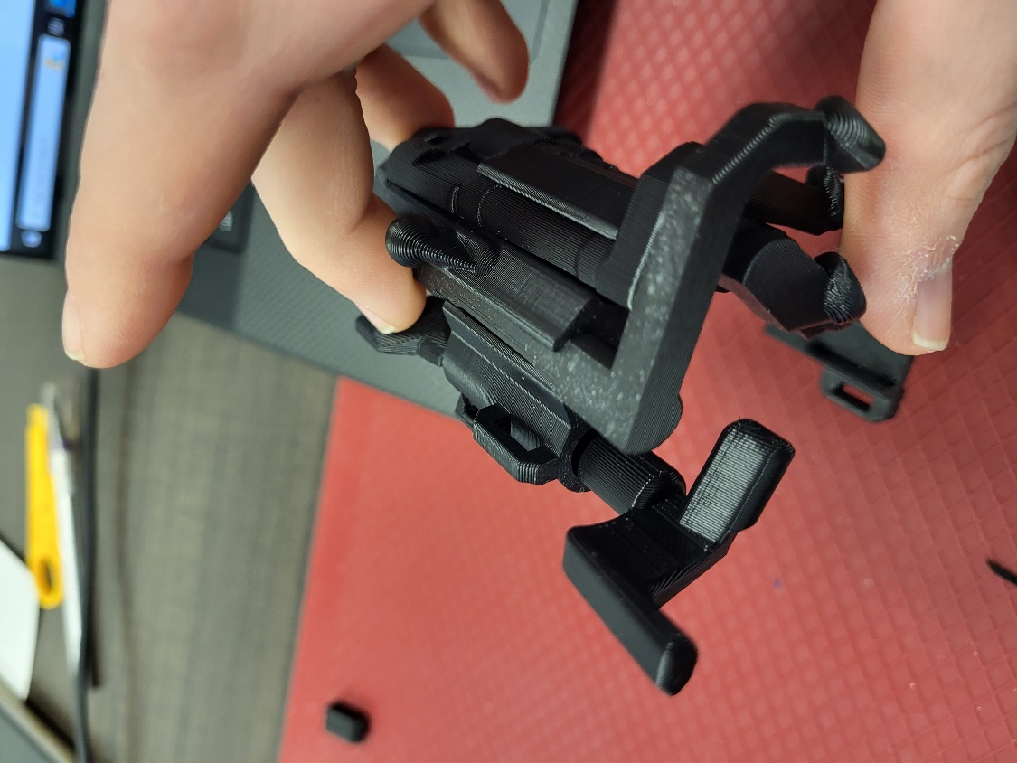

## Step 3

Clip the main housing piece onto the Xbox One controller. Do this by lining up the “view” and “menu” buttons on the front of the controller with the cut-outs on the housing piece, then pushing the bottom clip under the bottom of the controller. It should snap into place.

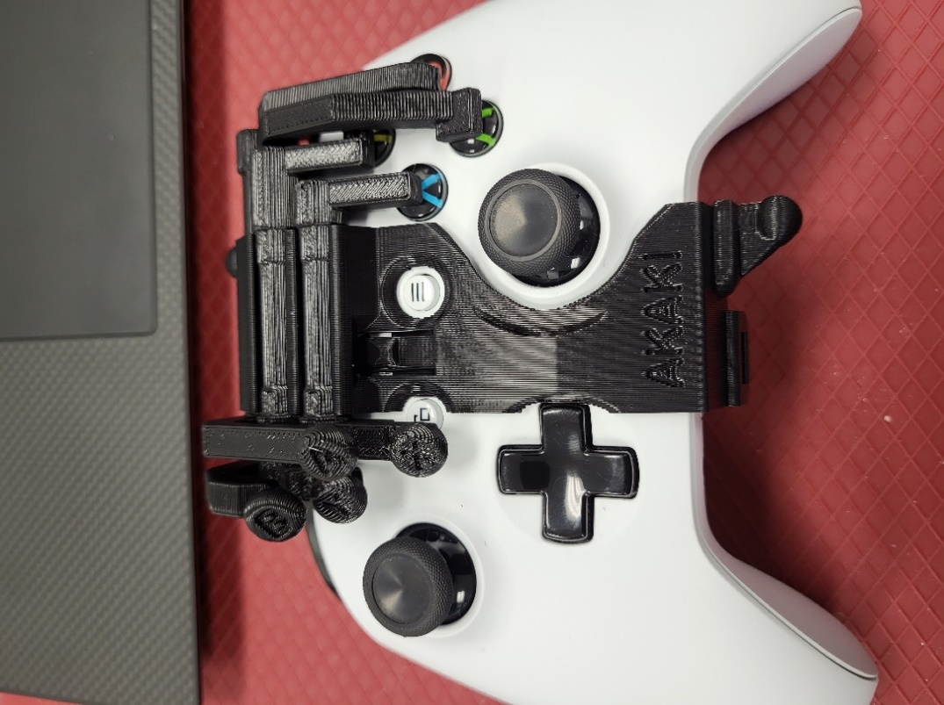

## Step 4

Take the pieces with socket joint connections on them. Notice that the two pieces are slightly different, the left-hand one being lined up, while the right-hand side one has the two ends offset from each other. The left-hand piece pictured gets snapped onto the ball joint on the top side of the controller mod, and the right-side piece is snapped onto the ball joint along the bottom of the controller mod, such that the longer ends point toward the back of the controller.

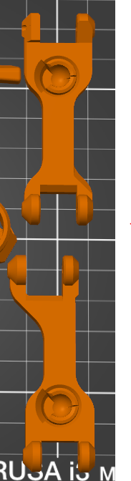

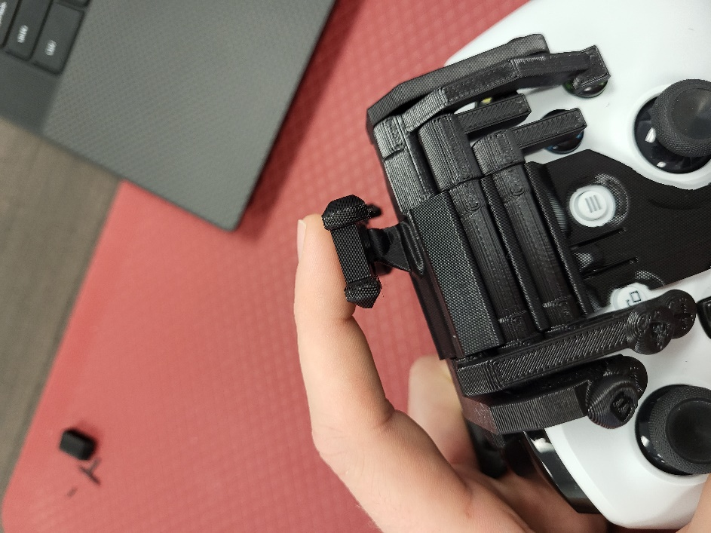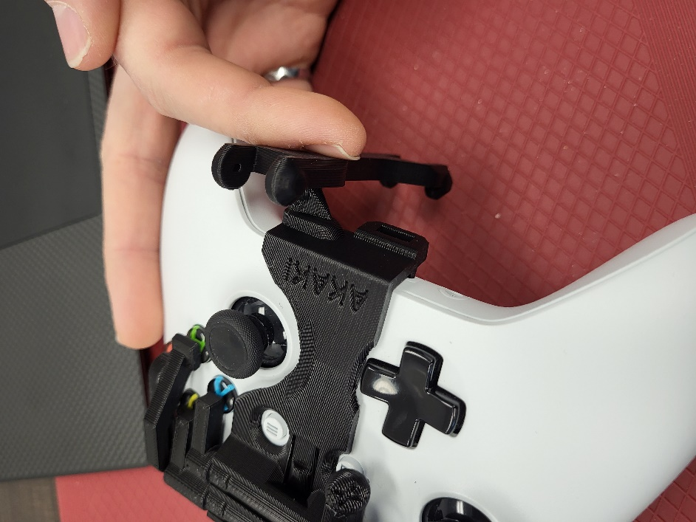

## Step 5

Attach the thumbstick over the top of the controller using scrap filament, toothpicks, or equivalent as pins. Glue the pins in place and cut them down flush to the 3D print. Be careful not to get any glue in the moving portion of this hinge.

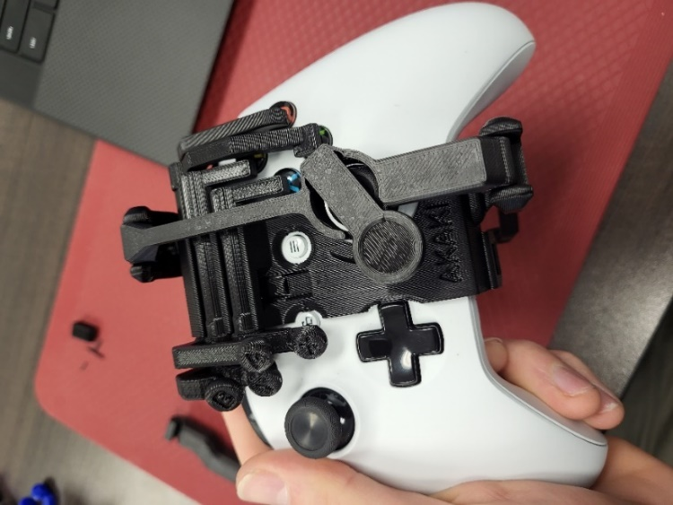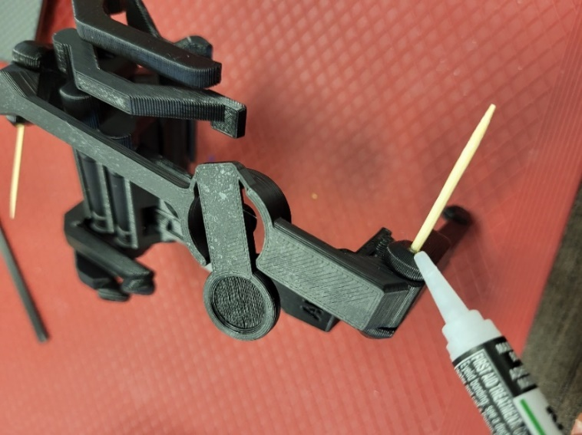

## Step 6

Attach the remaining connecting rod along the back of the controller such that the open latch end swings to the bottom of the controller.

