## Introduction

The Open Playback Recorder is an open-source device that can record three lists of voice messages that its user can playback via the trigger of an accessible button connected through a 3.5 mm mono jack. It aims to assist users with communication difficulties by giving them alternative methods to engage in conversation. This device has functionality like AbleNet’s Big Mack or Step by Step.

## Features

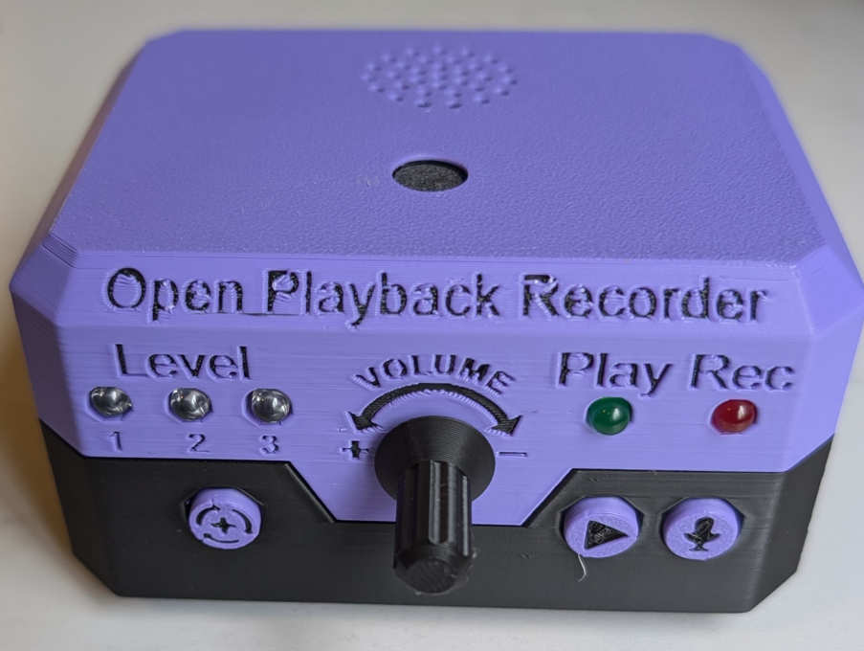

Volume Knob

Play Button

Level button

Record Button

Record LED LEDs

Play LED

Level LEDs

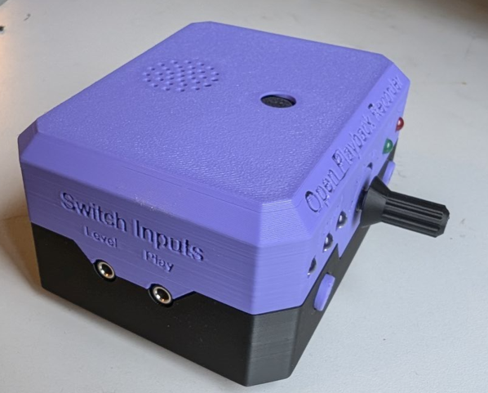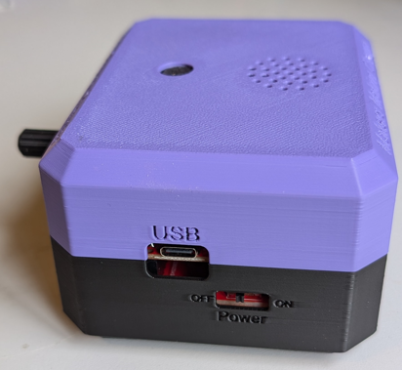

USB Port

Power Switch

Level Jack

Play Jack

Speaker

Microphone

## Usage

### Setup

Connect two assistive switches, one to the jack labeled PLAY, and one to the jack labeled LEVEL.

### Power On

To power on the device, toggle the switch on the side of the device from OFF to ON.

The device can also be power through the USB port on the side of the device without needing a battery.

### Message Recording

To record one or more messages, the device needs to be in Record Mode. The device will record messages to the currently selected level.

**Step 1.** To engage “Record Mode” hold down the REC button for 2 seconds. When Record Mode is engaged, the REC LED will turn red and remain solid.

Note: When Record Mode is engaged, all previous messages on that level will be erased.

**Step 2.** To start message recording, press and hold the PLAY button or assistive switch connected to the play jack. The REC LED will flash red. Record the message into the microphone and release the button to end and save the message. The RED LED will once again turn red and remain solid.

**Step 3.** To record additional messages, repeat Step 2.

Note: These messages will later by played back in the same order they were recorded.

**Step 4.** When the desired messages have been recorded, press the REC button to exit Record Mode. The red REC LED will turn off.

### Message Playback

To play back a message, press an assistive switch connected to the play jack. This will play a message from the current recording level. The play button on the device itself will also allow a secondary user to play a message. Continuing to press the button will cycle through all the messages on that level.

To change the message level, press an assistive switch connected to the level jack. The level shift button on the device will also allow a secondary user to change the message level. The current level will be indicated by the three blue LEDs on the left side of the device.

## Compatibility

The device is compatible with any 3.5mm assistive switch

## Specifications

|  |  |
| --- | --- |
| Weight | 250 grams |
| Length | 105 mm |
| Width | 85 mm |
| Height | 60 mm |
| Audio Recording Length | No limit, all recordings must fit in 512 MB, or roughly 500 minutes. |
| Assistive Switch Inputs | 2 |
| Battery Type | 9V |

## Maintenance

### Changing The Battery

To replace the 9V battery, use a Philips screwdriver to remove the screw holding the battery holder in place. Remove the battery holder, and remove the battery from the slot. A new battery can be can be inserted into the holder and the battery holder can then be put back into the device and secured with the screw.

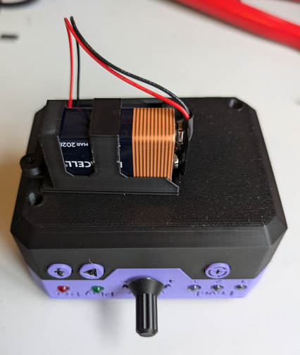

## Cleaning

To clean the device, wipe down the outside with a damp cloth or cleaning wipes. Do not get the internal electronics wet.

## Troubleshooting

### Noises from the speaker / Not playing audio messages

If the speaker starts making unwanted noises while in REC / PLAY modes or messages do not play during message playback, this can be a sign that the battery is low on power. Follow instructions in the maintenance section to replace the battery.

### Device power cycles/resets when volume is too high

If the device power cycles or resets when the volume is set too high, this is a sign that the battery cannot provide enough current. This issue was noticed when using a Samxieng PowerfulCell 9V battery, and was solved by changing to a Duracell 9V battery.