# Introduction

The Open Rocker Switch is an accessible switch with two buttons. The switch is activated by pressing down on one side or the other like a see-saw. This device is suitable for anyone and can be connected to any device with a 3.5 mm interface.

# Features

3.5 mm Mono Cables

Paddle Buttons

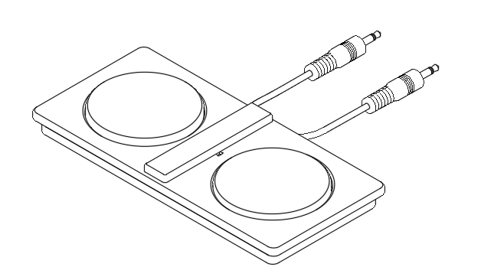

Divider

# Usage

Connect the cables to the assistive device.

|  |  |  |
| --- | --- | --- |
| Action | Action Time (seconds) | Function |
| **Press Button Left** | < 1 | Depends on interfaced device |
| **Press Button Right** | < 1 | Depends on interfaced device |

# Compatibility

Compatible with any device that accepts a 3.5 mm mono cable. The device can be connected to two separate devices, one device with two mono inputs, or one device with a stereo input with an appropriate mono to stereo adapter.

# Specifications

|  |  |
| --- | --- |
| **Activation Force** | 1.27 ± 0.49 N  130 ± 50 grams-force |
| **Activation Distance** | ~ 0.3 mm |
| **Dimensions**  **(Length x Width x Height)** | 170 x 80 x 18.35 mm |
| **Weight** | $\sim$ 100 grams  (Depends on print material) |
| **Switch Electrical Rating** | 50 mA at 24VDC |

# Cleaning

* Disassemble all pieces
* Wash paddle buttons, divider, and top piece in any cleaning solution
* Wipe clean bottom piece with a towel or paper towel and leave to dry completely to ensure that the buttons will not short circuit