# Overview

The Device Summary is intended to be a detailed summary of the device, product and maker information for the Open Rocker Switch, making it easier to add to the Makers Making Change website. It is intended for anyone who will view the device listing.

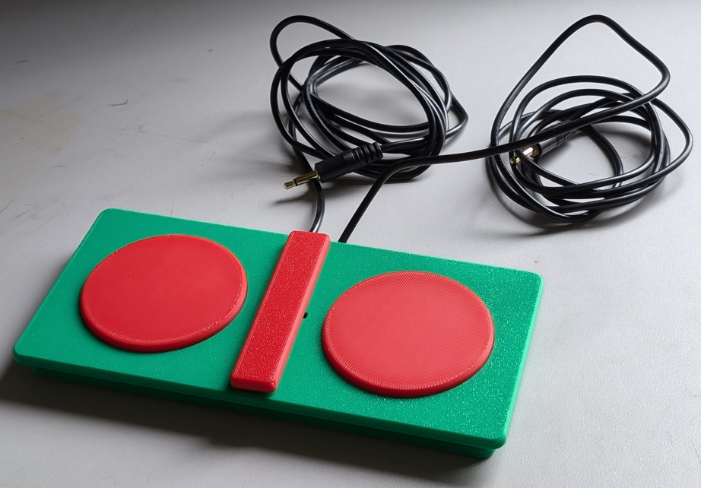

# Product Information

## Product Name

Open Rocker Switch

## Device Category

Mark any relevant categories with an “X”:

|  |  |
| --- | --- |
|  | Adapted Toys |
|  | Aids for Daily Living (ADL) |
| X | Assistive Switches |
| X | Communication Aids (AAC) |
| X | Computer Access |
|  | Environmental Controls |
|  | Gaming |
|  | Keyguard |
|  | Kits |
|  | LipSyncs |
|  | Mounting |
|  | Recreation and Leisure |
|  | Seating and Positioning |
|  | Switch Interfaces |
|  | Writing Aids |

## User Value Statement

If you are looking for an assistive switch to control two separate inputs on an accessible device, the dual action Open Rocker Switch might just be the two-in-one solution for you.

## Designer

Makers Making Change

# Device Information

## Overview

The Open Rocker Switch is a cost effective, 3D printed, dual action rocker switch that allows users to control dual input accessible devices.

# This switch is comparable in size, activation force, and travel to the discontinued AbleNet Rocker Switch. The Open Rocker Switch has interchangeable button pieces and center divider pieces for users to customize and personalize their switch.

## Disability Type

Select one or more disability types and mark with an “X”:

|  |  |
| --- | --- |
| X | Agility / Dexterity |
|  | Arthritis |
| X | Cognitive |
|  | Hearing |
| X | Mobility |
|  | Pain |
|  | SCI |
|  | Vision |
|  | Other |

## Disability Type Description

This device is designed for users of accessible switches, particularly those using devices that require dual inputs, such as scanning devices or morse code input.

## How To Use

The user presses on the buttons on either side of the central divider. The buttons activate the device connected to the corresponding mono cable.

## Estimated Cost

The estimated material cost of the device for a single build:

|  |  |
| --- | --- |
|  | $0 - $10 |
| X | $11 - $25 |
|  | $26 - $50 |
|  | $51 - $100 |
|  | $101 - $250 |
|  | $250+ |

## Attribution

The Open Rocker Switch is inspired by the design of the now discontinued Ablenet Rocker Switch, originally created by TASH.

Design:

* Gabriel Chiu
* Jake McIvor
* Brad Wellington

# This switch is comparable in size, activation force, and travel to the discontinued AbleNet Rocker Switch. The Open Rocker Switch has interchangeable button pieces and center divider pieces for users to customize and personalize their switch.

# Maker Information

## Project Skills

Mark the required project skills with an “X”:

|  |  |
| --- | --- |
| X | 3D Printing |
|  | Custom PCB |
|  | Electronics |
|  | Laser Cutting |
|  | Mechanics |
|  | Software |
| X | Soldering |
|  | Woodworking |
|  | Other |

## Skills Description

Hot glue to attach the buttons, 3D printing to create the components, soldering to attach the buttons to the cable, hand tools to trim parts and strip wires.

## Tools Needed

|  |  |
| --- | --- |
| X | 3D Printer |
| X | Common Hand Tools |
|  | Common Power Tools |
|  | Laser Cutter |
| X | Soldering Iron |
|  | Specialized Tooling |

## Print time (hrs)

3

## Assembly time (hrs)

0.25

## Build Instructions

All parts are 3D printed. The buttons are bent and trimmed to shape, then the mono cables soldered to them. The buttons are hot glued to the switch base, then the cables cable tied in place. The buttons prints and divider are attached to the top rocker face of the switch, then the top face is connected to the bottom using the axle pin.

## Download Link

https://github.com/makersmakingchange/Open-Rocker-Switch /archive/refs/heads/main.zip

## Project Link

https://github.com/makersmakingchange/Open-Rocker-Switch

# License

## License

Hardware:  CERN 2.0 Permissive license

Documentation: Creative Commons Attribution-ShareAlike 4.0